**# PHYSIQUE ATOMIQUE ET NUCLÉAIRE**

**# DEVOIR #4 - NUMÉRO 5**

**# CODE PYTHON**

**class** PB:  
 **def** __init__(self):  
 self.A = 208 *# Nombre de masse* self.Z = 82 *# Nombre atomique* self.Vo = 50 *# MeV* self.hw = 41 * self.A**(-1/3) *# MeV* self.D = 0.0225 * self.hw  
 self.C = 0.1 * self.hw  
  
 self.protons = [ *# couches complètées pour 82 protons* [1, 0, 0.5],  
 [1, 1, 1.5],  
 [1, 1, 0.5],  
 [1, 2, 2.5],  
 [2, 0, 0.5],  
 [1, 2, 1.5],  
 [1, 3, 3.5],  
 [2, 1, 1.5],  
 [1, 3, 2.5],  
 [2, 1, 0.5],  
 [1, 4, 4.5],  
 [2, 2, 2.5],  
 [1, 4, 3.5],  
 [3, 0, 0.5],  
 [2, 2, 1.5],  
 [1, 5, 5.5], *# 82 protons* ]  
  
 self.neutrons = [ *# couches complétées pour 126 neutrons* [1, 0, 0.5],  
 [1, 1, 1.5],  
 [1, 1, 0.5],  
 [1, 2, 2.5],  
 [2, 0, 0.5],  
 [1, 2, 1.5],  
 [1, 3, 3.5],  
 [2, 1, 1.5],  
 [1, 3, 2.5],  
 [2, 1, 0.5],  
 [1, 4, 4.5],  
 [2, 2, 2.5],  
 [1, 4, 3.5],  
 [3, 0, 0.5],  
 [2, 2, 1.5],  
 [1, 5, 5.5], *# 82 neutrons* [2, 3, 3.5],  
 [1, 5, 4.5],  
 [1, 6, 6.5],  
 [3, 1, 1.5],  
 [2, 3, 2.5],  
 [3, 1, 0.5] *# 126 neutrons* ]  
  
 **def** Enlsj(self,n,l,s,j): *# Énergie d’un nucléon selon nlsj*  
 **return** - self.Vo + self.hw * (2 * (n - 1) + l + 3/2) - self.D * l * (l + 1) - self.C * (j * (j + 1) - l * (l + 1) - s * (s + 1)) / 2  
  
 **def** bindingEnergy(self): *# Énergie de liaison*  
 protonsEnergy = 0  
 **for** shell **in** self.protons:  
 n, l, s, j = shell[0], shell[1], 0.5, shell[2]  
 protonsEnergy += self.Enlsj(n, l, s, j) * (2 * j + 1)

*# Ajout de l’énergie d’un proton multipliée par le degré de dégénérescence*  
 neutronsEnergy = 0  
 **for** shell **in** self.neutrons:  
 n, l, s, j = shell[0], shell[1], 0.5, shell[2]  
 neutronsEnergy += self.Enlsj(n, l, s, j) * (2 * j + 1)

*# Ajout de l’énergie d’un neutron multipliée par le degré de dégénérescence*  
 **return** - (protonsEnergy + neutronsEnergy) *# Somme de toutes les énergies*  
  
pb = PB()  
print(**'The binding energy is'**, pb.bindingEnergy(), **'MeV.'**)

***Output :***

The binding energy is 3422.517322322542 MeV.

**# PHYSIQUE ATOMIQUE ET NUCLÉAIRE**

**# DEVOIR #4 - NUMÉRO 3**

**# CODE PYTHON**

**import** numpy **as** np  
**from** matplotlib **import** pyplot **as** plt  
**import** scipy.special **as** ss  
**import** scipy  
  
  
**def** f(x):  
 **return** x  
   
**def** f0(x, Omega2):  
 **return** - (1 - x**2)**0.5 * (np.tan((Omega2 * (1 - x**2))**0.5))**-1  
  
**def** F(L, x, Omega2):  
 a = scipy.sqrt((Omega2 * (1 - x**2)))  
 b = 1j * Omega2**0.5 * x  
 coeff = -1j * scipy.sqrt((1 - x**2))  
 firstTerm = ss.spherical_jn(L - 1,a) / ss.spherical_jn(L,a)  
 secdTerm = (ss.spherical_jn(L,b) + 1j*ss.spherical_yn(L,b)) / (ss.spherical_jn(L-1,b) + 1j * ss.spherical_yn(L-1,b))  
 **return** coeff * firstTerm * secdTerm  
  
*# Omega^2 values*singlet = 2.23 * 4  
triplet = 3.57 * 4  
  
*# w values knowing w range is [0,1]*w = np.array([(i + 1)/100 **for** i **in** range(99)])  
  
*# left term of the transcendant equation*f = np.array([f(i) **for** i **in** w])  
  
*# right term of the transcendant equation*f_00 = np.array([f0(i, singlet) **for** i **in** w]) *# when (L,S) = (0,0)*f_01 = np.array([f0(i, triplet) **for** i **in** w]) *# when (L,S) = (0,1)*F_10 = np.array([F(1,i, singlet) **for** i **in** w]) *# when (L,S) = (1,0)*F_11 = np.array([F(1,i, triplet) **for** i **in** w]) *# when (L,S) = (1,1)  
  
# when (L,S) = (0,0)*plt.figure()  
plt.plot(w,f)  
plt.plot(w,f_00)  
idx = np.argwhere(np.diff(np.sign(f_00 - f))).flatten()print(**'intersection'**, w[idx])  
plt.plot(w[idx], f[idx], **'ro'**)  
plt.ylim([-1,10])  
plt.savefig(**'00'**, bbox_inches = **'tight'**)  
  
*# when (L,S) = (0,1)*plt.figure()  
plt.plot(w,f)  
plt.plot(w,f_01)  
idx = np.argwhere(np.diff(np.sign(f_01 - f))).flatten()  
print(**'intersection'**, w[idx])  
plt.plot(w[idx], f[idx], **'ro'**)  
plt.ylim([-1,10])  
plt.savefig(**'01'**, bbox_inches = **'tight'**)  
  
*# when (L,S) = (1,0)*plt.figure()  
plt.plot(w,f)  
plt.plot(w,np.real(F_10))  
idx = np.argwhere(np.diff(np.sign(F_10 - f))).flatten()  
print(**'intersection'**, w[idx])  
plt.plot(w[idx], f[idx], **'ro'**)  
plt.ylim([-10,10])  
plt.savefig(**'10'**, bbox_inches = **'tight'**)  
  
*# when (L,S) = (1,1)*plt.figure()  
plt.plot(w,f)  
plt.plot(w,np.real(F_11))  
idx = np.argwhere(np.diff(np.sign(F_11 - f))).flatten()  
print(**'intersection'**, w[idx])  
plt.plot(w[idx], f[idx], **'ro'**)  
plt.ylim([-1,10])  
plt.savefig(**'11'**, bbox_inches = **'tight'**)

***Output :***

intersection 00 [0.6477]

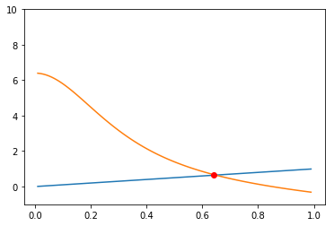

intersection 01 [0.5557 0.7636]

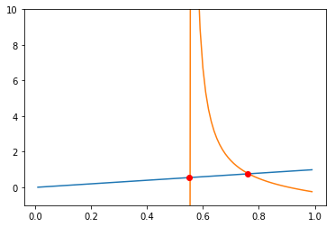

intersection 10 []

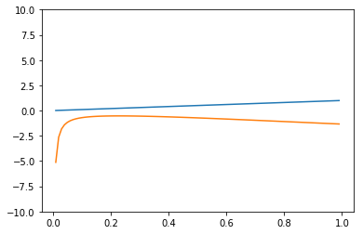

intersection 11 [0.4319]

