|  |
| --- |
| Linear Control Systems  Design of a controller with given criteria |
|  |
| December 2022  By Arian Hajizadeh |

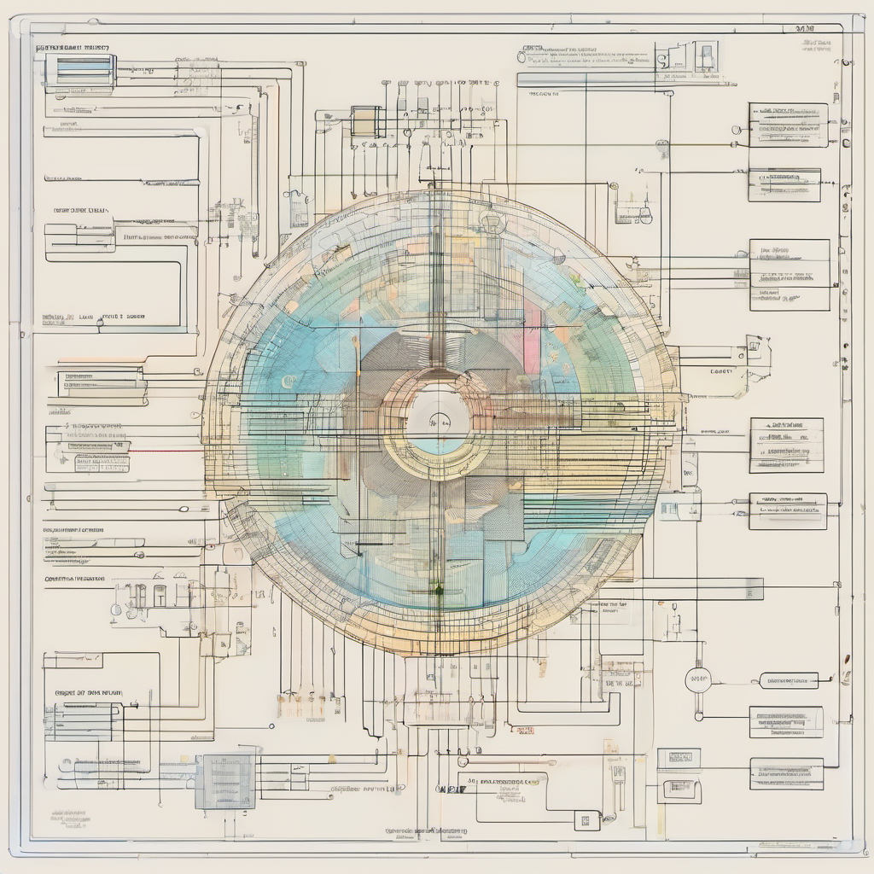



Contents

1 Introduction 3

2 System Analysis and Design Parameters 3

3 Phase Lead Controller Design 6

3.1 Design using graphical method 6

3.2 Design using placement of zero 10

# Introduction

This is the final project regarding linear control systems course conducted by Dr. Soheil Ganjefar at Iran University of Science and Technology during the fall of 2022 and winter of 2023. In this project we tackle the task of designing a controller for a given system illustrated in Figure 1.1 This system is structured as a closed-loop configuration with negative feedback. Our objective is to analyze the provided information in each section and devise a well-suited controller that ensures optimal performance for the system. Join us on this journey as we delve into the intricacies of control theory and embark on the exciting process of controller design.

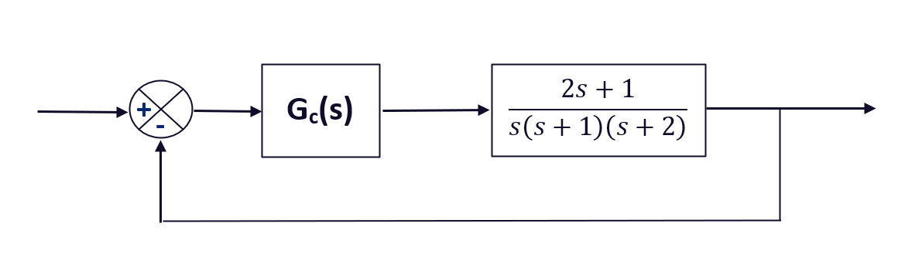

Figure 1-1 Block diagram of the system

In this project, our objective is to design a controller that meets specific performance requirements for the system. We aim to achieve a maximum overshoot of 30 percent, a settling time of less than 2 seconds, and a kv value greater than or equal to 40.

# System Analysis and Design Parameters

In this project, the initial step involves analyzing the system to determine whether an additional controller is required, and if the desired properties cannot be achieved using a simple gain as the control unit. The first step is on obtaining and studying the root locus of the system, as well as the desired poles. This analysis will provide valuable insights into the system's stability and performance characteristics, enabling informed decisions regarding the controller design. Therefore, the root locus and desired poles can be seen in figure 2-1.

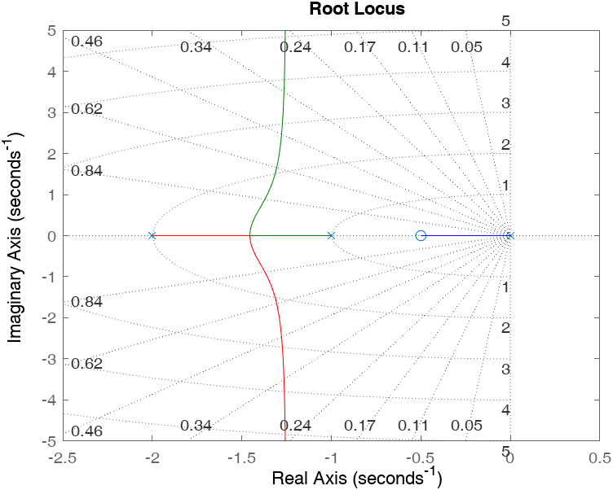

Figure 2-1 root locus of the given system

As for the desired poles we can write the following:

(2-1)

(2-2)

(2-3)

(2-4)

With these calculations the desired points are obtained and can be checked on the s plane alongside the root locus diagram in figure 2-2.

As it is inferred from figure 2-2, the desired poles are not on the root locus diagram of the system. Therefore, additional controller design is needed to achieve the desired characteristics given.

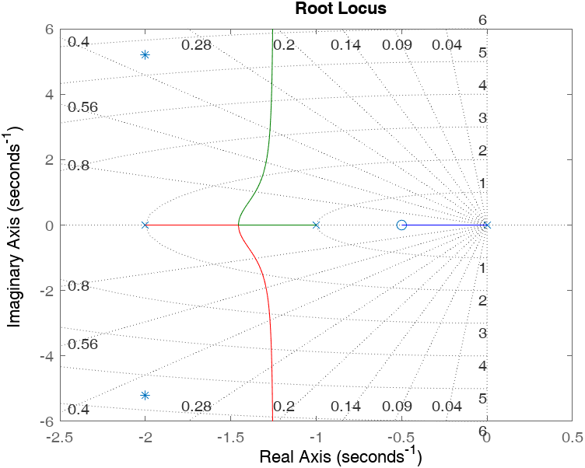

Figure 2-2 root locus of the system alongside desired poles

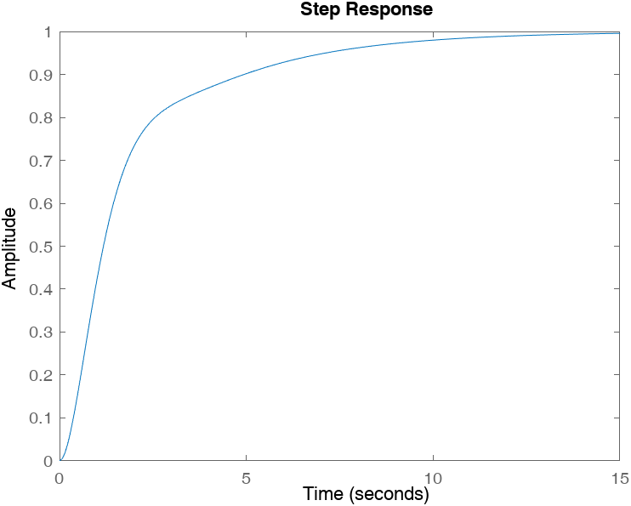

stepinfo(G/(1+G))

ans = struct with fields:

RiseTime: 4.5641  
 TransientTime: 9.9974  
 SettlingTime: 9.9974  
 SettlingMin: 0.9003  
 SettlingMax: 0.9983  
 Overshoot: 0  
 Undershoot: 0  
 Peak: 0.9983  
 PeakTime: 17.7866

Figure 2-3 step response of the initial system

Once it has been established that an additional controller is necessary for the system, the next step in the project is to design a suitable controller. However, due to the limitations of linear control systems, the scope of this project focuses on the design of a phase lead and phase lag controllers. More complex controller designs are not within the scope of this project. Consequently, the upcoming chapters will be dedicated to the objective of designing both phase lead and phase lag controllers. Through these controller designs, we aim to enhance the system's performance and achieve the desired system characteristics.

# Phase Lead Compensator

The general form of a phase lead compensator can be seen in (3-1).

; p > z > 0 (3-1)

Applying equation (3-1) and drawing upon existing knowledge, it is evident that the magnitude of the added pole to the system is consistently greater than magnitude of the added zero. This observation highlights that the injected angle of zero will invariably exceed the angle of the injected pole. Consequently, this design principle enables us to consistently achieve a lead angle (φ). Notably, the larger zero angle, in comparison to the phase lead angle of the injected pole, ensures that the injected angle remains positive. As a result, this controller ensures that using phase criterion the injected angle is such that the desired poles are on the root locus diagram of the system. Therefore, these conditions ensure that the desired properties or specifications are met.

## Design using graphical method

In this method, the real-axis of the frequency response plot for the linear system is first plotted. Then, based on the desired specifications, the desired pole locations are placed on the real-axis, and the corresponding angles are calculated. Using the component elements, the Phase Lead control network is designed, which alters the phase angle and increases the stability of the system.

The angles of zeros and poles can be determined by referencing Figure 3-1. By using this figure, we can calculate the respective angles associated with the zeros and poles of the system. Subsequently, the phase lead angle can be computed utilizing Equation (3-2).

(3-2)

(3-3)

(3-4)

(3-5)

(3-6)

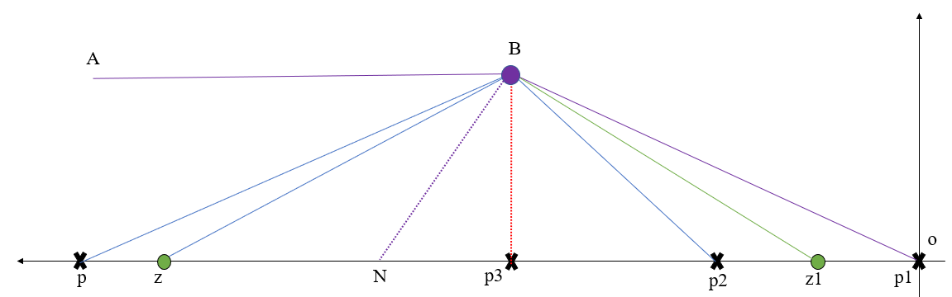

**Figure 3-1** system root locus diagram after adding the controller

Using the equation (3-2) now the following can be written:

(3-7)

With the calculated phase lead angle, it becomes possible to determine the pole and zero of the phase lead controller.

(3-8)

(3-9)

(3-10)

Now the precise location of zero and pole of the controller can be obtained.

(3-11)

(3-12)

With this information now the gain of the phase lead controller can be determined as follows using gain criterion.

(3-13)

(3-14)

Therefore, the phase lead controller using graphical design method can be seen at (3-15)

(3-15)

The performance and functionality of the phase lead controller can be seen in figure 3-3.

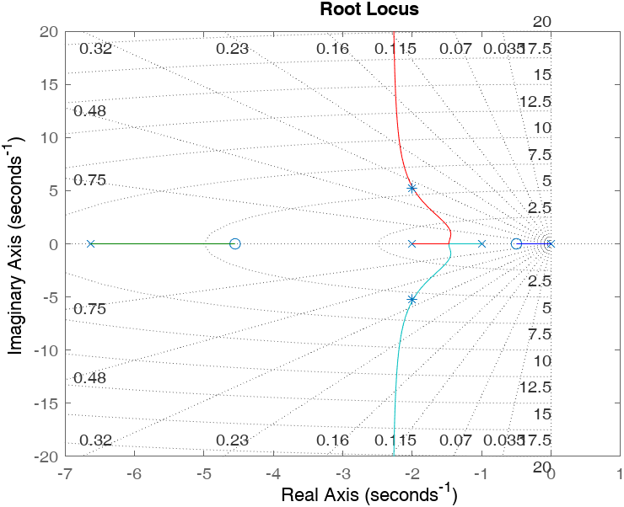

**Figure 3-3** successful implementation of phase lead controller using graphical design method

Figure 3-3 demonstrates that the desired poles align with the root locus diagram of the system, indicating that the designed phase lead controller possesses the necessary characteristics to meet the desired performance goals. This graphical representation provides valuable confirmation that the controller design has been successful in achieving the desired pole locations, which are crucial for system stability and performance optimization. By observing this alignment, we can conclude that the controller is well-suited to meet the specified requirements and can effectively regulate the system's behavior in accordance with the desired performance criteria.

In addition to the insights provided by Figure 3-3, further validation of the controller design's success can be obtained by analyzing the step response. The step response provides a valuable means to verify if the designed controller effectively meets the desired performance objectives. The step response of the system can be seen in figure (3-4)

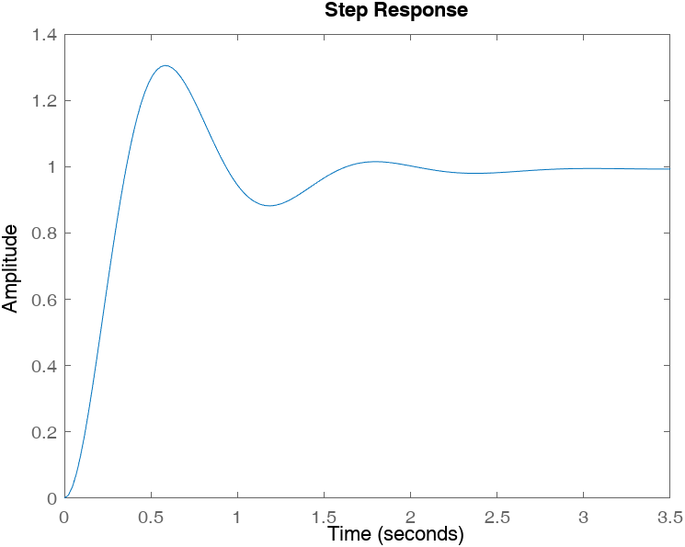

stepinfo(sys)

ans = struct with fields:

RiseTime: 0.2429  
 TransientTime: 2.3883  
 SettlingTime: 2.3883  
 SettlingMin: 0.8819  
 SettlingMax: 1.3054  
 Overshoot: 30.5420  
 Undershoot: 0  
 Peak: 1.3054  
 PeakTime: 0.5795

**Figure 3-4** step response and the characteristics of the step response

## Design using placement of zero

In this method, the undesired poles in the system are eliminated by analyzing the linear system and determining the desired pole locations. Then, by calculating the desired phase angle and utilizing control design algorithms, the Phase Lead control network is designed to achieve the desired phase angle and ensure system reaches desired characteristics.

Using this method and the information given by equation (3-7) the following can be written.

(3-16)

(3-17)

The designed controller can be seen in (3-18)

(3-18)

It is obvious that designing the controller using this method is quite simpler. The reason for the graphical method design over this method in some designs will be discussed in the following sections.

The performance of this controller can be analyzed similar to the previous one.

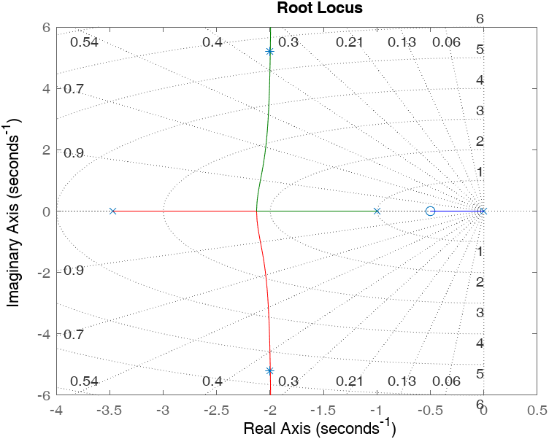

**Figure 3-5** successful implementation of phase lead controller using pole placement design method

This method has proven to provide the desired characteristics as well. The comparison between this method and the graphical method will take place in the following chapter.

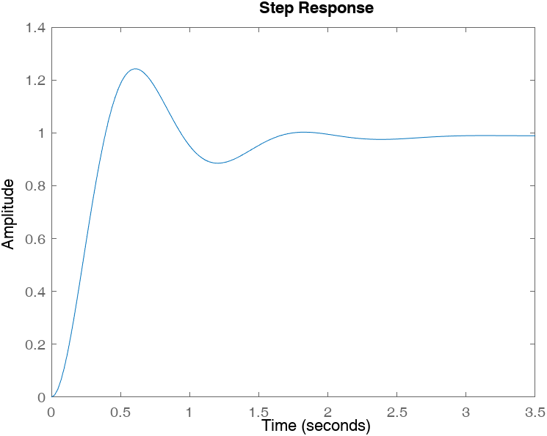

stepinfo(sys2)

ans = struct with fields:

RiseTime: 0.2650  
 TransientTime: 2.6093  
 SettlingTime: 2.6093  
 SettlingMin: 0.8851  
 SettlingMax: 1.2426  
 Overshoot: 24.2624  
 Undershoot: 0  
 Peak: 1.2426  
 PeakTime: 0.5994

**Figure 3-6** step response and the characteristics of the step response

## Comparison Between Two Methods

By utilizing two different methods analyzed in the field of linear control systems, a comparison can be made regarding the effectiveness, performance, and simplicity of the phase lead controller designs.

Both methods aim to modify the root locus diagram of the system, with the objective of placing the desired poles on the diagram. While achieving this goal is crucial for stability and performance, the performance can be further enhanced by employing fewer and more precise approximations.

Although both controller designs can yield satisfactory performance, in this case, the pole placement method offers superior results. By eliminating a pole from the system, the complexity decreases, making it easier to modify the system characteristics. Additionally, the pole placement method requires a smaller gain, simplifying the implementation process.

However, it is important to note that in certain systems, eliminating a pole may not be desired or feasible. In such cases, the graphical method for designing a phase lead controller is more appropriate. Overall, the choice between the two methods depends on the specific system requirements and constraints.

To summarize, the comparison of the effectiveness, performance, and simplicity of the two, phase lead controller designs is subjective and depends on the specific system characteristics. While the pole placement method generally offers advantages in terms of simplicity and performance, the graphical method remains a viable option in systems where pole elimination is not desired.

# Phase Lag Compensator

In this problem, the task is to calculate the steady-state error constant for the slope input (kv) in such a way that its value becomes greater than or equal to 40. Initially, the current value of this constant in the controller will be examined to determine if any controller design is necessary.

(4-1)

It is clear that the current value deviates from the desired value, indicating the need for controller design.

In general, a phase lag compensator is defined as follows.

z > p > 0 (4-2)

After careful observation, it has been observed that the steady-state error constant for the slope input (kv) in this system is lower than the desired value. The calculation will now be performed to determine the exact value.

## Phase lag on the graphical method

The calculations for the phase lag compensator are as follows.

(4-3)

(4-4)

Therefore, it can be said that:

(4-5)

(4-6)

The roots of the transfer function of the closed-loop system are calculated, and the dominant pole is determined below.

(4-7)

(4-8)

Therefore, the dominant pole is s1.

(4-9)

(4-10)

As the result the zero and pole of the lag compensator are determined and the phase lag compensator is.

(4-11)

The final designed lead-lag controller is:

(4-12)

## Phase lag on the graphical method

The steps in this section are similar to the previous one.

(4-13)

The dominant pole of this system is on -0.47

(4-14)

(4-15)

(4-16)

(4-17)

Therefore, the phase lag controller is:

(4-18)

The final controller on this method is:

(4-19)

## Result of the design

After completing the design of the controllers, the overall performance can now be evaluated by examining the root locus diagram of the final systems and analyzing the corresponding step response. The results are presented in Figures 4-1 to 4-4.

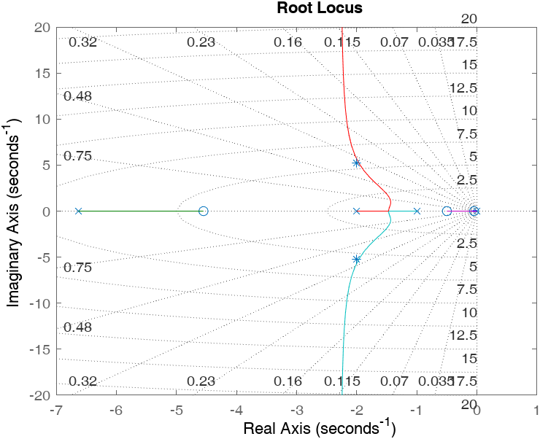

Figure 4-1 root locus of the system designed based on graphical phase lead design

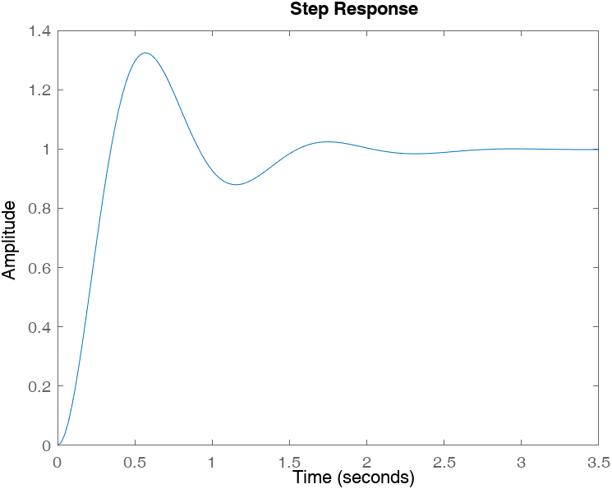

stepinfo(temp)

ans = struct with fields:

RiseTime: 0.2340  
 TransientTime: 1.8463  
 SettlingTime: 1.8463  
 SettlingMin: 0.8796  
 SettlingMax: 1.3242  
 Overshoot: 32.4233  
 Undershoot: 0  
 Peak: 1.3242  
 PeakTime: 0.5591

Figure 4-2 step response and step info of this system

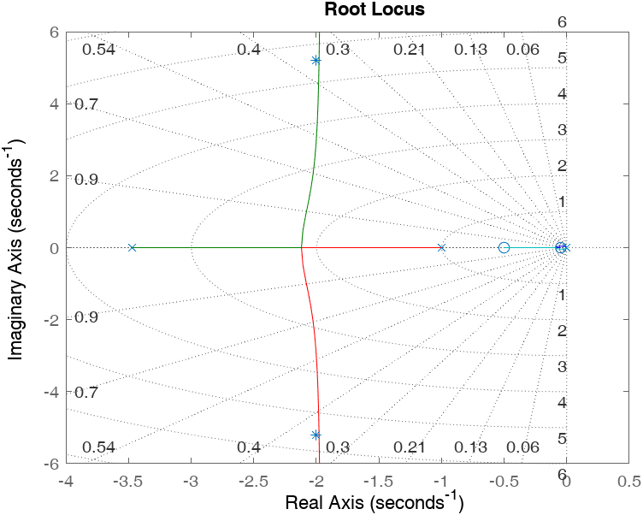

Figure 4-3 root locus of the system designed based on graphical phase lead design

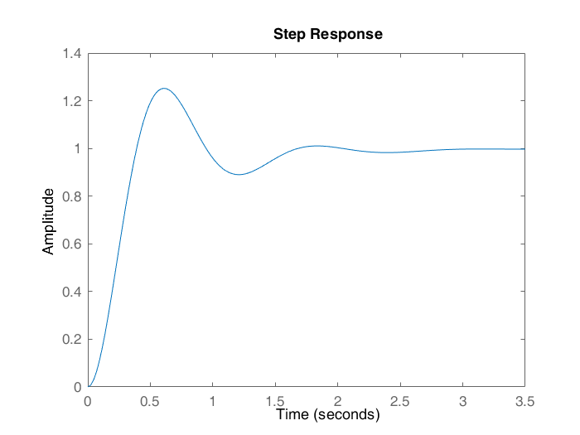

stepinfo(temp)

ans = struct with fields:

RiseTime: 0.2641  
 TransientTime: 1.5807  
 SettlingTime: 1.5807  
 SettlingMin: 0.8899  
 SettlingMax: 1.2520  
 Overshoot: 25.2034  
 Undershoot: 0  
 Peak: 1.2520  
 PeakTime: 0.6054

Figure 4-4 step response and step info of this system