|  |  |  |  |
| --- | --- | --- | --- |
|  | 26/04/2017 |  | |
| |  |  | | --- | --- | |  |  | |  |  | |  |  | |  |  | | |  | |
| The Moving Epidemics Method  *The mem Shiny web application* | | | |
|  |  | | |  |  |  | | --- | --- | --- | |  |  |  | |  |  |  | |  |  |  | |  |  |  | |  |  |  | |  |  |  | |
|  |  | | José Eugenio Lozano Alonso and Jakob Bergström  1 Foundation Institute of Health Sciences Studies of Castilla y León (Spain)  2 The Public Health Agency (Sweden) |

Contenido

Introduction 4

Running the app 5

Run memshy locally 5

Installation 5

Shiny app 8

Run memshy remotely 9

The memshy application 10

Data structure 11

Data series 11

Missing values and zero data 12

Week 53 12

Two waves in the same season 13

Check & describe 14

File 14

Data 14

Seasons 15

Series 16

Timing 16

Evolution 17

Stability 18

Model 18

Data 18

Seasons 18

Series 18

Timing 19

MEM 19

Goodness 21

Optimize 22

Surveillance 23

Visualize 23

Options 23

Left panel 23

Bottom panel 27

Right panel 28

References 31

# Introduction

The Moving Epidemics Method (MEM) is a tool developed in Castilla y León (Spain) to help in the routine influenza surveillance in health systems. It gives a better understanding of the annual influenza epidemics and allows the weekly assessment of the epidemic status and intensity.

Thought in its conception it was originally created to be used with influenza data and health sentinel networks, MEM has been tested with different diseases and surveillance systems so nowadays it can be used with any disease which present a seasonal accumulation of cases that can be considered an epidemic.

MEM development started in 2000 and the first record of its existence is dated in 2003 in the Options for the Control of Influenza V(1).

It was presented to the baselines working group of the European Influenza Surveillance Scheme (EISS) in the 12th EISS Annual Meeting (Malaga, Spain, 2007), with whom started a collaboration that continued when EISS was dissolved in 2008 to create the European Influenza Surveillance Network.

In 2009 MEM appears for the first time in an official European document: the Who European guidance for influenza surveillance in humans. A year later MEM was implemented in the European Centre for Disease Prevention and Control (ECDC) platform, and in 2012, after a year piloting, in the World Health Organization Regional Office for Europe (WHO-E).

As a result of the collaboration with ECDC and WHO-E, two papers have been published, one related to the establishment of epidemic thresholds(2) and other to the comparison of intensity levels in Europe(3).

In 2014 a tool was created to help users around the world to apply mem on their data. It was released in July as a library for R, a free software environment for statistical computing and graphics. This is the first version (4) of the library (also referred to as the stable version) and it is available at the official repositories: The Comprehensive R Archive Network (CRAN).

The second version of the mem R library was released in 2015 and features a lot of new features and graphics. It was published as an open source project at GitHub, a web-based Git or version control repository and Internet hosting service. It is available directly from github(5) and it is also known as the development version since it is constantly being updated.

In 2017 a web application was created to serve as a graphical user interface for the R mem library using Shiny, a web application framework for R. This application is based on the development version of the mem R library.

# Running the app

There are two options to run the web application:

* Locally.
* Remotely.

To run it locally you need to install R in your computer, set up the app dependencies and start it.

To run it remotely, you only need an internet connection and the address where the application is hosted, no need to install R or worry about dependencies since all is already set up in the server side.

## Run memshy locally

### Installation

The mem Shiny web application (memshy) is based on the mem R library and requires R to work. R is available as Free Software under the terms of the Free Software Foundation’s GNU General Public License in source code form. It compiles and runs on a wide variety of UNIX platforms and similar systems (including FreeBSD and Linux), Windows and MacOS. There are binaries for most operating systems at its official web page(6). To install it, download the binaries appropriate for your system and proceed to install it.

R is a command line program but there are a lot of graphical user interfaces available to users that wants a friendlier environment. The most popular is RStudio an open source powerful and productive user interface for R. Binaries can be downloaded from its official web(7) and installed on Windows, Mac, and Linux.

Shiny is a web application framework for R created by the RStudio team, there is no need to install separately because it acts as a library for the R language and will be installed with the rest of dependencies.

MEM Shiny app is a set of two files that Shiny framework is able to interpret in order to start the web application. They can be run directly from a remote web server or in a local directory of our hard disc (running a local server).

#### Dependencies

Packages are collections of R functions, data, and compiled code in a well-defined format. The directory where packages are stored is called the library. R is based on the contribution of the community, which creates their own code and share it creating new packages, which extend the features of the base package.

Most packages has requirements, they need other packages to work, these are the dependencies of the package.

MEM Shiny app and mem R library requires to install a set of packages (dependencies) on R to start the application. The list of dependencies required for both applications are those of the original mem R library and those added by the new features of the mem Shiny web application.

Mem R library requirements:

* sm
* boot
* grDevices
* graphics
* stats
* sqldf
* reshape2
* RColorBrewer
* mixtools

memshy requeriments:

* shiny
* shinythemes
* shinydashboard
* shinyjs
* shinyBS
* plotly
* ggplot2
* ggthemes
* R.utils
* openxlsx
* XLConnect
* stringr
* readr
* magick
* DT
* gplots
* RODBC
* mem
* shinysky

Almost all the libraries can be installed directly from the CRAN repositories. To install a package simply write in the command line:

install.package(“packagename”)

Installation of packages must be done only once, after a package is installed, to use it, it has to be loaded, no need to install it again.

library(“packagename”)

To automatize the work of installing and loading libraries, here it is a custom function to check all dependencies and install in case it is needed for memshy.

testinstall.packages <- function(i.packages) {

lapply(i.packages, function (x) if(sum(installed.packages()[, 1]%in%x)==0) install.packages(x))

lapply(i.packages, require, character.only=TRUE)

lapply(i.packages, function(x) paste(x, packageVersion(x)))

}

>testinstall.packages(c("shiny", "shinythemes", "shinydashboard", "shinyjs", "RColorBrewer", "shinyBS",

"plotly", "ggplot2", "ggthemes", "reshape2", "R.utils", "openxlsx", "XLConnect",

"stringr", "readr", "magick", "DT", "gplots", "RODBC", "mixtools"))

There are two missing packages in the above code, requires special installation, the mem R library is hosted at github, and the shinysky package does not provide binaries to the lastest version of R, so it has to be installed from sources, also at github.

To install from github another package must be installed: devtools.

install.package(“devtools”)

And to install and load the last two packages:

# Install mem development version

if ("mem" %in% installed.packages()[,"Package"]){

if (as.numeric(as.character(packageVersion("mem")))<2){

testinstall.packages("devtools")

devtools::install_github("lozalojo/mem")

}

}else{

testinstall.packages("devtools")

devtools::install_github("lozalojo/mem")

}

library("mem")

# There are no binaries for shinysky

if (!("shinysky" %in% installed.packages()[,"Package"])) devtools::install_github("AnalytixWare/ShinySky")

library("shinysky")

In windows, the only package that can give problems installing is rJava (required by XLConnect), which requires Java installed in your computer ([www.java.com](http://www.java.com)).

In *nix systems, there are libraries that need some specific packages installed on your system, each system is different, but these are some issues we’ve found while installing on debian and arch linux machines:

* hexbin (required by plotly) requires a fortran compiler.
* rJava (required by XLConnect) requires Java, with the same architecture (x32/x64) as R.
* RODBC requires an odbc package (unixodbc).

Finally, memshy is able to read access files. In *nix systems it is required to install mdbtools (<http://mdbtools.sourceforge.net/>), which is probably in the distribution repositories.

Once all requirements are fulfilled, you can start the application.

If you find any troubles installing dependencies, please refer to the installation chapter of the manual of each specific library to find a solution for your OS.

### Shiny app

Normally, shiny apps consist on two text files:

* server.R
* ui.R

The file ui.R sets the user interface of the application and server.R configure the server side of the application, running all processed, producing the outputs and creating the graphs that will be returned to the interface.

Someone can share the files with you, or you can download them from the internet. Those two files are hosted at github:

<https://github.com/jakob2025/MEM-app>

Just click on clone to download a zip file containing the app and extract the two required files to any directory of your hard disk.

From RStudio (or from R), to run a Shiny app you only need to pass the directory where you extracted the files:

runApp(path.to.the.files, launch.browser = T)

Set the launch.browser to F (false) if you want to use the R internal browser to open the application.

Alternatively you can run directly applications from github without storing them in your hard drive, this option is recommended since you always start the application that is hosted at the official repositories, so you are sure it is always updated to the latest version.

shiny::runGitHub('MEM-app', 'jakob2025')

This option requires an internet connection every time you run the app.

## Run memshy remotely

Start your browser and go to the server address:

<https://lozalojo.shinyapps.io/memshy>

The application will start your default browser and run the application.

# The memshy application

The application have four panels to navigate:

* Left panel: Allows to load data and has options that affects directly to the outputs of the application, like model or thresholds selection.
* Right panel: Has options to modify graphs, like the palette to use in plots or the axis names.
* Bottom panel: Options related to the mem function and all the parameters.
* Main panel: Where all outputs are displayed.

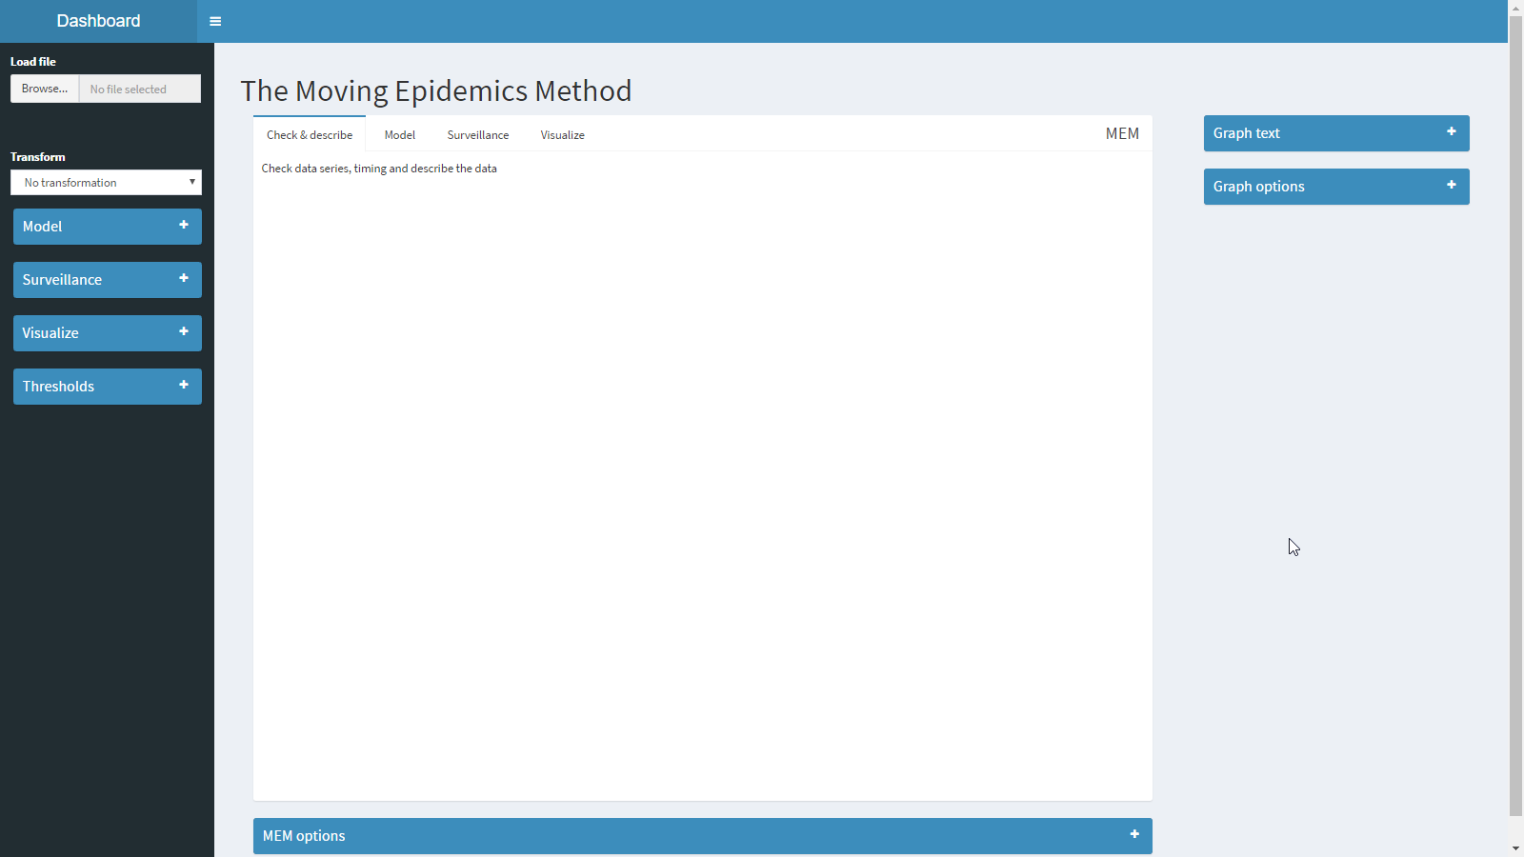

The main panel has four tabs:

* Check & describe
* Model
* Surveillance
* Visualize

While describing different outputs of the application we will explore more the options in the left, bottom and right panels.

## Data structure

### Data series

Data must containing information from the historical series. Surveillance period can start and end at any given week (tipically start at week 40th and ends at week 20th), and data can have any units and can be expressed in any scale (typically rates per 100,000 inhabitants or consultations).

The table must have one row per epidemiological week and one column per surveillance season. A season is a full surveillance period from the beginning to the end, where occurs at some point one single epidemic wave on it. No epidemic wave can be spared in two consecutive seasons. If so, you have to redefine the start and end of the season defined in your dataset. If a season have two waves, it must be split in two periods and must be named accordingly with the seasons name conventions described below. Each cell contains the value for a given week in a given season.

The first column should contain the names of the weeks. When the season contains two different calendar years, the week will go from 40th of the first year to 52nd, and then from 1st to 20th. When the season contains one year, the weeks will go from 1st to 52nd.

Note: If there is no column with week names, the application will name the weeks numbering from 1 to the number of rows.

* In the northern hemisphere countries, the surveillance period usually goes from week 40 to 20 of the following year (notation: season 2016/2017).

|  |  |  |  |  |  |
| --- | --- | --- | --- | --- | --- |
| Week No | 2012/2013 | 2013/2014 | 2014/2015 | 2015/2016 | 2016/2017 |
| *40* |  |  |  |  |  |
| *41* |  |  |  |  |  |
| *…* |  |  |  |  |  |
| *17* |  |  |  |  |  |
| *18* |  |  |  |  |  |

* In the southern hemisphere countries, the surveillance period usually goes from week 18 to 39 same year (notation: season 2017).

|  |  |  |  |  |  |
| --- | --- | --- | --- | --- | --- |
| Week No | 2013 | 2014 | 2015 | 2016 | 2017 |
| *18* |  |  |  |  |  |
| *19* |  |  |  |  |  |
| *…* |  |  |  |  |  |
| *37* |  |  |  |  |  |
| *38* |  |  |  |  |  |
| *39* |  |  |  |  |  |

The first row must contain the names of the seasons. This application understand the naming of a season when it contains one or two four digits year separated by ‘/’ and one one-digit number between parenthesis to identify the part of the season in case it has two different waves.

Examples:

* 2016/2017: Season starting at any point of 2016 (normally at 40th week) and ending in 2017 (normally at 20th week). This is normally used in northern hemisphere countries.
* 2016: Season starting and ending at 2016. Used in southern hemisphere countries.
* 2016/2016: The same as above.
* 2016/2017(1): First wave of season 2016/2017.
* 2016(1): Second wave of season 2016.
* 2016/2016(2): Second wave of season 2016.

### Missing values and zero data

Be sure that a cell is blank when there is no data (missing value) and 0 when the data is 0 cases/rate.

### Week 53

Since not all the seasons contain week 53rd, data must be adjusted in order to avoid gaps. When a season has a rate for week 53rd it must be pulled forward one week. So week 53 becomes week 1 of the following year, week 1 then turns to be week 2 and so on:

|  |  |  |  |  |
| --- | --- | --- | --- | --- |
| Original season | |  | Modified season | |
| Week No | 2000/2001 |  | Week No | 2000/2001 |
| *50* | 112.1 |  | *50* | 112.1 |
| *51* | 150.4 |  | *51* | 150.4 |
| *52* | 170.7 |  | *52* | 170.7 |
| ***53*** | 210.2 | **->** | *1* | 210.2 |
| *1* | 270.0 |  | *2* | 270.0 |
| *2* | 280.0 |  | *3* | 280.0 |
| *3* | 160.2 |  | *4* | 160.2 |
| *4* | 120.4 |  | *5* | 120.4 |

Week 53 must not be deleted, especially in northern hemisphere countries, since epidemics occur in winter time, and it is probable that week 53 is part of the epidemic. Deleting it will shorten the epidemic one week and also would affect the estimators, which probably use that weekly rate to calculate the thresholds.

### Two waves in the same season

Mem is designed to identify one single epidemic wave. When a season has two epidemics waves, data must be split in two, so that each column have information from one single wave.

|  |  |  |  |  |  |
| --- | --- | --- | --- | --- | --- |
| Original season | |  | Modified season | | |
| Week No | 2000/2001 |  | Week No | 2000/2001(1) | 2000/2001(2) |
| *30* | 30.1 |  | *30* | 30.1 |  |
| *31* | 120.3 |  | *31* | 120.3 |  |
| *32* | 240.3 | *first* | *32* | 240.3 | *missing* |
| *33* | 231.6 | *epidemic* | *33* | 231.6 | *values* |
| *34* | 160.3 |  | *34* | 160.3 |  |
| *35* | 100.1 |  | *35* | 100.1 |  |
| *36* | 40.9 |  | *36* | 40.9 |  |
| *…* |  | **->** | *…* |  |  |
| *52* | 60.4 |  | *52* |  | 60.4 |
| *1* | 140.7 |  | *1* |  | 140.7 |
| *2* | 210.2 |  | *2* | *missing* | 210.2 |
| *3* | 270.0 | *second* | *3* | *values* | 270.0 |
| *4* | 120.0 | *epidemic* | *4* |  | 120.0 |
| *5* | 40.2 |  | *5* |  | 40.2 |
| *6* | 30.4 |  | *6* |  | 30.4 |

Seasons thus split must be named using the same notation and adding 1 or 2 at the end between parentheses.

## Check & describe

This tab allows to see the full datasets to check if data is correct, see the timing and inspect the evolution of the data across time.

### File

Gives information of the file and the dataset loaded.

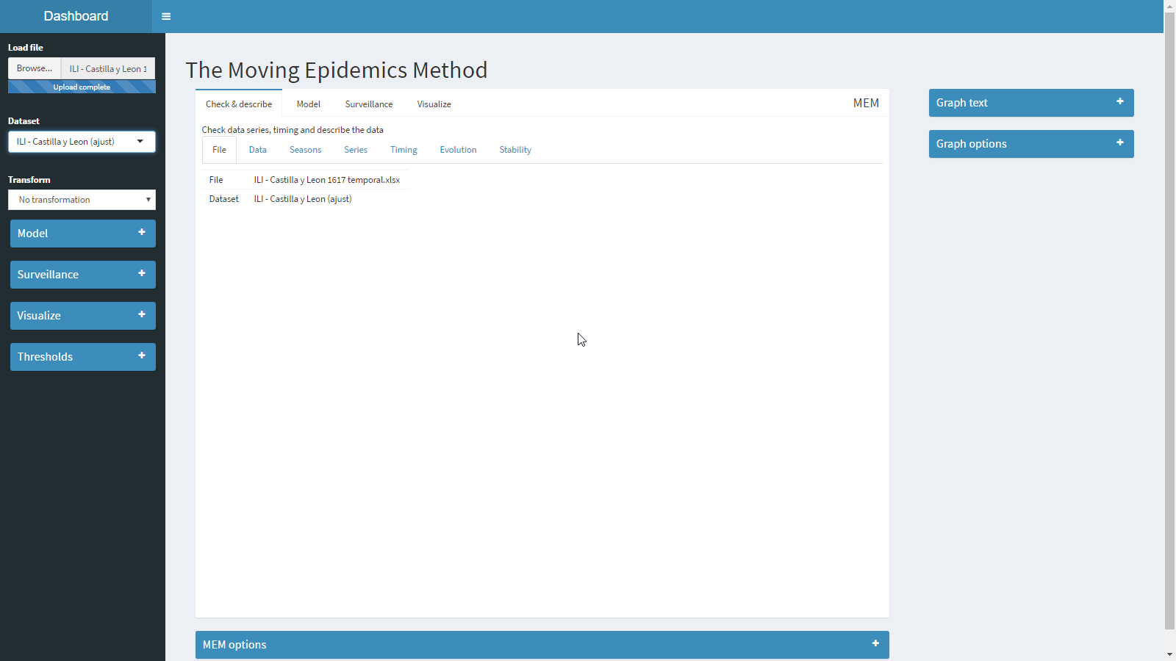

### Data

Shows the data loaded. Data can be exported as an excel or csv file.

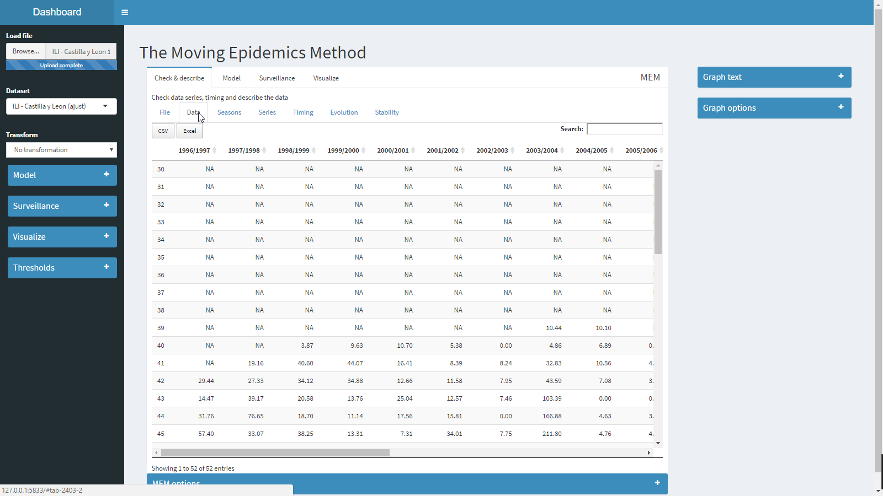

### Seasons

Makes an overlapped graph of all seasons to compare magnitudes and timings of all epidemics in the dataset.

It can be added the pre, post and intensity thresholds to this graph, calculated using the model currently selected in the Model panel (see below).

Note: graphs are interactive. Moving the cursor over one of the series give information of the numbers (week and value). Clicking in the legend activate/deactivate series and thresholds.

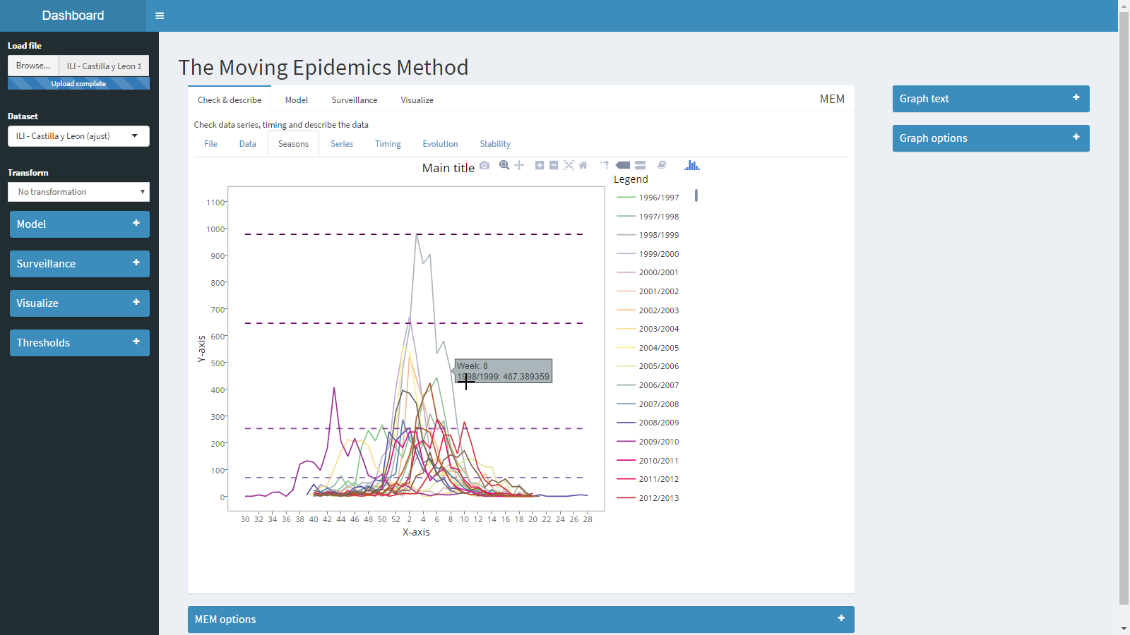

### Series

Makes a graph of all series across time.

It can be added the pre, post and intensity thresholds to this graph, calculated using the model currently selected in the Model panel (see below).

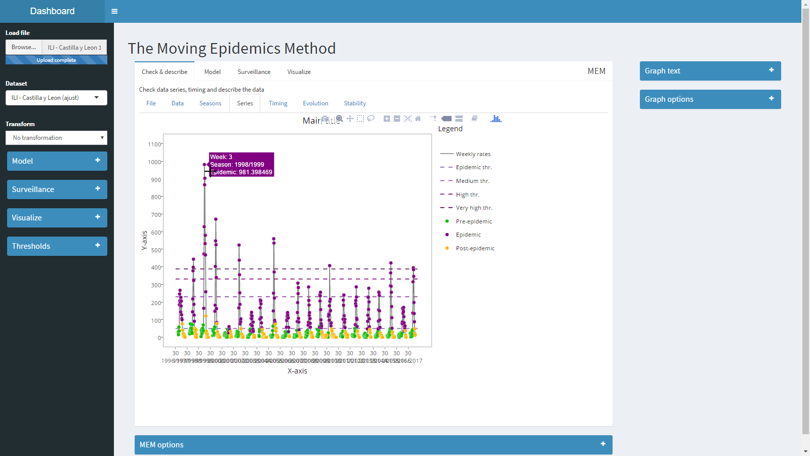

### Timing

Shows the timing of each season separately to see if the program is able to detect correctly the epidemics.

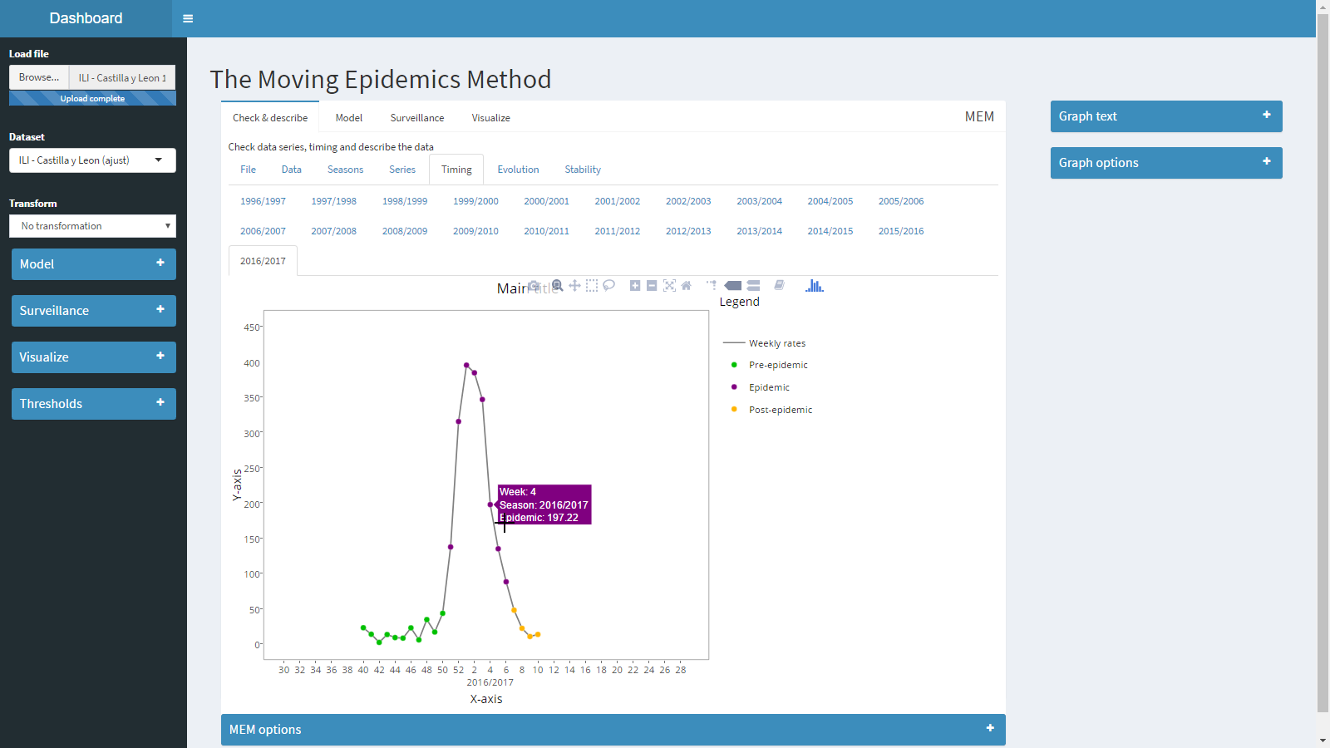

### Evolution

Shows the evolution of the following indicators across time: duration of the epidemic, start of the epidemic, epidemic percentage, pre, post and intensity thresholds.

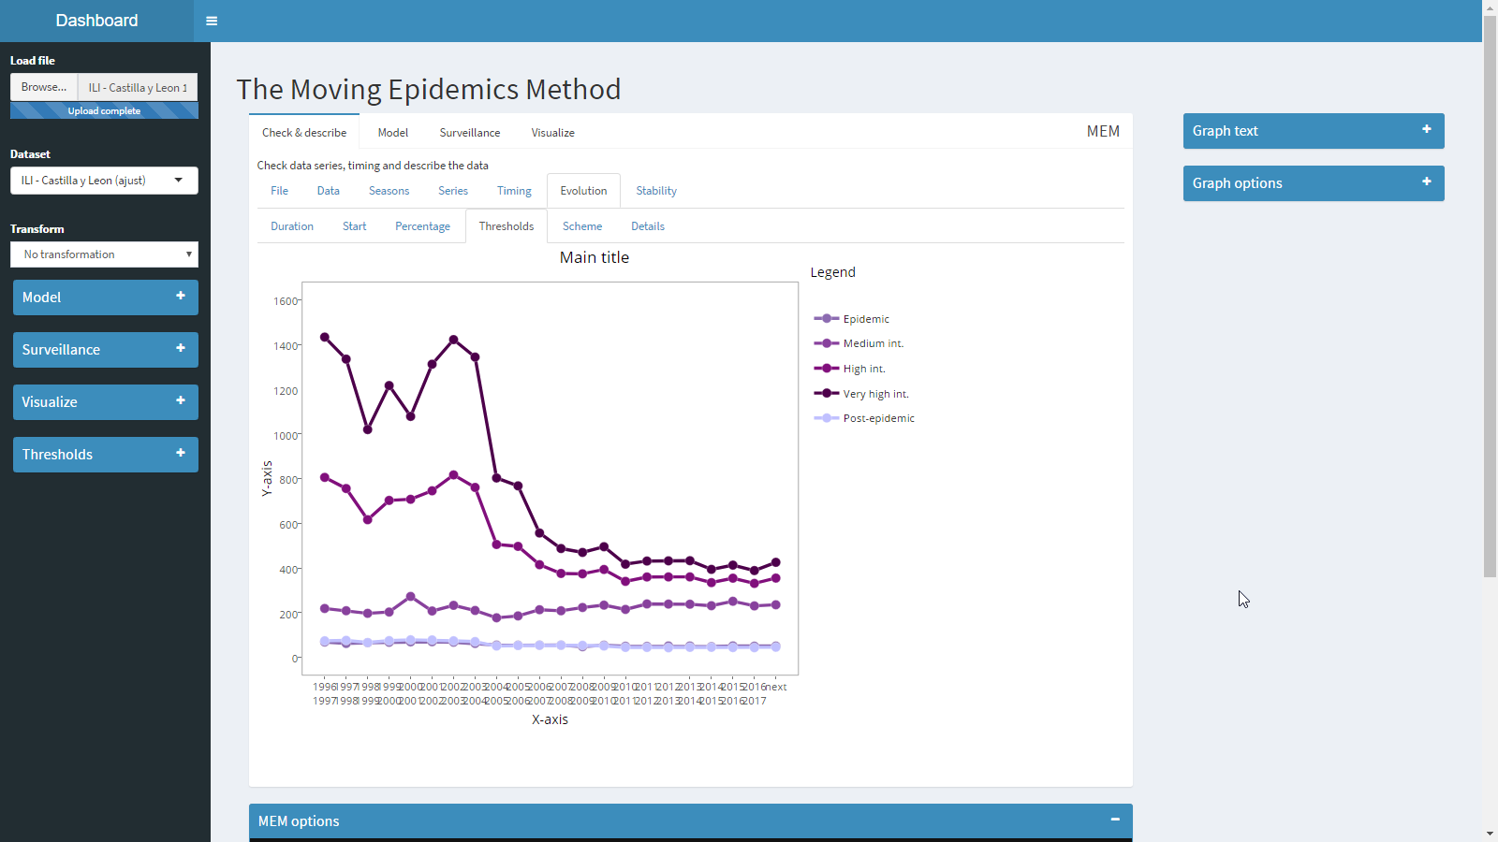

The x-axis shows the season the indicators are calculated for. The last point is “Next”, which means the thresholds are calculated for the upcoming season with data from the past seasons.

The tab scheme shows for each x-axis point the seasons selected to calculate thresholds. It depends on the validation method selected in the bottom panel and the max. seasons selected in the left model panel.

* Cross: For each value, the surrounding seasons (after or before the current value) are selected up to the number of max. seasons. To calculate the thresholds for season 2010/2011, data from 2005/2006 to 2009/2010 and from 2011/20012 to 2015/2016 will be taken.
* Sequential: Only preceding seasons are used (before the current value). To calculate the thresholds for season 2010/2011, data from 2000/2001 to 2009/2010.

Note that if you select sequential, first points in the graphs calculate thresholds using less data (there are less seasons before the current data than the max. seasons value), and this will affect the range of confidence intervals.

Note: confidence intervals for these indicators are calculated using the “Other thr.” Bottom option.

### Stability

Shows the stability of the following indicator depending on the number of seasons used to calculate the thresholds: duration of the epidemic, start of the epidemic, epidemic percentage, pre, post and intensity thresholds.

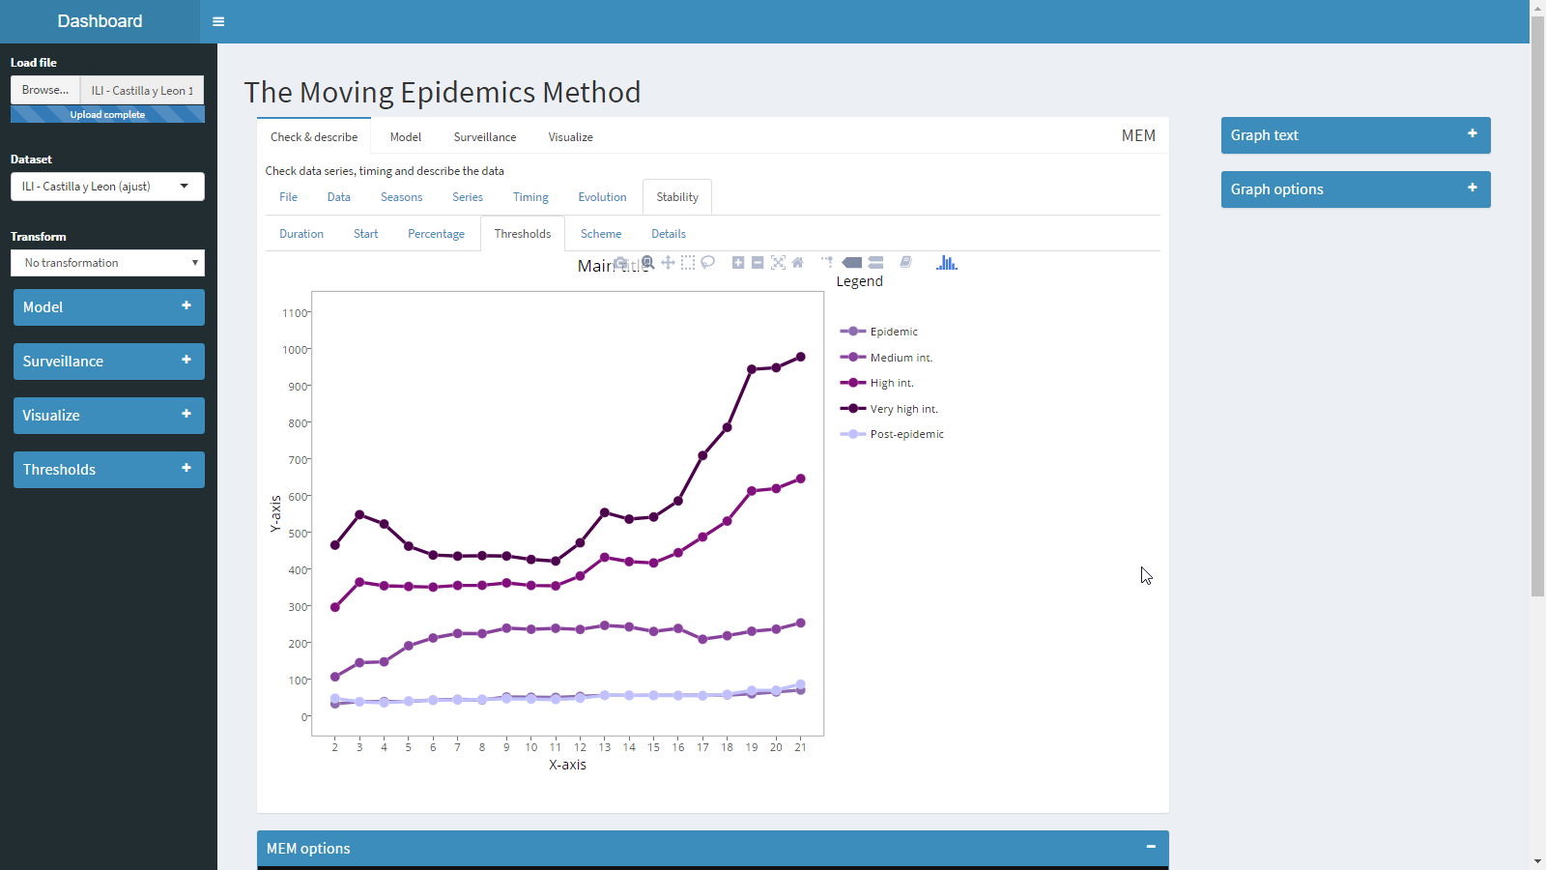

The indicators are always calculated for the next upcoming seasons, the x-axis shows the number of seasons used, 2 means “last two seasons”, 10 means “last ten seasons” and so on.

The tab “scheme” shows data used to calculate each particular point in the graph.

## Model

Shows summary of the model, graphs, goodness and optimization of the MEM model. See model panel to see how the program selects the seasons used to calculate the model.

### Data

Same as Check & describe, but only shows data selected for the model.

### Seasons

Same as Check & describe, but only shows data selected for the model.

### Series

Same as Check & describe, but only shows data selected for the model.

### Timing

Same as Check & describe, but only shows data selected for the model.

### MEM

Calculate the estimators using MEM with data provided by the Model panel.

#### Estimators

Shows the number of seasons used in the model, the average epidemic start week, the average epidemic length, the epidemic percentage (percentage of the total cases in the epidemic period) and the epidemic and intensity thresholds.

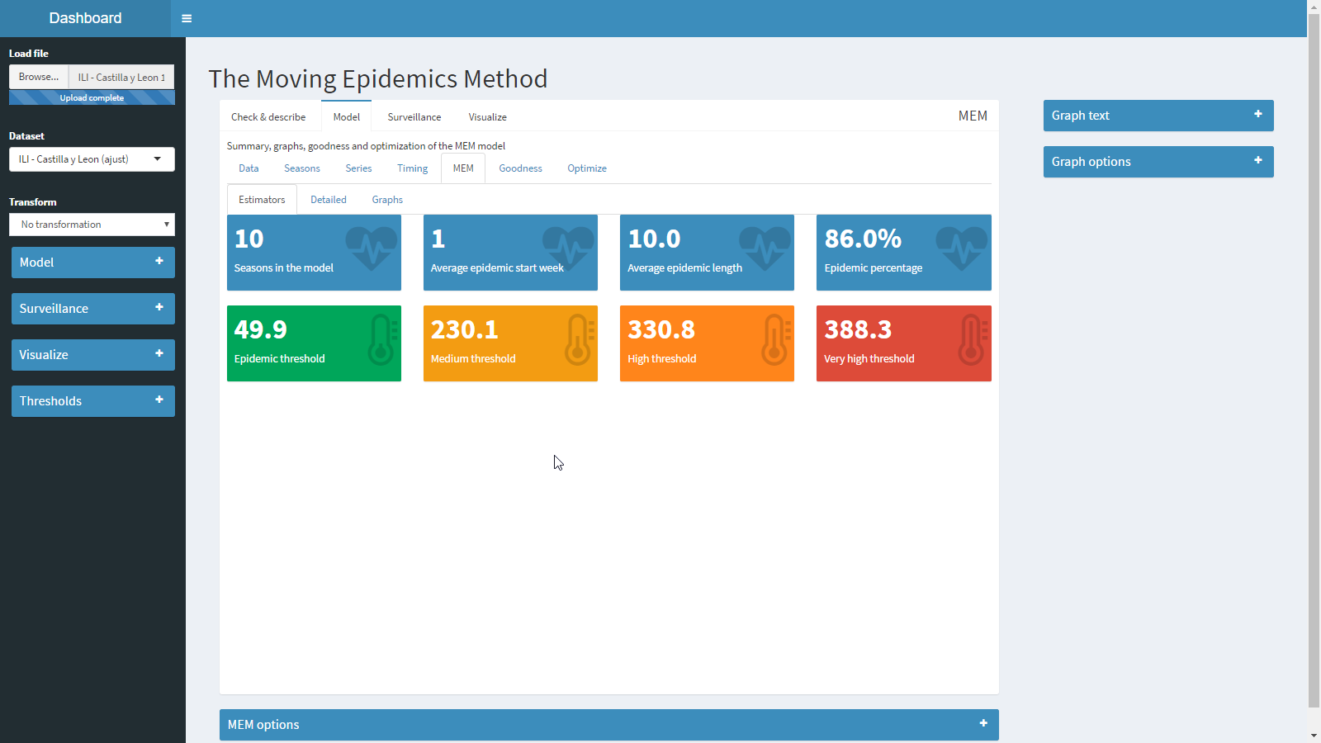

#### Detailed

Detailed information of the mem output, including the parameters used and the outputs.

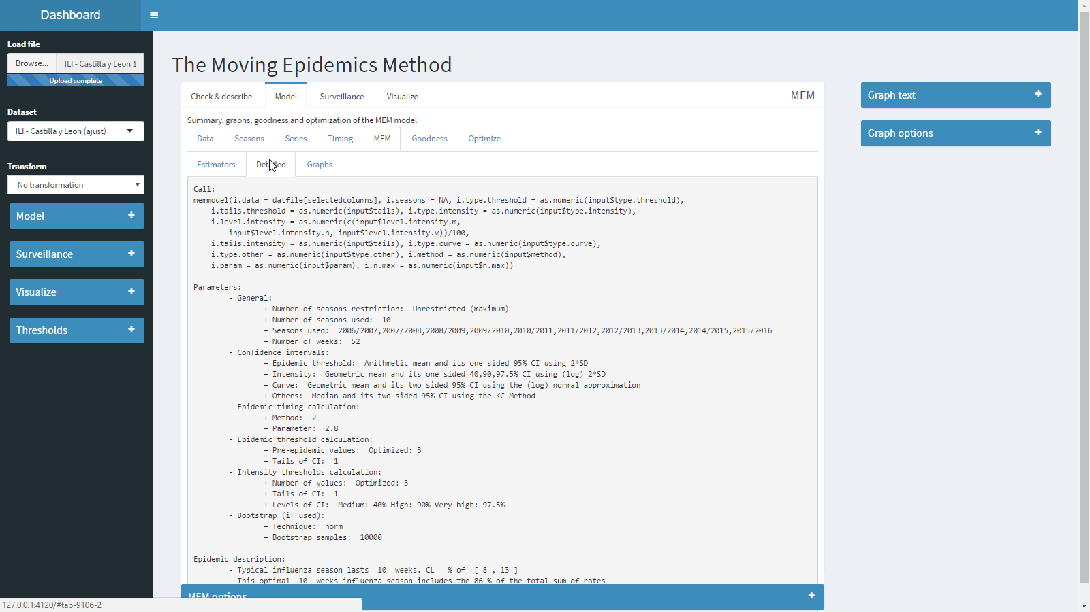

#### Graphs

Shows two graphs, the moving epidemics graph, which shows all the seasons in the model centred around their epidemic periods, which the average start and duration.

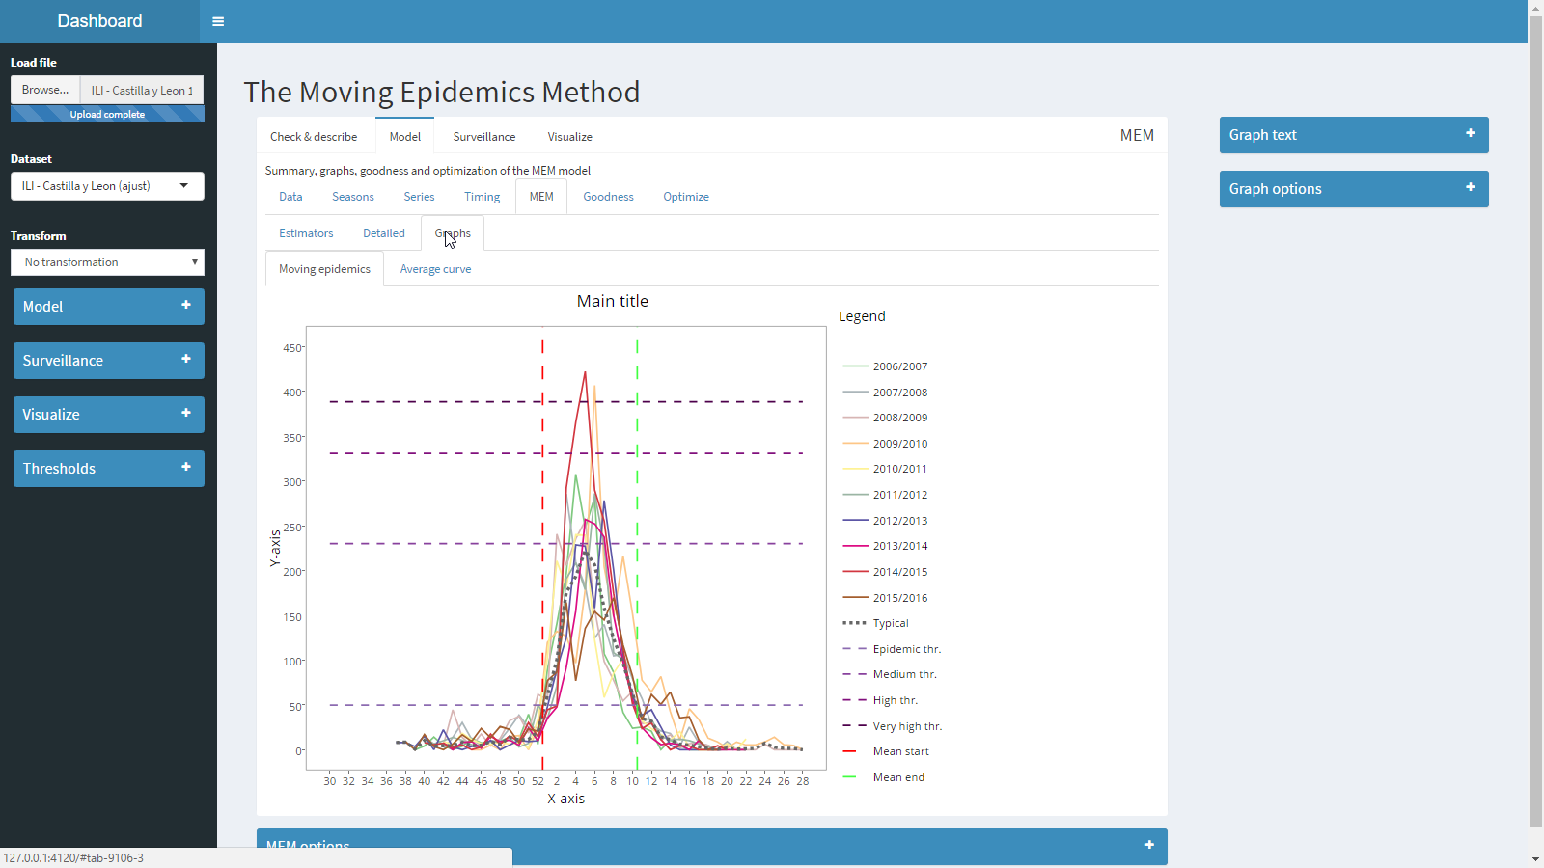

And the average curve graph, which shows the average epidemic along with the thresholds and the average start and duration.

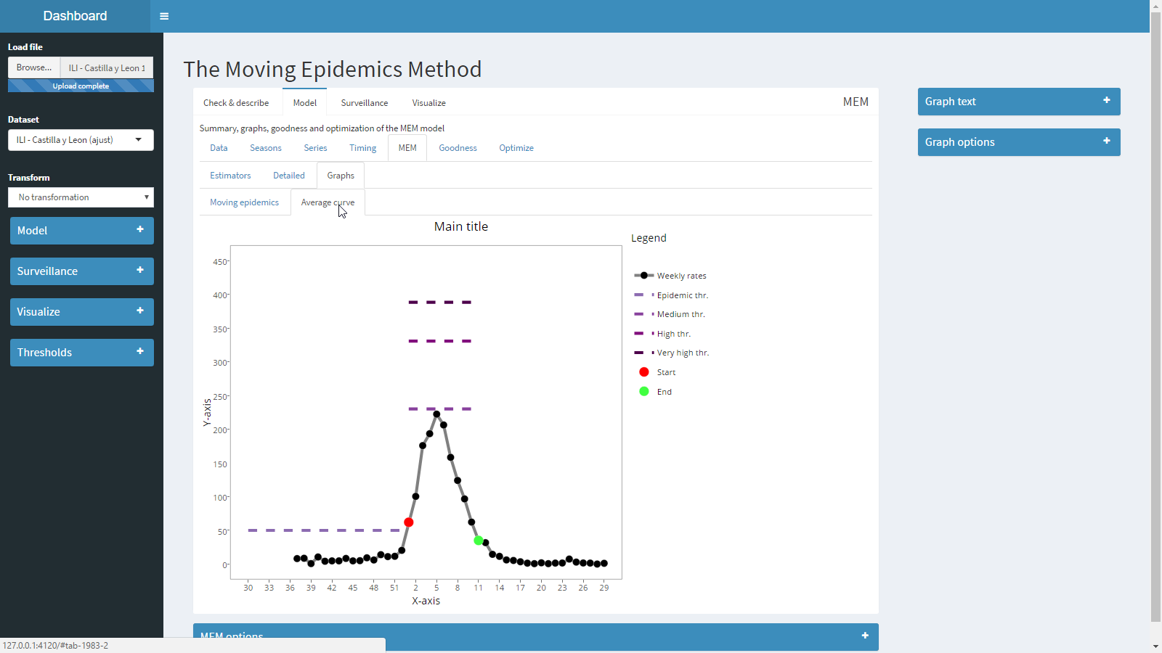

### Goodness

Calculate sensitivity, specificity, positive predictive value and negative predictive value for the current model. Also calculates summary indicators as the Matthew’s correlation coefficient and the agreement percentage.

The details tab shows information for each season separately.

How goodness is calculated.

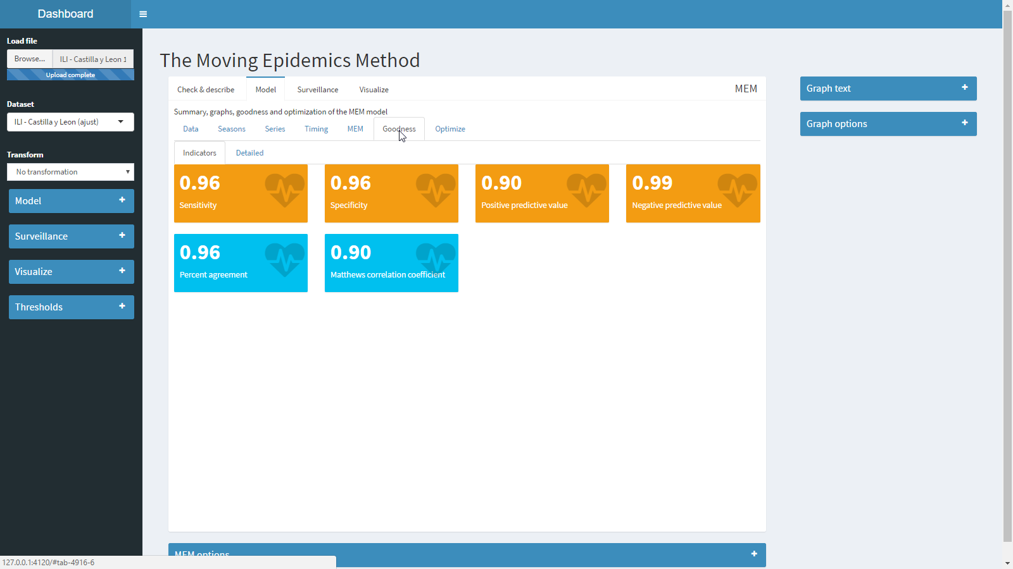

### Optimize

Calculate goodnes using different window parameters (for the fixed criterium) and compares estimates to find the optimum window parameter.

The details tab shows information of the estimators for each window parameter tested.

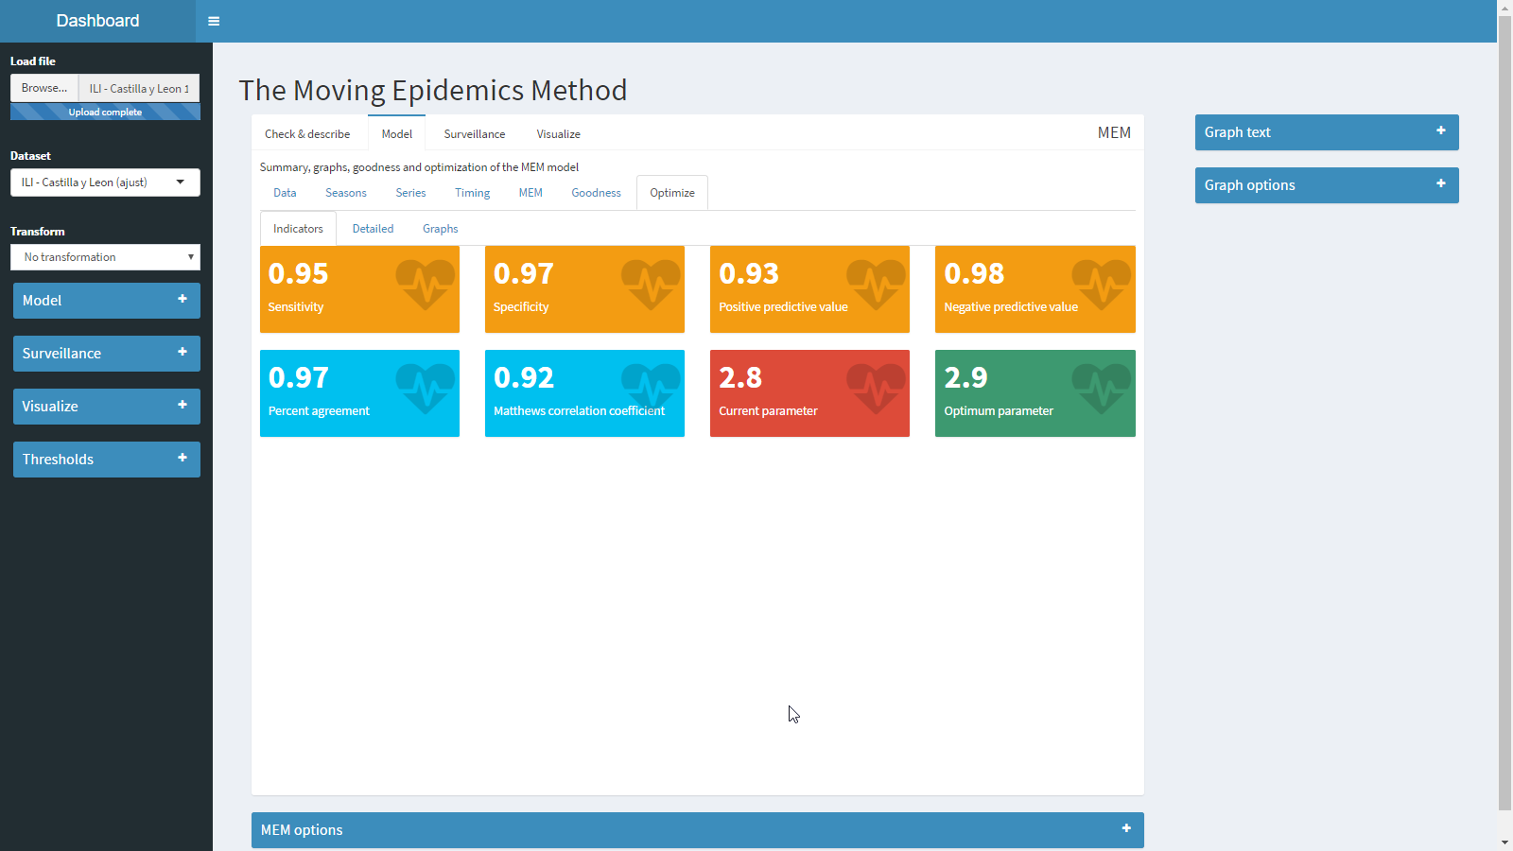

The graph tab shows a plot of the estimators for each window parameter value.

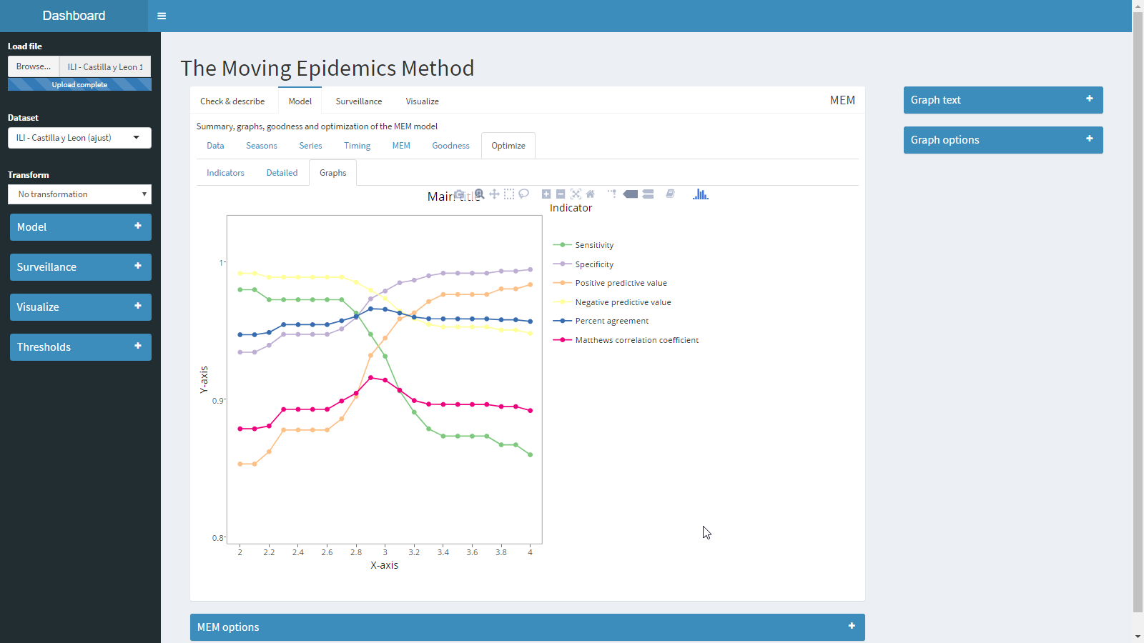

## Surveillance

Using the model selected in the Model panel, the thresholds are applied to the season selected as Surveillance and simulates how surveillance will look like at a given week.

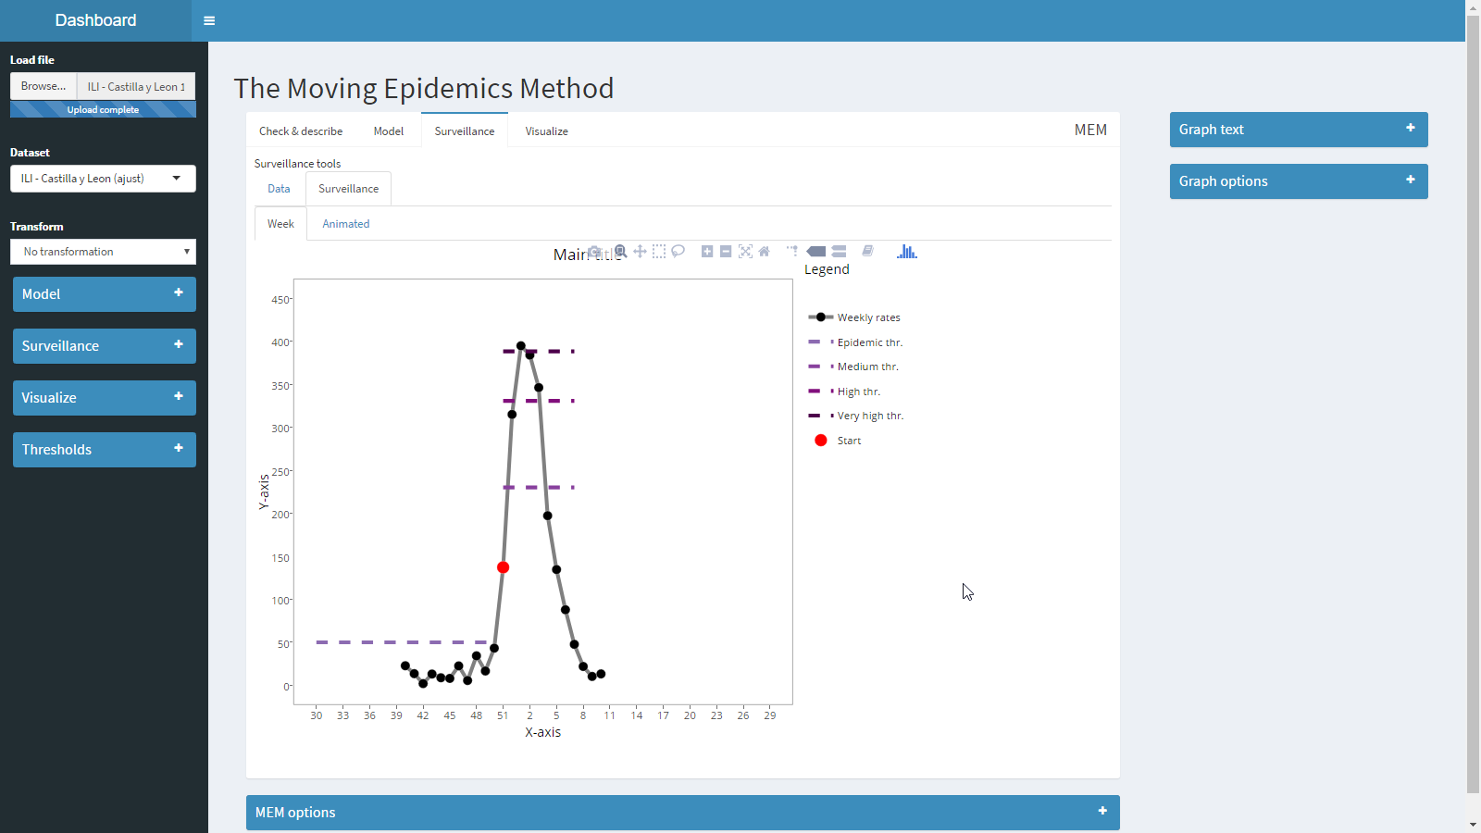

The animated tab shows an animated graph of the surveillance from the beginning to the week selected to see the evolution of the epidemic in the current season using a model.

## Visualize

Visualize tries to show information for a set of seasons, selected in the visualize panel, when a given model is applied.

Options are the same as previous tabs: Data to show the data of the selected seasons, Seasons to see the overlapped graph, Series to see the time series graph and Timing to see the timing of each season.

## Options

### Left panel

#### Load data

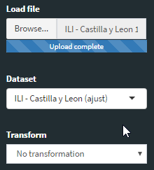

Click load file to open a dataset. Currently memshy is able to read the following formats:

* Text: files, with any encoding, any separator and any decimal point.
* R: files with rds extension from R.
* MS Excel: files with xls extension from MS Excel prior to 2007 and xlsx from 2007 on.
* MS Access: files with mdb extension from MS Access prior to 2007, and accdb from 2007 on.

When the format is able to contain more than one dataset (excel files with multiple sheets or access files with multiple tables), the application will show all the datasets in the file to let you chose which one you one to load.

Transform applies a transformation to the data and uses it in the application:

No transformation.

* Odd: Calculate the odds for percentage-like values. If the values are above 1, it converts first to 0-1 scale and then calculates the odd.
* Fill missing: Uses a loess regression to impute missing values in the original dataset. This transformation only applies to missing in the middle of the surveillance period. It does not impute starting or ending values that are missing.

|  |  |  |  |  |  |  |  |  |  |  |  |  |  |  |
| --- | --- | --- | --- | --- | --- | --- | --- | --- | --- | --- | --- | --- | --- | --- |
| x | x | 43 | 56 | x | 71 | 81 | x | x | 102 | 82 | x | 43 | x | x |

* Loess: Replaces all data in the original datasets with those coming from a loess regression.
* Two waves (observed): Fit a mixture of two normal distributions to each season to separate two waves in each original season, then separate the two waves in different columns, adding (1) and (2) to the original names.
* Two waves (expected): Fit a mixture of two normal distributions to each season and uses the predicted values of each normal in the mixture to create two new columns and names them adding (1) and (2) to the original names.

#### Model

Select the columns for the model.

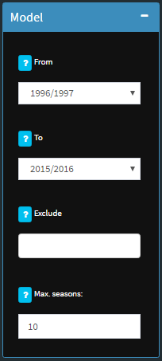

To select the columns to model, select the first season in From and the last season in To. If you want to exclude a season from the model, select it at Exclude. Finally, use the option max. seasons to limit the seasons selected to a number of seasons. If this number is lower than the column selection with From/To, the application will take the last 10 seasons of the current selection (it will exclude the seasons selected at Exclude). If the current selection has less seasons than max. seasons, this parameter will have no effect.

#### Surveillance

Select the season to use in the Surveillance tab. Only one season can be selected.

Surveillance consist on:

1. Draw weekly values along with the pre-epidemic threshold.
2. When the weekly value rises above the threshold a marker of the start of the epidemic is placed and the intensity thresholds are plot.
3. When the weekly value goes down the post-epidemic threshold, the marker of the end of the epidemic is placed and the post-epidemic threshold is added to the graph.

The Surveillance Week allows select the week to use in the surveillance, the values will be shown up to this week, and the program will ignore values past this week.

The Force epidemic start allows to force the placement of the epidemic start marker at a given week instead of using the first week above the epidemic threshold.

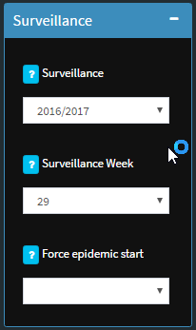

#### Visualize

Select the seasons to show in the Visualize tab. You can select multiple seasons.

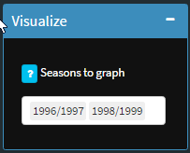

#### Thresholds

Determine if you want to draw pre, post and intensity thresholds. This options apply to Seasons, Series, Moving epidemics, Average curve and Surveillance.

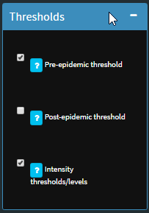

### Bottom panel

#### MEM Options

Allows to modify different parameters used by MEM to calculate thresholds, goodness and optimize.

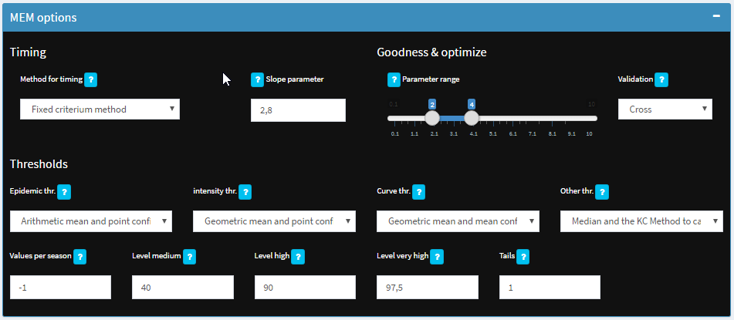

* Timing
  + Method for timing: there are four methods in MEM to calculate the timing of the epidemic. The default method is the fixed criterium, which uses a parameter to determine the optimum.
  + Slope parameter: the slope parameter used by the fixed criterium method. It will not affect the rest of methods.
* Goodness & optimize
  + Parameter range: Used by goodness to test the data with different timings using different parameters and averaging the results. Also this range is used by optimize to find the optimum slope parameter. It will only test values within this range.
  + Validation: Used by Goodness and Evolution to determine which data to include in the model. Cross allows to use data after or before the season we are testing. Sequential allows to use only data before the season that it is being tested.
* Thresholds
  + Epidemic thresholds: Method to calculate the epidemic (pre and post) thresholds.
  + Intensity thresholds: Method to calculate the intensity thresholds.
  + Curve thresholds: Method to calculate the average curve.
  + Other thresholds: Method to calculate estimates for epidemic start, epidemic duration, epidemic percentage.
  + Values per season: Number of values per season to calculate epidemic and intensity thresholds. -1 means use 30 values in total, 0 means use all the values, any other value means the number of points per season.
  + Levels: Levels of the confidence intervals used to calculate the intensity thresholds.
  + Tails: Use one or two tailed confidence intervals to calculate the epidemic and intensity thresholds.

### Right panel

#### Graph text

Change the main title, the x-axis label and the y-axis labels of all the graphs in the application.

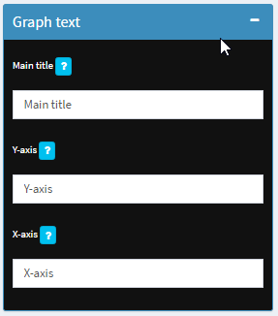

#### Graph options

Change the different colours used in the plots, allowing to use different palettes for different graphs.

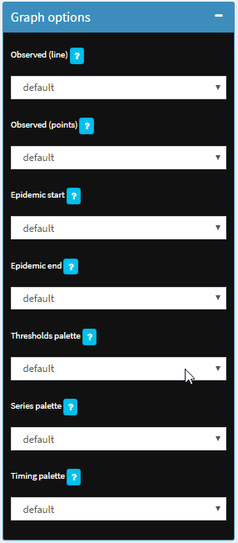

* Observed (line): Affects the graphs Series, Timing, Average curve and Surveillance.
* Observed (points): Affects the graphs Average curve and Surveillance.
* Epidemic start: Affects the graphs Moving epidemics, Average curve and Surveillance.
* Epidemic end: Affects the graphs Moving epidemics, Average curve and Surveillance.
* Thresholds palette: Affects the graphs Seasons, Series, Moving epidemics, Average curve and Surveillance.
* Seasons palette: Affects the graphs Seasons, Moving epidemics and Optimize.
* Timing palette: Affects the graphs Series and Timing.

# References

1. Vega Alonso T, Lozano Alonso JE, Ortiz de Lejarazu R, Gutiérrez Pérez M. Modelling influenza epidemic—can we detect the beginning and predict the intensity and duration? Int Congr Ser. 2004 Jun;1263:281–3.

2. Vega T, Lozano JE, Meerhoff T, Snacken R, Mott J, Ortiz de Lejarazu R, et al. Influenza surveillance in Europe: establishing epidemic thresholds by the moving epidemic method. Influenza Other Respir Viruses. 2013 Jul;7(4):546–58.

3. Vega T, Lozano JE, Meerhoff T, Snacken R, Beauté J, Jorgensen P, et al. Influenza surveillance in Europe: comparing intensity levels calculated using the moving epidemic method. Influenza Other Respir Viruses. 2015 Sep;9(5):234–46.

4. Lozano, José E. mem R package: First version of the MEM R library [Internet]. Valladolid, Spain: Foundation Institute of Health Sciences Studies of Castilla y León; 2014. Available from: https://cran.r-project.org/web/packages/mem/index.html

5. Lozano, José E. lozalojo/mem: Second release of the MEM R library. Zenodo [Internet]. [cited 2017 Feb 1]; Available from: https://zenodo.org/record/165983

6. R Core Team. R: A language and environment for statistical computing [Internet]. Vienna, Austria: R Foundation for Statistical Computing; 2017. Available from: https://www.R-project.org/

7. RStudio Team. RStudio: Integrated Development for R [Internet]. Boston, MA: RStudio, Inc.; 2016. Available from: http://www.rstudio.com/