User Manual Ch. 2

**Health, Work, Play, and Love**

Health – ½: I get a good amount of sleep but I don’t eat super well and rarely exercise.

Work. – ¾: I am a full-time student and get all A’s, but I don’t have a job so I am not making any money or staying as busy as I could be.

Play – ¾: I hang out with my boyfriend a lot and genuinely have a good time, but I feel like I could be a better friend to a lot of people instead of letting them go.

Love – Full: I love everyone who I am close to and don’t have any people that I struggle to be around. I am getting closer to my roommates and finding ways we can relate.

Compass

Workview – I think that it is important for me to have a reason for wanting to work. Most of the girls around me are hoping to get married and become a stay-at-home mom (which is my dream), but I feel like I might feel rushed into getting married if I don’t have a backup plan that would make it so that I could be successful even if I lived on my own. I also want to live a life without debt (outside of a house payment) so that I can have financial freedom without too much stress about money. I expect to eventually start a family and be a stay-at-home mom, but I want to have the stability and peace of mind knowing that if something happened, I would be able to work at a job that pays well and can support my family.

Lifeview – I think that the purpose of life is to grow and find joy. For me, that looks like studying so that I can get a good job and make deep connections with the people around me. I can continually work to strengthen my relationships with those around me. I also think that we all have the potential to become a God or Goddess and that we are here on earth to start that journey. Knowing this, makes me see that there are so many ways for me to work to become better daily. I also think that the best thing to do in most situations is to choose to love. I choose to love God and am constantly striving to love the people around me as well.

**Good Time Journal**

Playing piano - flow

Playing guitar

Talking to roommates - energy

Eating Takis

Playing the sound game

Walking to Dollar Tree

Playing ‘smash up’ and ‘star realms’ - engagement

Taking pictures

Making my own version of a sausage McMuffin.

Getting ready for a murder mystery party

Talking with Raelynn and eating lunch with her.

Calling Sefia

**Playing Piano**

1. Progress
2. Experimenting
3. Low stress

Works in a low-stress environment, experimenting to find new ways to help progress the industry.

**Spikeball**

1. Common goal
2. Nature
3. Friendly

Works in a friendly environment with a common goal. Everyone is working to enjoy nature.

**Talking to Friends**

1. Hopeful
2. Boosting Self-confidence
3. Appreciation

A hopeful work environment that boosts self-confidence by showing appreciation for every team member.

**3 Mind Maps**

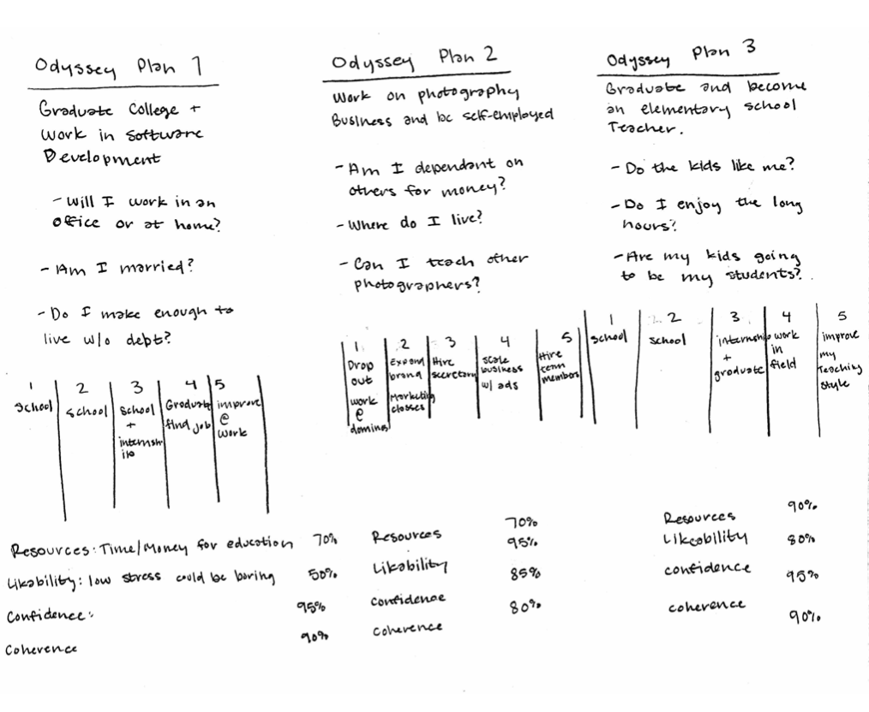

Odyssey Plans