Branding is important because not only is it what makes a memorable impression on consumers but it allows your customers and clients to know what to expect from your company. It is a way of distinguishing yourself from the competitors and clarifying what it is you offer that makes you the better choice. Your brand is built to be a true representation of who you are as a business, and how you wish to be perceived.

There are many areas that are used to develop a brand including advertising, customer service, social responsibility, reputation, and visuals. All of these elements (and many more) work together to create one unique and (hopefully) attention-grabbing profile.[1]

**What is branding?**

Branding has been around since 350 A.D and is derived from the word “Brandr”, meaning “to burn” in Ancient Norse language. By the 1500s, it had come to mean the mark that ranchers burned on cattle to signify ownership—a precursor of the modern logo Yet branding today is so much more than just a look or a logo. It has come to signify the emotional “gut feeling” reaction a company can elicit from its customers. Your brand is the set of perceptions people have about your company. But branding is the set of actions you take to cultivate that brand.In other words, your brand is a noun, but branding is a verb. When you design a logo, that’s branding. When you develop your brand voice, that’s branding. When you get together with your marketing team to brainstorm an ad campaign, that’s branding. Any action you take to shape your brand is, in a nutshell, branding.

**Branding is the perpetual process of identifying, creating, and managing the cumulative assets and actions that shape the perception of a brand in stakeholders’ minds.**

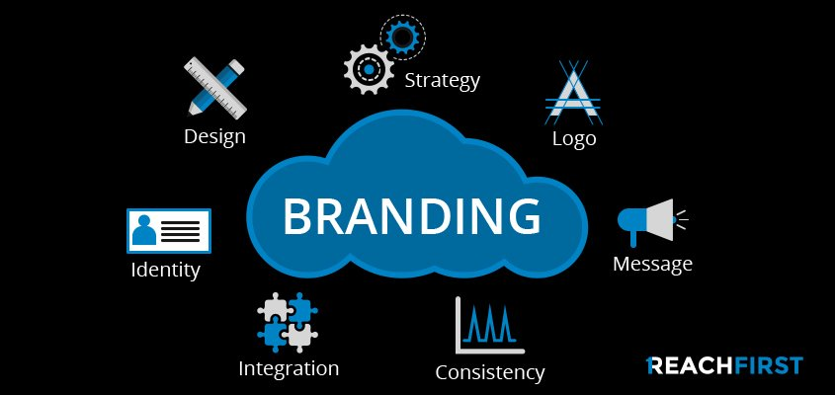

**Why is branding so important?**

Branding is important because it:

* **Helps you stand out from the competition.** It doesn’t matter what kind of company you have, what industry you’re in, or what type of customer you’re after—if you’re in business, you’ve got some serious competition. Branding helps you establish the ways in which you’re different, special, and unique. And it shows your customers why they should work with you instead of your competitors. 

*Branding is about making connections. Illustration by*[*Ulfvidh*](https://99designs.com/profiles/ulfvidh)*.*

* **Builds brand recognition.** If you want to build a successful brand, you need to be recognizable. The right branding (including designing an impactful logo, website, and other brand assets) helps you carve out a distinct style, and it increases your [brand recognition](https://99designs.com/blog/business/brand-recognition/) in the market.
* **Creates a consistent brand experience for your customers.** In order for your business to succeed, you need to provide a consistent experience for your customers however they interact with your brand—whether that’s through your website, at an in-person event or by following your social media accounts. Branding allows you to control how people perceive and experience your brand—and you can ensure that perception and experience stays consistent across all your brand touchstones.
* **Sparks a connection with your audience and turns that audience into loyal customers.** The most successful businesses are the ones that foster an emotional connection with their audience. That emotional connection is what transforms a prospect into a customer and a customer into a brand enthusiast. And how do you create and build that connection? Branding. Different branding strategies (like packing an emotional punch with your brand voice or leveraging [color psychology when designing your logo](https://99designs.com/blog/tips/logo-color-meanings/)) can help you connect with your audience on a deeper level and create a sense of loyalty to your brand.

**What are the elements of branding?**

These are the elements of branding that you’ll need to create in order to cultivate how your business is perceived by customers:

**1.Mission statement and brand values**: Your mission statement and brand values are the foundation for your branding. Think of your mission as the brains of the operation—a short and succinct statement that defines the present state and purpose of your organization. Meanwhile, your company’s vision is its heart, providing an inspirational and motivational snapshot of what you seek to achieve in the long term.

**2.Brand guidelines:** With the mission and vision statement set as the pillars of your organization, your brand strategy comes to encompass everything in between. This will take the form of [brand guidelines](https://99designs.com/blog/logo-branding/how-to-create-a-brand-style-guide/) (also known as your “brand bible”). These guidelines are comprised into a tangible document that will reflect and support your business goals, differentiate you from competitors, resonate with customers, provide a template for decision-making and precipitate ideas for future marketing campaigns. It will also include all the stylistic elements of your branding, including your color palette, fonts, and an outline of your brand voice.

**3.Additional assets:** There’s no one-size-fits-all approach to branding. Depending on your business and industry, you might need additional assets like business cards, product packaging or event flyers. Assess your business and your unique needs, and then develop additional branding assets accordingly.[2]

**A better brand means better marketing**

As a general rule, products have limited life cycles, but brands—if managed well—last forever. And once you’ve nailed down exactly who you are as a brand, it becomes much easier to market it.Your brand guidelines, coupled with ongoing market research and analysis, should give you a tactical advantage in determining the best way to market your products. Do you focus on traditional marketing like radio and billboard, or is your potential customer more swayed by viral Youtube videos and Snapchat filters? Marketing can be a mix and match of tactics, but be careful of spreading yourself too thin. By continually consulting your brand guide, you should be able to focus your efforts on the tactics that really matter. At the end, marketing is the process that brings you the leads and sales, but branding is the foundation upon which you build your reputation and customer loyalty. [3]

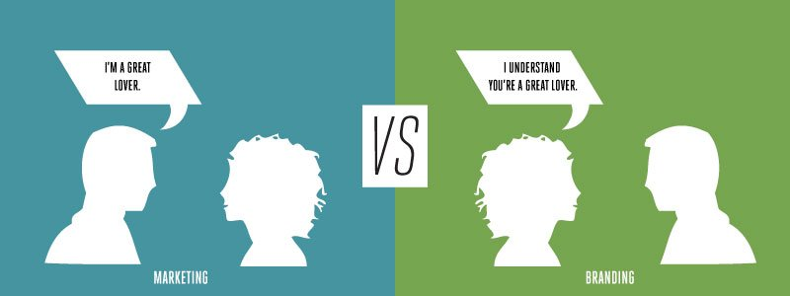

1-https://www.brandingmag.com/2015/10/14/what-is-branding-and-why-is-it-important-for-your-business/

2-<https://99designs.com/blog/logo-branding/what-is-branding/>

3-<https://www.thebrandingjournal.com/2015/10/what-is-branding-definition/>