Game Theory Definitions

Game theory is the process of modeling the strategic interaction between two or more players in a situation containing a set of rules and outcomes. While used in a number of disciplines, game theory is most notably used as a tool within the study of economics. The economic application of game theory can be a valuable tool to aid in the fundamental analysis of industries, sectors, and any strategic interaction between two or more firms. Any time we have a situation with two or more players that involves known payouts or quantifiable consequences, we can use game theory to help us determine the most likely outcomes. Let's start out by defining a few terms commonly used in the study of game theory:

* **Game**: Any set of circumstances that has a result that is dependent on the actions of two of more decision-makers(players).
* **Players**: A strategic decision-maker within the context of the game.
* **Strategy**: A complete plan of action a player devise, given the set of circumstances that might arise within the game.
* **Payoff**: The payout a player receives from arriving at a particular outcome. The payout can be in any quantifiable form, from dollars to utility.
* **Information set**: The information available at a given point in the game. The term “information set” is most usually applied when the game has a sequential component.
* **Equilibrium**: The point in a game where both players have made their decisions and an outcome is reached.

Assumptions in Game Theory

As with any concept in economics, there is the assumption of rationality. There is also an assumption of maximization. It is assumed that players in the game are rational and will strive to maximize their payoffs in the game. When examining the games that are already set up, it is assumed, on your behalf, that the payouts list include the sum of all payoffs associated with that outcome. This will exclude any "what if" questions that may arise. The number of players in a game can theoretically be infinite, but most games will be put into the context of two players. One of the simplest games is a sequential game involving two players.

Solving Sequential Games Using Backward Induction:

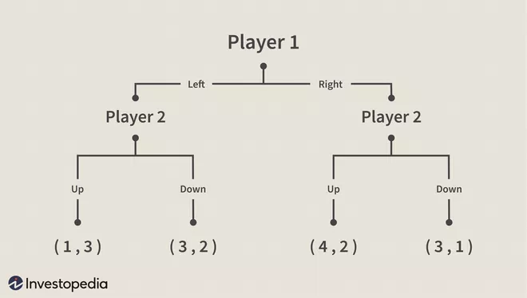In the section below is a simple sequential game between two players. The labels with Player 1 and Player 2 within them are the information sets for players one and two, respectively. The numbers in the parentheses at the bottom of the tree are the payoffs at each respective point. The game is also sequential, so Player 1 makes the first decision(left or right) and Player 2 makes its decision after Player 1(up or down).

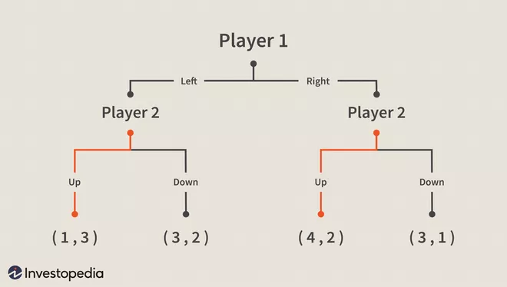Backward induction, like all game theory, uses the assumptions of rationality and maximization, meaning that Player 2 will maximize his payoff in any given situation. At either information set, we have two choices, four in all. By eliminating the choices that Player 2 will not choose, we can narrow down our tree. In this way, we will bold the lines that maximize the player's payoff at the given information set.

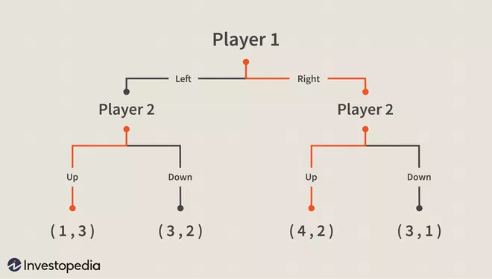After this reduction, Player 1 can maximize its payoffs now that Player 2's choices are made known. The result is an equilibrium found by backward induction of Player 1 choosing "right" and Player 2 choosing "up." Below is the solution to the game with the equilibrium bold path.

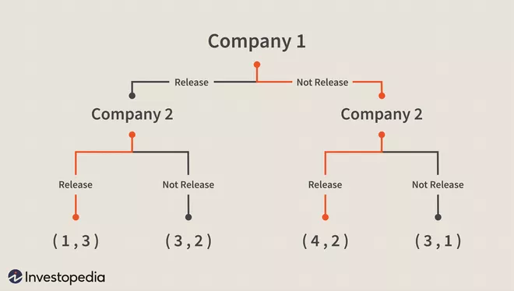

For example, one could easily set up a game similar to the one above using companies as the players. This game could include product release scenarios. If Company 1 wanted to release a product, what might Company 2 do in response? Will Company 2 release a similar competing product? By forecasting sales of this new product in different scenarios, we can set up a game to predict how events might unfold. Below is an example of how one might model such a game.

The Bottom Line

By using simple methods of game theory, we can solve what would be a confusing array of outcomes in a real-world situation. Using game theory as a tool for financial analysis can be very helpful in sorting out potentially messy real-world situations, from mergers to product releases.

Reference: https://www.investopedia.com/articles/financial-theory/08/game-theory-basics.asp