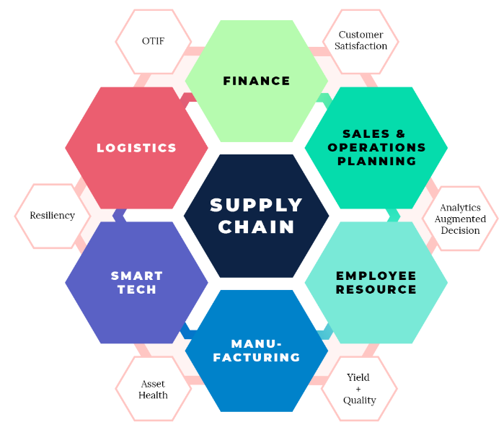

[1]

**What are Supply Chain and Supply Chain Management?**

A supply chain is a network between a company and its suppliers to produce and distribute a specific product to the final buyer. This network includes different activities, people, entities, information, and resources. The supply chain also represents the steps it takes to get the product or the service from its original state to the customer. Companies develop supply chains so they can reduce their costs and remain competitive in the business landscape. Supply chain management is a crucial process because an optimized supply chain results in lower costs and a faster production cycle.

Supply chain management(SCM) oversees each touchpoint of a company's product or service from initial creation to the final sale. With so many places along the supply chain that can add value through efficiencies or lose value through increased expenses, proper SCM can increase revenues, decrease costs, and impact a company's bottom line.

## Understanding Supply Chains

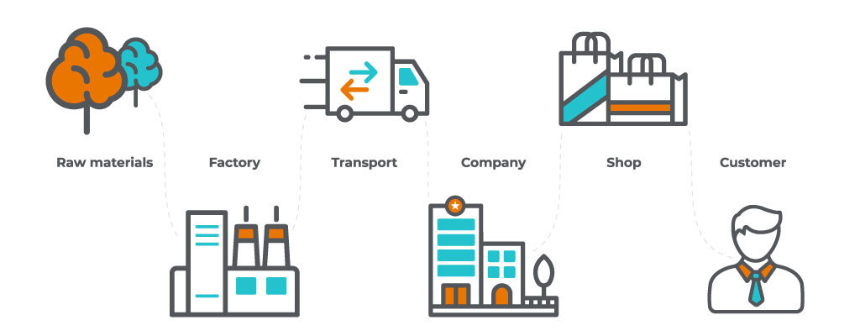A supply chain involves a series of steps to get a product or a service to the customer. The steps include moving and transforming raw materials into finished products, transporting those products, and distributing them to the end-user. The entities involved in the supply chain include producers, vendors, warehouses, transportation companies, distribution centers, and retailers. The elements of a supply chain include all the functions that start with receiving an order to meeting the customer’s request.

[4]

These functions include product development, marketing, operations, distribution network, finance, and customer service. Supply chain management is a very important part of the business process. There are many different links in this chain that require skill and expertise.

## How the Flow of Manufacturing Costs Works

The flow of manufacturing costs refers to the process of using materials and labor to complete the final product that can be sold to a customer. A “supply chain management system” can reduce the cost and complexity of the manufacturing process, particularly for a manufacturer who uses many parts. The manufacturer then incurs labor costs to run machinery and perform other work using the materials. Once the items are completed, they must be packaged and stored until they are sold to a customer.

## Supply Chain and Deflation

The evolution and increased efficiencies of supply chains have played a significant role in curbing inflation. As efficiencies in moving products from A to B increase, the costs in doing so decrease, which lowers the final cost to the consumer. While deflation is often regarded as a negative concept, supply chain efficiencies are one of the few examples where deflation is a good thing. As globalization continues, supply chain efficiencies become more optimized, which keeps the pressure on input prices.

## Supply Chain and COVID-19

The impact of the COVID-19 on the economy has been felt in nearly every sector, however, supply chain strategy has been one of the hardest-hit facets of every industry. Not only were companies' supply chains put in flux by ever-changing restrictions at national borders, which cut off access to key suppliers, but also demand for certain products changed. In late 2020, EY performed a survey of 200 senior-level supply chain executives. The study pointed to three essential points: the deep, negative effect of the pandemic felt by most respondents (72% reported a negative impact), the shifting priorities for the supply chain industry ("increased visibility" being the top priority for the next 12-36 months), and the fact that the pandemic has accelerated the transition to digitization (64% of surveyed supply chain executives say digital transformation will accelerate due to the pandemic). It's no doubt the pandemic has had an unprecedented impact on how businesses think about the supply chain. However, the shock to the system may help them usher in a new era of increased communication and visibility between suppliers as well as efficient use of technology to expedite supply chain strategies.

## What Are the Key Steps in a Supply Chain?

1. Planning the inventory and manufacturing processes to ensure supply and demand are balanced
2. Manufacturing or sourcing materials needed to create the final product
3. Assembling parts and testing the product
4. Packaging the product for shipment (or holding in inventory until a later date)
5. Transporting and delivering the finished product to the distributor, retailer, or consumer
6. Providing customer service support for returned items

## How Supply Chain Management Works

Supply chain management(SCM) represents an effort by suppliers to develop and implement supply chains that are as efficient and economical as possible. Supply chain cover everything from production to product development to the information systems needed to direct these undertakings. Typically, SCM attempts to centrally control or link the production, shipment, and distribution of a product. By managing the supply chain, companies can cut excess costs and deliver products to the consumer faster. This is done by keeping tighter control of internal inventories, internal production, distribution, sales, and the inventories of company vendors. SCM is based on the idea that nearly every product that comes to market are the result of the efforts of various organizations that make up a supply chain. Although supply chains have existed for ages, most companies have only recently paid attention to them as a value-adding tool to their operations.

**5 Parts of SCM**

The supply chain management coordinates the logistics of all aspects of the supply chain which are:

* The plan or strategy
* The resources(of raw materials or services)
* Manufacturing(focused on productivity and efficiency)
* Delivery and logistics
* The return system(for defective or unwanted products)

The supply chain manager tries to minimize shortages and keep costs down. This job is not only about logistics and purchasing inventory.

# References

1. <https://www.easternways.net/services/supply-chain/>
2. <https://www.investopedia.com/terms/s/scm.asp>
3. <https://www.investopedia.com/terms/s/supplychain.asp>
4. <https://unicsoft.com/blog/what-is-modern-supply-chain-management/>