# AdminPanel to manage companies

**NOTE:** It is so important to know that your code should meet the OOP standards such as SOLID principles and design patterns.

Basically, project to manage companies and their employees: Micro-CRM.

* Basic Laravel Auth: ability to log in as administrator
* Use database seeds to create first user with email admin@admin.com and password “password”
* CRUD functionality (Create / Read / Update / Delete) for two menu items: **Companies** and **Employees**.
* Companies DB table consists of these fields: Name (required), email, logo (minimum 100×100), website
* Employees DB table consists of these fields: First name (required), last name (required), Company (foreign key to Companies), email, phone
* Use database migrations to create those schemas above
* Store companies’ logos in **storage/app/public** folder and make them accessible from public
* Use basic Laravel resource controllers with default methods – index, create, store etc.
* Use Laravel’s validation function, using Request classes
* Use Laravel’s pagination for showing Companies/Employees list, 10 entries per page
* Use Laravel **make:auth** as default Bootstrap-based design theme, but remove ability to register

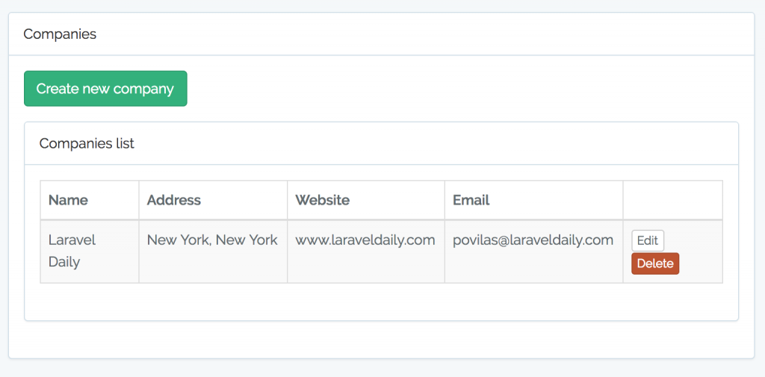

Basically, that’s it. With this simple exercise you show the skills in basic Laravel things:

* MVC
* Auth
* CRUD and Resource Controllers
* Eloquent and Relationships
* Database migrations and seeds
* Form Validation and Requests
* File management
* Basic Bootstrap front-end
* Pagination

Guess what – most of the basic’s web-applications will have these functions as core. There will be a lot more on top of that, but without these fundamentals you cannot move further. So, this task would test if you can create simple projects.

# Extra Task for “Advanced” Candidates

If you feel like this task is too small and simple, you can add these things on top:

* Use Datatables.net library to show table – with or without server-side rendering
* Create a RESTful API to manage the companies.
* Use more complicated front-end theme like AdminLTE
* Email notification: send email whenever new company is entered
* Make the project multi-language (using **resources/lang** folder)
* Basic testing with phpunit