# Modelo: vehiculos_shrigma / model8 | Test Accuracy: 91.86

## Tabla de Accuracy y Loss por Epoch

| Epoch | Training Accuracy | Validation Accuracy | Training Loss | Validation Loss |
| --- | --- | --- | --- | --- |
| 1.0 | 0.2538 | 0.848 | 2.4724 | 0.8586 |
| 2.0 | 0.715 | 0.8848 | 0.9914 | 0.5179 |
| 3.0 | 0.7967 | 0.8897 | 0.6947 | 0.4437 |
| 4.0 | 0.8319 | 0.8971 | 0.593 | 0.3855 |
| 5.0 | 0.8491 | 0.9069 | 0.5131 | 0.3491 |
| 6.0 | 0.8374 | 0.8946 | 0.4875 | 0.3442 |
| 7.0 | 0.8642 | 0.8971 | 0.4544 | 0.3208 |
| 8.0 | 0.862 | 0.9069 | 0.4292 | 0.3063 |

## Grafico de Accuracy y Loss

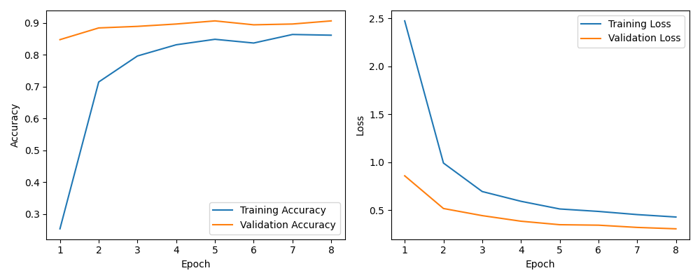

# Modelo: vehiculos_9 / model9 | Test Accuracy: 92.54

## Tabla de Accuracy y Loss por Epoch

| Epoch | Training Accuracy | Validation Accuracy | Training Loss | Validation Loss |
| --- | --- | --- | --- | --- |
| 1.0 | 0.4837 | 0.8738 | 1.7684 | 0.3957 |
| 2.0 | 0.8093 | 0.8981 | 0.5919 | 0.3145 |
| 3.0 | 0.8439 | 0.9078 | 0.4751 | 0.2999 |
| 4.0 | 0.8636 | 0.8859 | 0.426 | 0.3247 |
| 5.0 | 0.8798 | 0.9102 | 0.3537 | 0.2652 |
| 6.0 | 0.8859 | 0.9126 | 0.3106 | 0.2516 |
| 7.0 | 0.8946 | 0.915 | 0.3192 | 0.2634 |

## Grafico de Accuracy y Loss

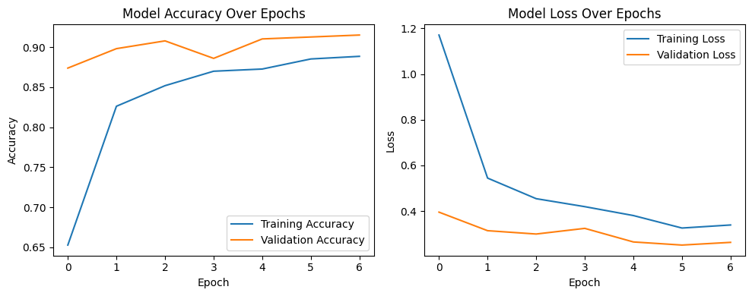

# Modelo: vehiculos_10 / model10 | Accuracy: 0.9296 | Loss: 0.2324

## Tabla de Accuracy y Loss por Epoca

| Epoch | accuracy | val_accuracy | loss | val_loss |
| --- | --- | --- | --- | --- |
| 1 | 0.6627 | 0.8838 | 1.2183 | 0.3997 |
| 2 | 0.8411 | 0.9189 | 0.5317 | 0.3232 |
| 3 | 0.8487 | 0.9123 | 0.489 | 0.2932 |
| 4 | 0.8646 | 0.8991 | 0.4148 | 0.2803 |
| 5 | 0.86 | 0.9254 | 0.426 | 0.2606 |
| 6 | 0.8988 | 0.9057 | 0.33 | 0.2701 |
| 7 | 0.8886 | 0.9145 | 0.3386 | 0.2684 |

## Grafico de Accuracy y Loss

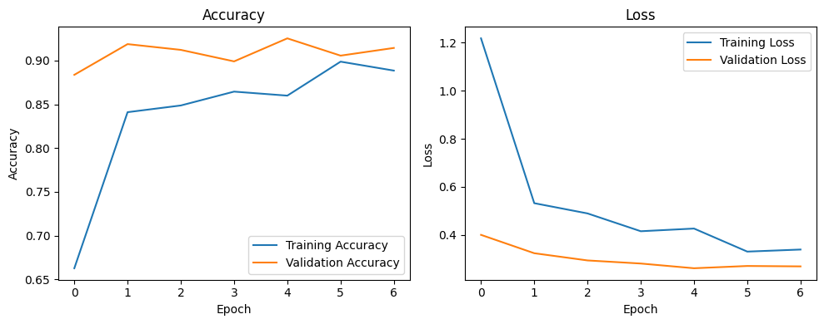

# Modelo: vehiculos_11 / model11 | Accuracy: 0.9594 | Loss: 0.1621

## Tabla de Accuracy y Loss por Epoca

| Epoch | accuracy | val_accuracy | loss | val_loss |
| --- | --- | --- | --- | --- |
| 1 | 0.6561 | 0.8947 | 1.2249 | 0.3672 |
| 2 | 0.8288 | 0.8947 | 0.5517 | 0.3135 |
| 3 | 0.86 | 0.9232 | 0.4622 | 0.2554 |
| 4 | 0.8656 | 0.9013 | 0.4165 | 0.2987 |
| 5 | 0.8723 | 0.9013 | 0.3871 | 0.3024 |
| 6 | 0.8942 | 0.9189 | 0.3383 | 0.2212 |
| 7 | 0.9044 | 0.932 | 0.2849 | 0.2306 |
| 8 | 0.9101 | 0.9276 | 0.2894 | 0.2201 |
| 9 | 0.9167 | 0.932 | 0.2737 | 0.202 |
| 10 | 0.9152 | 0.9254 | 0.2486 | 0.1997 |
| 11 | 0.9172 | 0.9189 | 0.2489 | 0.2078 |
| 12 | 0.9305 | 0.9298 | 0.2478 | 0.2151 |
| 13 | 0.9218 | 0.9364 | 0.2338 | 0.2013 |

## 

## Grafico de Accuracy y Loss

## 

## 

## 

## 

## 