History of commands to be executed:

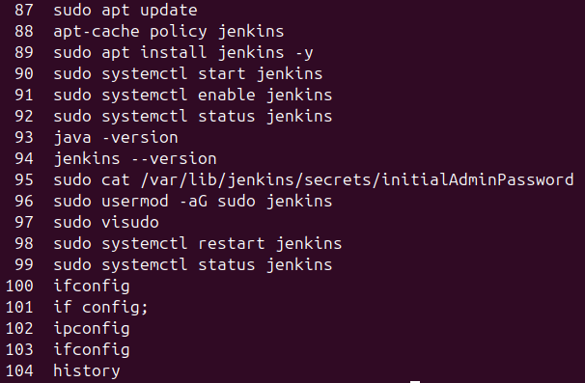

In the jenkins , create a new item and follow the steps:

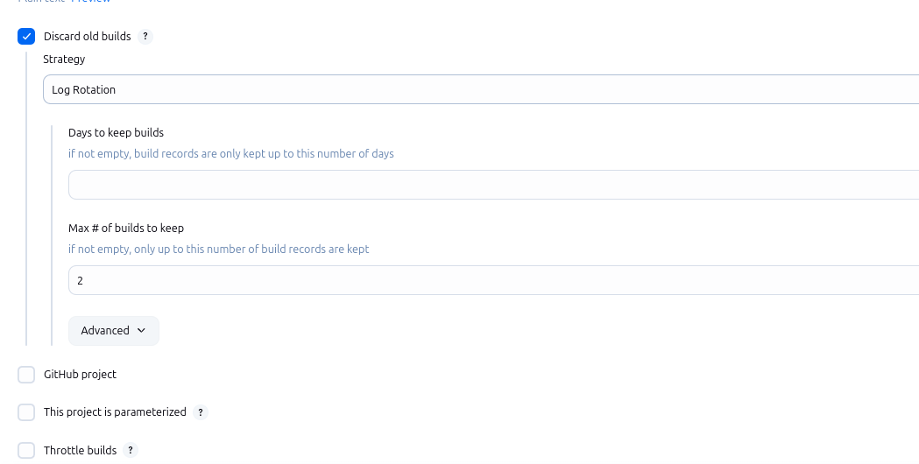

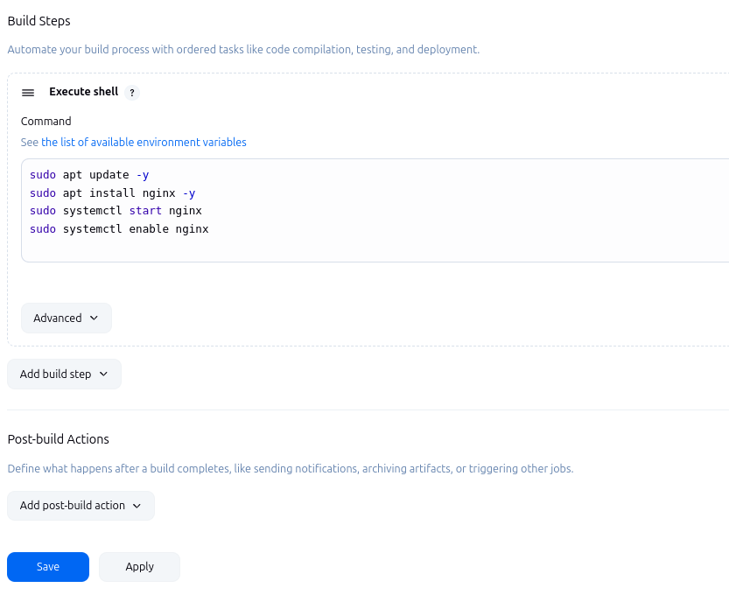

In the terminal give access to all the sections to the jenkins:

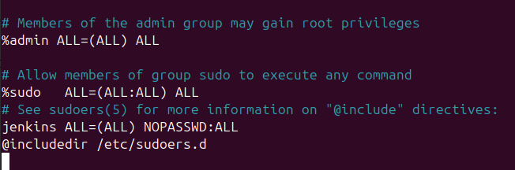

Build in the jenkins(http://localhost:8080)

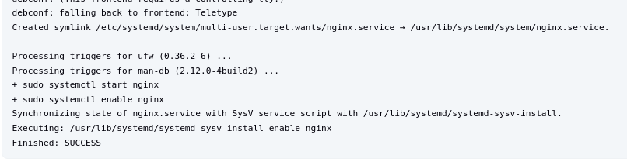

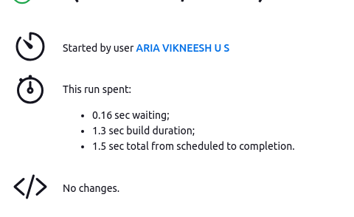

You can see the website in localhost:

