Министерство науки и высшего образования Российской Федерации

Федеральное государственное автономное учреждение высшего образования

МОСКОВСКИЙ ПОЛИТЕХНИЧЕСКИЙ УНИВЕРСИТЕТ (МОСКОВСКИЙ ПОЛИТЕХ)

Факультет информационных технологий

Кафедра «Прикладная информатика»

Форма обучения: очная

Лабораторная работа №2

Реализация структуры Data Vault

по дисциплине

«Хранилища данных»

|  |  |  |
| --- | --- | --- |
| Студент |  | И.И.Мельниченко |

Москва 2025

## Структура базы данных в соответствии с моделью 3NF

Вариант 7. Система должна описывать порядок поставок товара в систему розничных киосков.

Создадим таблицы поставки, поставщика, продуктов и киосков в соответствии с моделью 3NF (ПРИЛОЖЕНИЕ А):

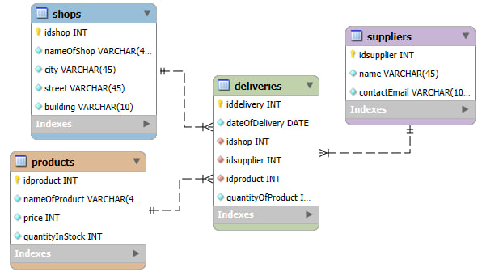

Рисунок - База данных, модель 3NF

## Структура базы данных в соответствии с моделью DataVault

Создадим таблицы поставки, поставщика, продуктов и киосков в соответствии с моделью Data Vault (ПРИЛОЖЕНИЕ Б):

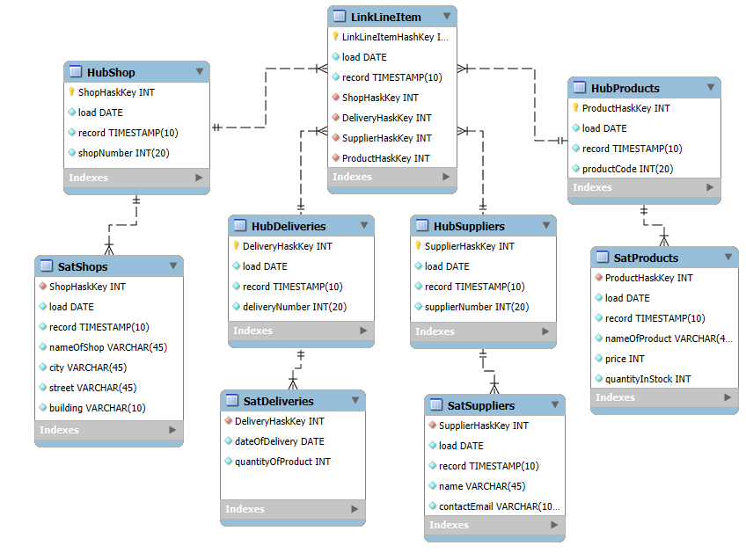

Рисунок - База данных, модель Data Vault

# ПРИЛОЖЕНИЕ А

-- MySQL Script generated by MySQL Workbench

-- Tue Jan 7 22:09:10 2025

-- Model: New Model Version: 1.0

-- MySQL Workbench Forward Engineering

SET @OLD_UNIQUE_CHECKS=@@UNIQUE_CHECKS, UNIQUE_CHECKS=0;

SET @OLD_FOREIGN_KEY_CHECKS=@@FOREIGN_KEY_CHECKS, FOREIGN_KEY_CHECKS=0;

SET @OLD_SQL_MODE=@@SQL_MODE, SQL_MODE='ONLY_FULL_GROUP_BY,STRICT_TRANS_TABLES,NO_ZERO_IN_DATE,NO_ZERO_DATE,ERROR_FOR_DIVISION_BY_ZERO,NO_ENGINE_SUBSTITUTION';

-- -----------------------------------------------------

-- Schema deliveryNF3

-- -----------------------------------------------------

-- -----------------------------------------------------

-- Schema deliveryNF3

-- -----------------------------------------------------

CREATE SCHEMA IF NOT EXISTS `deliveryNF3` DEFAULT CHARACTER SET utf8 ;

USE `deliveryNF3` ;

-- -----------------------------------------------------

-- Table `deliveryNF3`.`products`

-- -----------------------------------------------------

CREATE TABLE IF NOT EXISTS `deliveryNF3`.`products` (

`idproduct` INT NOT NULL AUTO_INCREMENT,

`nameOfProduct` VARCHAR(45) NOT NULL,

`price` INT NOT NULL,

`quantityInStock` INT NOT NULL,

PRIMARY KEY (`idproduct`),

UNIQUE INDEX `idproduct_UNIQUE` (`idproduct` ASC) VISIBLE)

ENGINE = InnoDB

DEFAULT CHARACTER SET = utf8

COLLATE = utf8_bin

COMMENT = 'Товары';

-- -----------------------------------------------------

-- Table `deliveryNF3`.`shops`

-- -----------------------------------------------------

CREATE TABLE IF NOT EXISTS `deliveryNF3`.`shops` (

`idshop` INT NOT NULL AUTO_INCREMENT,

`nameOfShop` VARCHAR(45) NOT NULL,

`city` VARCHAR(45) NOT NULL,

`street` VARCHAR(45) NOT NULL,

`building` VARCHAR(45) NOT NULL,

PRIMARY KEY (`idshop`),

UNIQUE INDEX `idshop_UNIQUE` (`idshop` ASC) VISIBLE)

ENGINE = InnoDB

DEFAULT CHARACTER SET = utf8

COLLATE = utf8_bin

COMMENT = 'Киоски';

-- -----------------------------------------------------

-- Table `deliveryNF3`.`suppliers`

-- -----------------------------------------------------

CREATE TABLE IF NOT EXISTS `deliveryNF3`.`suppliers` (

`idsupplier` INT NOT NULL AUTO_INCREMENT,

`name` VARCHAR(45) NOT NULL,

`contactEmail` VARCHAR(45) NOT NULL,

PRIMARY KEY (`idsupplier`),

UNIQUE INDEX `idsupplier_UNIQUE` (`idsupplier` ASC) VISIBLE)

ENGINE = InnoDB

COMMENT = 'Поставщики';

-- -----------------------------------------------------

-- Table `deliveryNF3`.`deliveries`

-- -----------------------------------------------------

CREATE TABLE IF NOT EXISTS `deliveryNF3`.`deliveries` (

`iddelivery` INT NOT NULL AUTO_INCREMENT,

`dateOfDelivery` DATE NOT NULL,

`idshop` INT NOT NULL,

`idsupplier` INT NOT NULL,

`idproduct` INT NOT NULL,

`quantityOfProduct` INT NOT NULL,

PRIMARY KEY (`iddelivery`),

INDEX `idshop_idx` (`idshop` ASC) VISIBLE,

INDEX `idsuppliers_idx` (`idsupplier` ASC) VISIBLE,

INDEX `idproduct_idx` (`idproduct` ASC) VISIBLE,

UNIQUE INDEX `iddelivery_UNIQUE` (`iddelivery` ASC) VISIBLE,

CONSTRAINT `idshop`

FOREIGN KEY (`idshop`)

REFERENCES `deliveryNF3`.`shops` (`idshop`)

ON DELETE CASCADE

ON UPDATE CASCADE,

CONSTRAINT `idsuppliers`

FOREIGN KEY (`idsupplier`)

REFERENCES `deliveryNF3`.`suppliers` (`idsupplier`)

ON DELETE CASCADE

ON UPDATE CASCADE,

CONSTRAINT `idproduct`

FOREIGN KEY (`idproduct`)

REFERENCES `deliveryNF3`.`products` (`idproduct`)

ON DELETE CASCADE

ON UPDATE CASCADE)

ENGINE = InnoDB

DEFAULT CHARACTER SET = utf8

COLLATE = utf8_bin

COMMENT = 'Поставки: дата, киоск, поставщик, продукт, количество продукта';

SET SQL_MODE=@OLD_SQL_MODE;

SET FOREIGN_KEY_CHECKS=@OLD_FOREIGN_KEY_CHECKS;

SET UNIQUE_CHECKS=@OLD_UNIQUE_CHECKS;

# ПРИЛОЖЕНИЕ Б

-- MySQL Script generated by MySQL Workbench

-- Tue Jan 7 22:00:08 2025

-- Model: New Model Version: 1.0

-- MySQL Workbench Forward Engineering

SET @OLD_UNIQUE_CHECKS=@@UNIQUE_CHECKS, UNIQUE_CHECKS=0;

SET @OLD_FOREIGN_KEY_CHECKS=@@FOREIGN_KEY_CHECKS, FOREIGN_KEY_CHECKS=0;

SET @OLD_SQL_MODE=@@SQL_MODE, SQL_MODE='ONLY_FULL_GROUP_BY,STRICT_TRANS_TABLES,NO_ZERO_IN_DATE,NO_ZERO_DATE,ERROR_FOR_DIVISION_BY_ZERO,NO_ENGINE_SUBSTITUTION';

-- -----------------------------------------------------

-- Schema mydb

-- -----------------------------------------------------

-- -----------------------------------------------------

-- Schema mydb

-- -----------------------------------------------------

CREATE SCHEMA IF NOT EXISTS `mydb` DEFAULT CHARACTER SET utf8 ;

USE `mydb` ;

-- -----------------------------------------------------

-- Table `mydb`.`HubProducts`

-- -----------------------------------------------------

CREATE TABLE IF NOT EXISTS `mydb`.`HubProducts` (

`ProductHaskKey` INT NOT NULL AUTO_INCREMENT,

`load` DATE NOT NULL,

`record` TIMESTAMP(10) NOT NULL,

`productCode` INT(20) NOT NULL,

PRIMARY KEY (`ProductHaskKey`))

ENGINE = InnoDB;

-- -----------------------------------------------------

-- Table `mydb`.`SatProducts`

-- -----------------------------------------------------

CREATE TABLE IF NOT EXISTS `mydb`.`SatProducts` (

`ProductHaskKey` INT NOT NULL,

`load` DATE NOT NULL,

`record` TIMESTAMP(10) NOT NULL,

`nameOfProduct` VARCHAR(45) NOT NULL,

`price` INT NOT NULL,

`quantityInStock` INT NOT NULL,

INDEX `ProductHashKey_idx` (`ProductHaskKey` ASC) VISIBLE,

CONSTRAINT `ProductHashKey`

FOREIGN KEY (`ProductHaskKey`)

REFERENCES `mydb`.`HubProducts` (`ProductHaskKey`)

ON DELETE CASCADE

ON UPDATE CASCADE)

ENGINE = InnoDB

DEFAULT CHARACTER SET = utf8

COLLATE = utf8_bin

COMMENT = 'Товары';

-- -----------------------------------------------------

-- Table `mydb`.`HubShop`

-- -----------------------------------------------------

CREATE TABLE IF NOT EXISTS `mydb`.`HubShop` (

`ShopHaskKey` INT NOT NULL AUTO_INCREMENT,

`load` DATE NOT NULL,

`record` TIMESTAMP(10) NOT NULL,

`shopNumber` INT(20) NOT NULL,

PRIMARY KEY (`ShopHaskKey`))

ENGINE = InnoDB;

-- -----------------------------------------------------

-- Table `mydb`.`SatShops`

-- -----------------------------------------------------

CREATE TABLE IF NOT EXISTS `mydb`.`SatShops` (

`ShopHaskKey` INT NOT NULL,

`load` DATE NOT NULL,

`record` TIMESTAMP(10) NOT NULL,

`nameOfShop` VARCHAR(45) NOT NULL,

`city` VARCHAR(45) NOT NULL,

`street` VARCHAR(45) NOT NULL,

`building` VARCHAR(10) NOT NULL,

INDEX `ShopHashKey_idx` (`ShopHaskKey` ASC) VISIBLE,

CONSTRAINT `ShopHashKey`

FOREIGN KEY (`ShopHaskKey`)

REFERENCES `mydb`.`HubShop` (`ShopHaskKey`)

ON DELETE CASCADE

ON UPDATE CASCADE)

ENGINE = InnoDB

DEFAULT CHARACTER SET = utf8

COLLATE = utf8_bin

COMMENT = 'Киоски';

-- -----------------------------------------------------

-- Table `mydb`.`HubDeliveries`

-- -----------------------------------------------------

CREATE TABLE IF NOT EXISTS `mydb`.`HubDeliveries` (

`DeliveryHaskKey` INT NOT NULL AUTO_INCREMENT,

`load` DATE NOT NULL,

`record` TIMESTAMP(10) NOT NULL,

`deliveryNumber` INT(20) NOT NULL,

PRIMARY KEY (`DeliveryHaskKey`))

ENGINE = InnoDB;

-- -----------------------------------------------------

-- Table `mydb`.`SatDeliveries`

-- -----------------------------------------------------

CREATE TABLE IF NOT EXISTS `mydb`.`SatDeliveries` (

`DeliveryHaskKey` INT NOT NULL,

`dateOfDelivery` DATE NOT NULL,

`quantityOfProduct` INT NOT NULL,

INDEX `DeliveryHashKey_idx` (`DeliveryHaskKey` ASC) VISIBLE,

CONSTRAINT `DeliveryHashKey`

FOREIGN KEY (`DeliveryHaskKey`)

REFERENCES `mydb`.`HubDeliveries` (`DeliveryHaskKey`)

ON DELETE CASCADE

ON UPDATE CASCADE)

ENGINE = InnoDB

DEFAULT CHARACTER SET = utf8

COLLATE = utf8_bin

COMMENT = 'Поставки: дата, киоск, поставщик, продукт, количество продукта';

-- -----------------------------------------------------

-- Table `mydb`.`HubSuppliers`

-- -----------------------------------------------------

CREATE TABLE IF NOT EXISTS `mydb`.`HubSuppliers` (

`SupplierHaskKey` INT NOT NULL AUTO_INCREMENT,

`load` DATE NOT NULL,

`record` TIMESTAMP(10) NOT NULL,

`supplierNumber` INT(20) NOT NULL,

PRIMARY KEY (`SupplierHaskKey`))

ENGINE = InnoDB;

-- -----------------------------------------------------

-- Table `mydb`.`SatSuppliers`

-- -----------------------------------------------------

CREATE TABLE IF NOT EXISTS `mydb`.`SatSuppliers` (

`SupplierHaskKey` INT NOT NULL,

`load` DATE NOT NULL,

`record` TIMESTAMP(10) NOT NULL,

`name` VARCHAR(45) NOT NULL,

`contactEmail` VARCHAR(100) NOT NULL,

INDEX `SupplierHashKey_idx` (`SupplierHaskKey` ASC) VISIBLE,

CONSTRAINT `SupplierHashKey`

FOREIGN KEY (`SupplierHaskKey`)

REFERENCES `mydb`.`HubSuppliers` (`SupplierHaskKey`)

ON DELETE CASCADE

ON UPDATE CASCADE)

ENGINE = InnoDB

COMMENT = 'Поставщики';

-- -----------------------------------------------------

-- Table `mydb`.`LinkLineItem`

-- -----------------------------------------------------

CREATE TABLE IF NOT EXISTS `mydb`.`LinkLineItem` (

`LinkLineItemHashKey` INT NOT NULL,

`load` DATE NOT NULL,

`record` TIMESTAMP(10) NOT NULL,

`ShopHaskKey` INT NOT NULL,

`DeliveryHaskKey` INT NOT NULL,

`SupplierHaskKey` INT NOT NULL,

`ProductHaskKey` INT NOT NULL,

PRIMARY KEY (`LinkLineItemHashKey`),

INDEX `ShopHashKey_idx` (`ShopHaskKey` ASC) VISIBLE,

INDEX `DeliveryHashKey_idx` (`DeliveryHaskKey` ASC) VISIBLE,

INDEX `SupplierHashKey_idx` (`SupplierHaskKey` ASC) VISIBLE,

INDEX `ProductHashKey_idx` (`ProductHaskKey` ASC) VISIBLE,

CONSTRAINT `ShopHashKey`

FOREIGN KEY (`ShopHaskKey`)

REFERENCES `mydb`.`HubShop` (`ShopHaskKey`)

ON DELETE CASCADE

ON UPDATE CASCADE,

CONSTRAINT `DeliveryHashKey`

FOREIGN KEY (`DeliveryHaskKey`)

REFERENCES `mydb`.`HubDeliveries` (`DeliveryHaskKey`)

ON DELETE CASCADE

ON UPDATE CASCADE,

CONSTRAINT `SupplierHashKey`

FOREIGN KEY (`SupplierHaskKey`)

REFERENCES `mydb`.`HubSuppliers` (`SupplierHaskKey`)

ON DELETE NO ACTION

ON UPDATE NO ACTION,

CONSTRAINT `ProductHashKey`

FOREIGN KEY (`ProductHaskKey`)

REFERENCES `mydb`.`HubProducts` (`ProductHaskKey`)

ON DELETE CASCADE

ON UPDATE CASCADE)

ENGINE = InnoDB;

SET SQL_MODE=@OLD_SQL_MODE;

SET FOREIGN_KEY_CHECKS=@OLD_FOREIGN_KEY_CHECKS;

SET UNIQUE_CHECKS=@OLD_UNIQUE_CHECKS;