# Final Project

Objectives

* Create a full-fledged Web Application

Problem: Create node.js Express web server using various front-end and back-end technologies

Create a website/app using the technologies that were covered in class. Select something that you strongly believe in, such as rescue pets, social issues, environmental issues, any business topic, a personal website etc.

**Minimum Requirements:**

* Application must use Express framework
* In addition, must use at least two of the following technologies:
  + Animation, jQuery, Bootstrap, AngularJS, ReactJS, Handlebars, MongDB
* Consistent look and feel by implementing Masterpage concept (header and footer):
  + Use templating engine on server or AngularJS/ReactJS on client side
  + Header should show application name (stored in configuration file)
  + Footer should always show current date
* A separate data source (Cloud MongoDB database/file-based/web service)
* One configuration file config.js to store config data, such as server, port, etc. stored in folder modules
* 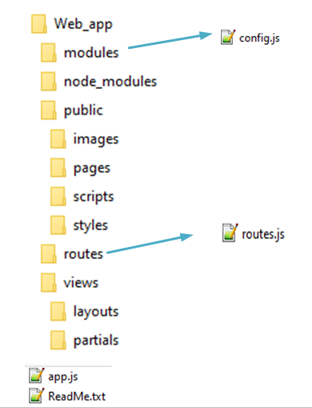HTML pages:
  + Either use static html pages (including AngularJS/ReactJS files) should be stored under public/pages
  + Or handlebars views (stored under views)
  + Or a combination of both
* One routing module stored in folder routes (at least 5 routes)
* One image/logo stored in folder images under public
* One stylesheet stored in folder styles under public
* One client-side JavaScript file stored in folder scripts to implement some client-side functionality under public

Upload the following files to Canvas:

* Zip up the entire project into one file (make sure it includes all files including package.json)
* **DO NOT** include the node_modules folder, I will use package.json to install necessary modules
* Optional: url of hosted website/app
* README.txt file - A description of your homework with your name and your student ID. Please include any problems you faced, any resources you used, names of friends/tutors you received help from.

**Notes:**

* This time zip up all the files into one file
* Your code should contain some meaningful comments (if applicable)
* Your code should be well organized and formatted