# Homework 2

Objectives

* Familiarize yourself with html forms and anchors
* Loading content into iframe
* Set up web page with CSS grids

Problem:

**Part 1:** Create an html page saved as hw2_content.html as shown below:

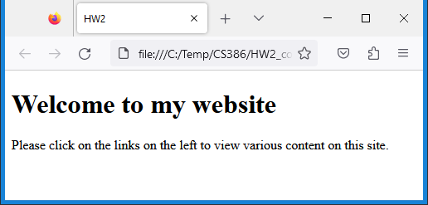

**Part 2:** Create the following html page (hw2.html and hw2.css) as shown including the following:

* CSS stylesheet:
  + Use CSS grid technology to create a 3 column and 3 row configuration (names shown in brown background)
  + Use row and column gaps, wrap grid into a div element (id=divMain), use height of 95vh in CSS
  + Set all margins to 0 (you may use shorthand property)
  + Use grid-template-rows to set top and bottom rows to a fixed height in pixels, middle row use 1fr
  + Use grid-template-columns to set left and right columns to a relative width in percent, middle column use 1fr
* HTML file:
  + Use the sectioning tags header, footer, aside (ads), nav, and article (content)
  + iframe element should be set to 100% for height and width in CSS
  + iframe should load page (hw2_content.html) from part 1 by default
  + The content cell contains an iframe where various content is loaded using the anchor links in the menu:
    - Home loads page from part 1(hw2_content.html)
    - Local News loads some local news web page (<https://www.sfchronicle.com/> or other)
    - National News loads some national news site (<https://www.wsj.com/> or other)
    - Registration form named HW2_register.html (see Part 3)

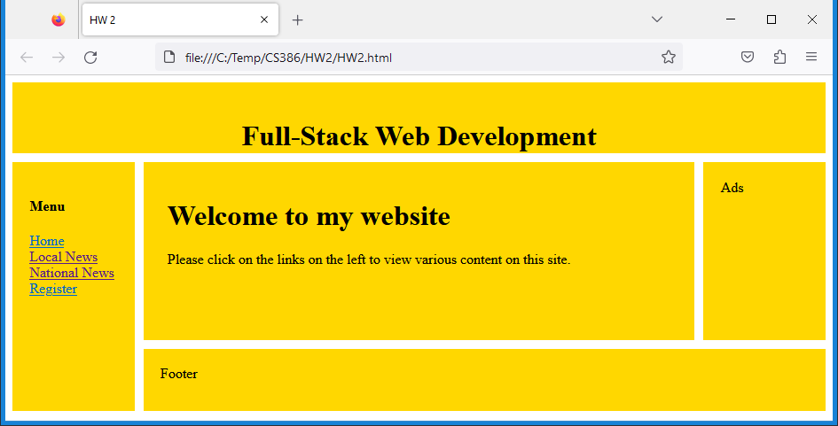

**nav**

**content**

**header**

**footer**

**ads**

**CSS grid**

**iframe**

**HW2_content.html**

**Part 3:** The registration form (HW2_register.html and HW2_register.css) is shown below:

* Styling should be done in CSS, it should look approximately like as shown below (I allow for some flexibility)
* There are many different ways to style, do your own research for finding CSS solutions
* All text inputs should be required
* Password inputs should be of type password
* Use labels and ensure they work correctly (when clicked on the input control is activated)
* Set href attribute of all anchor links to #
* Set the cursor CSS property of the register button to pointer (looks like a hand)

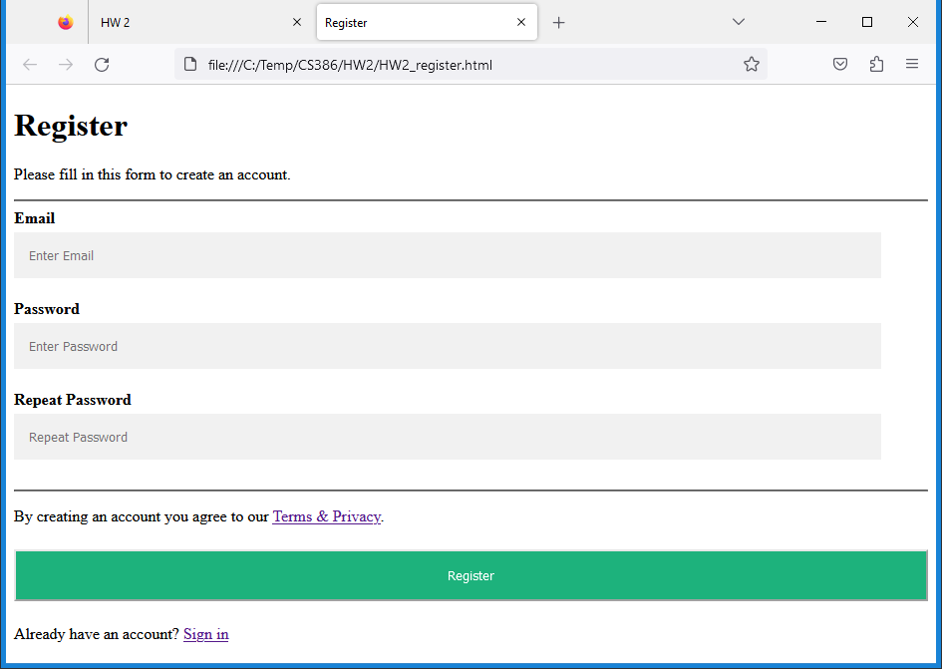

Upload the following files to Canvas:

* Screenshot of the browser window showing your html page (either pasted into a Word document or as an image)
* All css files
* The html files:
  + hw2.html, hw2_content.html, hw2_register.html (html extension)
* README.txt file - A description of your homework with your name and your student ID. Please include any problems you faced, any resources you used, names of friends/tutors you received help from.

**Notes:**

* Upload the files individually (no zipping, compressing)
* Your code should contain some meaningful comments (if applicable)
* Your code should be well organized and formatted