# Homework 5

Objectives

* Familiarize yourself with jQuery
* Building browser UI functionality
* Using jQuery Selectors and methods

Problem: Create HTML table and format it using jQuery

**Part 1:** Create HW5.html page

* Load HW5.css, jQuery and HW5.js files in head section
* Use h1 header and an hr element as shown
* Add two HTML5 color input elements (use even and odd as id values), attach labels to these inputs
* Create table (id tblData) as shown, use table, thead and tbody, th and td elements
* 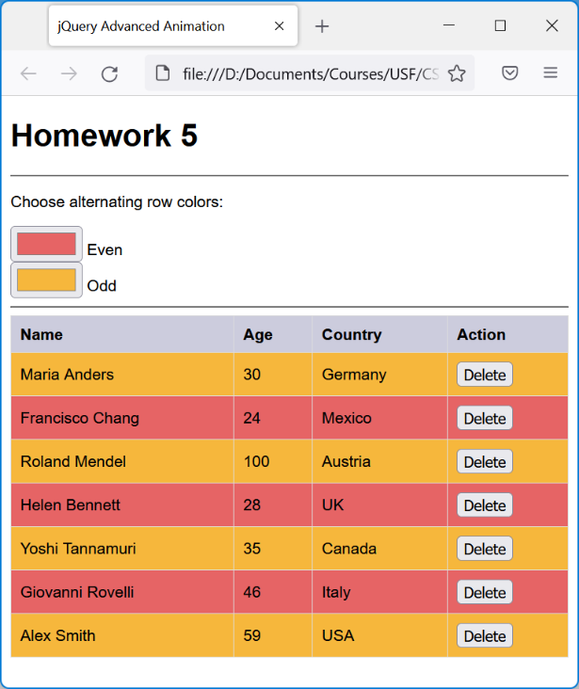The delete button is an input element with type button and a class of delete
* Use proper indentation in html page to show parent and child elements

**Part 2:** Create HW5.css file

* Style body element with font-family (your choice) and font-size (14px)
* Style table element with border-collapse property to collapse (show single border rather than double border lines) and width to 100%
* Style th and td elements with border set to 1px solid and a color of your choice, padding set to 8px, and text-align to left
* Style the th element only with a background color to some shade of gray

**Part 3:** Create HW5.js file

* Use only jQuery properties and methods unless otherwise specified
* In the load event, register the following event handlers:
  + Select all elements with class delete, use click event and respond with fDeleteRow
  + Select all elements with class delete, use mouseover event and respond with fMousePointer
  + Select elements with id of even and odd, use change event and respond with fAlternateRow
* Create the three event handler functions and place a console.log statement inside them for testing
* Save everything and test your event handlers (open web developer tools in browser)

**Part 4:** Modify function fAlternateRow

* Select all even rows and use css method to set the background color to the value of input with id of even
* Select all odd rows and use css method to set the background color to the value of input with id of odd
* Call function fAlternateRow in load event
* Save everything and test the html page, rows should be now colored alternately

**Part 5:** Modify function fMousePointer

* Select the current delete button (use JavaScript this object and wrap jQuery function around it)
* Use css method to set the cursor property to pointer
* Save everything and test the html page, when moving the mouse over the delete button the mouse pointer should change to a hand

**Part 6:** Modify function fDeleteRow

* Create variable tr and assign the following jQuery selection to it:
* Select the current delete button (use JavaScript this object and wrap jQuery function around it)
* Use the closest method and pass the tr element into it
* Now use variable tr and chain it with the fadeout method with 2 seconds
* Within the callback function:
* Use variable tr again and the remove method passing the tr element
* Call function fAlternateRow (since one row is deleted and alternate color needs to be refreshed)
* Save everything and test the html page, delete a row and make sure that alternate coloring is refreshed

Upload the following files to Canvas:

* Screenshot of the browser window showing the html page (either pasted into a Word document or as an image)
* The JavaScript file HW5.txt (txt extension)
* The CSS file HW5.css
* The html page HW5.html
* README.txt file - A description of your homework with your name and your student ID. Please include any problems you faced, any resources you used, names of friends/tutors you received help from.

**Notes:**

* Upload the files individually (no zipping, compressing)
* Your code should contain some meaningful comments (if applicable)
* Your code should be well organized and formatted