# Homework 6

Objectives

* Familiarize yourself with server-side JavaScript
* Building http web server
* Using request and response objects

Problem: Create Express server for view and downloading csv and json data

**Part 1:**

In this part you set up the web server and error routes

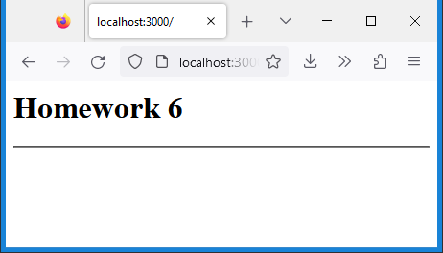Create basic Express web server containing the following components:

* + Create constants host and port and populate with appropriate values
  + Routing for “/” url displaying Homework 6 in an h1 header followed by a horizontal ruler (use variable strHTML to store html markup)
  + 404 error middleware
  + 500 error middleware
  + Create server using constants host and port

**Part 2:**

In this part you set up the initial html page using a string, use template strings for multiline strings

* 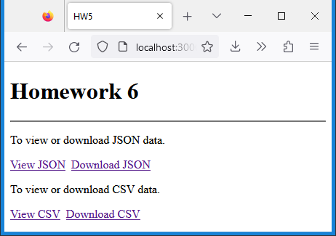Create string variable html_top starting from doctype to opening body tag including charset utf-8 and title tag HW6 (beginning of html markup)
* Create string variable html_bottom containing the closing body and html tag (the end of html markup)
* In the route “/” create an html string using variable strHTML to create the html page as shown (concatenate html_top, strHTML and html_bottom to create complete HTML markup), all anchor links open in a new tab
* The anchor links are set up as follows:
  + View JSON: href = /view-json
  + Download JSON: href = /json
  + View CSV: href = /view-csv
  + Download CSV: href = /csv
* Since the routes the anchor links are redirecting to, clicking on them should produce a 404 error

**Part 3:**

In this part you set up the individual routes for viewing and downloading the data files:

* Download the zip file HW6.zip from Canvas containing two files (dataCSV.csv and dataJSON.json), place them in the same folder
* Load both files into variables dataJSON and dataCSV
* Create four routes matching the href attributes of the anchor links:
  + /view-json: Set http status code to 200, send the file content dataJSON using res.json method
  + /view-csv: Replace line breaks with html break elements, then set content type to html, http status code to 200, send the file content dataCSV
  + /json: Set the http header content-disposition to "attachment; filename=dataJSON.json", the content type to “application/json”, http status code to 200, send the file content dataJSON
  + /csv: Set the http header content-disposition to "attachment; filename=dataCSV.csv", the content type to “application/csv”, http status code to 200, send the file content dataCSV

**Note:** Different browsers will handle viewing and downloading in different ways

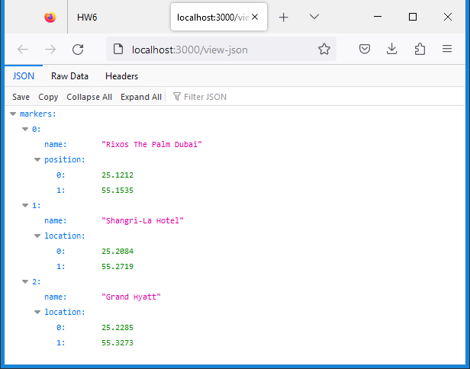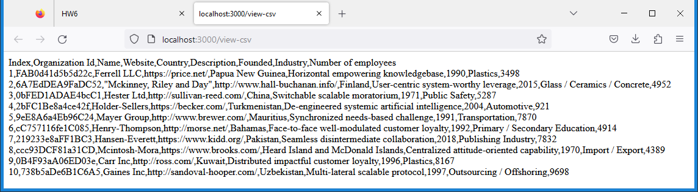view-json view-csv

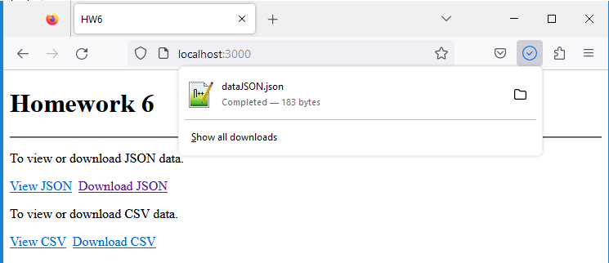

Upload the following files to Canvas:

* Screenshots of the executed JavaScript file in your browser (either pasted into a Word document or as an image) for all four anchor links click:
  + View json
  + View csv
  + Download json
  + Download csv
* The JavaScript file HW6.txt (txt extension)
* README.txt file - A description of your homework with your name and your student ID. Please include any problems you faced, any resources you used, names of friends/tutors you received help from.

**Notes:**

* Upload the files individually (no zipping, compressing)
* Your code should contain some meaningful comments (if applicable)
* Your code should be well organized and formatted