# In-Class Programming 11

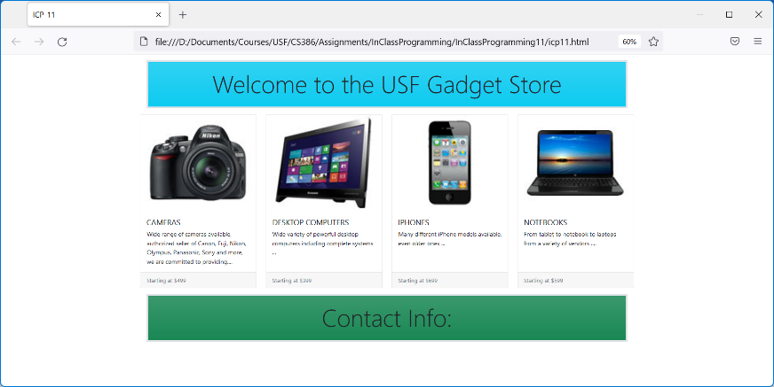Create the following html page using Bootstrap simulating a tech gadget shopping web site. The individual elements between the header and the footer are Bootstrap card elements.

Download image files from Canvas

**Step 1:**

* Make sure to load necessary Bootstrap files over CDN
* 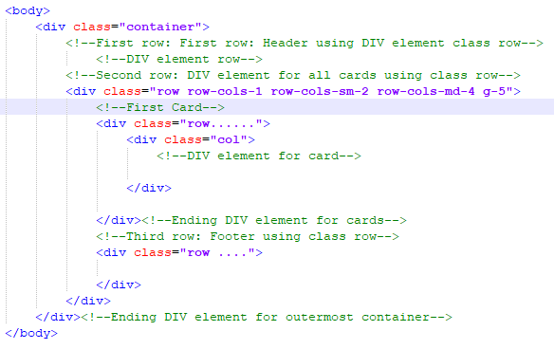Inside the body element, create an outermost div element of class container as shown:
* Inside this div element, there are 3 rows:
  + Header
  + Cards
  + Footer
* For the header (first row):
  + Create a border using a value of 5, center the text, all margins and paddings of value 3, and a background color
  + Place an h1 element using a class of display-3 and the text shown
* For the footer (third row):
  + Choose the same settings as for the header except for the background color
  + Place an h1 element using a class of display-5 and the text shown
* For the middle row (card elements) create a div element and the classes as shown
* Save everything and test the html page, it should show the header and footer

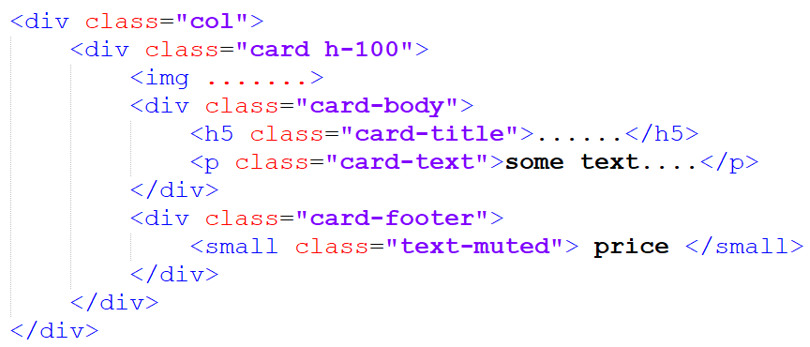

**Step 2:**

* Within the cards row (second row), create Bootstrap elements as shown:
* Use div element with class col for each card
* Add the image element using one image from the img folder
* Enter some text in the card title, card text and card footer
* Repeat these steps for the remaining 3 cards
* Save everything and test the html page

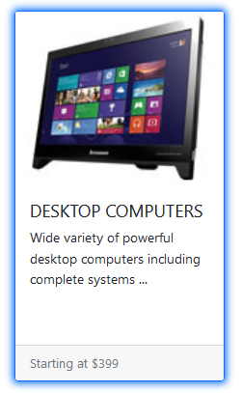**Step 3:**

* Create a stylesheet file named icp11.css and link it in the html file icp11.html (after the Bootstrap links)
* Add a rule using the pseudo class hover on the class card:
  + Style the border color to any color of your choice
  + Style the box-shadow short-hand property with 0px 0px 10px 2px and a color of your choice
* Save everything and now move your mouse over the cards, you should see a shadow (as shown)

**Step 4:**

* Create a JavaScript file named icp11.js and link it in the html file icp11.html (after the Bootstrap links)
* 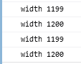Register the event resize on the window object
* The event handler should show the window.innerWidth property in the console as shown
* Save everything and resize the window, notice in the console the changing width values
* This allows you to see the breakpoint widths

Upload the following files to Canvas:

* Screenshot of the browser window showing the entire page (header ,cards, footer) (either pasted into a Word document or as an image)
* Screenshot of the console showing some width values when window is resized
* The html file icp11.html
* The stylesheet file icp11.css
* The JavaScript file icp11.txt (txt extension)

**Notes:**

* Upload the files individually (no zipping, compressing)
* Your code should contain some meaningful comments (if applicable)
* Your code should be well organized and formatted (very important for this assignment due to multiple nesting levels of elements)