# In-Class Programming 12

Create the following html page and JavaScript code to query a web service and display the results in the page. The web service is: <https://v2.jokeapi.dev/joke/>

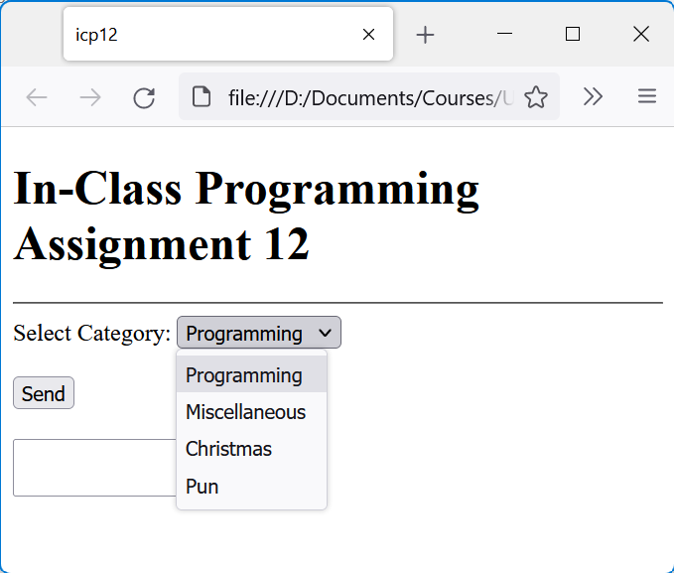

**Step 1:** Build the html page as shown

* In the head section, specify the title as shown and character set to utf-8
* Drop down list id is ddlCategory
* Drop-down list values are the same as displayed values except for Miscellaneous it should be just Misc
* The button is not a submit button and its id is btnSend
* The big text box is a textarea element

**Step 2:** Create JavaScript file

* Register the load event with function fLoad
* In function fLoad get the reference for the button and register a click event for it
* Respond to the click event with fAJAX
* In function fAJAX place an alert just for testing purposes
* Save everything and click on the button to ensure that the event registration works correctly

**Step 3:** Build function fAJAX

* Get the reference to the textarea element and initialize with an empty string (in case there is an entry from a previous operation)
* Create an AJAX request using the following url: <https://v2.jokeapi.dev/joke/Programming?safe-mode&type=single> (test this url in your browser) using variable xhr
* Display the response text in the console for status 200 using the load event on the xhr object
* Save everything and click on the Send button, then verify that a response is sent to the console

**Step 4:** Modify function fAJAX to incorporate drop-down list and display joke only in text area

* Instead of the hard-coded Programming category in Step 3 in the url, use the selected drop-down list’s value in the url
* In the xhr load event, display potential error (when status code is unequal to 200) in console using status and statusText (modify url to produce an error)
* If the status code is 200, then extract the joke from the response text and display it in the textarea element

Upload the following files to Canvas:

* Screenshot of the browser window showing a populated textarea with a joke (either pasted into a Word document or as an image)
* Screenshot of the browser console when an error occurs (modify url to generate an error)
* The icp12.html file
* The JavaScript file icp12.txt (txt extension)

**Notes:**

* Upload the files individually (no zipping, compressing)
* Your code should contain some meaningful comments (if applicable)
* Your code should be well organized and formatted

Example of error:

