# In-Class Programming 14

Create the following JavaScript code to create and save data into MongoDB

**Step 1:** Set up a model

* You can use the CS386 folder or a sub folder as your main folder
* If not already done, create a models folder under your chosen main folder
* Create a file named CreateCSCourses.js to create USF CS courses:

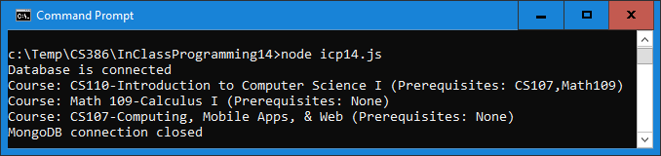

* Fields are courseID (String), name (String), preReqs (Array), and active (Boolean)
* All fields are required
* courseID must be unique, defaults for name and preReqs are ‘unknown’, and default for active is true
* Export the model, name the collection ‘CSCourse’ (remember, MongoDB will rename it cscourses)

**Step 2:** Test database connection using db.js and credentials.js

* Use the db.js and credentials.js files as demonstrated and used in class (download db.zip from Canvas)
* Place the db.js and credentials.js files in a folder named modules under your chosen main folder
* Update the credentials.js with your database password
* Place TestDB.js in your main folder
* Execute TestDB.js in nodejs to test your database connection
* Make a screenshot of the output of TestDB.js and upload it with the other files

**Step 3:** Create icp14.js to populate data

* As demonstrated in class with the users data, create a program to add the course data into the collection cscourses
  + Test whether the collection already exists. If it does:
    - Produce the output as shown above in the console
    - Loop over the courses, test whether the array preReqs contains elements:
      * If so, display the prerequisites
      * If not, display None
  + If it does not:
    - Add the data (you may use insertMany or new model instance and save() method)
    - For courses with no prerequisite, add an empty array

Upload the following files to Canvas:

* Screenshot of the database connection window (Step 2) (either pasted into a Word document or as an image)
* Screenshot of the icp14.js output
* The JavaScript file icp14.txt (txt extension)
* The JavaScript file CreateCSCourse.js (txt extension)

**Notes:**

* Upload the files individually (no zipping, compressing)
* Your code should contain some meaningful comments (if applicable)
* Your code should be well organized and formatted