**Assignment No. 6**

1. In Assignment 3 of previous session, print the details of Managers with the help of delegate

EmployeeDelegate. (UniCast Delegate)

**INPUT:**

using System;

namespace DelegateAssignment

{

public delegate void EmployeeDelegate(int ManagerId, string ManagerName,double ManagerSalary);

public class DelegateProgram

{

public static void ManagerDetails(int ManagerId, string ManagerName, double ManagerSalary)

{

Console.WriteLine("Manager Details");

Console.WriteLine("Manager Id: {0}\nManager Name: {1}\nManager Salary:{2}", ManagerId, ManagerName, ManagerSalary);

}

public static void Main(string[] args)

{

EmployeeDelegate delegateemp = new EmployeeDelegate(DelegateProgram.ManagerDetails);

delegateemp(111, "Muskan Khan", 90000);

Console.Read();

}

}

}

**OUPUT:**

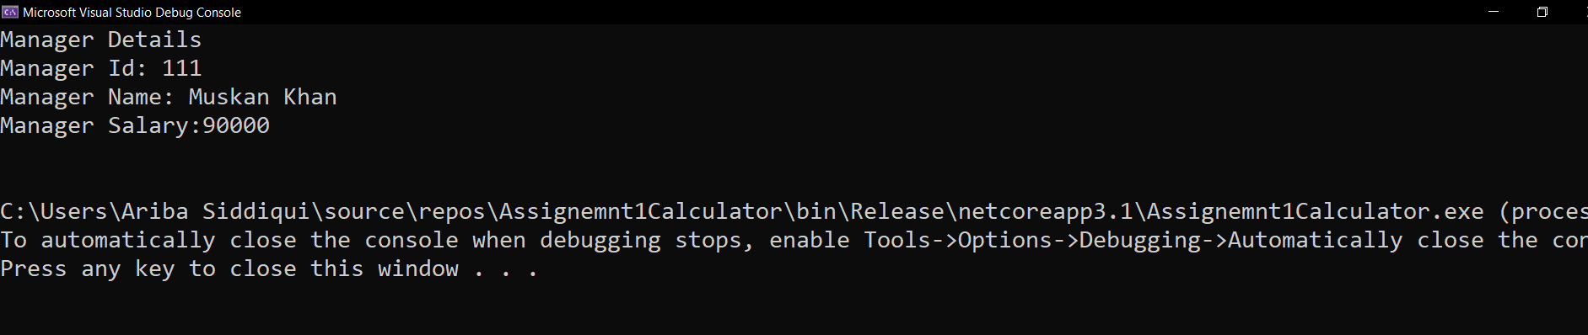

1. Create a MultiCast Delegate by adding address of another method to the above delegate to list the details of Marketing Executive.

**INPUT:**

using System;

namespace DelegateAssignment

{

public delegate void EmployeeDelegate(int Id, string Name, double Salary);

public class DelegateProgram

{

public static void ManagerDetails(int ManagerId, string ManagerName, double ManagerSalary)

{

Console.WriteLine("Manager Details\n");

Console.WriteLine("Manager Id: {0}\nManager Name: {1}\nManager Salary:{2}\n", ManagerId, ManagerName, ManagerSalary);

}

public static void MarketingExecutive(int MarketingExecuId , string MarketingExecuName, double MarketingExecuSalary)

{

Console.WriteLine("Marketing Executive Details..\n");

Console.WriteLine("Manager Id: {0}\nManager Name: {1}\nManager Salary:{2} \n", MarketingExecuId, MarketingExecuName, MarketingExecuSalary);

}

public static void Main(string[] args)

{

EmployeeDelegate delegateemp = DelegateProgram.ManagerDetails;

delegateemp(111, "Muskan Khan", 90000);

delegateemp(201, "Aidtya Salunke", 100000);

delegateemp(101, "Pratik Hadawale", 97000);

Console.WriteLine("**********************************");

delegateemp += DelegateProgram.MarketingExecutive;

Console.WriteLine("");

delegateemp(105, "Sushmita Gupta", 80000);

Console.Read();

}

}

}

**OUTPUT:**

