

**National University of Computer and Emerging Sciences, Karachi Campus**

**CS3009 Software Engineering**

**Assignment 01**

**BS(CS) – A**

Group Members:

Ariba 19K-0252

Anjiya Saleem 19K-0254

**PROBLEM DEFINITION:**

The system provides car rental services, where the car owner will lend his car and the customer will lease his car. This system will aid the person who wants to commute and is ready to make earning by lending his car; he can lend it to a person who wants to lease it. The system will work as a moderator between the customer and the car owner.

**PROPOSED SOLUTION:**

1. **Functional Requirements:**
2. The system will store each car owner's name, unique CNIC, email, residential address, phone number and date.
3. The system will save each customer’s name, unique CNIC, email, residential address, phone number, driving license number.
4. The system keeps track of Date of car issuance (when the car owner brought his car to us), Date of car return (when the car owner took back his car), and the number of days the car was rented.
5. The system should provide quota to the car owner.
6. The system will preserve the car owner information such as Number plate of his car, customer CNIC, Issuance Date, Return Date and the amount.
7. Car owner can register as many cars as he or she wants to in the system with correct car and date details.
8. Customer can rent exactly one car at a time. He must rent the car for at least 7 days.
9. After the car is booked, the amount will be displayed on the screen of customer.
10. When the customer selects the appropriate data, only the car available in the range must be displayed.
11. **Non-Functional Requirements:**
12. Portability and Compatibility: This software can be moved from one machine platform to another. Hence, the software can be moved from one operating system to another.
13. Security: All the accounts and details of the car owner and customer will be protected by password. Hence, the system does not compromise on data integrity and authentication.
14. Usability: The application is easy to navigate and efficient from the users' point of view. The system has visual clarity and friendly user interface.
15. Quality: The application is secured for both the end users and developers. With this, it is easy to maintain for developers.
16. Scalability: The system performance does not degrade with the increase in user’s traffic.
17. Car information should be updated accordingly and immediately in the database when the user chooses to edit/delete or add car.
18. Car owner and customer's credentials must be kept confidential and secured within the database.
19. External users must not be given access to confidential section of the system.
20. After the car has been returned by customer, database must update the status of both car and customer.
21. **Tools and Technology:**
22. MongoDB
23. Node.js (Backend technology)
24. React.js (Frontend technology)
25. Visual Studio Code 2017
26. Google chrome
27. **Process Model:**

For this we are employing agile methodology, teams can quickly adapt to requirements changes without deadlines. Agile helps reduce technical debt, improve customer satisfaction and deliver a higher quality product.

1. **Which frame work you are using Kanban/Scrum?**

The frame that we will be using is Kanban. We have planned to develop a system based on structured work process which allows improvisation at any stage and flexibility to add new components.

**SCOPE:**

The scope of this project is as follows:

1. The system will keep detail records of cars, car owner, customers, duration they car the car as well as the type of the car they rent.
2. By using this system, there will be different capabilities provided to different systems such as car owners and customers.

**MAINTAIN COMPLETE BACKLOG:**

1. **Map all the proposed solution into user stories using online platform JIRA.**

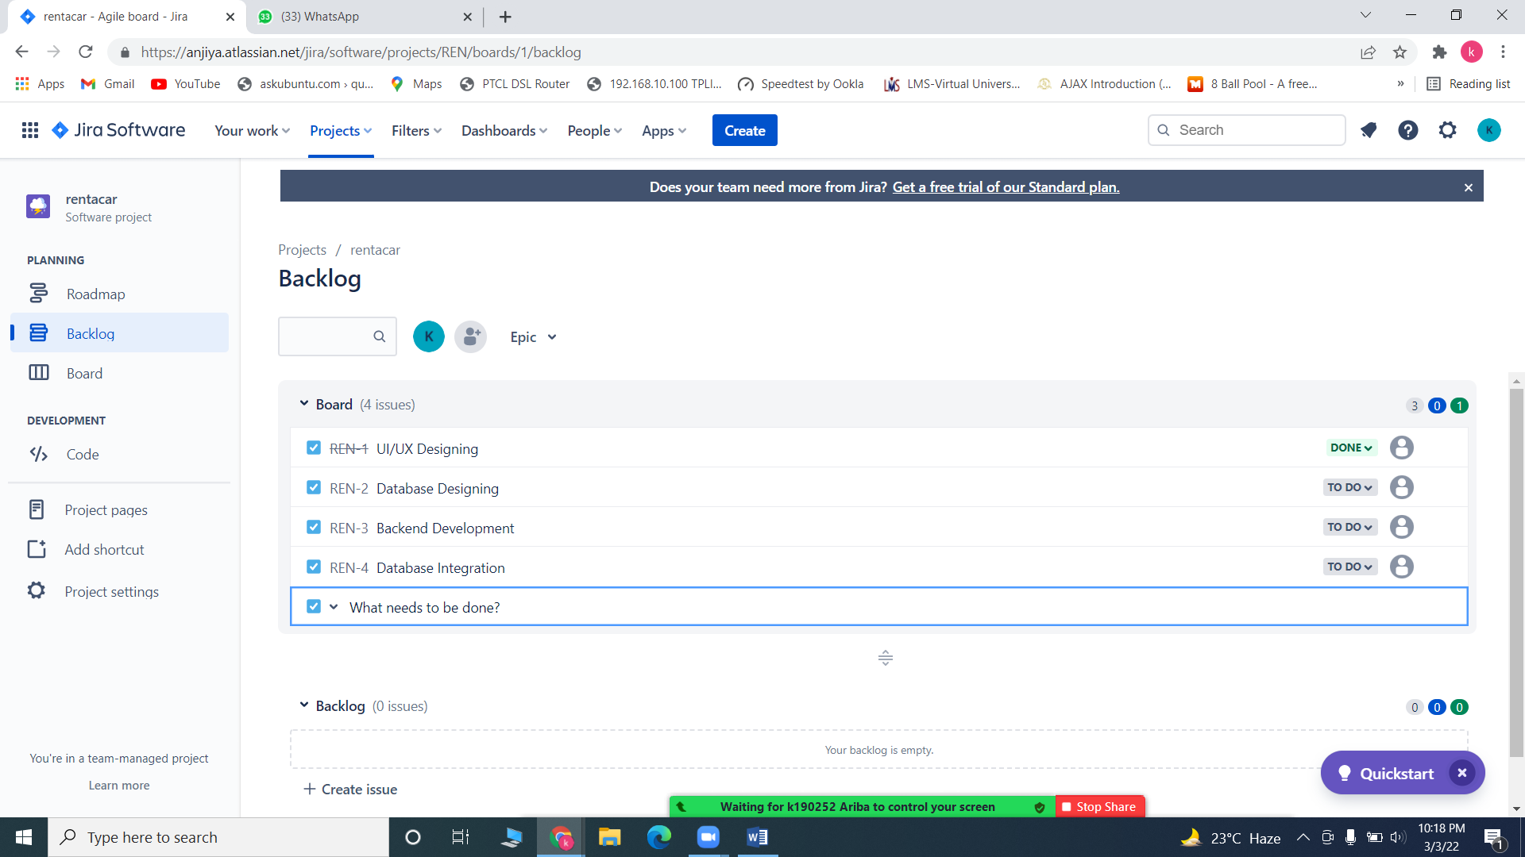

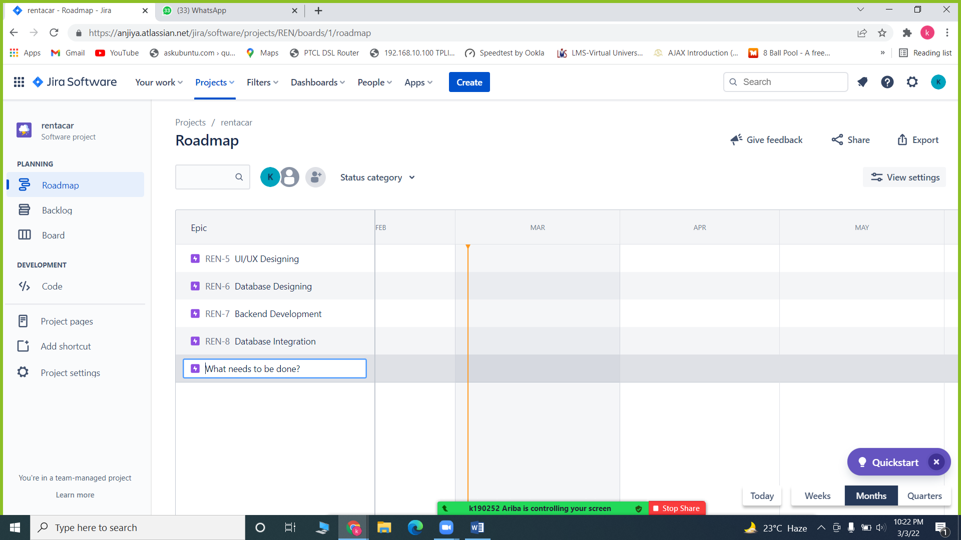

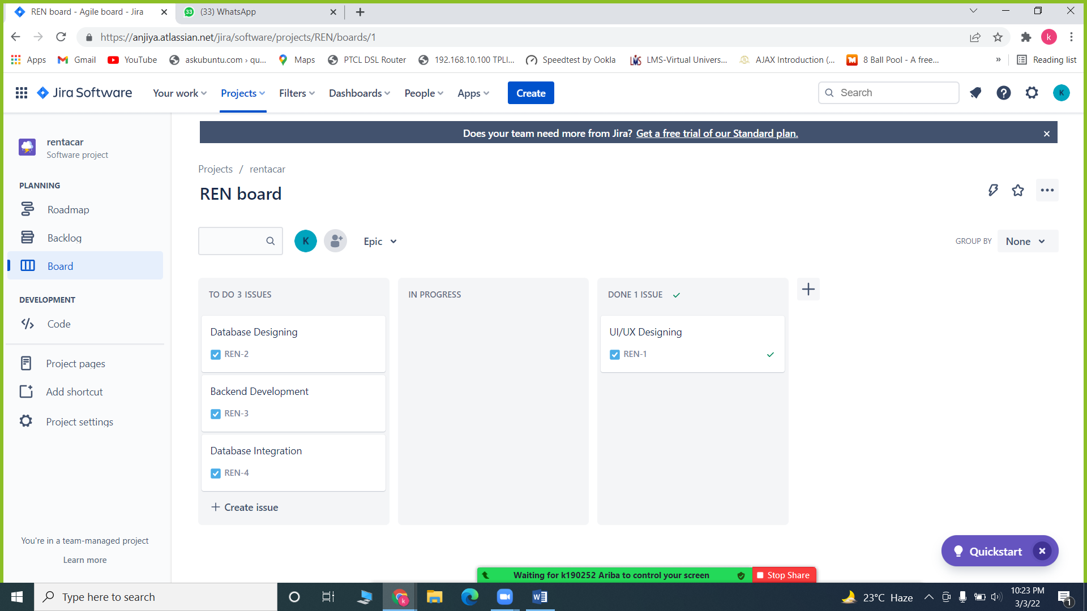

1. 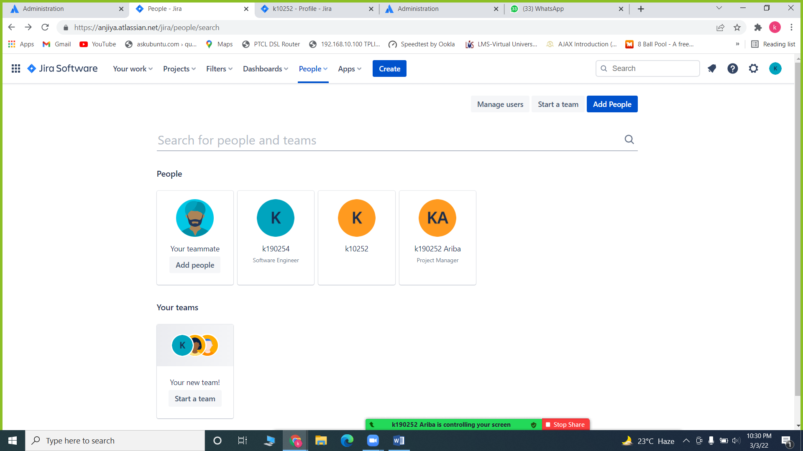**Create a Team on JIRA**