
National University of Computer and Emerging Sciences, Karachi

CS3009 Software Engineering
Assignment 01
BS(CS) – A

Group Members:
Ariba 19K-0252
Anjiya Saleem 19K-0254

Software Requirements Specification
(SRS) Document

Contents

1. Introduction 3
2. General Description 3
3. Functional Requirements 4
4. Interface Requirements 5
4.1 User Interfaces 5
4.2 Hardware Interfaces 5
4.3 Communications Interfaces 5
4.4 Software Interfaces 5
5. Performance Requirements 5
6. Other non-functional attributes 6
6.1 Security 6
6.2 Binary Compatibility 6
6.3 Reliability 6
6.4 Maintainability 6
6.5 Portability 6
6.6 Extensibility 6
6.7 Reusability 6
6.8 Application Affinity/Compatibility 7
6.9 Resource Utilization 7
6.10 Serviceability 7
7. Operational Scenarios 7
8. Preliminary Use Case Models and Sequence Diagrams 8
8.1 Use Case Model 8
8.2 Object Diagrams 9
9. Appendices 10
9.1 Definitions, Acronyms, Abbreviations 10

1. Introduction
  - Introduction
The purpose of this document is to define and describe the requirements of the project and to spell out the system’s functionality and its constraints.

  - Scope of this Document
The car owners and customers are the intended users of the system. The document provides the framework for organizing and managing resources that these resources match the project deliverables within the defined scope, time and cost constraints.

  - Overview
The product is a Node.js and React.js Web application interacting with MongoDB Database that will hold necessary information on car owners (email, name, CNIC, address, phone number), customers details, car details (model, make, year, number plate, body type etc), customer car details (return date, issue date) and car registration details.

  - Business Context
As it applies to this project, the system provides car rental services, where the car owner will lend his car and the customer will lease his car. This system will aid the person who wants to commute and is ready to make earning by lending his car; he can lend it to a person who wants to lease it. The system will work as a moderator between the customer and the car owner.

2. General Description
2.1 Product Functions
The system will keep detail records of cars, car owner, customers, duration of the rent as well as the type of the car they rent. By using this system, there will be different capabilities provided to different systems such as car owners and customers.

2.2 Similar System Information
The product utilized NoSQL database program. MongoDB Atlas is a cloud service, source-available cross-platform document-oriented database program. Not only is MongoDB easy-to-use, but it also supports excellent scaling options. Moreover, the performance capabilities of MongoDB are unbeatable compared to other databases.

2.3 User Characteristics
The users include the car owners and customer who wants to rent the car. It is important for them to know the all the features the web site provides. They should be well aware of all the important steps they have to go through like sign up and log in before utilizing the facility.

2.4 User Problem Statement
Currently, the system restricts the customer to fill the application of renting a car, a day before he wants to rent a car. The system fails to facilitate the customer who wants to rent the car on the day, he fills the application. Thus, the customers who want to rent the car must submit the application, at least a day prior to renting the car.

2.5 User Objectives
The user wants a database that will store all its credential safely. It must ensure privacy and security of user information. The program must faciliatate the speed and ease of input.

2.6 General Constraints
Constraints include an easy to use interface for the end users which will assist them in renting and registering their car details. The recommended interface is web application which is the most convenient and easy to interact with type of interface.

3. Functional Requirements
- The system will store each car owner's name, unique CNIC, email, residential address, phone number and date.
- The system will save each customer’s name, unique CNIC, email, residential address, phone number, driving license number.
- The system keeps track of Date of car issuance (when the car owner brought his car to us), Date of car return (when the car owner took back his car), and the number of days the car was rented.
- The system should provide quota to the car owner.
- The system will preserve the car owner information such as Number plate of his car, customer CNIC, Issuance Date, Return Date and the amount.
- Car owner can register as many cars as he or she wants to in the system with correct car and date details.
- Customer can rent exactly one car at a time. He must rent the car for at least 7 days.
- After the car is booked, the amount will be displayed on the screen of customer.
- When the customer selects the appropriate data, only the car available in the range must be displayed.

4. Interface Requirements
4.1 User Interfaces
- 4.1.1 GUI
The user interface for this system is the interface provided in the form of web application. The system websites includes user registration forms and car registration forms. This way the inputted information of users and car is safely stored in MongoDB database.
- 4.1.2 CLI
There is no command line interface
- 4.1.3 API
REST-APIs (get, post) were developed for rendering of pages and passing dynamic data between front-end and backend.
- 4.1.4 Diagnostics or ROM
There is no troubleshooting and help section provided. Instead, there is a FAQs section on the landing page of the website.
4.2 Hardware Interfaces
The visual studio code 2017 is managed by the operating system and it supports code completion of Node JS and React JS project.
4.3 Communications Interfaces
MongoDB Atlas backs up the data using the native snapshot capabilities of the cloud provider, and provides global cluster supporting global data distribution. The backups are stored in the same cloud region as your managed databases.
4.4 Software Interfaces
Visual Studio code 2017 is used for the development of front-end and back-end. It assists in hosting the website locally during the implementation period. Also, MongoDB Atlas, a cloud service, was used as the database which is only visible for developers.

5. Performance Requirements
Since, the system is implemented as a web application; the end user will require having a solid internet connection to utilize all the features.

6. Other non-functional attributes

6.1 Security
All the accounts and details of the car owner and customer will be protected by password. Hence, the system does not compromise on data integrity and authentication. The system shall be designed with a level of security appropriate for the sensitivity of information enclosed in the database.

6.2 Binary Compatibility
This system will be compatible with any computer since it is a web application and doesn’t rely on any particular operating system.

6.3 Reliability
Reliability is one of the key attributes of the system. The application is secured for both the end users and developers. With this, it is easy to maintain for developers.

6.4 Maintainability
The system shall be maintained by responsible developers to cope with modifying customer needs, optimize code and correcting bugs.

6.5 Portability

This software can be moved from one machine platform to another. Hence, the software can be moved from one operating system to another. Moreover, for the end user, all they need is a solid internet connection to access the website.

6.6 Extensibility

The system shall be designed and documented in such a way that anybody with the understanding of operating the user interface shall be able to utilize the system. The user interface shall fulfill the needs of the team.

6.7 Reusability

The system should be designed in a way that allows the database to be re-used regularly for the car booking and car registration. The application is easy to navigate and efficient from the users' point of view. The system has visual clarity and friendly user interface.

6.8 Application Affinity/Compatibility

This system requires the setup and configuration of Node.js, React.js and MongoDB Atlas, as it stores important information in MongoDB Atlas with the help of Node.js and React.js implementation.

6.9 Resource Utilization

The resources used in the creation of this system include: Visual Studio code 2017, MongoDB Atlas, Node.js and React.js packages and modules and most importantly, the developers.

6.10 Serviceability

The maintenance of the system should be able to be sufficiently performed by any person with a basic understanding of operating User interface of the website.

7. Operational Scenarios
Scenario A: Initial Item Definitions
The user shall enter the information about the items into the database for its initial construction and evolution. The fields will be completed via a form that will manipulate the data.

Scenario B: Car owner registers car
The car owner shall be able to enter the car details, for recording his car information. He is provided a quota considering the car body type.

Scenario C: Customer books a car
Initially, the customer shall input the car issuance and return date so that the system displays the relevant car according to his search.

8. Preliminary Use Case Models and Sequence Diagrams
This section presents a list of the fundamental sequence diagrams and use cases that satisfy the system’s requirements. The purpose is to provide an alternative, "structural" view of the requirements stated above and how they might be satisfied in the system.
8.1 Use Case Model
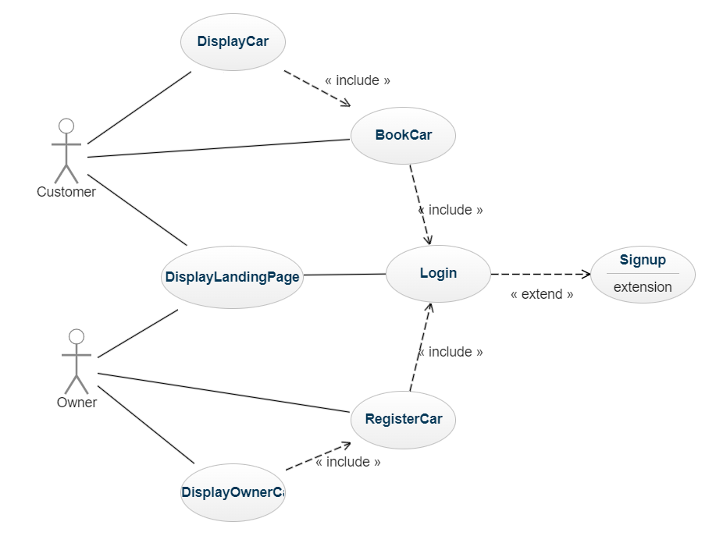

8.2 Object Diagram:
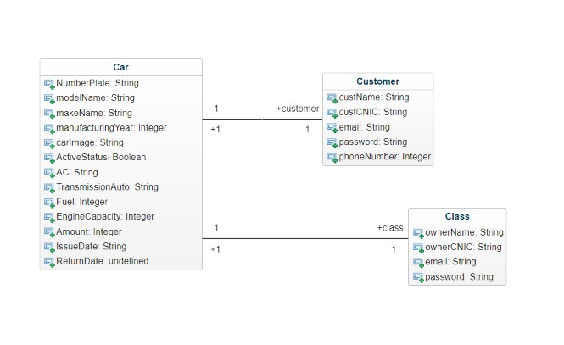

9. Appendices
11.1 Definitions, Acronyms, Abbreviations
NoSQL: Non structured query language
User Interface: Screen that is visible to end users
Front-end: Implementation of the user interface that is visible to the client or end users (React.js, a front-end javascript library)
Back-end: Implementation of logical part of the system (Node.js, a backend framework of javascript)
Visual Studio Code 2017: IDE for backend and frontend implementation

