Embedded Systems
Project Title:
4x4x4 LED Cube with esp 32
Team Members:
- Ariba Mumtaz BSCE22020

1. Introduction
This project involves the design and implementation of a 4x4x4 LED Cube, a three-dimensional grid of 64 LEDs arranged in four layers. The system is powered by an ESP32 microcontroller, using FreeRTOS for concurrent task management. It visually displays various 3D lighting animations through efficient multiplexing and frame buffering, demonstrating real-time embedded control principles.

2. Objective
- Construct a functional 4-layer × 16-column LED Cube.
- Program multiple lighting effects using FreeRTOS tasks.
- Implement multiplexing for smooth visual output.
- Explore real-time programming concepts with FreeRTOS.

3. Components Used
Component | Quantity
ESP32 DevKit v1 | 1
LEDs (single-color) | 64
NPN Transistors | 4
Power Supply (5V) | 1
Breadboard / PCB | 1
Jumper Wires | As needed

4. System Design

GPIO Configuration
- Anode (Columns): 16 GPIOs used (pins 32, 33, 25, 26, ..., 15)
- Cathode (Layers): 4 GPIOs used (pins 4, 0, 2, 15)

Multiplexing
Each frame consists of 4 layers, displayed rapidly (2ms each) one after another using FreeRTOS task displayTask. Layer switching is achieved via GPIO-driven transistors. Only one layer is active at a time, avoiding ghosting.

5. Software Implementation

Development Platform
- IDE: Arduino IDE with ESP32 Board Package
- Language: C/C++
- Libraries Used: Arduino.h, FreeRTOS.h (included by default on ESP32)
CODE
// === LED Cube GPIO Configuration ===
// Column GPIOs (Anode side)
const int columnPins[16] = {
32, 33, 25, 26, 27, 14, 12, 13,
23, 22, 21, 19, 18, 5, 17, 15
};

// Layer GPIOs (Cathode side)
const int layerPins[4] = {4, 0, 2, 15};

// Frame buffer
bool frameBuffer[16][4] = {false};

// === FreeRTOS Task Handles ===
TaskHandle_t displayTaskHandle;
TaskHandle_t patternTaskHandle;

void setup() {
Serial.begin(115200);

for (int i = 0; i < 16; i++) {
pinMode(columnPins[i], OUTPUT);
digitalWrite(columnPins[i], HIGH); // Anode OFF
}

for (int i = 0; i < 4; i++) {
pinMode(layerPins[i], OUTPUT);
digitalWrite(layerPins[i], HIGH); // Cathode OFF
}

// Start FreeRTOS Tasks
xTaskCreatePinnedToCore(displayTask, "DisplayTask", 2048, NULL, 2, &displayTaskHandle, 0);
xTaskCreatePinnedToCore(patternTask, "PatternTask", 4096, NULL, 1, &patternTaskHandle, 1);
}

// === Frame Display Task ===
void displayTask(void *pvParameters) {
while (true) {
for (int l = 0; l < 4; l++) {
// Turn off all layers
for (int i = 0; i < 4; i++) {
digitalWrite(layerPins[i], HIGH);
}

// Set columns for this layer
for (int c = 0; c < 16; c++) {
digitalWrite(columnPins[c], frameBuffer[c][l] ? LOW : HIGH);
}

// Turn on current layer
digitalWrite(layerPins[l], LOW);
delay(2);
}
}
}

// === Utility Functions ===
void clearFrame() {
for (int c = 0; c < 16; c++) {
for (int l = 0; l < 4; l++) {
frameBuffer[c][l] = false;
}
}
}

// === Effects ===
void raindropEffect() {
clearFrame();
for (int drop = 0; drop < 10; drop++) {
int column = random(16);
for (int layer = 0; layer < 4; layer++) {
frameBuffer[column][layer] = true;
delay(60);
frameBuffer[column][layer] = false;
}
}
}

void spiralEffect() {
clearFrame();
int spiral[16][2] = {
{0,0},{1,0},{2,0},{3,0},
{3,1},{3,2},{3,3},
{2,3},{1,3},{0,3},
{0,2},{0,1},
{1,1},{2,1},{2,2},{1,2}
};

for (int step = 0; step < 16; step++) {
clearFrame();
for (int i = 0; i <= step; i++) {
int col = spiral[i][0] * 4 + spiral[i][1];
frameBuffer[col][0] = true;
}
delay(100);
}
}

void layerWave() {
for (int cycles = 0; cycles < 3; cycles++) {
for (int l = 0; l < 4; l++) {
clearFrame();
for (int c = 0; c < 16; c++) frameBuffer[c][l] = true;
delay(150);
}
for (int l = 3; l >= 0; l--) {
clearFrame();
for (int c = 0; c < 16; c++) frameBuffer[c][l] = true;
delay(150);
}
}
}

void randomSparkle() {
for (int i = 0; i < 50; i++) {
clearFrame();
for (int j = 0; j < 5; j++) {
int col = random(16);
int layer = random(4);
frameBuffer[col][layer] = true;
}
delay(60);
}
}

void cubeOutline() {
clearFrame();
for (int x = 0; x < 4; x++) {
frameBuffer[x*4 + 0][0] = true;
frameBuffer[x*4 + 3][0] = true;
frameBuffer[0*4 + x][0] = true;
frameBuffer[3*4 + x][0] = true;

frameBuffer[x*4 + 0][3] = true;
frameBuffer[x*4 + 3][3] = true;
frameBuffer[0*4 + x][3] = true;
frameBuffer[3*4 + x][3] = true;
}

for (int l = 0; l < 4; l++) {
frameBuffer[0*4 + 0][l] = true;
frameBuffer[0*4 + 3][l] = true;
frameBuffer[3*4 + 0][l] = true;
frameBuffer[3*4 + 3][l] = true;
}

delay(1200);
}

void diagonalWipe() {
clearFrame();
for (int diag = 0; diag < 7; diag++) {
clearFrame();
for (int x = 0; x < 4; x++) {
for (int y = 0; y < 4; y++) {
if (x + y == diag) {
for (int z = 0; z < 4; z++) {
frameBuffer[x * 4 + y][z] = true;
}
}
}
}
delay(100);
}
}

// === Animation Manager (RTOS Task) ===
void loopEffect(void (*effect)(), int repeats) {
for (int i = 0; i < repeats; i++) {
effect();
}
}

const int numEffects = 6;
int currentEffect = 0;

void patternTask(void *pvParameters) {
while (true) {
switch (currentEffect) {
case 0: loopEffect(raindropEffect, 6); break;
case 1: loopEffect(spiralEffect, 3); break;
case 2: loopEffect(layerWave, 3); break;
case 3: loopEffect(randomSparkle, 3); break;
case 4: loopEffect(cubeOutline, 3); break;
case 5: loopEffect(diagonalWipe, 3); break;
}
currentEffect = (currentEffect + 1) % numEffects;
}
}

// Add this mandatory Arduino loop function, even if empty
void loop() {
// Intentionally empty because FreeRTOS tasks are running the logic
}

Circuit Design
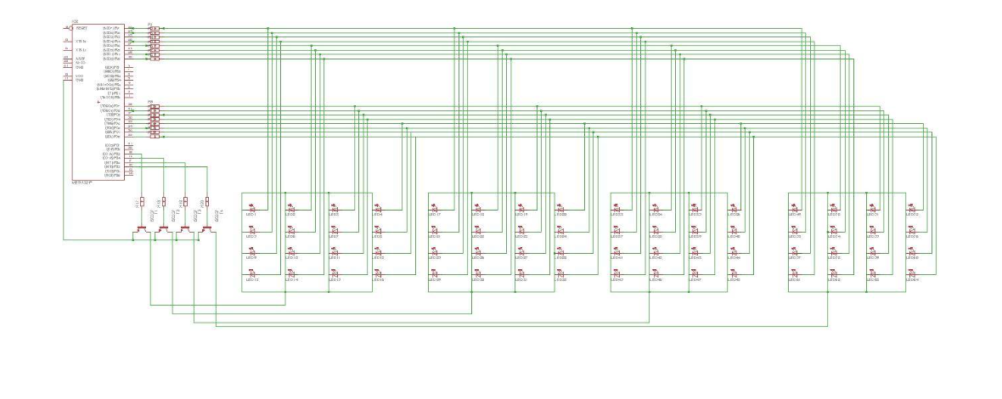

FreeRTOS Task Breakdown
Task Name | Core | Priority | Purpose
displayTask | Core 0 | 2 | Continuously refresh display
patternTask | Core 1 | 1 | Control animation sequence logic

Frame Buffer
- First dimension: columns (0–15)
- Second dimension: layers (0–3)

Implemented Lighting Effects
Effect Name | Description
raindropEffect() | Drops light from top to bottom randomly
spiralEffect() | Spirals the bottom layer’s LEDs
layerWave() | Lights each layer up and down in sequence
randomSparkle() | Random twinkling of LEDs
cubeOutline() | Highlights the outer frame of the cube
diagonalWipe() | Diagonal LED activation by sum of coordinates

6. Challenges and Solutions
Challenge |  | Solution
High flicker / ghosting |  | Used fast switching and delay management
Pin limitations |  | Optimized GPIO usage with static mapping
Precise timing |  | Used FreeRTOS for multitasking and accurate control
LED brightness inconsistency |  | Limited ON-time per layer to avoid overcurrent

7. Results and Observations
- Successfully demonstrated six effects with smooth animation.
- Real-time switching handled without flicker or visible delay.
- FreeRTOS enabled smooth multitasking between display and animation.
- Stable performance on 5V USB power.

8. Learning Outcomes
- Practical implementation of LED multiplexing.
- Hands-on experience with ESP32 and FreeRTOS.
- Understood how to manage concurrent tasks and core pinning.
- Improved skills in embedded C/C++, debugging, and real-time design.

9. Conclusion
The 4x4x4 LED Cube using ESP32 and FreeRTOS was a successful embedded system prototype. It displayed complex lighting patterns, used real-time task scheduling, and offered expandability. The project not only fulfilled academic objectives but also opened doors for future development in interactive lighting systems and IoT integration.

