Esri Professional Services, March 2025
Pinellas County SDE to agol sync Documentation

Contents
SDE to AGOL 1
Overview 1
Configuration 1
Scripts 2
Publishing 2
egdbToFGDB 3
OverwriteFS 3
Status Dashboard 3
Windows Task Scheduler 4

SDE to AGOL

Overview
The SDE to AGOL process is a series of scripts written in Python that oversee the periodic syncing of data between the EGIS SQL Server database and ArcGIS Online (AGOL). A configuration .csv is used to arrange layers into services and set the update interval. To avoid layer downtime and provide redundancy, a modified version of the OverwriteFS library is used to orchestrate a “layer swap”. Finally, a status dashboard was created so that the process can be monitored.

Configuration
There are two main configuration files for the process – a .json file for defining environment parameters and a .csv file with the master layer list determining service creation. The following is a template of the .json file and a description of its contents.
{
"agol":{
"dashboardTableItemId": "<item id for the hosted status table>",
"dashboardTableLayerIndex": "<layer index for the hosted status table>",
"profile": "<persistent AGOL profile used to authenticate>",
},
"layersSpreadsheet": "<path to layers config csv file>",
"fgdbOutputDirectoryName": "<name of output workspace where fgdbs are exported>",
"swapZipBackupDirectory": "<path to zip backup directory for swap process>",
"overwriteFSDirectory": "<path to OverwriteFS library>",
"sdeWorkspace": "<path to EGIS .sde file>"
}
The layer spreadsheet details how layers should be grouped into services, how often they should be swapped, and contains AGOL IDs for the view and services items. It was created using a one-time run of the egdbToConfig custom script (provided in the deployment directory). A list of “top-level” layers were passed in, and their relationship trees were traversed to create service groupings. These can be rearranged to fit business needs. A snapshot of the spreadsheet is provided below:

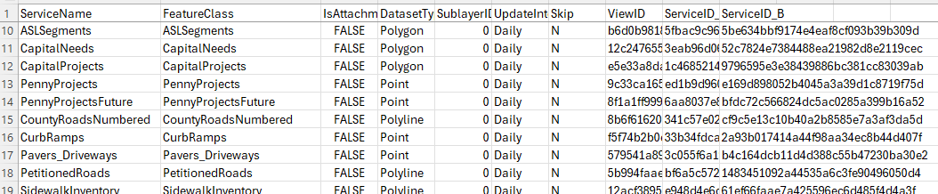

Scripts
An ArcGIS Conda Python environment was cloned to the deployment directory. This was done using ArcGIS Pro on the deployment machine. The scripts run off this environment with no additional libraries necessary.
The swap process is initiated by the main.py script. It accepts 4 flags as listed below:
- –c “path-to-json-config” (Required)
- –w “name-of-fgdb-workspace” (Required)
- –i “update-interval” (Required)
- –p
The -c flag must be followed by the full path to the config file. The -w flag specifies the directory name for where the script will create fgdbs. It’s important that all the scheduled tasks use different directory names in case they happen to run at the same time (avoid interference). The -i flag should be followed by the update interval being run – the options are “Nightly”, “Weekly”, “Monthly”, “Yearly”, and “On Demand”. See the following section for a description of the –p flag

Publishing
The -p is optional and takes no arguments. If included, it will publish new A, B, and view copies for all services in the layers csv file. A recommended workflow would be to create a second layer csv with the new services, edit the config to point to the new csv, and run the script with the -p flag. If run in the terminal, it will print out a comma separated list of the new IDs to be pasted in the production layers csv – when copying those over, use the text import wizard and select commas as your delimiter. You can also manually publish A, B, and view copies, and then add the new rows (with IDs) to the config.

egdbToFGDB
egdbToFGDB.py is class consumed by main.py to construct file geodatabases. Editor tracking in each FGDB is disabled and the editor tracking fields are renamed. The LENGTH and AREA geometry fields are also copied over to persist the data in a state plane spatial reference after publishing. The following renaming scheme is used:
- int_created_user -> Internal Created User (renamed)
- int_created_date -> Internal Created Date (renamed)
- int_edited_user -> Internal Edited User (renamed)
- int_edited_date -> Internal Edited Date (renamed)
- SHAPE_Length -> StatePlane_Length (copied)
- SHAPE_Area -> StatePlane_Area (copied)

OverwriteFS
A modified version of the OverwriteFS library was developed for this project (branched off of v2.1.4) that supports layer swaps with multi-layer services. Using this version, a service that has multiple tables and/or layers can participate in a view swap. When calling swapFeatureViewLayers, noProps=True should be set - this makes sure the view’s layers are mirrored from the target service.

Status Dashboard
To assist with monitoring the process, data is collected throughout and reported back in an ArcGIS Dashboard. Examples of data collected include swap status, time taken to perform the swap, and log messages upon failure. The dashboard can be used to see recent errors, keep track of significant changes in swap time, and view other metrics related to the process.
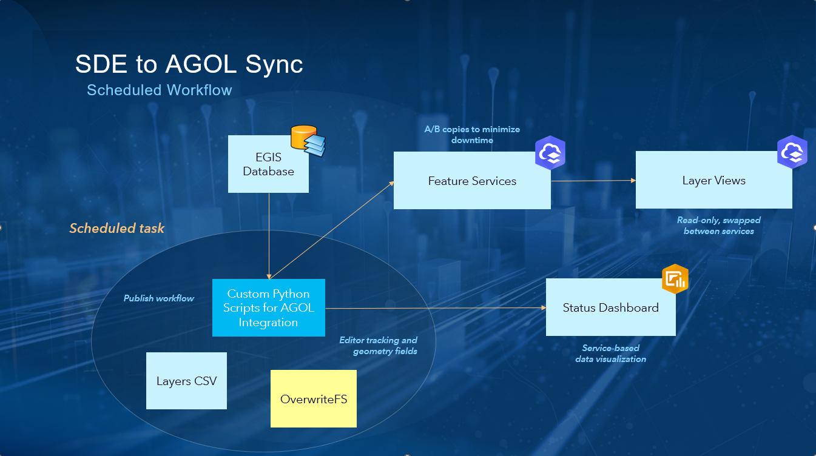

Windows Task Scheduler
There are 5 tasks set up in the Task Scheduler – each for a different update interval. The nightly, weekly, monthly, and yearly tasks are scheduled on their respective intervals. “On Demand” is not scheduled but can be run at any time. They all point to the same script but pass in different values for the interval command line argument and fgdb workspace.

