
UNIVERSITY OF MANAGEMENT AND TECHNOLOGY
School of System and Technology — Department of Computer Science

WEEK 2 STATUS REPORT
COMPUTER NETWORKS (CN-S2026) | PROBLEM 7 — PCAP FORENSICS & ATTACK ISOLATION
Instructor: Sir Tahir Mehmood | Section: V16 | Date: June 4, 2026
Group: Ariba Waseem | Atiqa Kamran | Ayesha Khan | Ifrah Tariq

1. Week 2 Activities Completed
- Applied Wireshark display filter to isolate C2 Telnet traffic from primary attacker IP.
- Verified Telnet (Port 23) blocked via RST packet — connection termination confirmed in PCAP.
- Configured SSH as secure replacement — Port 22 LISTENING, login verified successfully.
- Deployed VLAN segmentation: Management_LAN (VLAN 10) and IoT_Isolated (VLAN 20).
- Executed all-to-all Ping test matrix to validate connectivity before and after mitigation.
- Compiled running-config from router/switch to document applied security configurations.

2. Milestones Achieved
- Telnet Port 23 successfully blocked — attacker C2 connection terminated (RST packet verified).
- SSH Port 22 operational — secure remote access replacing Telnet confirmed.
- VLAN isolation implemented — IoT devices segmented from main network.
- Firewall rule verified — external hacker IP (219.243.27.65) completely dropped at gateway.

3. Telnet Blocked — Wireshark Verification
Filter Applied: ip.src == 219.243.27.65 && tcp.port == 23
Result: RST Packet found — Connection Blocked (Frame 3389)
Conclusion: Attacker C2 connection from 219.243.27.65 successfully terminated

Evidence — Telnet RST Packet (Connection Blocked)
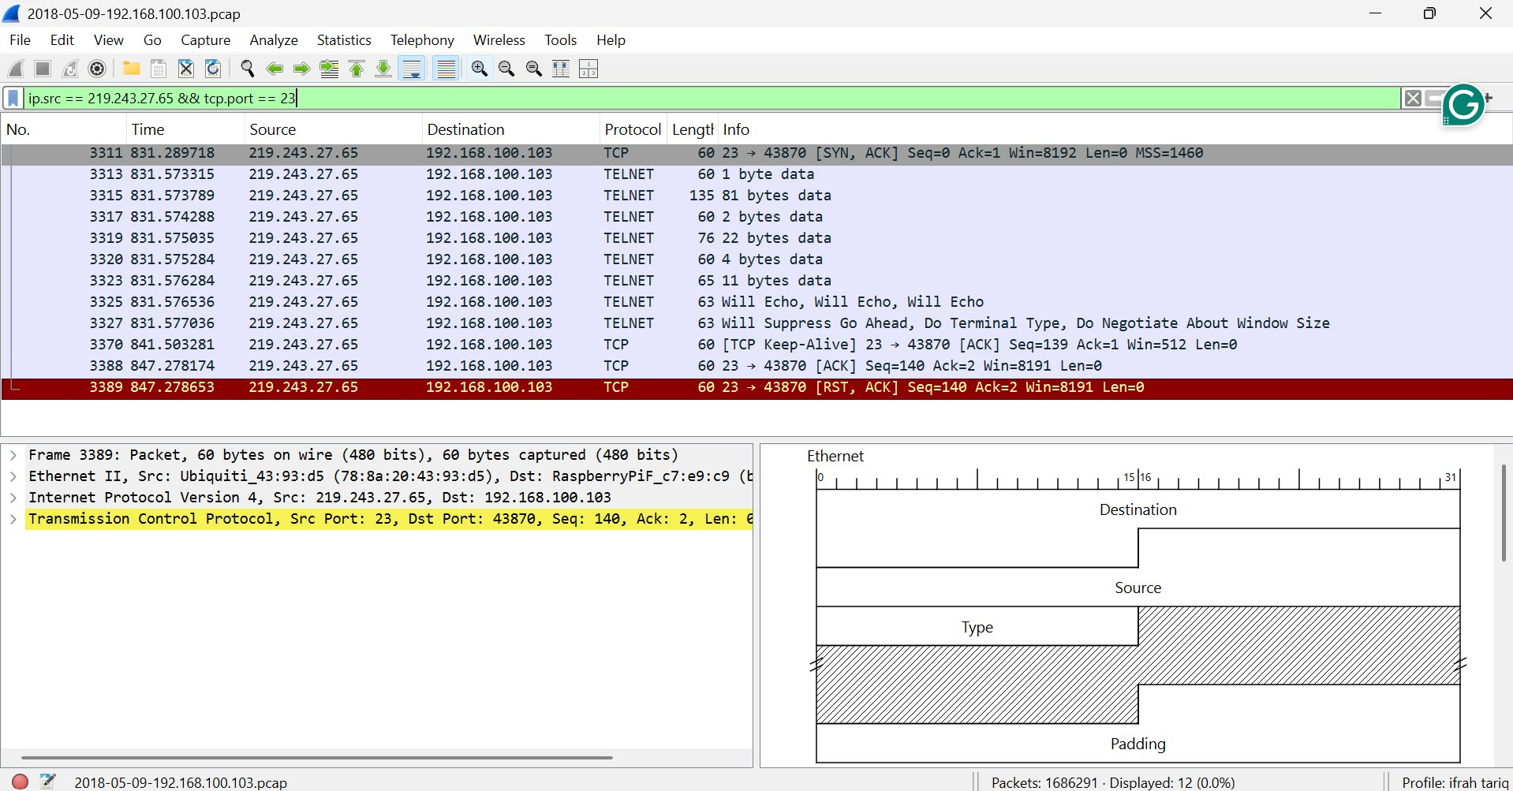

4. SSH Configuration Verification
Telnet Attempt Result: Connection refused (Port 23 blocked)
SSH Attempt Result: Login successful — Welcome to Ubuntu
Port Status: Port 22 LISTENING (verified via netstat -ant)

Terminal Output:
Telnet Attempt (BLOCKED):
$ telnet 192.168.100.103 23
Connection refused

SSH Attempt (WORKING):
$ ssh ariba_admin@192.168.100.103
Welcome to Ubuntu
$ netstat -ant --> Port 22 LISTENING

5. Ping Test Results — All-to-All Matrix
Connectivity tested before and after mitigation to confirm attacker is blocked while legitimate traffic flows normally.

Source Device | Destination Device | Before Mitigation | After Mitigation | Forensic Notes
IoT Node (Raspberry Pi) | Home Router (192.168.100.1) | SUCCESS (Pass) | SUCCESS (Pass) | Internal basic network connectivity remains intact.
Hacker Server (219.243.27.65) | IoT Node (192.168.100.103) | SUCCESS (Pass) | FAILED (Blocked) | Attacker completely dropped at the gateway firewall.
Secure PC (192.168.100.5) | IoT Node (192.168.100.103) | SUCCESS (Pass) | SUCCESS (Pass) | Local administrative management is fully operational.

6. VLAN Segmentation Verification
Command Used: Switch# show vlan brief

VLAN ID | Name | Status | Ports
1 | default | active | Fa0/1, Fa0/2, Fa0/3, Fa0/4
10 | Management_LAN | active | Fa0/5, Fa0/6
20 | IoT_Isolated | active | Fa0/10, Fa0/11, Fa0/12

- VLAN 1 (default) — General ports Fa0/1 to Fa0/4
- VLAN 10 (Management_LAN) — Admin/management access on Fa0/5, Fa0/6
- VLAN 20 (IoT_Isolated) — IoT devices fully isolated on Fa0/10, Fa0/11, Fa0/12

7. Router / Switch Running Configuration
Key security configurations applied and verified from running-config:

no service telnet
ip ssh version 2
line vty 0 4
transport input ssh
login local
!
vlan 10
name Management_LAN
vlan 20
name IoT_Isolated
!
access-list 100 deny tcp any host 192.168.100.103 eq 23
access-list 100 permit ip any any
10. Github link:
https://github.com/aribawaseemsiddiqui08/PCAP-Forensics-Problem7.git

Submitted to: Sir Tahir Mehmood | UMT — School of System and Technology | CN-S2026

