
COMPLEX COMPUTING PROBLEM (CCP) REPORT
COURSE: COMPUTER NETWORKS (CN-S2026)
INSTRUCTOR: SIR TAHIRR MEHMOOD
PROJECT TITLE: PROBLEM 7 - PCAP FORENSICS & ATTACK ISOLATION
WEEK 2:
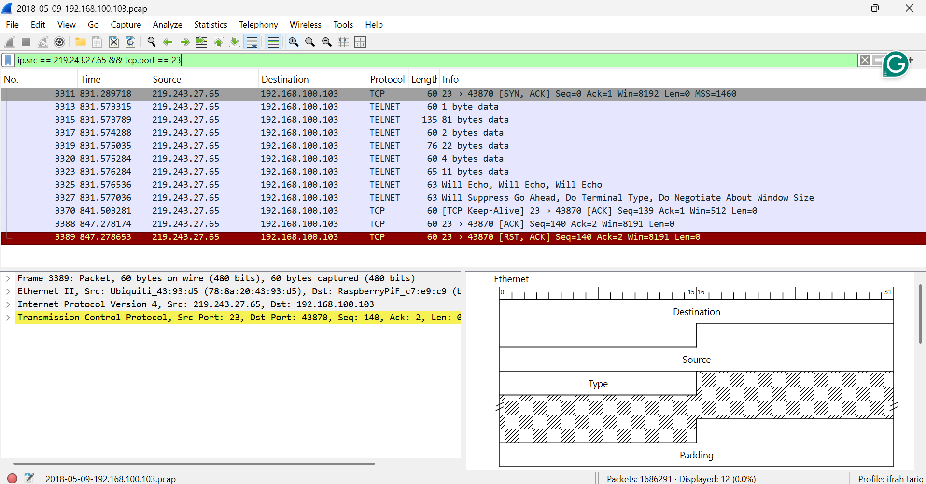
Filter used: ip.src == 219.243.27.65 && tcp.port == 23
Result: RST packet found - Connection blocked
SSH LOGIN PROOF

Telnet Attempt (BLOCKED):
$ telnet 192.168.100.103 23
Connection refused

SSH Attempt (WORKING):
$ ssh ariba_admin@192.168.100.103
Welcome to Ubuntu
$ netstat -ant
Port 22 LISTENING

CONCLUSION: Telnet blocked, SSH working.

