
UNIVERSITY OF MANAGEMENT AND TECHNOLOGY
School of System and Technology — Department of Computer Science

COMPLEX COMPUTING PROBLEM (CCP) REPORT
COMPUTER NETWORKS (CN-S2026)
PROBLEM 7 — PCAP FORENSICS & ATTACK ISOLATION

Instructor: Sir Tahir Mehmood | Section: V16 | Date: June 4, 2026

GROUP MEMBERS
Ariba Waseem (F2024266905) — Git & Deployment Lead
Atiqa Kamran (F2024266914) — Technical & Topology Specialist
Ayesha Khan (F2024266918) — Documentation Specialist
Ifrah Tariq (F2024266939) — Risk & Resource Analyst

1. Executive Summary
This forensic report details the investigation into a homeowner's smart IoT devices that exhibited erratic network behavior. A PCAP file was analyzed using Wireshark to determine the root cause, map indicators of compromise (IOCs), recover plaintext attack vectors, and construct a chronological incident timeline. The analysis successfully identified an automated external brute-force attack originating from an active botnet node.
2. Device Identification & Initial Observation
Initial scrutiny of the unfiltered network capture reveals a single internal node actively flooding the network with rapid, high-volume outbound synchronization packets targeting TCP Port 23 (Telnet) — a textbook Mirai botnet indicator.

Compromised Device IP: 192.168.100.103
Compromised Device MAC: b8:27:eb:c7:e9:c9
Device Type: Raspberry Pi — Homeowner's Smart IoT Node

Evidence 1 — Compromised Device MAC Address
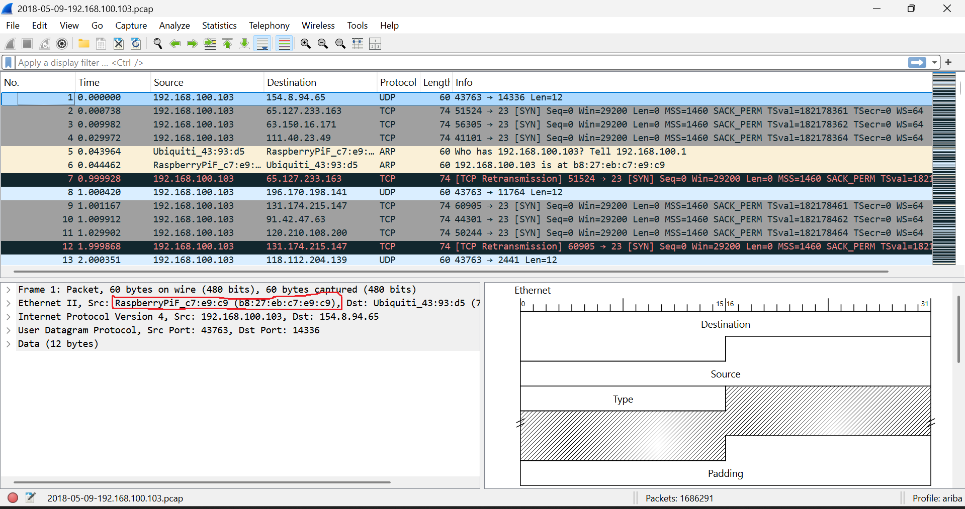

3. Security Investigation & Attack Analysis
A Telnet display filter was applied in Wireshark to isolate the direct interactive paths of threat actors and suppress background protocol noise.

Attack Vector: Telnet Protocol (TCP Port 23)
Primary C2 Server IP: 219.243.27.65
Secondary Threat IP: 71.181.6.40
The external IP 219.243.27.65 acts as the primary orchestrator pushing inbound payloads into the Raspberry Pi. IP 71.181.6.40 appears in concurrent unencrypted paths, signaling a distributed multi-tiered malicious server pattern.

Evidence 2 — C2 Server IP (Telnet Filter Applied)
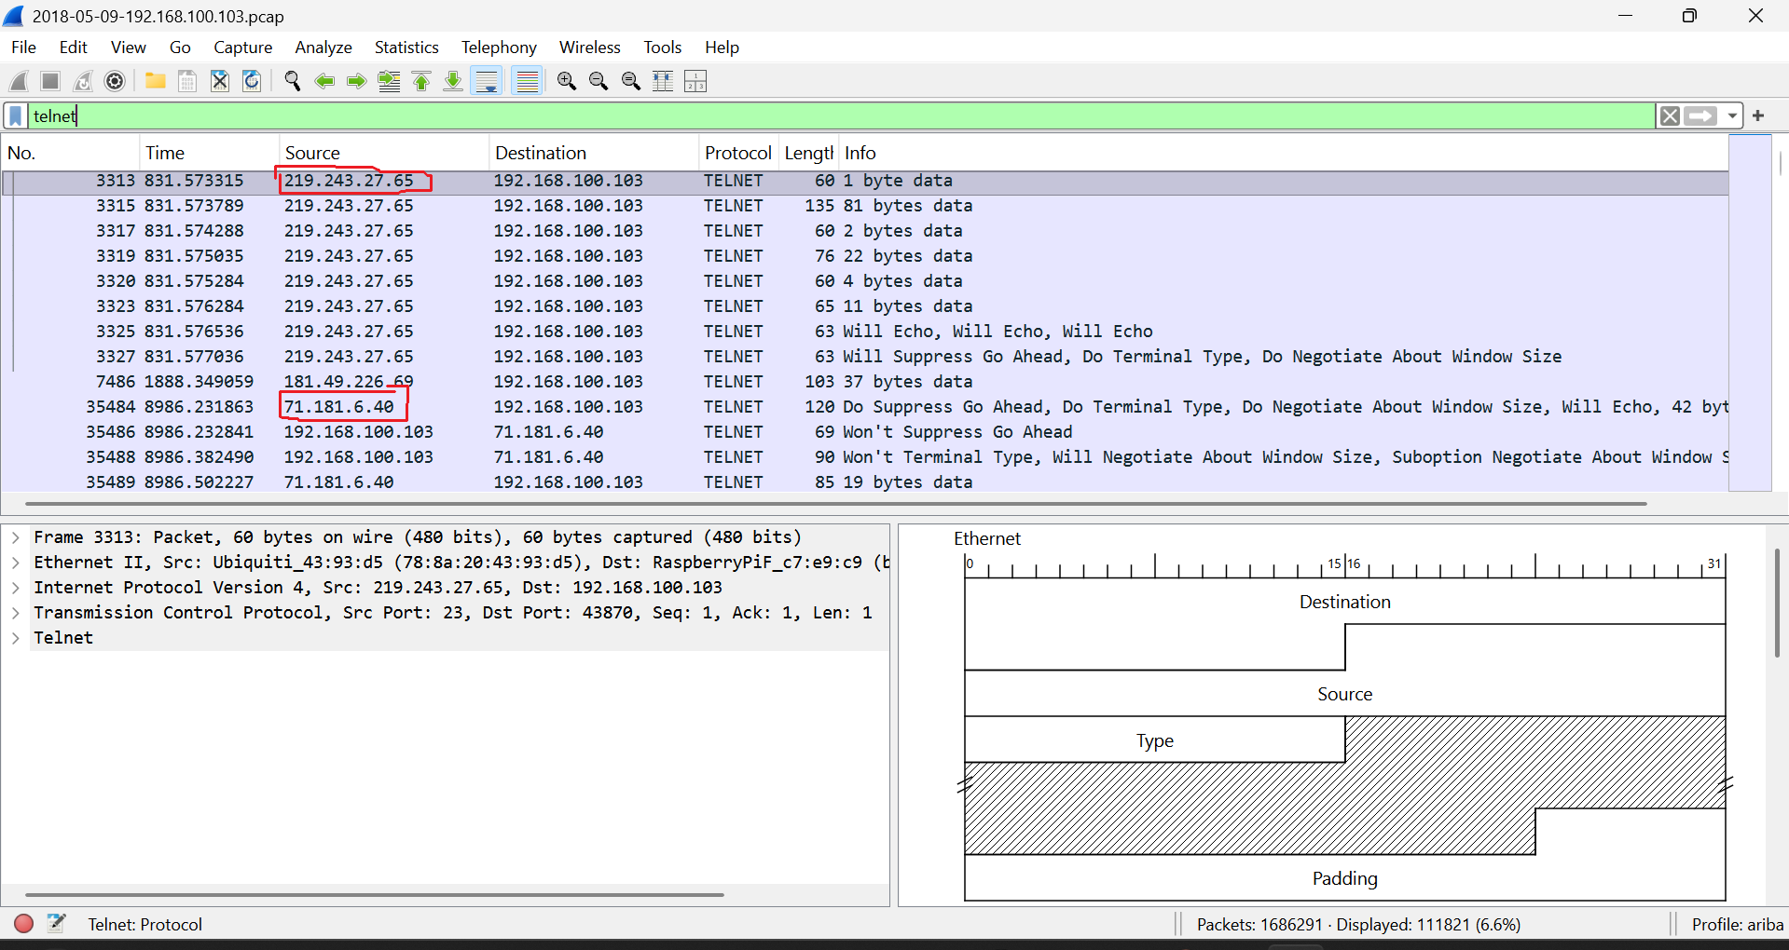

4. Credential Recovery Analysis
Because Telnet transfers data completely unencrypted, Wireshark's TCP Stream feature (Stream 5119) was used to extract the interactive terminal session, exposing the attacker's dictionary attempts.

Attempt 1: Username: root | Password: 123456 | Result: Bad username/Password
Attempt 2: Username: enable | Password: system | Result: Bad username/Password
Attempt 3: Username: shell | Password: sh | Result: Bad username/Password

Forensic Conclusion: All brute-force attempts failed. However, thousands of concurrent streams confirm the network remained under severe dictionary testing.

Evidence 3 — Brute Force Credential Attempts (TCP Stream 5119)
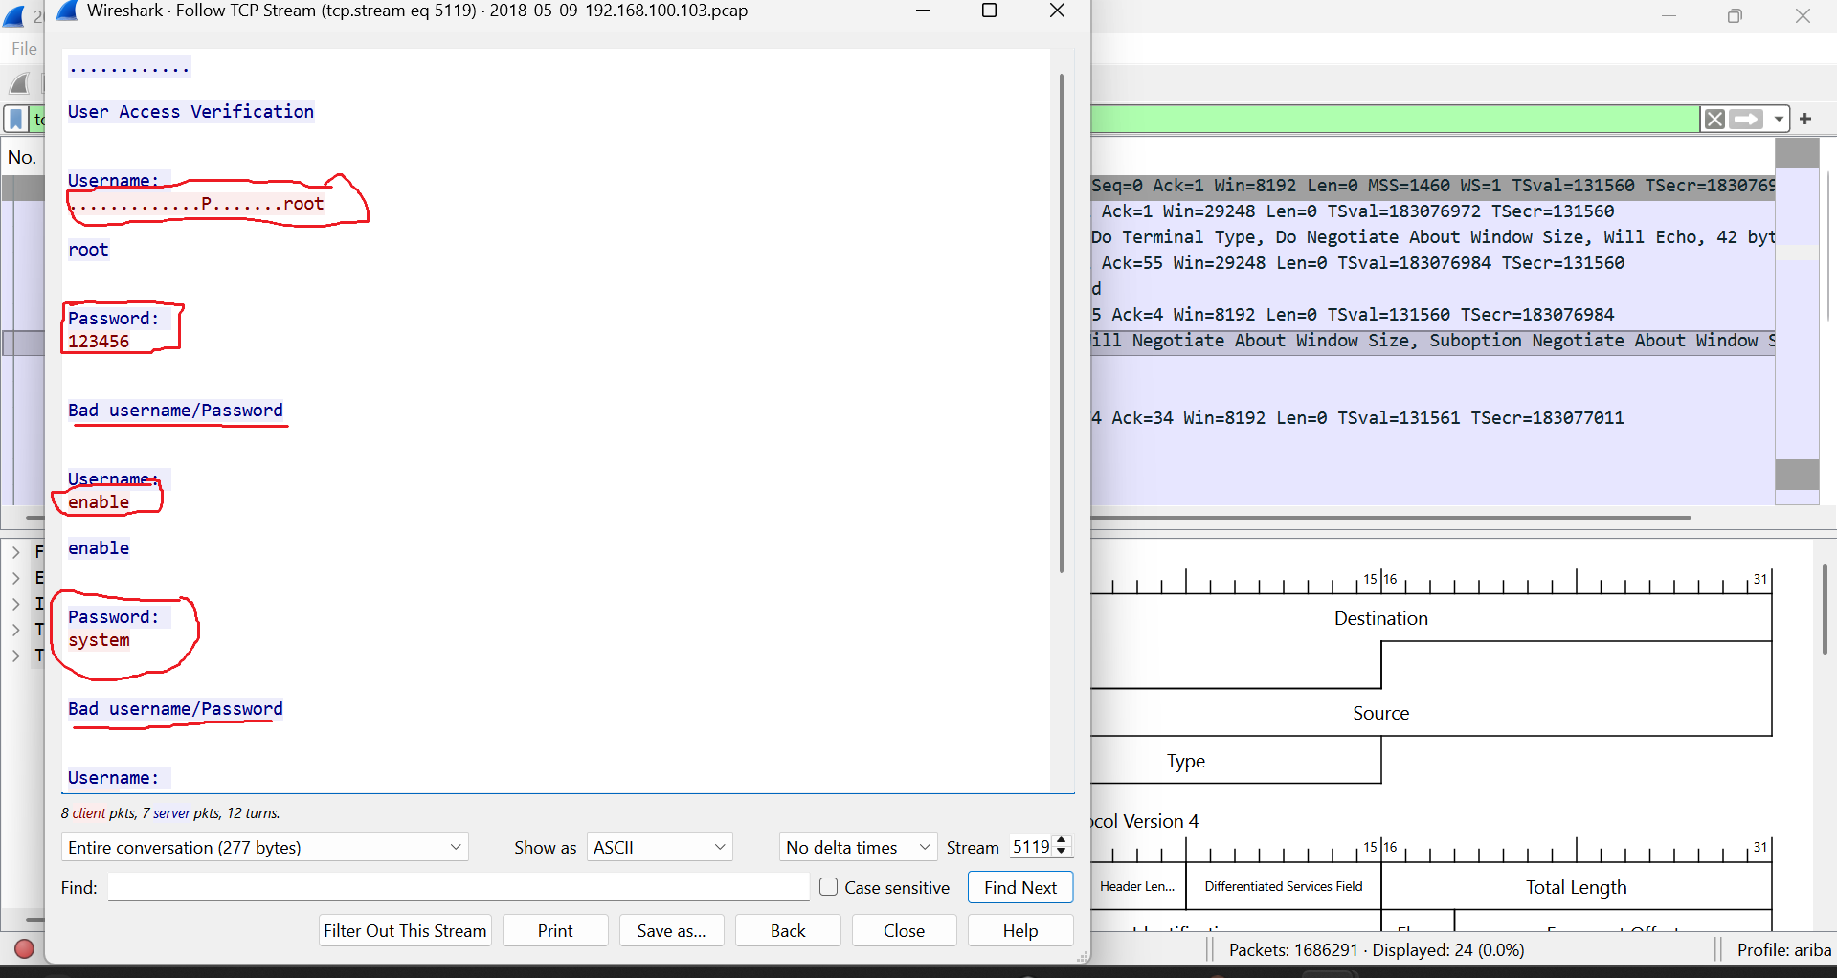

5. Artifact Tables & System Data
Table 1: Indicators of Compromise (IOC)
Indicator Type | Value | Context / Description
Infected Device IP | 192.168.100.103 | Victim smart IoT device (Raspberry Pi) generating malicious outbound traffic.
Infected Device MAC | b8:27:eb:c7:e9:c9 | Physical hardware address of the compromised Raspberry Pi.
Primary C2 Server IP | 219.243.27.65 | Active external C2 node interacting with the victim via Telnet.
Secondary Threat IP | 71.181.6.40 | Additional external host in concurrent unencrypted communication paths.
Target Protocol/Port | TCP Port 23 (Telnet) | Unsecured vector exploited for password dictionary attacks.

Table 2: Incident Timeline
Timestamp (s) | Source IP | Destination IP | Event Description
0.000000 | 192.168.100.103 | 154.8.9.65 | Initial outbound UDP connection attempt, signaling start of capture.
0.000738 | 192.168.100.103 | 65.127.233.163 | Victim initiates rapid [SYN] scanning on Port 23 (Telnet), confirming infection.
0.044462 | 192.168.100.103 | Local Network | ARP broadcast linking IP to Raspberry Pi hardware MAC address.
831.573315 | 219.243.27.65 | 192.168.100.103 | C2 Server establishes inbound Telnet stream (Stream 5119), triggering auth prompt.
831.574288 | 219.243.27.65 | 192.168.100.103 | Attacker executes automated dictionary-based brute-force password attempts.
831.575035 | 192.168.100.103 | 219.243.27.65 | Device responds with Bad username/Password, failing the login session.

Table 3: IP Addressing Plan
Device Name | IP Address | MAC Address | Subnet Mask | Gateway | Role
Home Router | 192.168.100.1 | 78:8a:20:43:93:d5 | 255.255.255.0 | 0.0.0.0 | Default Gateway / Wireless AP
Smart IoT Node | 192.168.100.103 | b8:27:eb:c7:e9:c9 | 255.255.255.0 | 192.168.100.1 | Victim Raspberry Pi — Botnet Traffic
Primary C2 Server | 219.243.27.65 | N/A (External) | N/A (WAN) | N/A | Telnet brute-force C2
Secondary Threat | 71.181.6.40 | N/A (External) | N/A (WAN) | N/A | Secondary attack source

6. Root Cause & Architectural Mitigation
The root cause is deployment of an IoT device running unencrypted Telnet (TCP Port 23) without any firewall protection or access control.
- Disable Telnet service (TCP Port 23) on all IoT devices immediately.
- Enforce SSH key-based authentication with complex, non-default passwords.
- Isolate all smart devices within a dedicated, restricted Guest VLAN.

7. Resource Acquisition Report
- Wireshark Version 4.0+ — Network protocol analyzer for PCAP examination. Source: wireshark.org
- PCAP Evidence File (2018-05-09-192.168.100.103.pcap) — Captured network traffic from compromised IoT environment. Provided as part of Problem 7 assignment.
- Hardware/Environment — Windows/Linux workstation for running Wireshark analysis.

8. Risk Assessment Matrix
ID | Risk Description | Likelihood | Impact | Risk Level | Mitigation Strategy
R-001 | Cleartext Telnet Management (Port 23 Enabled) | High | Critical | HIGH | Disable Telnet immediately; enforce SSH key-based authentication.
R-002 | Weak/Default Device Password Storage | High | High | HIGH | Replace all default credentials with complex alphanumeric passwords.
R-003 | Unsegmented IoT Deployment | Medium | High | MED-HIGH | Segment smart nodes within a restricted Guest VLAN.

9. Network Topology
The logical topology below illustrates the attack path from external threat actors through the internet and Wi-Fi router to the compromised Raspberry Pi IoT node.

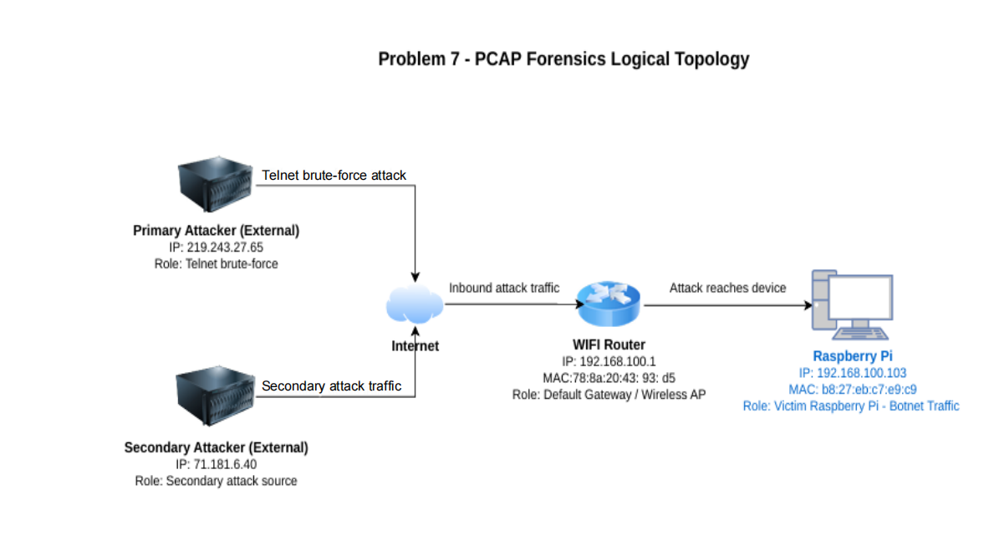
Submitted to: Sir Tahir Mehmood | UMT — School of System and Technology | Computer Networks CN-S2026

