The screenshot for the SMS sent is given below:

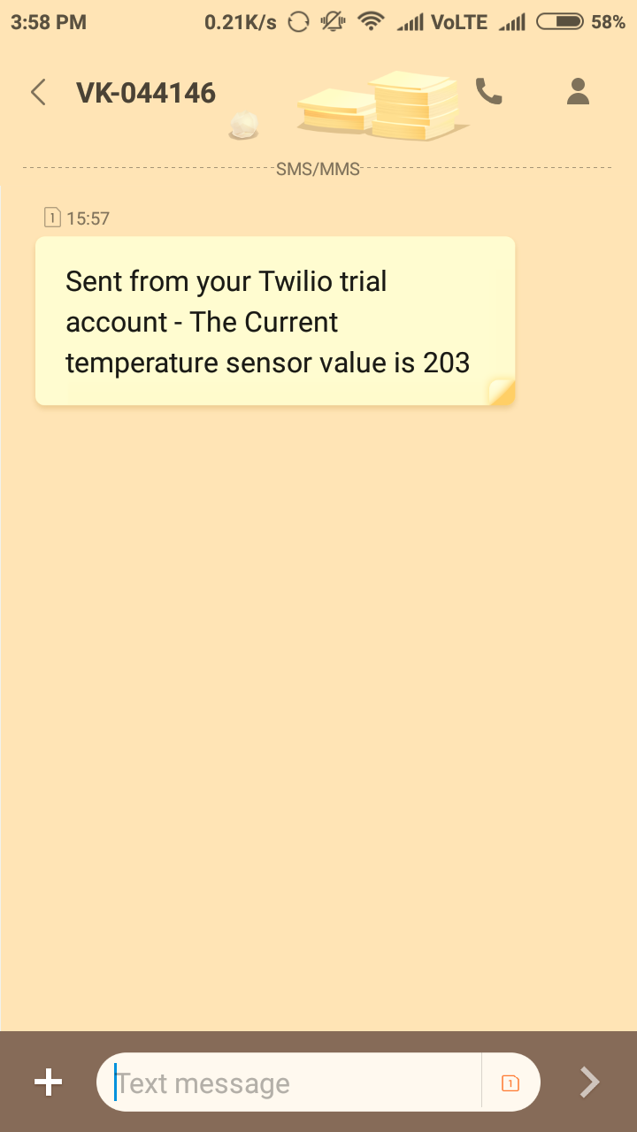

Thanks to Bolt Library which makes this lesson very easy to collect the data and send SMS