Upload databases from three different systems to HDFS using Sqoop

Below are the command lines used to execute each table from each system.

MySQL:
sqoop import \
--connect jdbc:mysql://localhost/solarplants \
--username root \
--password ******* \
--m 1 \
--table plant2sensor \
--target-dir /user/input/solarplants_mysql/plant2sensor

PostgreSQL:
sqoop import \
--connect jdbc:postgresql://localhost:5432/solarplants \
--username postgres \
--password *********** \
--m 1 \
--table plant1sensor \
--target-dir /user/input/solarplants_postgresql/plant1sensor

SQL Server:
sqoop import --connect 'jdbc:sqlserver://localhost:1433;databaseName=solarplants' --username 'SA' --password ******** --m 1 --table plant2gen --target-dir /user/input/solarplants_sqlserver/plant2gen

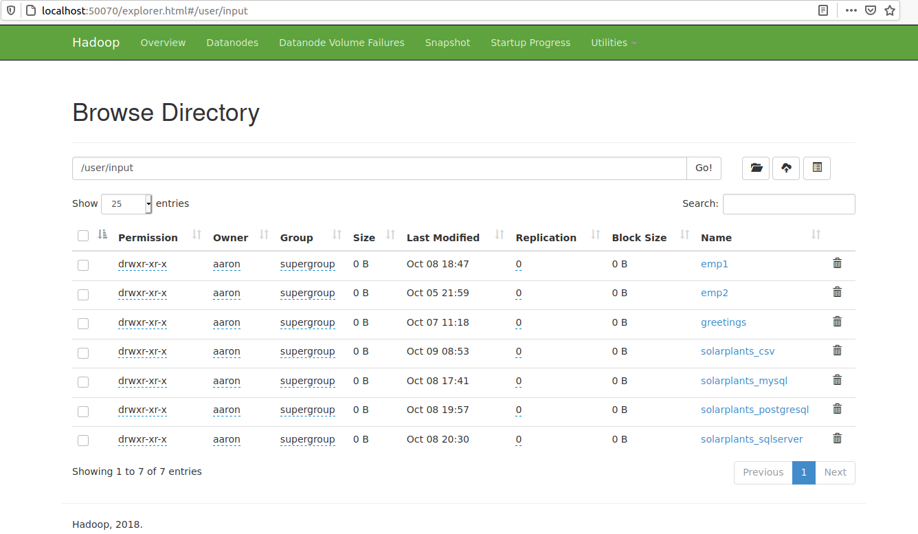

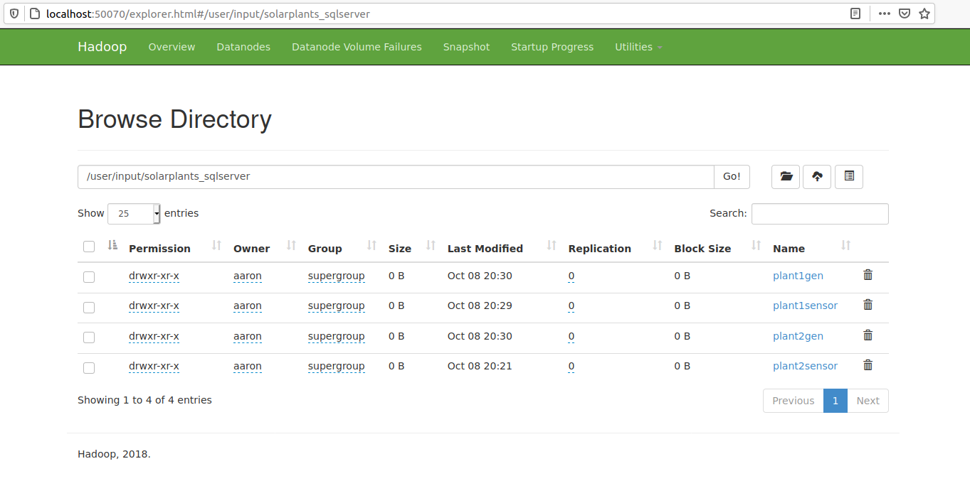
Put and get csv files to and from GCP.
(I used “history” to find commands. Thus, put and get commands from sftp prompt are not shown below. Execution and connection to gcp instance was a success)

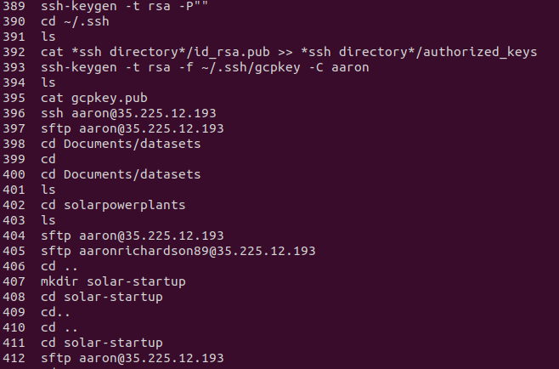

The CSV files transferred to HDFS successfully
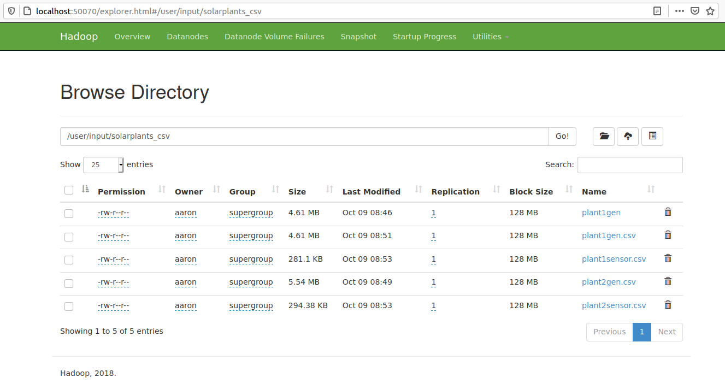
Create database “solarplantshive”and table in HIVE to load files from HDFS
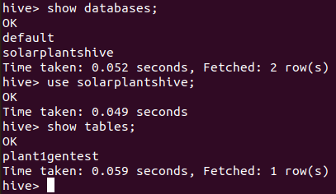

Tables below do have data. Columns with NULL titles exists because the data type of those columns are double. The first few records contain 0.0 because the solar panels were not producing power at that time stamp.
