I successfully configured files in preparation of flume and near real time twitter data streaming.

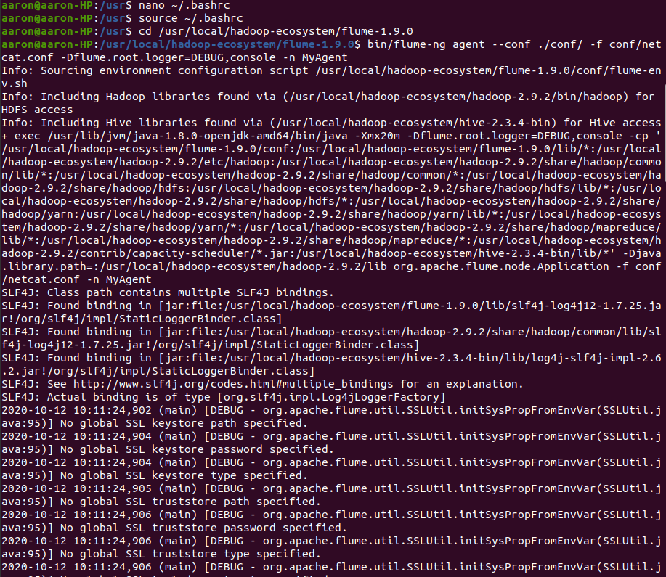

Twitter approved my developer account and I configured my keys which allows me to stream twitter data as shown below.

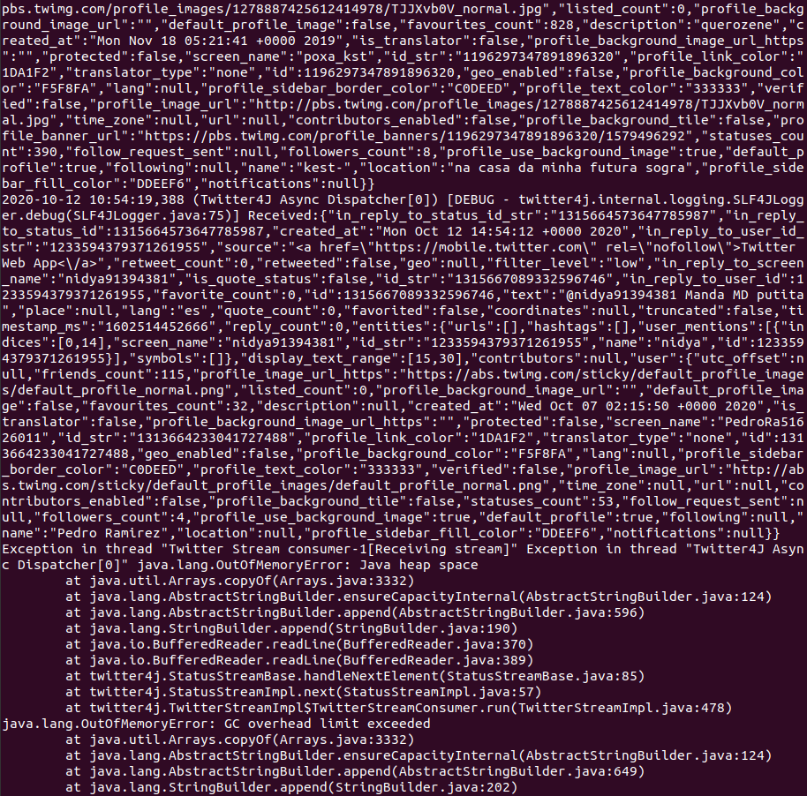

Below shows where streaming finished
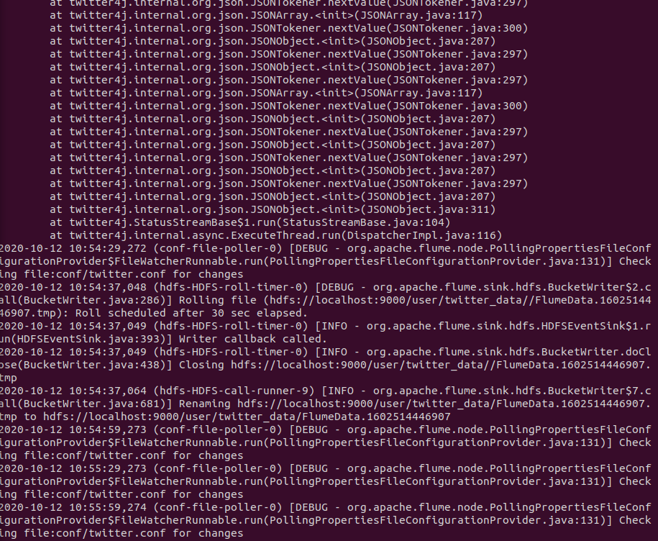

Twitter/Flume data files in my HDFS.

