Machine Learning

Table of Contents

Introduction 1
Characterisation and EDA 2
Machine Learning Models: 10%, 15% and 20% training splits 3
Performance of the Machine Learning Models 3
Hyperparameters 4
Comparing models 5
Conclusions 6
References 7

Introduction
Education is an important pillar of society. Over the years, countries have made efforts to make education attainable and accessible for everyone. Moreover, education has become a social responsibility, and not only a family or personal one.
While most students in developed countries finish secondary and higher education, many developing nations still face challenges with students leaving school before graduation. Consequently, only a small portion of students reach higher education in these countries. For this reason, it is crucial that efforts focus on ensuring that those who do access higher education remain enrolled until they successfully complete their studies.
The scientific community has provided evidence that education not only offers personal benefits, such as higher income, but also promotes social justice, and reduces economic inequality. For example, even though the costs of higher education have risen, investing in a college education still appears to be a wise economic decision¹. Moreover, studies show that higher education significantly reduces income inequality in the long term, particularly in emerging economies⁵. However, returns from additional schooling tend to decline as countries develop⁴. Therefore, education remains especially crucial for developing economies. Additionally, educational attainment is linked to intergenerational factors such as parental education and family income³.
Therefore, given the evidence on education and welfare, this project focuses on predicting students’ dropout risk and academic success. Using data from Portuguese higher education institutions, this study aims to develop a tool that can be applied to other economies to identify students at risk of not completing higher education.

Characterisation and EDA
The dataset includes 4,424 observations and 37 numerical and categorical variables on higher education students, capturing individual and family characteristics. Its purpose is to predict student dropout and academic success, with the categorical target variable indicating enrolment, dropout, or graduation. After exploratory analysis, the dataset was expanded to 264 features (excluding the target).
As illustrated in Figure 1, the target variable is imbalanced. Consequently, training a model on such data can bias predictions toward the majority class. To address this, SMOTE was applied to generate synthetic samples to equalize the categories.
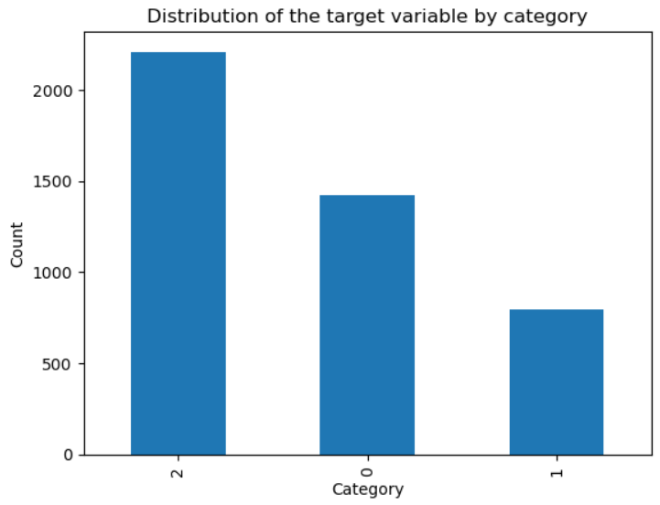
Figure 1. Distribution of the target variable by category

Source: Author’s own compilation, based on the Dataset “Predict Students' Dropout and Academic Success”.
Even after adding synthetic observations, the dataset had many more features than observations. Since too many features can reduce model accuracy, PCA was applied. It showed that 50 components capture 99.5% of the variance, so the dataset was reduced to 50 independent variables.

Machine Learning Models: 10%, 15% and 20% training splits
This dataset involves a classification task, so only certain models are suitable. Therefore, kNN, Decision Tree, and Random Forest were selected to compare performance and assess how dataset characteristics affect each model.
Because the dataset is sparse, with many dummy variables and some outliers, kNN performance may be negatively affected. Including kNN allows assessment of this impact. In contrast, Decision Trees are less sensitive to sparsity and high feature counts, while their results are easier to interpret. Additionally, Random Forest was chosen for its flexibility, lower risk of overfitting, and because it is robust to standardized features, making it well-suited for this dataset.

Performance of the Machine Learning Models
When examining the kNN model, accuracy remains largely consistent across different training splits, reaching 76% for 10% and 15% splits, and slightly decreasing to 74% for the 20% split. Moreover, precision is consistently highest for the Graduate category across all splits.
A similar trend is observed with the Decision Tree model. Accuracy remains stable across all training splits, with a slight increase to 71% for the 15% split. However, precision varies depending on the category: it is higher for Graduate at the 10% and 15% splits, whereas for the 20% split, precision is highest for the Dropout category.
For the Random Forest model, the highest accuracy of 82% is achieved with the 10% training split, while the other splits remain near 81%. Precision for the Dropout category remains consistently highest across all splits.
Overall, the Random Forest model demonstrates the highest accuracy and maintains consistency across training splits. While precision varies by category depending on the split, Random Forest remains the most reliable model for predicting the student’s dropout risk and educational success.

Hyperparameters
Hyperparameters are those variables that define how a model is configured to best fit the data. In particular, they determine what the model can learn, how it learns, and how well it performs on out-of-sample data. As a result, hyperparameters play a central role in a model’s ability to generalize².
Regarding this dataset, each model required specific tuning. For example, kNN only needed the number of neighbours, set to 3. In contrast, Decision Tree and Random Forests have multiple hyperparameters, such as maximum tree depth, which affects underfitting or overfitting. Additionally, Random Forest requires the number of trees that will balance between performance and computational cost.
There are several techniques available to optimise a set of hyperparameters for machine learning models. In this case, GridSearchCV was implemented. It will exhaustively search through all the possible combinations of parameters provided. The optimal parameters found were: 3 neighbours for kNN, maximum depth of 10 for Decision Tree, and 300 trees with unlimited depth for Random Forest.

Comparing models
The following visualisation shows the confusion matrices for all three models after tuning the hyperparameters.
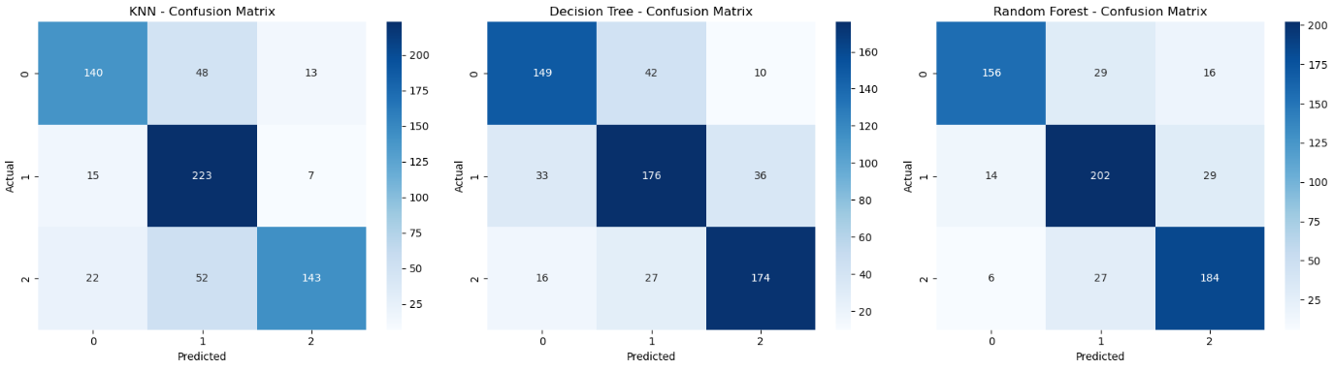
Figure 2. Confusion Matrices for the kNN, Decision Tree and Random Forest models
Source: Author’s own compilation, based on the Dataset “Predict Students' Dropout and Academic Success”.
The confusion matrices show that the Random Forest model achieves the best overall performance, as it records the highest number of true positives in two of the three categories. In contrast, the kNN model performs better for Category 1, which corresponds to students who are “enrolled.” However, the Random Forest model also produces the highest number of false negatives for Category 0, predicting that a student graduated instead of identifying that the student dropped out. Although Random Forest performs best overall, this misclassification must be considered in the analysis, as it provides important insight into the model’s capacity to generalize.
Table 1. Performance Metrics
Model | Cross-Validation Accuracy | Accuracy | Precision | Recall
kNN | 0.73 | 0.76 | 0.78 | 0.76
Decision Tree | 0.74 | 0.75 | 0.75 | 0.75
Random Forest | 0.81 | 0.82 | 0.82 | 0.82
Source: Author’s own compilation, based on the Dataset “Predict Students' Dropout and Academic Success”.
In terms of metrics, the Random Forest model clearly performs better than the others in all aspects. It achieves the highest cross-validation accuracy and also provides the best accuracy on the test set after hyperparameter tuning. In comparison, the Decision Tree model shows slightly better cross-validation accuracy than kNN. However, both the accuracy and precision on the test set are lower for the Decision Tree model, which may indicate a reduced capacity to generalize. Furthermore, the gap between these two models is more pronounced when considering precision, suggesting that kNN produces fewer false positives. In other words, kNN is less likely to incorrectly predict that a student is “graduated” or “enrolled” when the student has actually dropped out.

Conclusions
Overall, all models perform well with the given data. Random Forest stands out as the best across all metrics, balancing complexity without compromising generalization and successfully addressing the goal of predicting students’ risk of dropout and educational success. On the other hand, the Decision Tree, as a simpler version of Random Forest, was expected to perform similarly. However, the k- kNN model, despite using different mechanisms, performs better even with sparse data and many features. This suggests that data preprocessing effectively addressed these issues, allowing kNN a better performance.

References
¹Abel, J. and Deiz, R., 2014. Do the Benefits of College Still Outweigh the Costs? Current Issues in Economics and Finance, 20(3).
²Arnold, C., Biedebach, L., Küpfer, A. and Neunhoeffer, M., 2021. The role of hyperparameters in machine learning models and how to tune them. Political Science Research and Methods, Volumen 12, pp. 841-848.
³Bonneau, C. and Grobon, S., 2022. Unequal Access to Higher Education Based on Parental Income: Evidence from France. World Inequality Lab, 1(2022).
⁴Coady, D. and Dizioli, A., 2017. Income Inequality and Education Revisited: Persistence, Endogeneity, and Heterogeneity. International Monetary Fund.
⁵Qazi, W., Raza, S., Jawaid, S. and Karim, M., 2016. Does expanding higher education reduce income inequality in emerging economy? Evidence from Pakistan. Studies in Higher Education.

