About the Virginia Tech Programming Team

The path to the international competition begins with a local contest held in September. At this contest, individuals compete for a position on the team. Of the approximately 40 students participating in the local contest, 15 are chosen to compete in 4 teams (all representing Virginia Tech). A team consists of 3 full time students, with no more than 1 grad student per team. Any major is welcome, but the participants are generally CS, ECPE and Math students. These teams then practice for 5–8 hours a week so that the best combination of teams may be formed. When the teams are organized, they practice 5 hours per week on Saturday mornings. On November 14, the three Virginia Tech teams compete in the Mid-Atlantic Regional Programming contest. New Jersey through North Carolina, Eastern Pennsylvania and Maryland through West Virginia compete in this region. The regional competition is hosted by Virginia Tech, and several schools help form additional sites for competition across the region. Usually the top two teams from the regional competition advance to international competition. Only one team per school can advance to the international competition, which allows only one of the Virginia Tech teams the possibility of competing internationally.
Virginia Tech's coach, Dr. Sallie Henry has been coaching the Virginia Tech teams for the last 15 years. For the last 10 years, Virginia Tech has won the regional competition. Dr. Henry is a faculty member of the department of computer science.
In the Association for Computing Machinery's (ACM) 1997-1998 International Collegiate Programming Contest in Atlanta (held in March 1998), MIT placed 5th overall and first among the U.S. teams. The University of California-Berkeley and Duke University tied with Virginia Tech in 11th place. This places Virginia Tech 2nd among schools in the United States.
The annual competition draws student teams from around the world to solve up to eight problems in five hours. Problems ranged from writing programs to determine the insulating capacity of polygonal pieces composed of hypothetical insulating crystals; to determining optimal altitude during legs of an airplane flight in order to minimize fuel consumption; to selecting pages by keyword matching.
The contest also draws attention from nationally recognized companies like IBM, Microsoft, and AT&T. This offers a good opportunity for students to become exposed to companies of this caliber.
“It was definitely a worthwhile experience,” said team member Tim McGaughey, “One of the biggest things was that we needed to know our own strengths and how to work to the team’s advantage. We had three people and one computer, so the computer use had to be efficient.”
In the 1998-1999 regional contest, Virginia Tech team 1 placed 1st, and Virginia Tech team 2 placed 3rd.

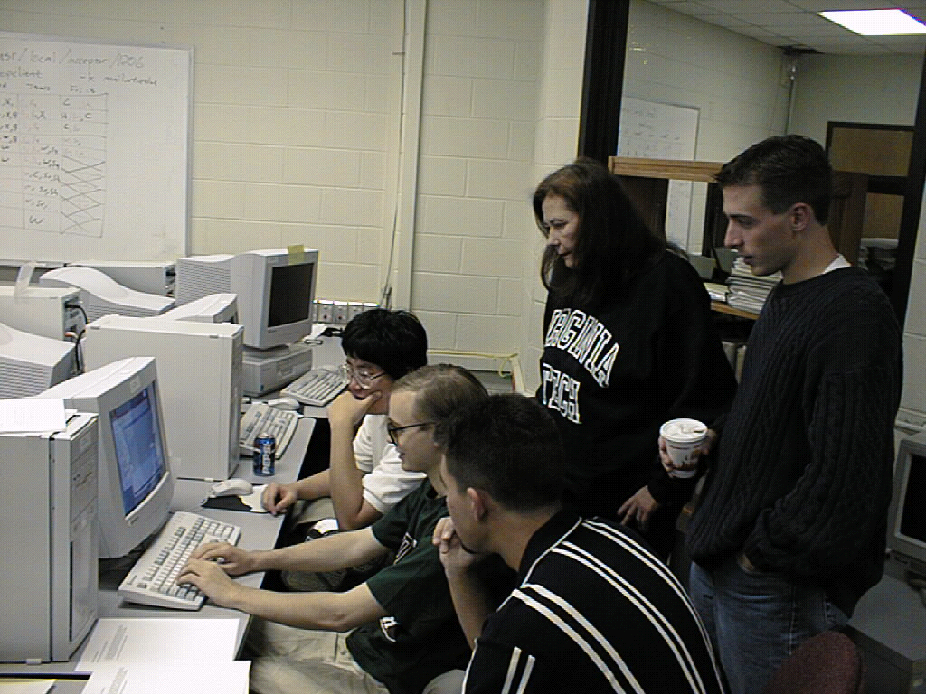
Tech's Programming Team 1. From rear, Albert Suk Chan Lee (CS, MATH, PHYS), Tim Terriberry (CS, MATH), and David Mayhew (GRAD EE). Standing behind the team are Coach Sallie Henry (CS) and Assistant Coach Chad Wingrave (CS).

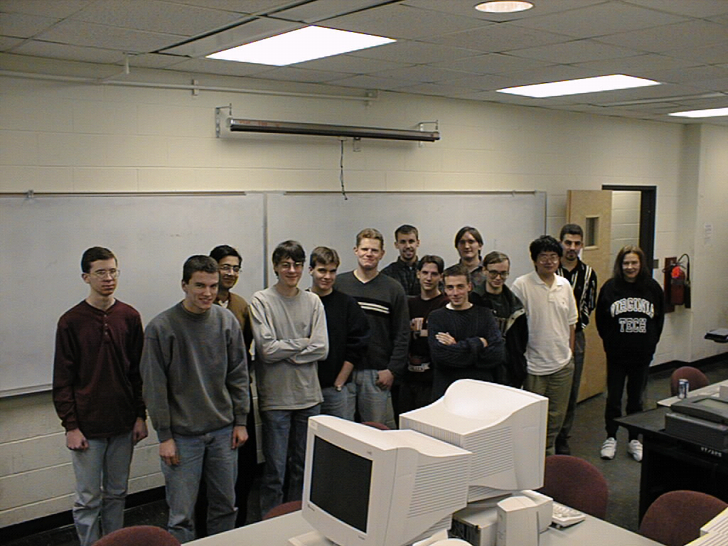
From Left: Brad Shepard, James Fogarty, Akash Rai, Logan Hanks, Tim McGaughey, Zachary Swain. In rear: Rob Clancy, Alex Verstak, David Mayhew. Middle row: John Dailey, Tim Terriberry, Albert Suk Chan Lee, Coach Sallie Henry. Front: Chad Wingrave

