Arick Mounts

This program reads data from a csv file, and loads it into two linked lists, the first organized as a stack, and the second organized as a queue. I had some difficulty wrapping my head around the concepts of stacks and queues, but I finally figured it out after studying the examples, and doing some googling on specific issues that confused me.

Stack output

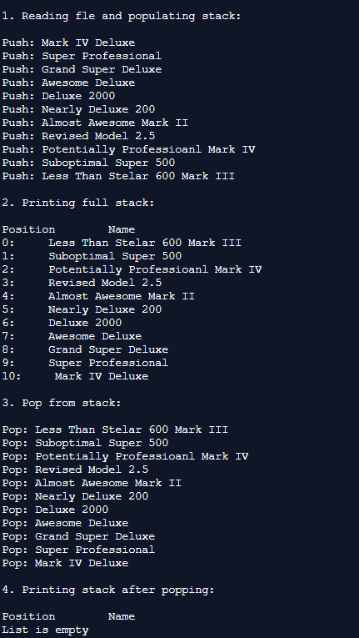

Queue output

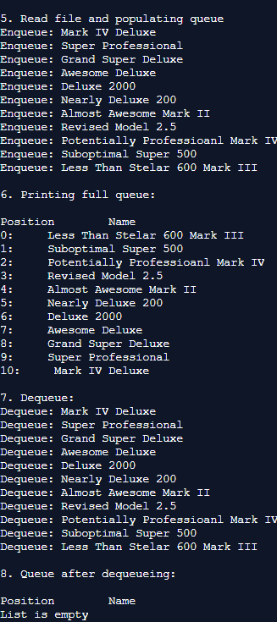

I used repl.it while writing this program.