Statement of Work
Self-Guided Audio Tour Infrastructure Solution

Prepared for: Museums In Europe

Prepared by: Ariel Eshkol

Date: January 12, 2026

Document Control
Document Title | Museums In Europe - Self-Guided Tours Infrastructure SOW
Version | 6.0 (Condensed with Diagrams)
Date | January 12, 2026
Author | AllCloud Solutions Team
Client Contact | Ofer Gradus, CEO
Status | Draft for Review

Table of Contents
1. Executive Summary
2. Organization Overview
3. Critical Requirements & Solution Overview
4. User Experience Flows
5. Scope of Work & Roles/Responsibilities
6. Project Timeline & Deliverables
7. Pricing & Commercial Terms

1. Executive Summary

1.1 Project Overview
Museums In Europe seeks to implement a self-guided audio tour infrastructure for their Israel museum location. AllCloud proposes a WiFi-enabled, accuracy-focused AWS solution that provides personalized visitor experiences while maintaining strict historical accuracy controls.
Key Solution Components:
- Content Management System (CMS) with curator approval workflows
- AI-powered personalization engine (content selection only, NO fact generation)
- RESTful API layer for frontend integration
- Secure content repository with Israel data residency
- Real-time content delivery via strong WiFi infrastructure

1.2 Critical Success Factors
Factor | Requirement | AllCloud Solution
**Historical Accuracy** | NO AI-generated facts | RAG + Curator approval + Bedrock Guardrails
**WiFi Performance** | Real-time content delivery | S3 caching + API Gateway + DynamoDB DAX
**Data Residency** | All data in Israel | il-central-1 region + LZA enforcement
**Clear Roles** | Defined responsibilities | AllCloud: Infrastructure/CMS; Partner: Frontend

1.3 Project Scope
AllCloud Deliverables:
- AWS infrastructure (multi-account LZA architecture)
- Content Management System (backend + curator portal)
- RESTful APIs for frontend integration
- AI personalization engine (Amazon Bedrock)
- Security, monitoring, and backup systems
Out of Scope (Frontend Partner):
- Mobile application development (iOS/Android/Web)
- User interface and UX design
- QR code scanning functionality
- Visitor-facing features

1.4 Investment Summary
Item | Cost | Notes
**Professional Services** | $70,000 | One-time implementation
**Monthly AWS Infrastructure** | $200-315/month | Israel region, serverless
**3-Year Total Cost of Ownership** | $77,200-81,340 | Services + infrastructure

1.5 Timeline
Total Duration: 8-10 weeks from contract signature to production launch
Phase | Duration | Key Deliverable
Infrastructure Setup | 2 weeks | Operational AWS environment
CMS Development | 2-3 weeks | Operational CMS with APIs
Integration & Testing | 2-3 weeks | Integrated system
UAT & Launch | 1-2 weeks | Live production system

2. Organization Overview

2.1 Client Profile
Organization: Museums In Europe
Project Sponsor: Ofer Gradus, CEO
Location: Israel
Project: Self-Guided Audio Tour Infrastructure

2.2 Current State
The museum currently lacks a digital infrastructure for self-guided audio tours. Visitors have no personalized experience, and content management is manual and fragmented.
Current Challenges:
- No digital content delivery system
- No personalization capabilities
- Manual content management
- No visitor analytics
- Limited scalability

2.3 Desired Future State
A modern, WiFi-enabled infrastructure that delivers personalized audio tours to visitors while maintaining strict historical accuracy controls and curator oversight.
Key Objectives:
- Personalized visitor experiences based on preferences
- Real-time content delivery via strong WiFi
- Curator-controlled content with approval workflows
- AI-powered content selection (NOT generation)
- Israel data residency compliance
- Scalable, secure AWS infrastructure

3. Critical Requirements & Solution Overview

3.1 Critical Requirements
Requirement | Description | AllCloud Solution
**Historical Accuracy** | NO AI-generated facts; all content curator-approved | RAG approach + Bedrock Guardrails + Human approval gates + Audit trail
**WiFi-Enabled** | Real-time content delivery with strong WiFi | S3 caching + API Gateway caching + DynamoDB DAX + Optimized delivery
**Israel Data Residency** | All data must remain in Israel | il-central-1 region + LZA enforcement + No cross-border transfers
**Clear Roles** | Defined responsibilities between parties | See Roles & Responsibilities table (Section 5)

3.2 Personalization Questionnaire (7 Parameters)
The system collects visitor preferences to generate personalized itineraries:
Parameter | Options | Purpose
**Language** | English, Hebrew, others | Content language selection
**Age Range** | Children, Teens, Adults, Seniors | Content complexity level
**Culture/Religion** | Dietary, observances, sensitivities | Content filtering
**Points of Interest** | Art periods, themes, collections | Content matching
**Gender** | Optional | Analytics and recommendations
**Visit Duration** | 30min - 4+ hours | Itinerary length
**Must-See Items** | Specific exhibits | Anchor points in itinerary

3.3 Solution Architecture Overview
[See Diagram 1: LZA OU & Account Structure]
Figure 1: AWS Landing Zone Accelerator multi-account organizational structure with Security, Infrastructure, and Workloads OUs.
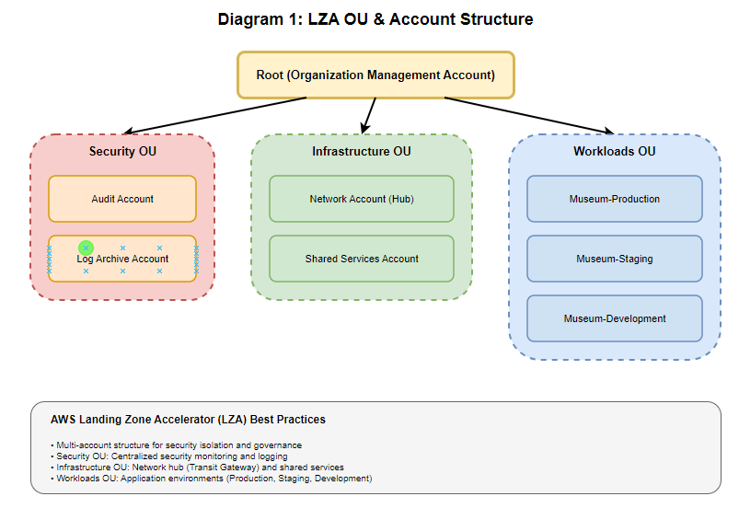

[See Diagram 2: Detailed Technical Architecture]
Figure 2: Complete AWS architecture showing VPCs, subnets, all AWS services, Transit Gateway hub-spoke topology, and security components in Israel region.
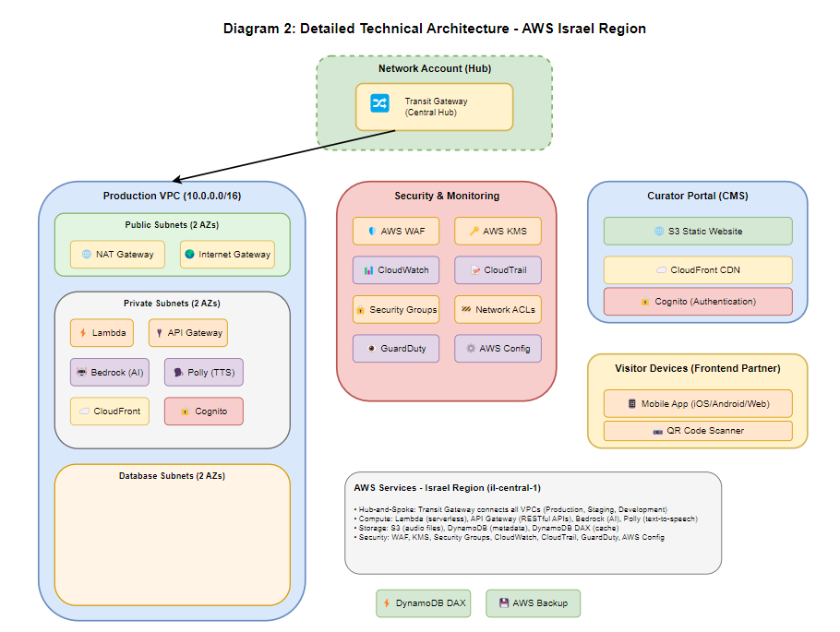

Core Components
Component | Technology | Purpose
**Content Management** | S3 + DynamoDB + Cognito | Curator portal for content upload and approval
**API Layer** | API Gateway + Lambda | RESTful APIs for frontend integration
**Personalization Engine** | Amazon Bedrock (RAG) | AI content selection and itinerary generation
**Voice Generation** | Amazon Polly | Text-to-speech for approved content (Phase 1)
**Data Storage** | S3 + DynamoDB | Audio files, transcripts, metadata
**Caching** | S3 + DynamoDB DAX | Pre-generated audio by visitor profile
**Security** | WAF + KMS + CloudTrail | Access control, encryption, audit logging
**Monitoring** | CloudWatch + AWS Backup | Metrics, logs, automated backups

AWS Services Summary
Service | Monthly Cost | Justification
Lambda | $25-40 | Serverless compute, automatic scaling, pay-per-use
API Gateway | Included in Lambda | Managed RESTful APIs, built-in caching
S3 | $6-10 | 99.999999999% durability, versioning, lifecycle policies
DynamoDB | $15-25 | Single-digit ms latency, automatic scaling
DynamoDB DAX | Included | In-memory cache, microsecond latency
Bedrock | $15-25 | Grounded AI, RAG, no hallucination
Polly | $10-15 | Natural voice generation, multiple languages
CloudFront | $20-30 | Global CDN, edge caching
VPC/Networking | $85-130 | Transit Gateway, NAT, VPC endpoints
Security (WAF/KMS) | $16-23 | Web firewall, encryption key management
Monitoring | $20-35 | CloudWatch, CloudTrail, AWS Backup
**Total** | **$200-315** | **Serverless, auto-scaling, Israel region**

4. User Experience Flows

4.1 Visitor Journey
[See Diagram 3: Visitor User Experience Flow]
Figure 3: Complete visitor journey from arrival through questionnaire, AI-powered itinerary generation, gallery experience with real-time content delivery, and exit.
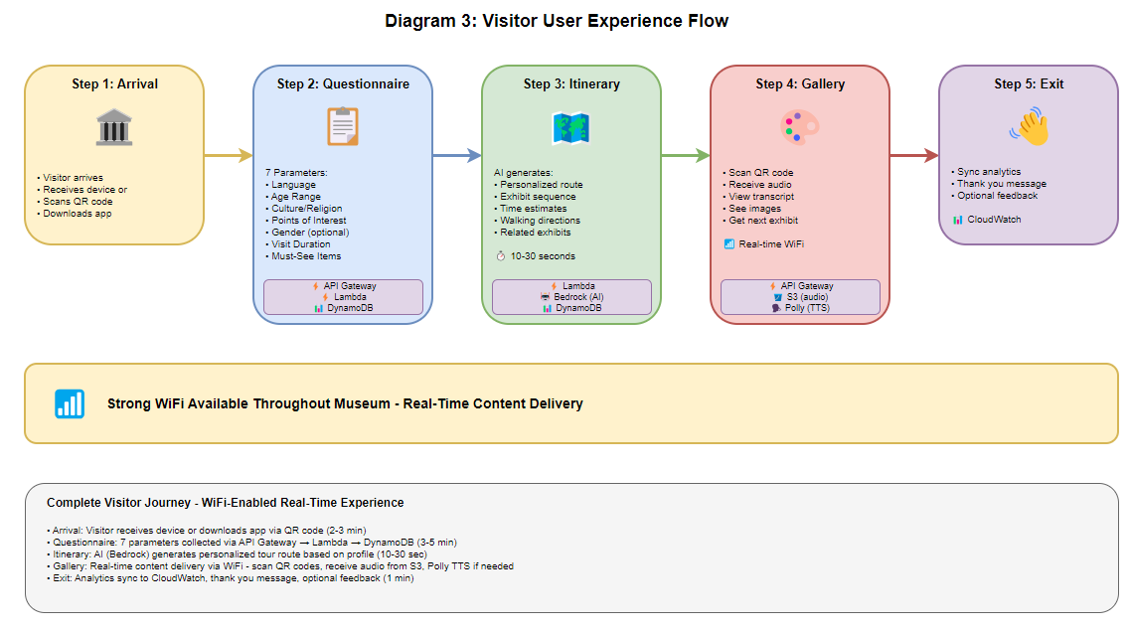

Visitor Journey Summary
Step | Activity | Technology | Duration
**1. Arrival** | Receive device or download app via QR code | Frontend app | 2-3 min
**2. Questionnaire** | Answer 7 personalization questions | API Gateway + Lambda + DynamoDB | 3-5 min
**3. Itinerary** | AI generates personalized tour route | Bedrock + Lambda | 10-30 sec
**4. Gallery** | Scan QR codes, receive audio content | API Gateway + S3 + Polly | Real-time
**5. Exit** | Sync analytics, thank you message | CloudWatch + DynamoDB | 1 min
Note: All technical details (API calls, AWS services, data flow) are shown in Diagram 3. The system leverages strong WiFi throughout the museum for real-time content delivery.

4.2 Museum Employee Workflow
[See Diagram 4: Museum Employee User Experience Flow]
Figure 4: Content creation workflow showing staff upload, AI voice generation (Amazon Polly), curator approval gates, and publication process with AWS service integration.
[DIAGRAM 4 PLACEHOLDER - Insert diagram here]

Content Lifecycle Summary
Role | Activity | System | Status
**Content Creator** | Upload text content + images | CMS Portal (S3 + CloudFront) | Draft
**System** | Auto-generate audio via Polly | Amazon Polly + Lambda | Pending Approval
**Curator** | Review content for accuracy | CMS Portal (Cognito auth) | Under Review
**Curator** | Approve or reject with comments | Lambda + Bedrock Guardrails | Approved/Rejected
**System** | Publish to production repository | S3 + DynamoDB + CloudWatch | Published
**AI** | Select content for visitor itineraries | Bedrock (RAG) | In Use
Key Controls:
- All content requires curator approval before publication
- AI can only select from approved content (cannot generate facts)
- Complete audit trail (author, approver, date, version)
- Bedrock Guardrails prevent unauthorized content modifications
- Content versioning and rollback capability
Note: All technical details (authentication, API calls, approval logic, AWS services) are shown in Diagram 4.

4.3 AI Usage Policy

What AI WILL Do
- ✅ Analyze questionnaire responses to understand visitor profile
- ✅ Select which approved exhibits to recommend
- ✅ Generate personalized itinerary with optimal sequence
- ✅ Match visitor age group to appropriate content variants
- ✅ Suggest related exhibits based on interests
- ✅ Optimize route through museum based on time available

What AI Will NOT Do
- ❌ Generate new historical facts or information
- ❌ Modify curator-approved content
- ❌ Create new audio narration (Polly generates from approved text only)
- ❌ Translate content without curator approval
- ❌ Answer visitor questions with generated responses
- ❌ Make up information not in approved content

Amazon Bedrock Guardrails
- Content filters prevent generation of new historical facts
- Topic filters restrict AI to approved content only
- Word filters block unauthorized modifications
- Hallucination detection prevents fabricated information
- Grounding check verifies all AI responses reference approved source content
- Violations logged and alerted to security team

5. Scope of Work & Roles/Responsibilities

5.1 Roles & Responsibilities
Component | AllCloud | Frontend Partner | Museum Staff
**AWS Infrastructure** | ✅ Design & implement | ❌ | ❌
**LZA Multi-Account Setup** | ✅ Deploy & configure | ❌ | ❌
**CMS Backend** | ✅ Build APIs & logic | ❌ | ❌
**CMS Frontend (Curator Portal)** | ✅ Build web portal | ❌ | ❌
**Mobile App** | ❌ | ✅ Develop (iOS/Android/Web) | ❌
**QR Code Scanning** | ❌ | ✅ Implement | ❌
**Audio Playback UI** | ❌ | ✅ Implement | ❌
**Content Upload** | ✅ Provide APIs | ❌ | ✅ Upload via CMS
**Content Approval** | ✅ Workflow system | ❌ | ✅ Review & approve
**AI Voice Generation** | ✅ Polly integration | ❌ | ❌
**API Documentation** | ✅ Provide specs | ✅ Consume APIs | ❌
**Integration Testing** | ✅ Backend testing | ✅ Frontend testing | ✅ UAT
**Infrastructure Monitoring** | ✅ CloudWatch setup | ❌ | ❌
**End-User Support** | ❌ | ✅ App support | ✅ Content support
**AWS Cost Management** | ✅ Optimize & monitor | ❌ | ✅ Budget approval

5.2 AllCloud Deliverables
Deliverable | Description | Timeline
**AWS Infrastructure** | Multi-account LZA setup, VPCs, networking | Week 1-2
**Content Management System** | Backend APIs + Curator portal | Week 3-5
**AI Personalization Engine** | Bedrock integration, RAG setup | Week 4-5
**Voice Generation** | Polly integration, audio pipeline | Week 4-5
**Security & Monitoring** | WAF, KMS, CloudWatch, CloudTrail | Week 2-6
**API Documentation** | OpenAPI specs, integration guide | Week 5-6
**Testing & Validation** | Load testing, security testing | Week 7-8
**Training** | CMS training for museum staff | Week 8
**Production Launch** | Go-live support | Week 8-10

5.3 Frontend Partner Deliverables (NOT AllCloud)
Deliverable | Description | Notes
**Mobile App** | iOS/Android/Web application | AllCloud provides APIs only
**UI/UX Design** | Visitor-facing interface | AllCloud provides recommendations
**QR Code Scanner** | Exhibit code scanning | AllCloud provides exhibit IDs
**Offline Caching** | Local content storage | AllCloud provides caching strategy
**Audio Player** | Playback controls | AllCloud provides audio files
**App Store Submission** | iOS/Android deployment | AllCloud not involved
**End-User Support** | Visitor troubleshooting | AllCloud supports infrastructure only

5.4 Museum Staff Responsibilities
Responsibility | Description | Support from AllCloud
**Content Creation** | Write exhibit descriptions, record audio | CMS portal provided
**Content Approval** | Review and approve all content | Approval workflow provided
**Content Management** | Organize exhibitions and exhibits | Hierarchical CMS provided
**User Acceptance Testing** | Validate system meets requirements | Testing support provided
**Budget Approval** | Approve AWS infrastructure costs | Cost monitoring provided
**Staff Training** | Learn CMS portal usage | Training sessions provided

5.5 Integration Points
Integration | AllCloud Provides | Frontend Partner Consumes
**Questionnaire API** | POST /api/questionnaire/submit | Submit visitor preferences
**Itinerary API** | POST /api/itinerary/generate | Get personalized tour
**Content API** | GET /api/content/{exhibitId} | Retrieve audio + metadata
**Recommendations API** | POST /api/recommendations/next | Get next exhibit suggestion
**Analytics API** | POST /api/analytics/sync | Send usage data
**Authentication** | OAuth 2.0 / API keys | Secure API access
API Documentation: AllCloud will provide complete OpenAPI specifications, example requests/responses, and integration guide.

6. Project Timeline & Deliverables

6.1 Project Timeline
Total Duration: 8-10 weeks from contract signature to production launch
Phase | Duration | Key Activities | Deliverables | Dependencies
**Phase 1: Infrastructure** | 2 weeks | AWS account setup, LZA deployment, VPC configuration, Transit Gateway, security baseline | Operational AWS environment, network connectivity, security controls | Contract signature, AWS account access
**Phase 2: CMS Development** | 2-3 weeks | Backend APIs, curator portal, content upload, approval workflows, Polly integration | Operational CMS with APIs, curator portal, API documentation | Phase 1 complete
**Phase 3: Integration** | 2-3 weeks | Frontend integration, API testing, Bedrock setup, end-to-end testing | Integrated system, tested APIs, personalization engine | Phase 2 complete, frontend partner ready
**Phase 4: Testing & UAT** | 1-2 weeks | Load testing, security testing, UAT with museum staff, bug fixes | Test reports, UAT sign-off, production-ready system | Phase 3 complete, test content available
**Phase 5: Launch** | 1 week | Production deployment, monitoring setup, staff training, go-live support | Live production system, trained staff, operational runbooks | Phase 4 complete, UAT approved

6.2 Milestones
Milestone | Target Week | Success Criteria
**M1: Infrastructure Ready** | Week 2 | AWS accounts operational, VPCs configured, security baseline deployed
**M2: CMS Operational** | Week 5 | Curator portal live, APIs functional, content upload working
**M3: Integration Complete** | Week 7 | Frontend integrated, APIs tested, personalization working
**M4: UAT Approved** | Week 8 | Museum staff sign-off, all test cases passed
**M5: Production Launch** | Week 10 | System live, visitors using app, monitoring active

6.3 Detailed Deliverables

Infrastructure Deliverables
Deliverable | Description | Format
**AWS Account Structure** | LZA multi-account setup (Management, Security, Infrastructure, Workloads) | AWS Organizations
**Network Architecture** | VPCs, subnets, Transit Gateway, NAT, Internet Gateway | Terraform/CDK code
**Security Baseline** | WAF, KMS, Security Groups, NACLs, IAM roles | Terraform/CDK code
**Monitoring Setup** | CloudWatch dashboards, alarms, CloudTrail, AWS Backup | AWS Console + IaC
**Infrastructure Documentation** | Architecture diagrams, network topology, security controls | PDF + Diagrams

Application Deliverables
Deliverable | Description | Format
**CMS Backend** | RESTful APIs for content management, approval workflows | Lambda + API Gateway
**Curator Portal** | Web application for content upload and approval | S3 + CloudFront
**Personalization Engine** | Bedrock integration, RAG setup, itinerary generation | Lambda + Bedrock
**Voice Generation** | Polly integration, audio pipeline, multi-language support | Lambda + Polly
**API Documentation** | OpenAPI specs, integration guide, example code | Markdown + OpenAPI YAML

Testing Deliverables
Deliverable | Description | Format
**Test Plan** | Test strategy, test cases, acceptance criteria | PDF
**Load Test Results** | Performance metrics, scalability validation | PDF + Screenshots
**Security Test Results** | Vulnerability scan, penetration test findings | PDF (confidential)
**UAT Sign-Off** | Museum staff approval, test case results | Signed document

Training & Support Deliverables
Deliverable | Description | Format
**CMS User Guide** | Step-by-step guide for content creators and curators | PDF + Video
**Training Sessions** | Live training for museum staff (2 sessions) | Virtual/On-site
**Operational Runbooks** | Incident response, troubleshooting, maintenance | PDF
**Go-Live Support** | 2 weeks of dedicated support post-launch | Email + Slack

6.4 Dependencies & Assumptions

Dependencies
Dependency | Owner | Impact if Delayed
**AWS Account Access** | Museum IT | Cannot start infrastructure setup
**Frontend Partner Readiness** | Frontend Partner | Cannot complete integration testing
**Test Content** | Museum Staff | Cannot perform UAT
**Budget Approval** | Museum Finance | Cannot deploy production resources
**Staff Availability for Training** | Museum HR | Cannot complete training

Assumptions
Assumption | Risk if Invalid
Strong WiFi available throughout museum | May need offline caching strategy
Museum staff available for UAT | UAT phase may extend
Frontend partner has API integration experience | May need additional integration support
Content available in digital format | May need content digitization phase
AWS Israel region (il-central-1) available | May need alternative region strategy

7. Pricing & Commercial Terms

7.1 Professional Services Pricing
Service Category | Cost | Description
**Infrastructure Setup** | $15,000 | AWS account setup, LZA deployment, VPC configuration, security baseline
**CMS Development** | $30,000 | Backend APIs, curator portal, content management, approval workflows
**AI Integration** | $15,000 | Bedrock setup, RAG configuration, Polly integration, personalization engine
**Testing & Validation** | $5,000 | Load testing, security testing, UAT support
**Training & Documentation** | $5,000 | CMS training, API documentation, operational runbooks
**Total Professional Services** | **$70,000** | **One-time implementation cost**

7.2 AWS Infrastructure Costs

Monthly Cost Breakdown
Service Category | Monthly Cost | % of Total | Notes
**Compute (Lambda)** | $25-40 | 10-13% | Serverless, pay-per-use, automatic scaling
**Storage (S3)** | $6-10 | 2-3% | Audio files, images, backups
**Database (DynamoDB)** | $15-25 | 5-8% | Metadata, profiles, on-demand pricing
**AI/ML (Bedrock, Polly)** | $25-40 | 8-13% | Content selection, voice generation
**Networking (VPC, TGW, NAT)** | $85-130 | 28-41% | Transit Gateway, NAT Gateway, VPC endpoints
**Security (WAF, KMS)** | $16-23 | 5-7% | Web firewall, encryption
**Monitoring (CloudWatch, Backup)** | $20-35 | 6-11% | Logs, metrics, automated backups
**CDN (CloudFront)** | $20-30 | 7-10% | Global content delivery
**Total Monthly** | **$200-315** | **100%** | **Israel region, serverless architecture**
Note: Costs based on estimated usage (5,000 visitors/month, 100 exhibits, 3 languages). Actual costs may vary based on usage patterns.

Annual Cost Projection
Year | Professional Services | AWS Infrastructure | Total
**Year 1** | $70,000 | $2,400-3,780 | $72,400-73,780
**Year 2** | $0 | $2,400-3,780 | $2,400-3,780
**Year 3** | $0 | $2,400-3,780 | $2,400-3,780
**3-Year TCO** | **$70,000** | **$7,200-11,340** | **$77,200-81,340**

7.3 Payment Terms
Milestone | Payment | Deliverable
**Contract Signature** | 30% ($21,000) | Project kickoff, AWS account setup begins
**Infrastructure Complete** | 20% ($14,000) | Operational AWS environment (Week 2)
**CMS Operational** | 30% ($21,000) | Functional CMS with APIs (Week 5)
**UAT Approved** | 15% ($10,500) | UAT sign-off (Week 8)
**Production Launch** | 5% ($3,500) | Go-live (Week 10)
**Total** | **100% ($70,000)** | **Complete implementation**
AWS Infrastructure Costs: Billed monthly by AWS directly to client's AWS account. AllCloud provides cost monitoring and optimization recommendations.

7.4 Commercial Terms

Warranty & Support
Term | Details
**Warranty Period** | 90 days from production launch
**Warranty Coverage** | Bug fixes, performance issues, security vulnerabilities
**Response Time** | Critical: 4 hours; High: 8 hours; Medium: 24 hours; Low: 48 hours
**Go-Live Support** | 2 weeks of dedicated support post-launch (included)

Post-Warranty Support (Optional)
Support Tier | Monthly Cost | Coverage
**Basic** | $2,000/month | Email support, 48-hour response, business hours
**Standard** | $4,000/month | Email + phone, 8-hour response, extended hours
**Premium** | $8,000/month | 24/7 support, 2-hour response, dedicated engineer

Change Requests
Type | Rate | Notes
**Minor Changes** | Included | Small configuration changes, bug fixes
**Feature Enhancements** | $150/hour | New features, significant changes
**Emergency Changes** | $200/hour | After-hours, urgent changes

Assumptions & Exclusions
Included:
- ✅ AWS infrastructure design and implementation
- ✅ CMS backend and curator portal
- ✅ AI personalization engine
- ✅ API documentation and integration guide
- ✅ Training for museum staff
- ✅ 90-day warranty
Excluded:
- ❌ Mobile app development (frontend partner responsibility)
- ❌ Content creation or digitization
- ❌ On-premise hardware or networking
- ❌ Third-party software licenses
- ❌ Post-warranty support (optional, see above)
- ❌ Travel expenses (if on-site visits required)

7.5 Success Criteria & KPIs
KPI | Target | Measurement
**System Availability** | 99.9% uptime | CloudWatch monitoring
**API Response Time** | < 200ms (p95) | API Gateway metrics
**Content Delivery** | < 2 seconds | CloudFront + S3 metrics
**Curator Approval Time** | < 24 hours | CMS workflow metrics
**Visitor Satisfaction** | > 4.0/5.0 | Post-visit survey
**Historical Accuracy** | 100% curator-approved | Audit trail verification
**Data Residency** | 100% Israel region | AWS Config compliance

7.6 Governance & Communication
Activity | Frequency | Participants
**Project Kickoff** | Once | AllCloud team, Museum stakeholders, Frontend partner
**Weekly Status Meetings** | Weekly | Project managers, technical leads
**Sprint Reviews** | Bi-weekly | Development team, Museum stakeholders
**Steering Committee** | Monthly | Executives, project sponsors
**Go-Live Readiness Review** | Once (Week 8) | All stakeholders
Communication Channels:
- Email: Daily updates, documentation
- Slack: Real-time collaboration
- Video Calls: Weekly meetings, reviews
- Project Management Tool: Jira or equivalent

7.7 Terms & Conditions

Intellectual Property
- AllCloud retains IP rights to reusable components and frameworks
- Museum owns all custom code and configurations specific to this project
- Museum owns all content uploaded to the system

Confidentiality
- Both parties agree to maintain confidentiality of proprietary information
- Non-disclosure agreement (NDA) required before project start

Liability
- AllCloud liability limited to professional services fees paid
- Museum responsible for content accuracy and legal compliance
- AWS infrastructure subject to AWS Service Level Agreements

Termination
- Either party may terminate with 30 days written notice
- Museum pays for work completed to date
- AllCloud provides knowledge transfer and documentation

Acceptance
- UAT sign-off required for final payment
- Museum has 10 business days to review and approve deliverables
- Issues must be documented and communicated within acceptance period

