Screenshots :

Observe:

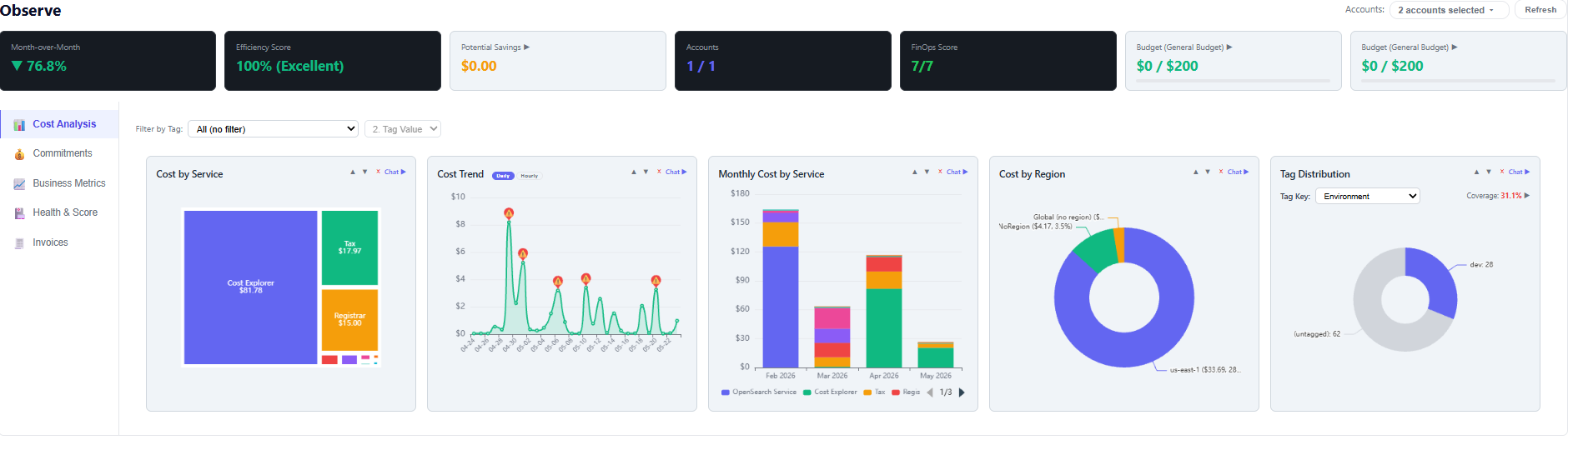
Interactive Chat

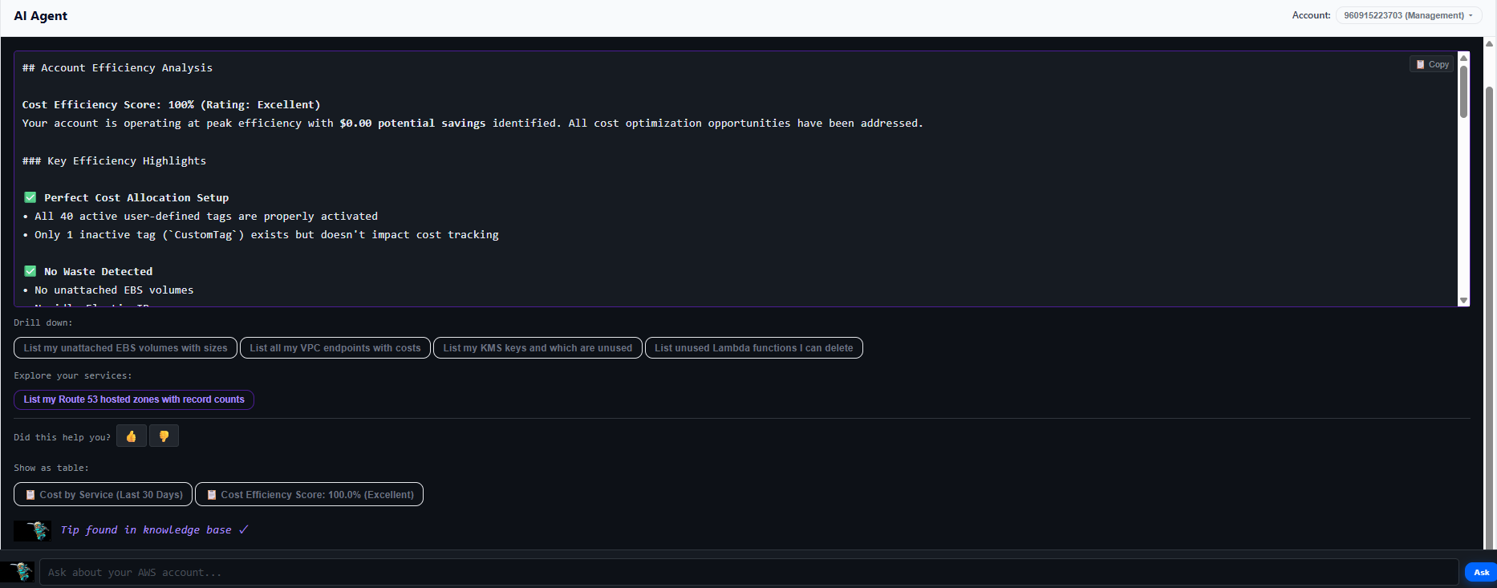
And dynamic data analysis
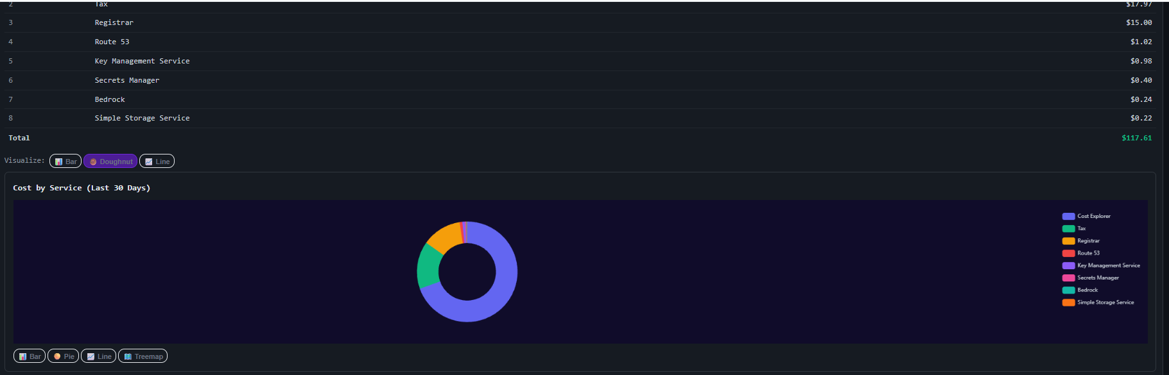

Plan : Budget
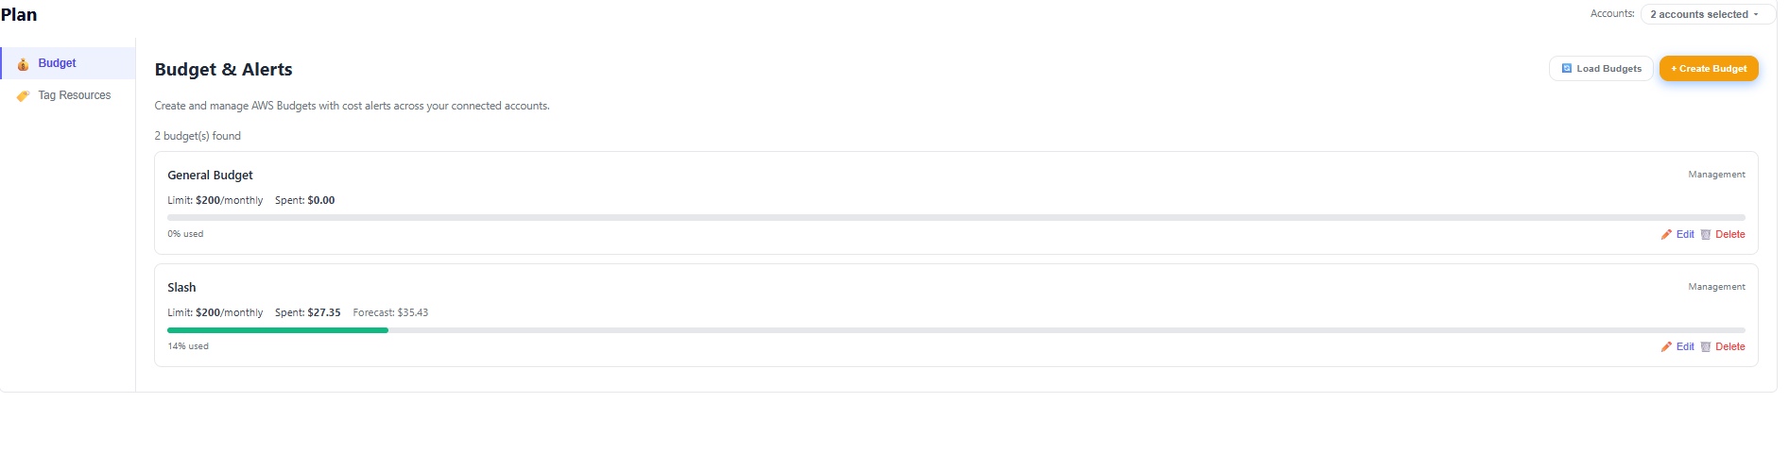
Plan – Easily tag resources
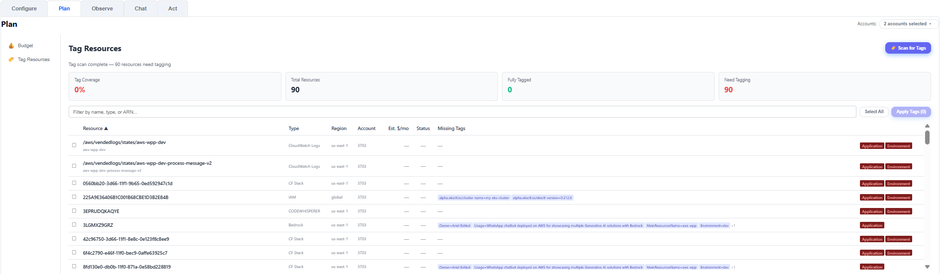

Act :
Waste Cleanup
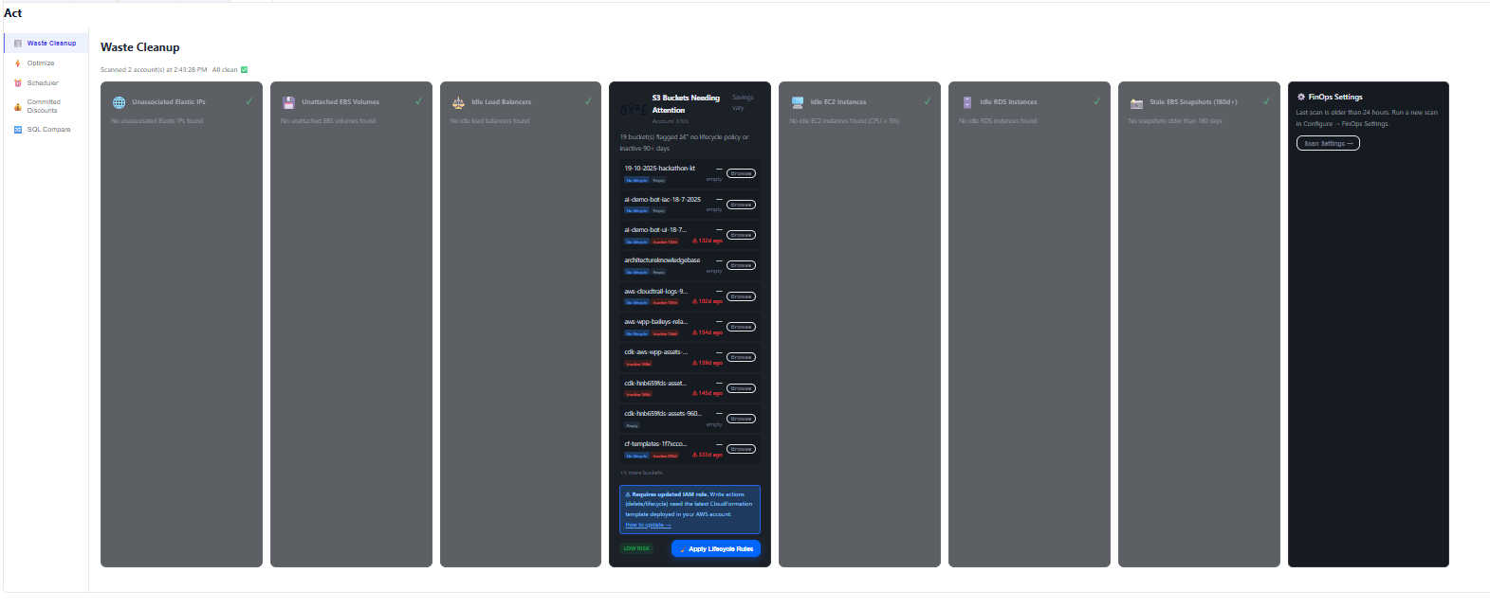
Optimize a server
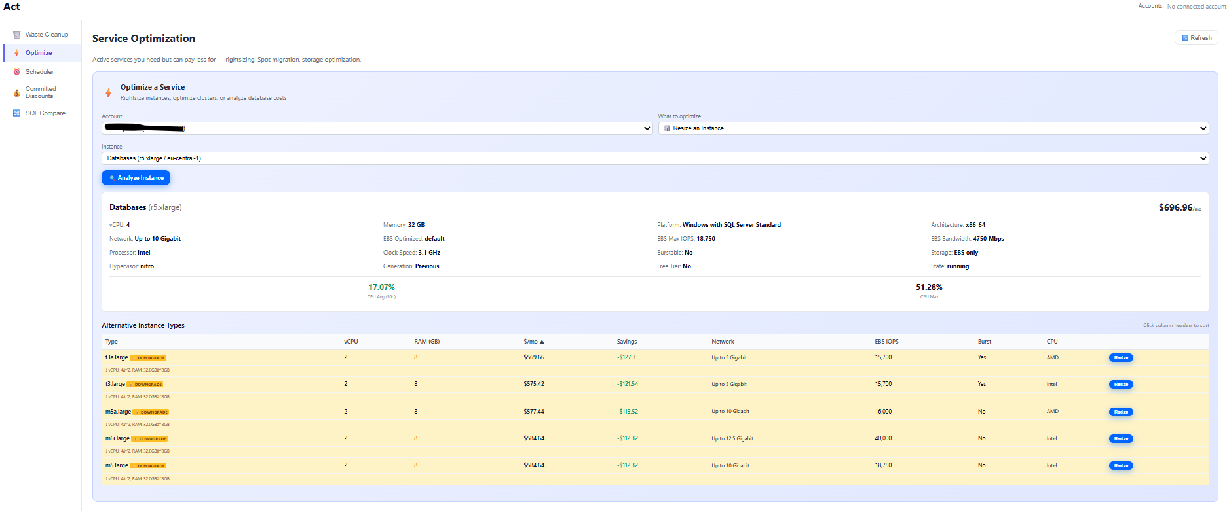
Schedule ongoing tasks
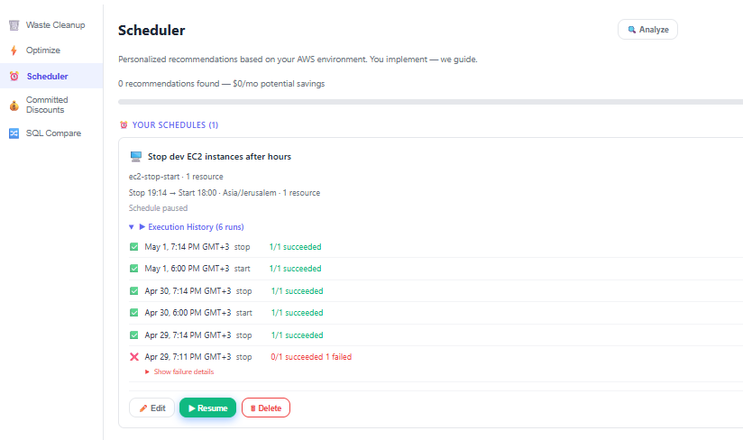
Optiize costs for Windows and SQL servers
