**Brand-, Market- and Competitive Analysis**

Research has been done to find out and explore the different kinds of artists that are similar to Aisha in some way or another. The results and findings of this research will be visible below.



**Maan**

**At a glance**

Maan has a interesting background, she came to the foreground of the Dutch music scene with the help of the national singing contest ‘The Voice Of Holland’ and even though a lot of the time singing contest winners disappear to the background after a while she kept herself in the spotlights. She has a strong and clear position in the scene and has a specific target audience. Aisha herself sees Maan as an inspiration and at a first glance there are definitely some similarities.

**What is Maan’s target audience?**

*Target Audience:*

Age: 14-28

Gender: Mostly female

Location: All of the Netherlands and Flanders

**How does Maan relate with her target group?**As earlier stated has Maan a good connection with her target group, she does multiple things to reach this stronghold with the her target group.

* Sings in Dutch
* Collaborating with other popular artists in her target group
* Being present on the right platforms
* Sings relevantly

**What are Maan’s main ways of communicating?**The way Maan communicates with her fans is mostly with the help of social media platforms like Facebook and Instagram. She also has a website for some general information (tour dates, little biography etc.).   
  
*Instagram (700k+ followers)*: used more as a personal way of communicating and relating to her fans and followers. Maan posts regularly on her Instagram page and besides professional pictures she also shows pictures of more personal affairs like going out with friends and being with her boyfriend. Her personality is visible within these posts and the many ‘Instagram Stories’ she posts.

*Facebook (40k followers):* is barely used with breaks of sometimes even multiple months in between posts. The posts that are posted are almost exclusively updates of her upcoming tour dates.

*Website:* The website is mostly used for general information like her upcoming tour dates and ways to listen to her music. A noticable difference between the other platforms is that the website also has a big part dedicated to the business aspect.

**What does this mean?**As clearly visible there is a case of disparity between the certain platforms and how they are being used.

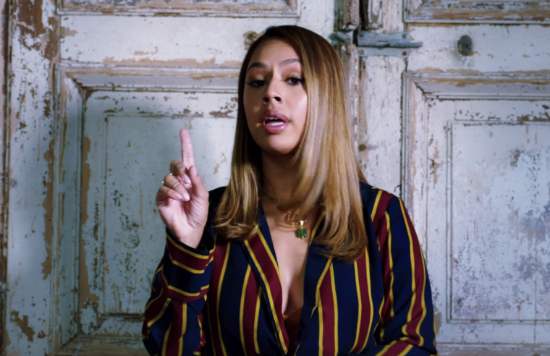

**Tabitha**

**At a glance**

Tabitha recently came to prominence in the Netherlands thanks to a big hit with an already established musician named ‘Ronnie Flex’. She tried getting a foothold in the United States but moved back to the Netherlands and has since sung in the Dutch language. She recently founded a foundation to help kids with insecurity issues.

**What is Tabitha’s target audience?**

Age: 14-28

Gender: Mostly female

Location: All of the Netherlands and Flanders

**How does Tabitha relate with her target group?**Tabitha is doing a lot to relate to and connect with her audience. She feels a special connection with a lot of her following because of similar upbringing and backgrounds. She likes to share her experiences with her followers and even founded a foundation to help with insecurities among youth.

* Sings in Dutch
* Collaborating with other popular artists in her target group
* Being present on the right platforms
* Singing about relevant things
* Talking about and helping with issues prevalent in the target group

**What are Tabitha’s main ways of communicating?***Instagram (170k+ followers)*:

*Facebook (20k followers):*



**Snelle**

**At a glance**

Lars Bos called as the rapper Snelle is following an study at the Herman Brood Academie and got in Februari 2019 a golden record and in April 2019 a platina record for his song Scars. Lars was born with a cleft and was used to be bullied because of his appearance. His song Reünie is all about this bullying behavior.

**What is Snelle’s target audience?**

*Target Audience:*

Age: 12-24

Gender: Male & Female

Location: All of the Netherlands

**How does Snelle relate with his target group?**

As earlier stated has Maan a good connection with her target group, she does multiple things to reach this stronghold with the her target group.

* Raps in Dutch
* Collaborates with other popular artists in his target group
* Being present on the right platforms
* Raps about real and relevant things

**What is Snelle his main ways of communicating?**Snelle communicates with his fans mostly with social media platforms like Facebook and Instagram. He has also a manager that is helping him with his bookings etc. Snelle is also going to plan making his own label “Lieve Jongens”. *Instagram (266k+ followers)*: used more as a personal way of communicating and relating to his fans and followers. Snelle mostly uses instagram to update his followers.

*Facebook (4k followers):* Snelle is almost not using his Facebook. It’s already a long time ago he uploaded some content on there. Mostly his label / manager will upload upcoming events on other accounts.

*Website:* He has no website, he is using <https://atbookings.com/boeken/snelle/> so you can book him there.