**✅ Rekomendasi Perbaikan untuk Query**

**Langkah 1:** Tambahkan index:  
sql  
CREATE INDEX idx_transaksi_tanggal ON transaksi(tanggal_transaksi);

CREATE INDEX idx_transaksi_produk ON transaksi(id_produk);

**Langkah 2:** Gunakan materialized view jika memungkinkan:

Sql  
CREATE MATERIALIZED VIEW mv_penjualan_produk AS

SELECT p.id_produk, p.nama_produk, SUM(t.total_harga) AS total_penjualan, DATE_TRUNC('month', t.tanggal_transaksi) AS bulan

FROM transaksi t

JOIN produk p ON t.id_produk = p.id_produk

GROUP BY p.id_produk, p.nama_produk, DATE_TRUNC('month', t.tanggal_transaksi);

**Langkah 3:** Query bisa cukup dari materialized view:

sql

SELECT nama_produk, SUM(total_penjualan) AS total_penjualan

FROM mv_penjualan_produk

WHERE bulan BETWEEN '2023-01-01' AND '2023-12-31'

GROUP BY nama_produk

ORDER BY total_penjualan DESC;

Desain database

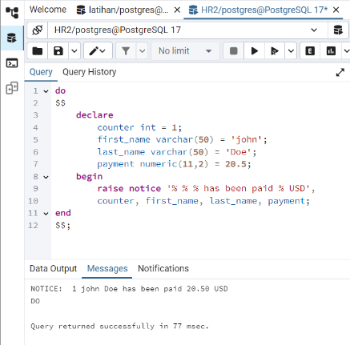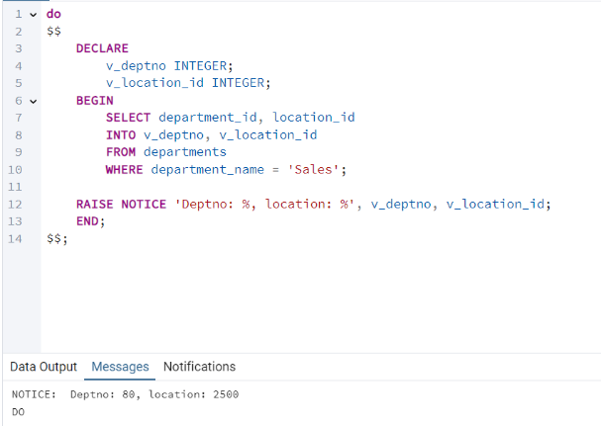

**🧩 Komponen Utama dalam Desain Database**

**1. Entitas (Entity)**

Objek nyata yang datanya ingin kita simpan. Contoh:

* Mahasiswa
* Produk
* Pelanggan
* Transaksi

**2. Atribut**

Sifat atau informasi dari entitas.  
Contoh pada entitas Mahasiswa:

* nim, nama, jurusan, angkatan

**3. Primary Key (PK)**

Kolom unik yang membedakan setiap baris.  
Contoh: id_produk, nim, id_transaksi

**4. Foreign Key (FK)**

Kolom yang menghubungkan satu tabel ke tabel lain.  
Contoh: id_pelanggan di tabel transaksi mengacu ke id_pelanggan di tabel pelanggan.

