HOME PAGE (INDEX.PHP)

<!doctype **html**>  
<**html lang="en"**>  
<**head**>  
 <**meta charset="UTF-8"**>  
 <**meta name="viewport"  
 content="width=device-width, user-scalable=no, initial-scale=1.0, maximum-scale=1.0, minimum-scale=1.0"**>  
 <**meta http-equiv="X-UA-Compatible" content="ie=edge"**>  
 <**title**>Index Page</**title**>  
  
 <**link href="https://fonts.googleapis.com/css?family=Raleway" rel="stylesheet"**/>  
 <**link rel="stylesheet" href="https://maxcdn.bootstrapcdn.com/font-awesome/4.7.0/css/font-awesome.min.css"**/>  
 <**script src="http://localhost/libs/js/jQuery.js" type="text/javascript"**></**script**>  
 <**link rel="stylesheet" href="assets/css/index.css"**/>  
 <**link rel="stylesheet" href="assets/css/navbar.css"**/>  
 <**link rel="stylesheet" href="assets/css/global.css"**/>  
  
  
  
</**head**>  
<**body**>  
 *<!-- start navbar -->* **<?php include "assets/html/navbar.php"**;**?>** *<!-- end navbar -->  
  
 <!-- start container here -->* <**div class="right-container"**>  
 <**div class="right-inner-container clearfix"**>  
 <**h3 class="right-inner-container-title" id="beranda-inner-container-title"**>Beranda</**h3**>  
</**div**>  
 <**div class="right-inner-container"**>  
 <**p**>Selamat Datang di website saya</**p**>  
 <**p**>  
 Website ini berisi tentang Koleksi buku,  
 juga untuk melihat referensi nya  
 </**p**>  
 </**div**>  
 </**div**>  
 *<!-- end container here -->*</**body**>  
 <**script src="assets/js/navbar.js"**></**script**>  
 <**script src="assets/js/index.js"**></**script**>  
</**html**>

Home Page

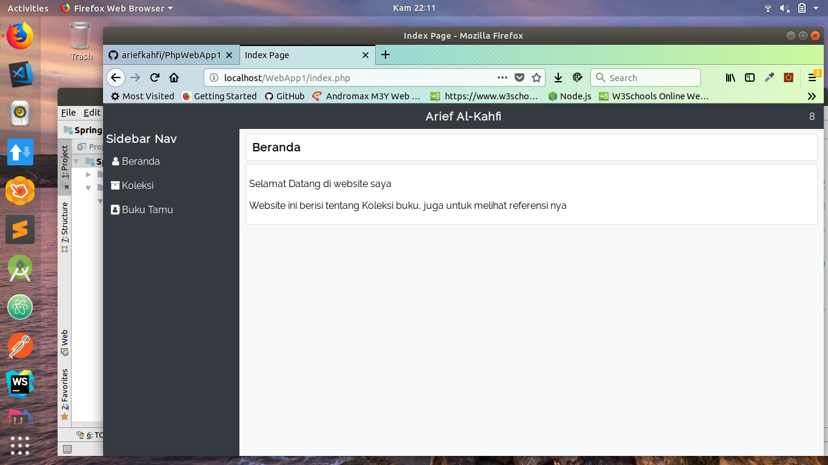

Halaman detail buku (buku-detail.php)

<!doctype **html**>  
<**html lang="en"**>  
<**head**>  
 <**meta charset="UTF-8"**>  
 <**meta name="viewport"  
 content="width=device-width, user-scalable=no, initial-scale=1.0, maximum-scale=1.0, minimum-scale=1.0"**>  
 <**meta http-equiv="X-UA-Compatible" content="ie=edge"**>  
 <**title**>Detail Page</**title**>  
 <**link rel="stylesheet" href="https://maxcdn.bootstrapcdn.com/font-awesome/4.7.0/css/font-awesome.min.css"**/>  
 <**script src="http://localhost/libs/js/jQuery.js" type="text/javascript"**></**script**>  
 <**link rel="stylesheet" href="/WebApp1/assets/css/navbar.css"**/>  
 <**link rel="stylesheet" href="/WebApp1/assets/css/global.css"**/>  
 <**link rel="stylesheet" href="/WebApp1/assets/css/dialog.css"**/>  
</**head**>  
<**body**>  
 **<?php include "../assets/html/navbar.php" ?>** <**div class="right-container"**>  
 <**div class="right-inner-container"**>  
 <**h3 class="right-inner-container-title" id="detail_title"**></**h3**>  
 </**div**>  
 <**div class="right-inner-container"**>  
 <**h3 class="right-inner-container-title" id="detail_kategori"**></**h3**>  
 </**div**>  
 <**div class="right-inner-container"**>  
 <**div class="right-inner-content"** >  
 <**div class="right-inner-content-image-wrapper" id="detail_gambar_container"**>  
</**div**>  
 <**p id="detail_deskripsi"**></**p**>  
 </**div**>  
 </**div**>  
 </**div**>  
  
</**body**>  
 <**script src="/WebApp1/assets/js/navbar.js"**></**script**>  
 <**script src="/WebApp1/assets/js/deskripsi-buku.js"**></**script**>  
 <**script src="/WebApp1/assets/js/global.js"**></**script**>  
</**html**>

Halaman Buku Tamu (buku-tamu.php)

<!doctype **html**>  
<**html lang="en"**>  
<**head**>  
 <**meta charset="UTF-8"**>  
 <**meta name="viewport"  
 content="width=device-width, user-scalable=no, initial-scale=1.0, maximum-scale=1.0, minimum-scale=1.0"**>  
 <**meta http-equiv="X-UA-Compatible" content="ie=edge"**>  
 <**title**>Buku Tamu</**title**>  
 <**link href="https://fonts.googleapis.com/css?family=Raleway" rel="stylesheet"**/>  
 <**link rel="stylesheet" href="https://maxcdn.bootstrapcdn.com/font-awesome/4.7.0/css/font-awesome.min.css"**/>  
 <**script src="http://localhost/libs/js/jQuery.js" type="text/javascript"**></**script**>  
 <**link rel="stylesheet" href="/WebApp1/assets/css/navbar.css"**/>  
 <**link rel="stylesheet" href="/WebApp1/assets/css/global.css"**/>  
 <**link rel="stylesheet" href="/WebApp1/assets/css/form.css"**/>  
</**head**>  
<**body**>  
 **<?php include "../assets/html/navbar.php" ?>** <**div class="right-container"**>  
 <**div class="right-inner-container"**>  
 <**h3 class="right-inner-container-title"**>Buku Tamu</**h3**>  
 </**div**>  
 <**div class="right-inner-container" id="form-buku-tamu-container"**>  
 <**h3 class="right-inner-container-title" id="form-buku-tamu-title"**>Form Buku Tamu</**h3**>  
 <**div class="right-inner-content"**>  
 <**div class="form-wrapper"**>  
 <**div class="form-row clearfix"**>  
 <**label for="nama_tamu" class="form-label"**>Nama</**label**>  
 <**input type="text" id="nama_tamu" class="form-input"**/>  
 </**div**>  
 <**div class="form-row clearfix"**>  
 <**label for="saran_tamu" class="form-label"**>Saran Anda</**label**>  
 <**textarea class="form-input" id="saran_tamu" cols="30" rows="10"**>  
  
 </**textarea**>  
 </**div**>  
 <**div class="form-row clearfix"**>  
 <**button class="form-button form-button-blue" id="submitBukuTamu"**>Submit</**button**>  
 </**div**>  
 </**div**>  
 </**div**>  
 </**div**>  
 </**div**>  
  
</**body**>  
 <**script src="/WebApp1/assets/js/global.js"**></**script**>  
 <**script src="/WebApp1/assets/js/navbar.js"**></**script**>

<**script src="/WebApp1/assets/js/buku-tamu.js"**></**script**>  
</**html**>

Form Buku Tamu

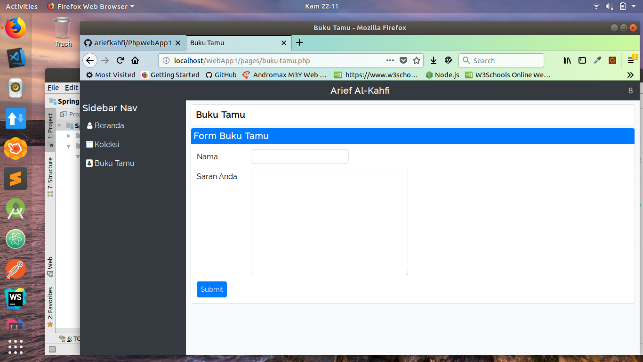

Halaman Koleksi (koleksi.php)

<!doctype **html**>  
<**html lang="en"**>  
<**head**>  
 <**meta charset="UTF-8"**>  
 <**meta name="viewport"  
 content="width=device-width, user-scalable=no, initial-scale=1.0, maximum-scale=1.0, minimum-scale=1.0"**>  
 <**meta http-equiv="X-UA-Compatible" content="ie=edge"**>  
 <**title**>Koleksi</**title**>  
  
 <**link href="https://fonts.googleapis.com/css?family=Raleway" rel="stylesheet"**/>  
 <**link rel="stylesheet" href="https://maxcdn.bootstrapcdn.com/font-awesome/4.7.0/css/font-awesome.min.css"**/>  
 <**script src="http://localhost/libs/js/jQuery.js" type="text/javascript"**></**script**>  
 <**link rel="stylesheet" href="/WebApp1/assets/css/navbar.css"**/>  
 <**link rel="stylesheet" href="/WebApp1/assets/css/global.css"**/>  
 <**link rel="stylesheet" href="/WebApp1/assets/css/dialog.css"**/>  
 <**link rel="stylesheet" href="/WebApp1/assets/css/form.css"**/>  
</**head**>  
<**body**>  
 **<?php include "../assets/html/navbar.php"**;**?>** <**div class="right-container"**>  
  
 <**div class="right-inner-container clearfix"**>  
 <**h3 class="right-inner-container-title" id="koleksi-title"**>Koleksi</**h3**>  
 <**div id="tambah-koleksi"**>  
 <**i class="fa fa-lg fa-plus fa-fw"**></**i**>Tambah Koleksi  
 </**div**>  
 </**div**>  
  
<**div class="right-inner-container"**>  
 <**div class="card-container clearfix" id="card-container"**>  
  
</**div**>  
 </**div**>  
 </**div**>  
  
 <**div class="dialog-outer-container" id="koleksi-dialog-outer-container"**>  
 <**div class="dialog-inner-container"**>  
 <**h3 class="dialog-inner-container-title"**>Tambah Koleksi Buku</**h3**>  
 <**div class="dialog-inner-container-content"**>  
<**div class="form-wrapper"**>  
 <**div class="form-row clearfix"**>  
 <**label for="nama_buku" class="form-label"**>Nama Buku</**label**>  
 <**input type="text" id="nama_buku" class="form-input"**/>  
 </**div**>  
 <**div class="form-row clearfix"**>  
 <**label for="kategori_buku" class="form-label"**>Kategori Buku</**label**>  
 <**select id="kategori_buku" class="form-input"**>  
 <**option value="novel"**>Novel</**option**>  
 <**option value="pendidikan"**>Pendidikan</**option**>  
 <**option value="politik"**>Politik</**option**>  
 </**select**>  
 </**div**>  
 <**div class="form-row clearfix"**>  
 <**label for="desk_buku" class="form-label"**>Deskripsi Buku</**label**>  
 <**textarea id="desk_buku" class="form-input" cols="30" rows="10"**></**textarea**>  
 </**div**>  
 <**div class="form-row clearfix"**>  
 <**label for="pilih_buku_container" class="form-label"**>Pilih File</**label**>  
 <**div id="pilih_buku_container" class="form-input"**>  
 <**input type="file" id="pilih_buku"**/>  
 </**div**>  
 </**div**>  
 <**div class="form-row"**>  
 <**button class="form-button-blue form-button" id="upload_file"**>Submit Data</**button**>  
 </**div**>  
 </**div**>  
  
 </**div**>  
 </**div**>  
 </**div**>  
  
</**body**>  
 <**script src="/WebApp1/assets/js/global.js"**></**script**>  
 <**script src="/WebApp1/assets/js/koleksi.js"**></**script**>  
 <**script src="/WebApp1/assets/js/navbar.js"**></**script**>  
 <**script src="/WebApp1/assets/js/dialog.js"**></**script**>  
</**html**>

Halaman Koleksi Buku

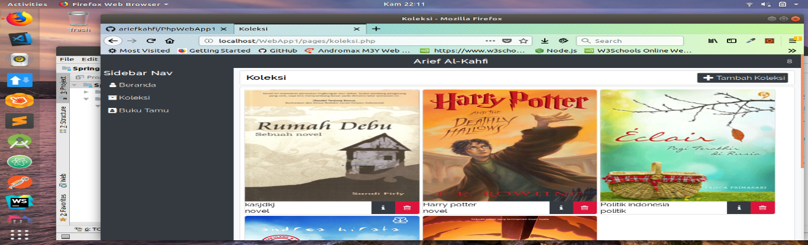

Navigasi bar

**<?php  
 include_once "/var/www/html/WebApp1/models/base/BasePDO.php"**;  
  
 $pageWasRefreshed = **isset**($_SERVER[**'HTTP_CACHE_CONTROL'**]) && $_SERVER[**'HTTP_CACHE_CONTROL'**] === **'max-age=0'**;  
 $nama_berkas = **"/var/www/html/WebApp1/counter/counter.txt"**;  
**if**(*file_exists*($nama_berkas)){  
 $berkas = *fopen*($nama_berkas,**"r"**);  
 $pencacah = (integer)*trim*(*fgets*($berkas,255));  
  
**if**($pageWasRefreshed){  
 $pencacah++;  
 }  
  
 *fclose*($berkas);  
 }**else** $pencacah = 1;  
  
 $berkas = *fopen*($nama_berkas,**"w"**);  
 *fputs*($berkas,$pencacah);  
 *fclose*($berkas);  
**?>**<**nav id="top-navbar-fixed-container"**>  
 <**nav id="top-navbar"**>  
 <**div id="top-navbar-item-container"**>  
 <**h3 class="title space" id="title-top-navbar"**>  
 Arief Al-Kahfi  
 </**h3**>  
 <**div id="top-navbar-visitor-counter-container" class="space"**>  
 <**span**>  
 **<?php****echo** $pencacah;  
 **?>** </**span**>  
 </**div**>  
 </**div**>  
 <**div id="top-navbar-secondary-item-container"**>  
 <**div class="horizontal-line"**></**div**>  
 <**div class="left-navbar-content"**>  
 <**i class="fa fa-user fa-fw"**></**i**><**a class="left-navbar-content-a"**>Beranda</**a**>  
 </**div**>  
 <**div class="left-navbar-content"**>  
 <**i class="fa fa-archive fa-fw"**></**i**><**a class="left-navbar-content-a"**>Koleksi</**a**>  
 </**div**>  
 <**div class="left-navbar-content"**>  
 <**i class="fa fa-address-book fa-fw"**></**i**><**a class="left-navbar-content-a"**>Buku Tamu</**a**>  
 </**div**>  
 </**div**>  
 </**nav**>  
</**nav**>  
  
<**nav id="left-navbar"**>  
 <**h3 class="title" id="left-navbar-title"**>Sidebar Nav</**h3**>  
 <**div id="left-navbar-container"**>  
 <**div class="left-navbar-content"**>  
 <**i class="fa fa-user fa-fw"**></**i**><**a class="left-navbar-content-a" id="b-a"**>Beranda</**a**>  
 </**div**>  
 <**div class="left-navbar-content"**>  
 <**i class="fa fa-archive fa-fw"**></**i**><**a class="left-navbar-content-a" id="k-a"**>Koleksi</**a**>  
 </**div**>  
 <**div class="left-navbar-content"**>  
 <**i class="fa fa-address-book fa-fw"**></**i**><**a class="left-navbar-content-a" id="b-t-a"**>Buku Tamu</**a**>  
 </**div**>  
 </**div**>  
</**nav**>