
Ben Gurion University of the Negev

Flood Detection Using Yamnet-based Sound Classification

A Final Project Report
Course No. 001-2-5074
Submitted to Dr Elad Levintal

The Jacob Blaustein Institutes for Desert Research

Submitted by: Arie Kobylansky ID No. 207223447
Nitzan Hahamov ID No. 315224816
Noam Budin ID No. 313266686
July 2026

Introduction

Flash floods are among the most hazardous and least predictable hydrological events in arid and semi-arid such as the Negev Desert. Ephemeral desert streams (known by the Arabic term as wadi) remain dry for prolonged periods in these environments, and afterwards convey sudden, high-energy flows in response to intense, often spatially localized, convective rainfall. These events are characteristically sharp and unexpected, thus reaching peak discharge in only a few hours of the causative storm, leaving very little warning or response time and making them notoriously difficult to forecast with conventional instrumentation. Moreover, they are frequently destructive, as was seen in the 2010 flash floods that struck Egypt, which caused 13 deaths and further affected 16,000 people. (Saber et al., 2015). The most dangerous characteristic of wadi floods is that there is little or no visual warning about the oncoming deluge, as the channel may remain completely dry despite occurring rainfall kilometers upstream. However, this does not mean that there can be no warning at all. The sound of a turbulent flow over a rough channel bed produces a broadband, sustained sound signature that is very distinct from both rainfall and the quiet flow of a dry channel. Hence, for detecting wadi floods, acoustic sensing is an attractive modality for early warning, as it is low-cost, omnidirectional, robust to darkness and poor visibility, and capable of detecting an approaching front before it reaches the sensor. These properties make microphones less constrained by the line-of-sight and orientation that affect camera-based monitoring (Bansal & Garg, 2022).

The automatic interpretation of such acoustic signals falls within the field of environmental sound classification (ESC), which has matured considerably over the past decade. A comprehensive review by Bansal and Garg (2022) documents the standard ESC pipeline: data collection, preprocessing, feature extraction, feature selection, and classification, and notes that, while deep neural networks now generally surpass traditional machine-learning classifiers in accuracy, the absence of large, consolidated benchmark datasets remains a persistent obstacle that is frequently addressed through data augmentation. In the specific context of arid-zone flood monitoring, existing detection approaches rely predominantly on radar and satellite remote sensing, in-channel water-level or pressure transducers, rain-gauge networks, and physical-based distributed hydrological models driven by satellite precipitation estimates (Saber et al., 2015). These methods are powerful but are typically expensive, depend on fixed infrastructure or continuous connectivity, and in the case of in-channel instruments are physically vulnerable to the very flows they measure; moreover, conventional rain-gauge networks poorly capture the storms that generate flash floods, and the chronic paucity of high-quality observational data in arid regions further limits model-based forecasting (Saber et al., 2015). There is consequently a clear gap: no low-cost, self-contained acoustic system designed to perform real-time flood detection at the edge in arid wadi environments, where intermittent power and the absence of reliable network coverage are the norm. The need for low-complexity recognition systems that can run on constrained embedded hardware, rather than on power-hungry deep models requiring GPUs, has been emphasized directly in the embedded-audio literature (Jesudhas & Ranjan, 2024).

This work addresses that gap by developing and deploying a complete, low-cost acoustic flashflood early-warning system that runs entirely on a single-board computer at the edge. Rather than training a deep network from scratch, which is an approach that overfits severely on the small, imbalanced datasets typical of this domain, the system adopts a transfer-learning strategy built on YAMNet, a convolutional model pretrained by Google on the large-scale AudioSet corpus. YAMNet serves as a fixed feature extractor, producing a 1024-dimensional embedding for each three-second audio segment, on top of which a compact dense classifier distinguishes three classes: flowing flood water (flood_water), rainfall (rain), and the dry ambient state (ambient_dry). This design mirrors recent findings that YAMNet-based transfer learning yields compact, high-accuracy classifiers from limited labelled data and is well suited to resource-constrained edge deployment, outperforming heavier architectures such as ResNet-50 and VGG-16 (Liu et al., 2025). The trained classifier is exported to the TensorFlow Lite format and executed on a UNIHIKER single-board computer (ARM Cortex-A35, 512 MB RAM). When flood conditions are detected, the system issues remote logs classification results locally for later analysis. The result is a self-contained, field-deployable demonstrator that illustrates how modern pretrained audio models can be adapted to run on inexpensive edge hardware for environmental monitoring in arid regions.
Materials and Methods

Hardware

The entire system is built around a single, self-contained single-board computer (SBC), the UNIHIKER, which integrates the compute, sensing, display, and alerting functions in one inexpensive unit. The UNIHIKER is a Linux-based SBC built around a quad-core ARM Cortex-A35 processor with 512 MB of RAM, running Python 3.7 with TensorFlow 2.7 — the version constraint that governed the model-export strategy described in Section 2.2 — and several required peripherals are integrated directly on the board, removing the need for external sensors or breakout modules: a built-in microphone provides the acoustic input the classifier operates on, a 2.8-inch colour touchscreen (240 × 320 pixels) serves as the local user interface for displaying live class probabilities and on-screen controls; the use of the integrated microphone rather than an external acoustic sensor keeps the bill of materials minimal but imposes a known limitation on input quality that is discussed in Section 4. During development the UNIHIKER is connected to a power supply over a single USB-C cable that supplies power from a portable power bank. power is drawn from a standard 5 V USB with no dedicated power-conditioning or battery-management module used in the present prototype — a choice whose implications for true field autonomy are addressed in Section 4 — and data logging is handled entirely on-device, with classification records written as comma-separated-value (CSV) files to the board's internal storage, as detailed in Section 2.2.
[Figure 1 — Connection diagram: UNIHIKER ↔ host PC via USB-C (power + SSH/SCP); UNIHIKER ↔.]

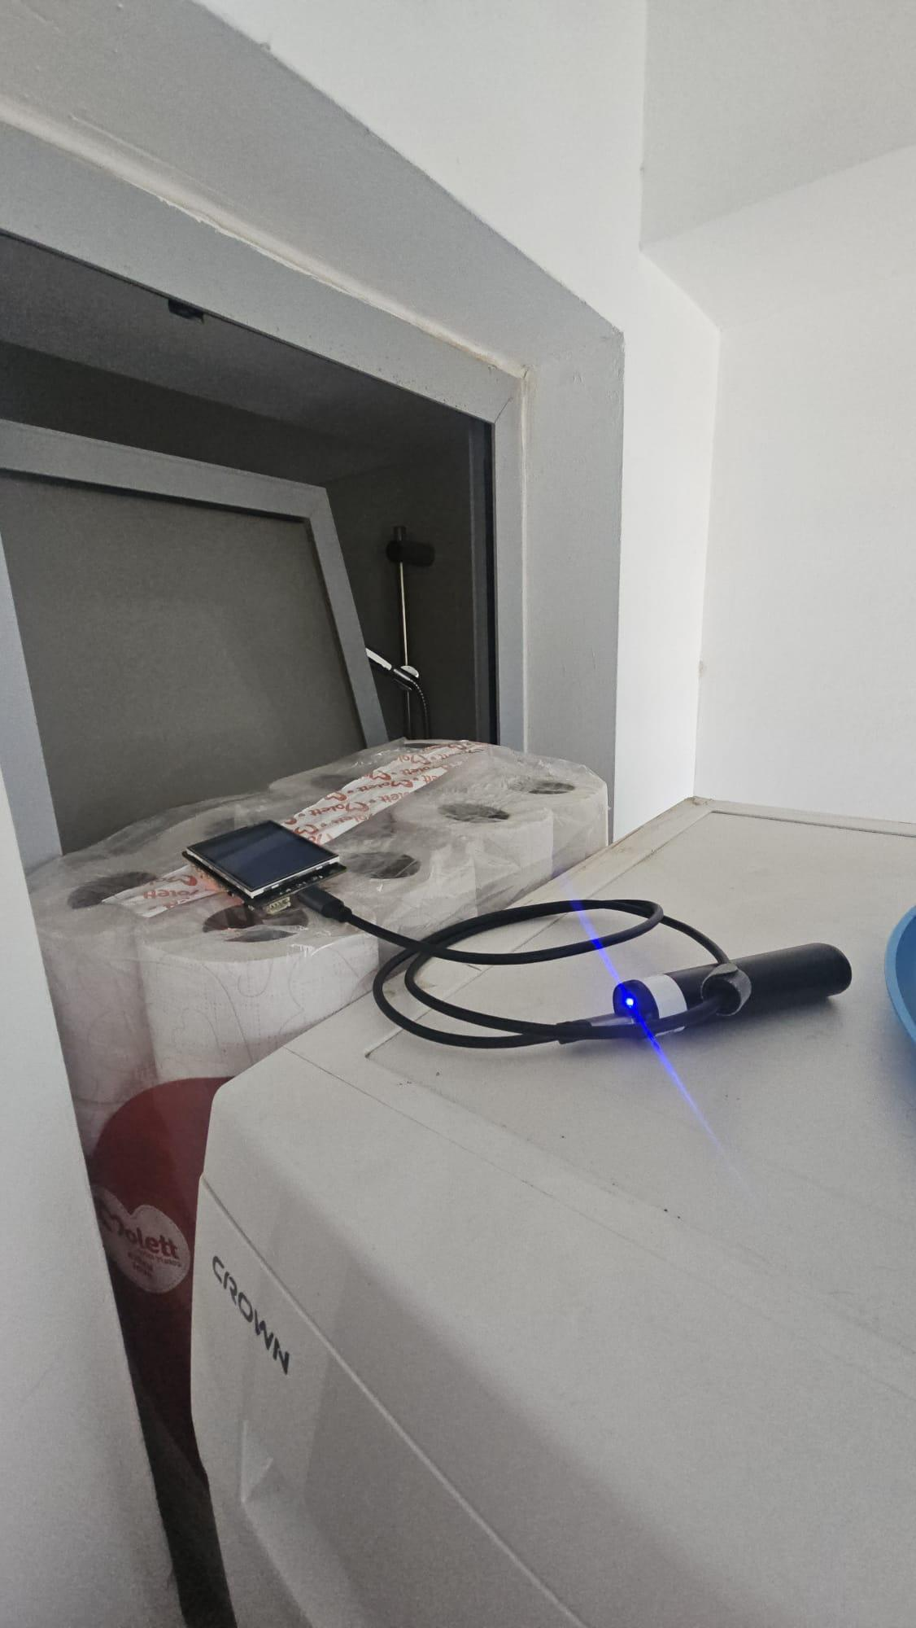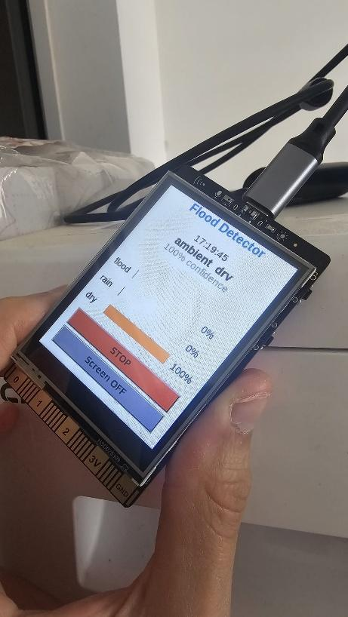
A
B
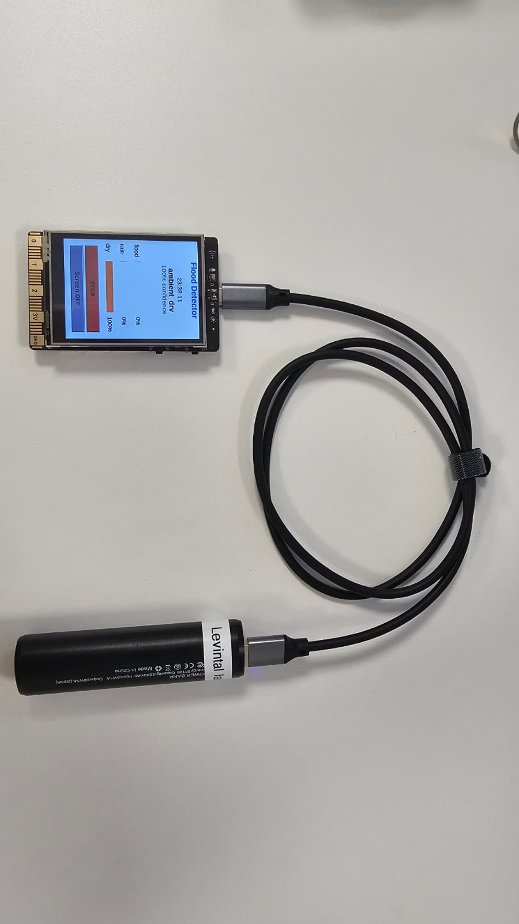
C
Figure 2 - Indoor deployment of the acoustic flood detector for the controlled monitoring run (a) The device positioned near the bathroom fixtures to capture dry-ambient conditions with intermittent shower, sink, and toilet events serving as proxies for sustained water flow. (b) The UNIHIKER displaying the live interface per-class probability bars, current prediction and confidence, and touchscreen controls — here reporting ambient_dry at 100% confidence. (c) - clear view of the setup - unihiker running the model and connected to a powerbank

TABLE OF MATERIALS
# | Component | Specification | Quantity | Function
1 | UNIHIKER single-board computer | Quad-core ARM Cortex-A35, 512 MB RAM, built-in microphone, 240 × 320 touchscreen | 1 | On-device audio capture, inference, and display
2 | USB Type-C cable | Standard USB-C, power/data | 1 | Power delivery from power bank to board
3 | Portable power bank | 5V USB output 2500mAh capacity | 1 | Untethered power supply for the run

Software
The software is written in Python and organized into three pipelines: open-source data collection, model training (executed once in Google Colab with GPU acceleration), and on-device deployment (detect.py) for real-time inference. Only two compact TensorFlow Lite files are transferred to the UNIHIKER, keeping the on-device code minimal, which is consistent with the need for sound-recognition systems that run on resource-constrained embedded hardware rather than full deep networks (Jesudhas & Ranjan, 2024; Liu et al., 2025). The runtime loop is shown in Figure 3.

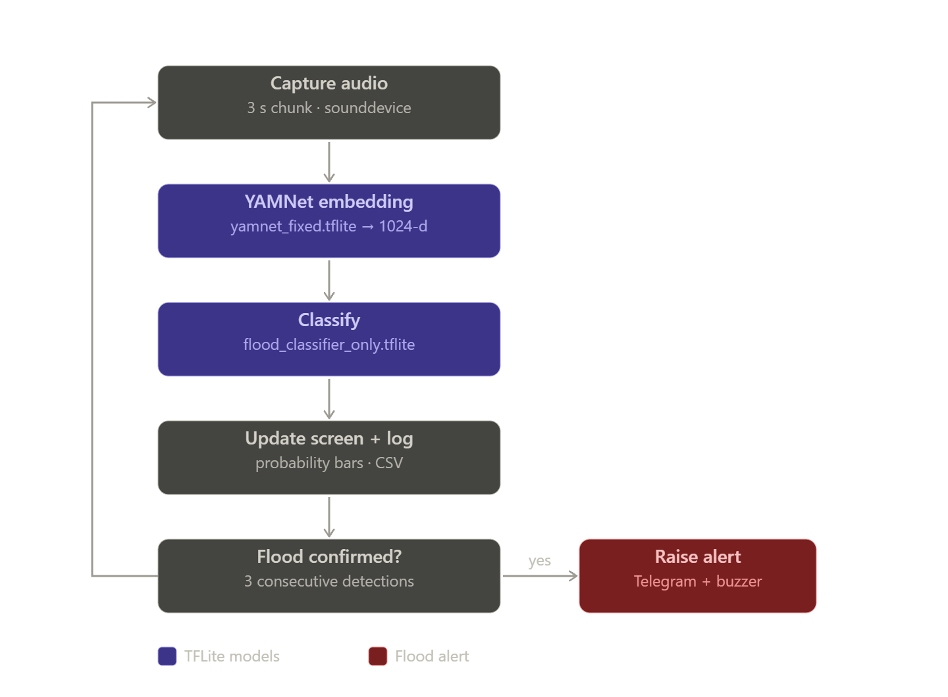
Figure 3 - Flow Chart For flood detection

Model training. YAMNet (Google's AudioSet-pretrained network) is used as a frozen feature extractor, converting each 3 s segment (48 000 samples at 16 kHz) into a 1024-dimensional embedding. A small dense classifier (1024 → 256 → 128 → 3) is then trained on these embeddings, achieving approximately 95% validation accuracy. This freeze-and-fine-tune approach mitigates the overfitting to which from-scratch CNNs are prone on small datasets, and follows the established YAMNet transfer-learning paradigm (Bansal & Garg, 2022; Liu et al., 2025). Two TensorFlow Lite files are exported: yamnet_fixed.tflite (fixed input [1, 48 000] → output [1, 1024]) and flood_classifier_only.tflite (~100 kB). The fixed input shape was required for reliable behavior across the differing TensorFlow versions of the two environments, a constraint discussed further in Section 4.

Deployment. On the UNIHIKER, both models are executed via tflite_runtime. detect.py records 3 s chunks using sounddevice, performs inference in a background thread, displays live class-probability bars on the touchscreen, and logs results to CSV at 15 s intervals.

Results and Discussion

The classifier was trained on YAMNet embeddings with the convolutional feature extractor held frozen and only the dense head (1024 → 256 → 128 → 3) optimized. On the validation set (n = 203), the model achieved 95% overall accuracy, with per-class results summarized in Table 1 and the confusion matrix shown in Figure 4. Recall was 0.88 for flood_water, 0.98 for rain, and 0.95 for ambient_dry, with precision high across all classes. Residual errors were concentrated at the flood_water–rain boundary, as expected given the spectral similarity of broadband water noise under both conditions: of 42 flood_water samples, five were misclassified as rain, while the ambient_dry class was well separated (four of 80 misclassified), confirming that the synthetic clips added to that class resolved the earlier contamination problem. This level of performance is consistent with the use of frozen, AudioSet-pretrained embeddings on a small dataset (Bansal & Garg, 2022) and is closely comparable to the 94.21% reported by Liu et al. (2025) for an equivalent YAMNet transfer-learning approach.

It must be emphasized that these metrics derive from curated audio and reflect validation rather than field performance. As Jesudhas and Ranjan (2024) demonstrate, laboratory accuracy tends to overstate real-time reliability for embedded acoustic recognition (80% validation versus 60% real-time). Field validation has therefore not yet been completed. As a first controlled test under realistic conditions, a multi-day monitoring run is planned in which the detector is deployed indoors with intermittent running-water events (cistern refill and flush), providing continuous ambient_dry recordings interspersed with broadband water noise as a proxy for the flood/rain classes; results will characterize the false-positive rate under sustained dry-ambient conditions and inform recalibration of the detection threshold and consecutive-detection count prior to wadi deployment

Class | Precision | Recall | F1-score | Support
flood_water | 0.93 | 0.88 | 0.90 | 42
rain | 0.91 | 0.98 | 0.94 | 81
ambient_dry | 1.00 | 0.95 | 0.97 | 80
Accuracy |  |  | 0.95 | 203
Macro avg | 0.94 | 0.94 | 0.94 | 203
Weighted avg | 0.95 | 0.95 | 0.95 | 203
Table 1. Per-class performance of the YAMNet-based classifier on the validation set (n = 203).
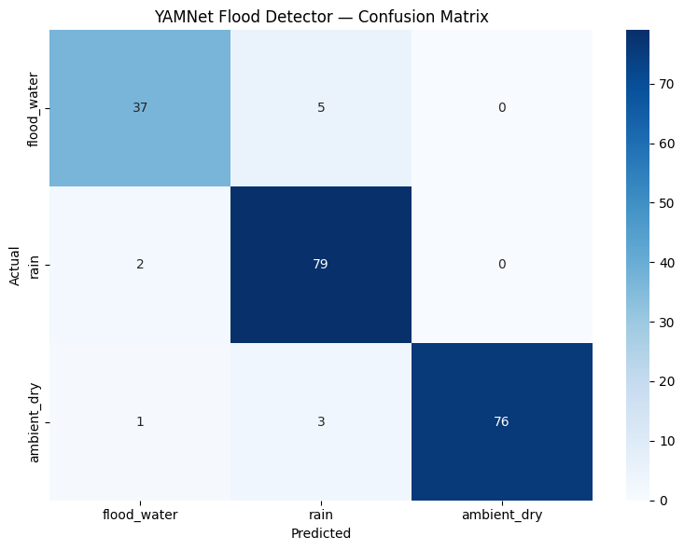
Figure 4 - Confusion matrix for the YAMNet-based classifier on the validation set (n = 203), with rows indicating actual class and columns predicted class.
The detector was deployed in a domestic bathroom over three monitoring sessions totalling approximately 38 h (Run 1: 12.6 h from 17 June 17:19; Run 2: 12.5 h from 18 June 21:06; Run 3: 12.5 h from 25 June 03:01), each separated by a gap during which the power supply ran out. The average runtime on one 2500mAh power bank was 12.6 hours. There was an attempt to reduce the consumption by turning the screen off but due to the screen's technology (LCD) it showed no change as the black screen consumes a similar amount of power(De Sousa et al, 2025).

the first two on consecutive days and the third roughly a week later. Across the combined 8,782 logged chunks, the model predicted ambient_dry for 8,423 chunks (95.9%), flood_water for 274 (3.1%), and rain for 85 (1.0%), yielding an overall non-ambient (false-positive) rate of approximately 4.1% under conditions that were predominantly dry (Figure 5). The third run was the most active, contributing a substantial share of the flood_water predictions with several short excursions reaching 40–50% class probability, while the first two runs stayed closer to baseline. Even so, in a realistic indoor acoustic environment the model maintains a high ambient_dry baseline and does not trigger spurious water detections at high frequency.
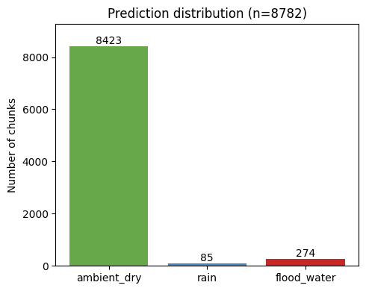
Figure 5 - Distribution of per-chunk predictions over the combined monitoring run

The temporal structure of the detections (Figure 6) is informative when interpreted against the household water-use events recalled during the runs. The largest and most sustained flood_water excursions, such as those in which the smoothed flood probability rose above approximately 30% for several consecutive chunks, coincided with shower use and other continuous high-flow events, during which the microphone was exposed to broadband running-water noise closely resembling the flood_water training class. This behaviour was most pronounced in Run 3, which contained several such excursions reaching 40–50% probability. In contrast, the numerous brief, low-amplitude spikes distributed across all three runs corresponded most plausibly to short, intermittent water events such as handwashing at the sink and toilet use. These produced transient probability excursions that rarely persisted beyond one or two chunks. This pattern is consistent with the intended detection logic: genuine sustained water flow elicits a strong, prolonged response, whereas incidental water noise produces only short-lived activations.
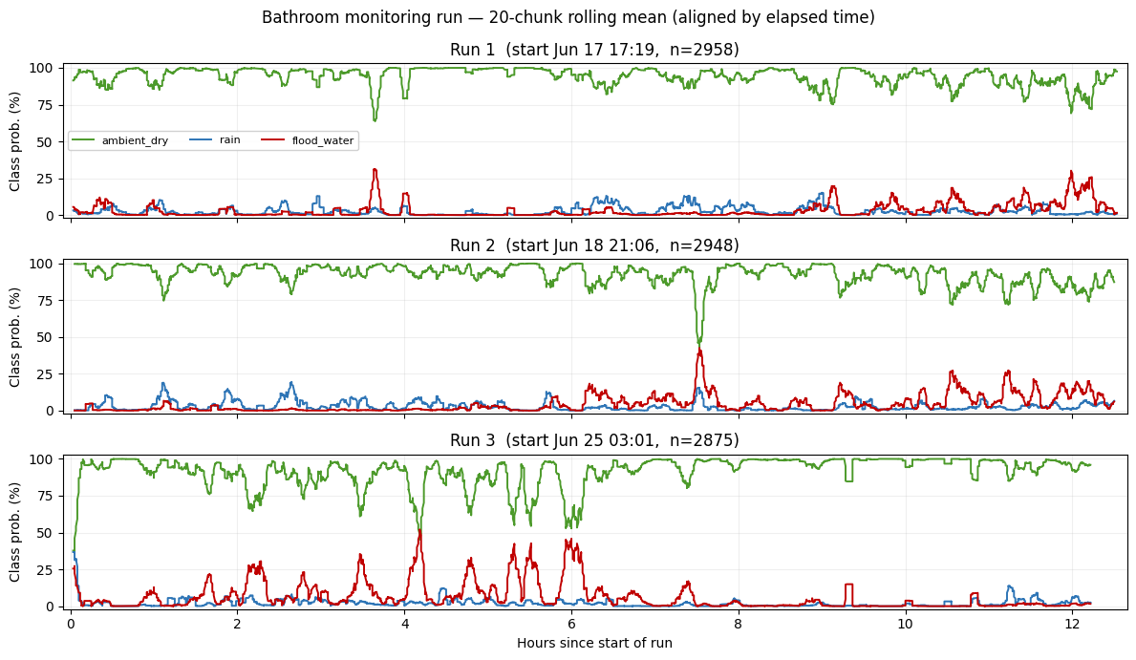
Figure 6 - Smoothed class probabilities during the three-bathroom monitoring sessions, plotted against elapsed time since the start of each run (20-chunk rolling mean, ~5 min). Run 1 (top), Run 2 (middle), and Run 3 (bottom) are shown separately because power interruptions between runs prevent treating the logs as a single continuous record.
This distinction has a direct operational implication. Because the consecutive-detection requirement (three successive positive chunks before an alert is issued) discriminates by persistence rather than by peak amplitude, the brief handwashing- and shower-related spikes are largely suppressed, while sustained flow events of the kind that a flood would produce are retained. The bathroom run therefore provides preliminary evidence that the debouncing rule effectively separates incidental indoor water noise from sustained flow, although it should be emphasized that these event attributions are based on occupant recollection rather than a synchronized event log, and that the shower serves only as an approximate acoustic proxy for flood flow. The run also exposed a practical power constraint: the portable power bank sustained continuous operation for an average of 12.6 h before draining completely, which terminated the first session and necessitated splitting the experiment into two separate runs. A controlled run with timestamped ground-truth events would be required to quantify detection latency and recall against known water onsets, and continuous unattended deployment would require a substantially larger power reserve or improving efficiency.

Challenges and considerations

Several limitations qualify the present findings and define the work required before operational deployment. First, the bathroom monitoring run, while informative as a first test under realistic indoor acoustics, does not constitute a validation of flood detection: the water events it captured (shower, sink, and toilet use) serve only as approximate acoustic proxies for wadi flow, and the run characterizes the false-positive rate under dry conditions rather than the model's recall against genuine floods. Rigorous validation would require a controlled experiment with known, timestamped water onsets. For instance, an artificial flood simulator or instrumented flume that reproduces the broadband, sustained, debris-laden character of wadi flow, so at detection latency and recall can be quantified against ground truth. Second, the system as demonstrated is a proof of concept rather than a field-ready instrument. Its scaling to autonomous field deployment introduces requirements not addressed here, including reliable connectivity at remote sites lacking Wi-Fi, weatherproofing and microphone protection against dust and moisture, and validation against the natural background sounds of a wadi environment (wind, fauna, vehicular and human activity), which differ substantially from the indoor conditions tested. Third, energy supply is a critical unresolved constraint: the present run was terminated by battery exhaustion after approximately 12 h, whereas a deployed early-warning station must operate unattended for weeks or months. A viable deployment would therefore require a dedicated power solution, most plausibly a solar panel coupled with a rechargeable battery, given the high solar availability of the Negev, together with reductions in the system's duty cycle or power draw to ensure sustained autonomous operation. Addressing these constraints, together with the collection of real Negev flood recordings, defines the path from the present prototype to a field-deployable system.

Conclusion

This work aimed to showcase a functional, low-cost acoustic flash flood early-warning system built on YAMNet-based transfer learning and deployed on an edge single-board computer. The classifier achieved a 95-percent validation accuracy across three classes, namely flood_water, rain, and ambient_dry, with performance consistent with comparable YAMNet transfer-learning approaches in literature. The controlled indoor monitoring run, which totalled into approximately 38 hours, confirmed that the system maintains a high ambient_dry baseline (~96.7 percent of chunks) and that the consecutive-detection debouncing logic effectively suppresses brief, incidental water noise while retaining sustained flow events.

However, the system remains a proof of concept at this stage, as key limitations (absence of field validation against real wadi floods, the use of acoustic proxies through indoor water events, unresolved weatherproofing and connectivity requirements for remote deployment, and a 12-hour ceiling on power supply) still remain. Once these limitations are addressed, a field-deployable early-warning instrument can be made and vetted, as this proof of concept’s result can be effectively adapted for environmental monitoring using inexpensive edge hardware. Lastly, this also offers a viable alternative or complement to conventional radar- and gauge-based flooed detection in arid regions.

References:

Bansal, A., & Garg, N. K. (2022). Environmental sound classification: A descriptive review of the literature. Intelligent Systems with Applications, 16, 200115. https://doi.org/10.1016/j.iswa.2022.200115

De Sousa, J. O., Ribeiro, R. M., Pinheiro, B. De M., & Arnez, J. J. A. (2025). Power consumption analysis in LCD and AMOLED display technologies for mobile devices. Proceedings of the 2025 IEEE International Conference on Consumer Electronics (ICCE), Las Vegas, NV, USA, 1–2. 10.1109/ICCE63647.2025.10930080

Jesudhas, P. P., & Ranjan, P. V. (2024). A novel approach to build a low complexity smart sound recognition system for domestic environment. Applied Acoustics, 221, 110028. https://doi.org/10.1016/j.apacoust.2024.110028

Liu, L., Xu, Q., Mao, S., Mu, J., Zhao, X., Song, W., & Cheng, P. (2025). YAMNet-based transfer learning for compact noise classification in urban and wireless systems. EURASIP Journal on Wireless Communications and Networking, 2025, Article 74. https://doi.org/10.1186/s13638-025-02483-8

Saber, M., Hamaguchi, T., Kojiri, T., Tanaka, K., & Sumi, T. (2015). A physically based distributed hydrological model of wadi system to simulate flash floods in arid regions. Arabian Journal of Geosciences, 8(1), 143–160. https://doi.org/10.1007/s12517-013-1190-0

