NAMA | : | Ari Eka Prianda
NPM | : | 12522045
PRODI | : | Teknik Informatika (A)

DOKUMENTASI SISTEM
======================================================================
DOKUMEN KODE PROGRAM & PEMROGRAMAN
SKEMA SERTIFIKASI: PEMROGRAM MUDA (ASSOCIATE PROGRAMMER)
Kode Dokumen: FR.IA.02 - Tugas Praktik Demonstrasi | LSP EDI
Judul Aplikasi: Sistem Informasi Perpustakaan Digital (Manajemen Buku)
======================================================================
---------------------------------------------------------------------------------------------------------------------------
A. SPESIFIKASI LINGKUNGAN PENGEMBANGAN (TOOLS & ENVIRONMENT)
---------------------------------------------------------------------------------------------------------------------------1. Tools / Software Pemrograman yang Digunakan:
- Text Editor / IDE: Visual Studio Code / Antigravity IDE
- Web Server: Apache (via XAMPP v8.2)
- Database Management System (DBMS): MySQL Server 8.3
- Web Browser: Google Chrome

2. Bahasa Pemrograman yang Digunakan:
- PHP v8.2: Logika Backend, Enkapsulasi OOP, dan Koneksi Basis Data PDO.
- HTML5 & CSS3: Struktur antarmuka dan tata letak gaya UI.
- JavaScript (ES6): Interaktivitas modal dialog dan pemicu ekspor PDF.

3. Library, Komponen Pre-existing, & Framework:
- Bootstrap v5.3 (CDN): Framework CSS untuk tata letak responsif.
- FontAwesome v6.4 (CDN): Library ikon visual.
- html2pdf.js / jsPDF (CDN): Library pihak ketiga (3rd Party Library) untuk eksport PDF.
- Google Fonts (Inter & Plus Jakarta Sans): Tipografi web modern.

---------------------------------------------------------------------------------------------------------------------------B. DOKUMENTASI KODE PROGRAM & ARSITEKTUR SISTEM (OOP)
---------------------------------------------------------------------------------------------------------------------------
Sistem dibangun menggunakan paradigma Pemrograman Berorientasi Objek (OOP) dengan struktur modular:
1. Class Database (classes/Database.php)
- Fungsi: Mengelola koneksi ke database MySQL menggunakan driver PDO.
- Penerapan OOP: Singleton Pattern & Encapsulation. Memiliki fitur Auto-Migration tabel otomatis.
- Metode Utama: getInstance(), getConnection(), initTables().
2. Class Auth (classes/Auth.php)
- Fungsi: Mengelola proses login autentikasi, verifikasi kata sandi (password_verify), dan session pengguna.
- Metode Utama: login($username, $password), check(), user(), logout().
3. Class Buku (classes/Buku.php)
- Fungsi: Mengelola operasi CRUD data buku (Create, Read, Update, Delete), pencarian kata kunci, dan filter kategori.
- Metode Utama: getAll($search, $kategori_id), getById($id), create($data), update($id, $data), delete($id), count().
4. Class Kategori (classes/Kategori.php)
- Fungsi: Mengelola operasi CRUD data kategori/genre buku.
- Metode Utama: getAll(), getById($id), create($nama, $deskripsi), update($id, $nama, $deskripsi), delete($id), count().
5. Class Peminjaman (classes/Peminjaman.php)
- Fungsi: Mengelola transaksi sirkulasi peminjaman/pengembalian buku serta otomatisasi pembaruan stok.
- Metode Utama: getAll(), create($data), returnBook($id, $id_buku), delete($id), countActive().

---------------------------------------------------------------------------------------------------------------------------C. DAFTAR HALAMAN & MODUL TAMPILAN (MINIMAL 5 TAMPILAN)
---------------------------------------------------------------------------------------------------------------------------
1. (Auth/login.php): Halaman Autentikasi Pengguna & Form Login.
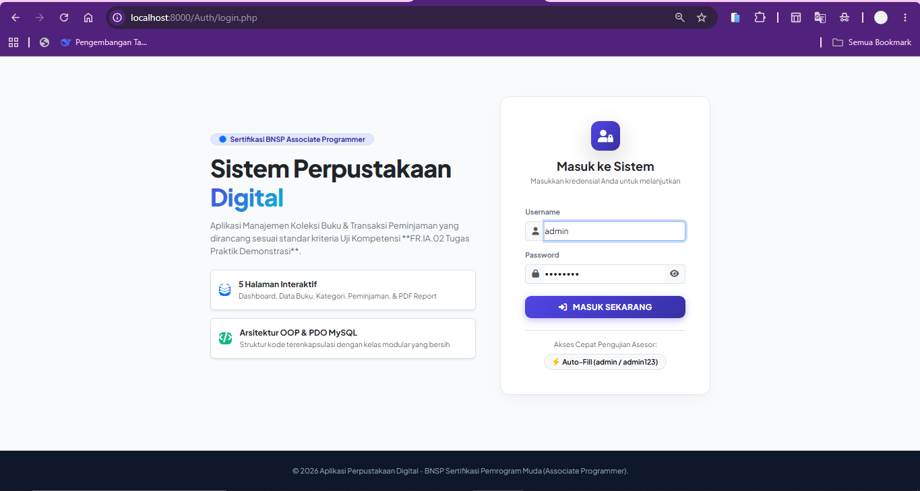
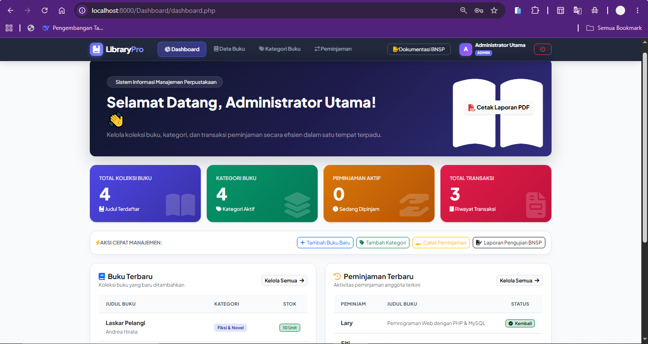
2. (Dashboard/dashboard.php): Dashboard Utama Ringkasan Statistik & Widget Aktivitas.

3. (Buku/buku.php): Pengelolaan Data Buku (CRUD), Modal Form, & Filter Pencarian.
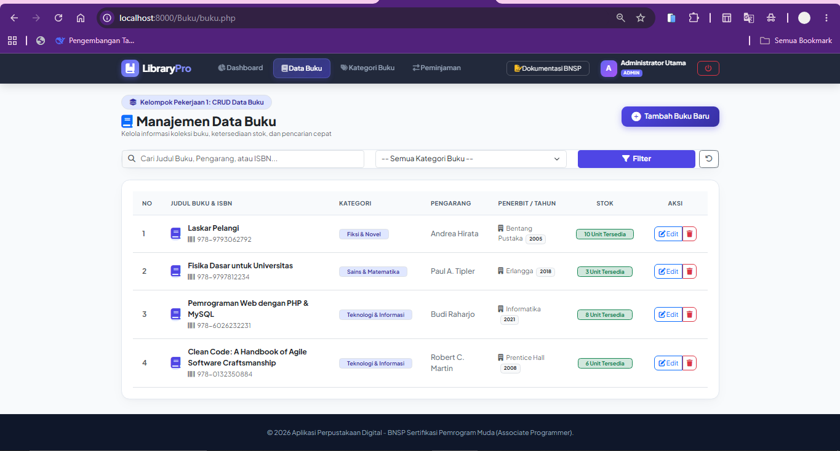
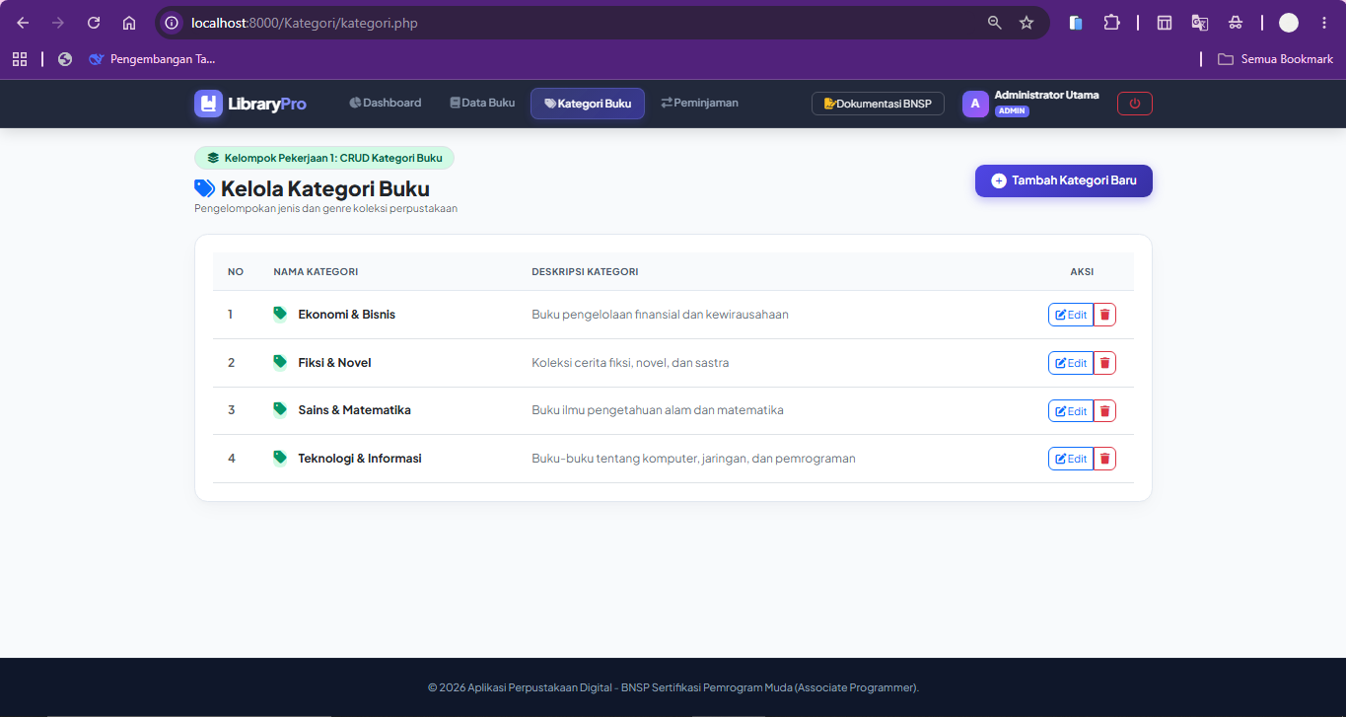
4. (Kategori/kategori.php): Pengelolaan Kategori Buku (CRUD) dalam Tabel Responsif.

5. Halaman 5 (Peminjaman/peminjaman.php): Transaksi Peminjaman, Pengembalian, & Integrasi Cetak PDF.
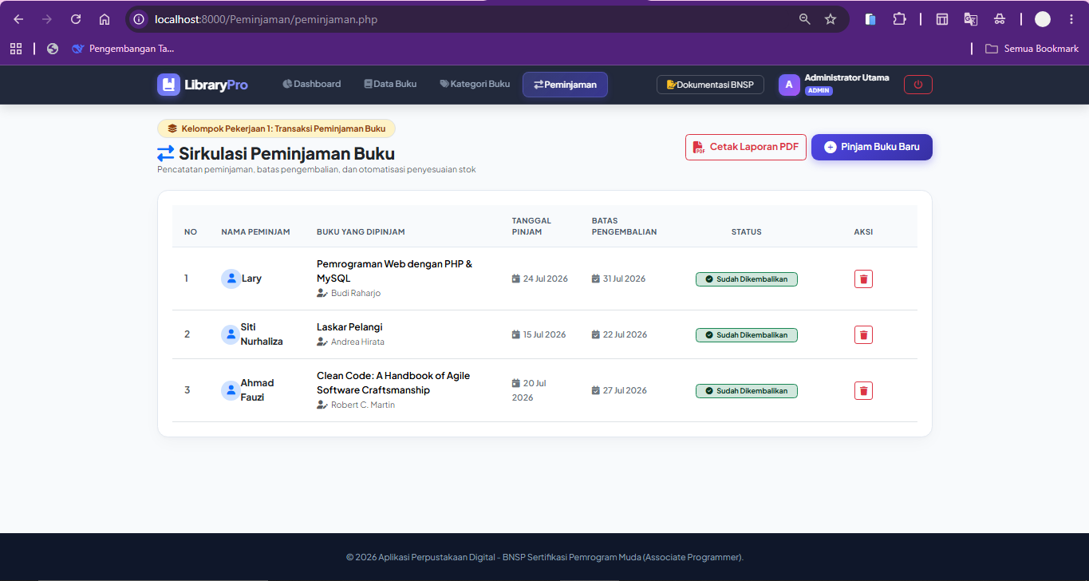
6. (Laporan/cetak_pdf.php): Ekspor Laporan Rekapitulasi Berformat PDF (html2pdf.js).
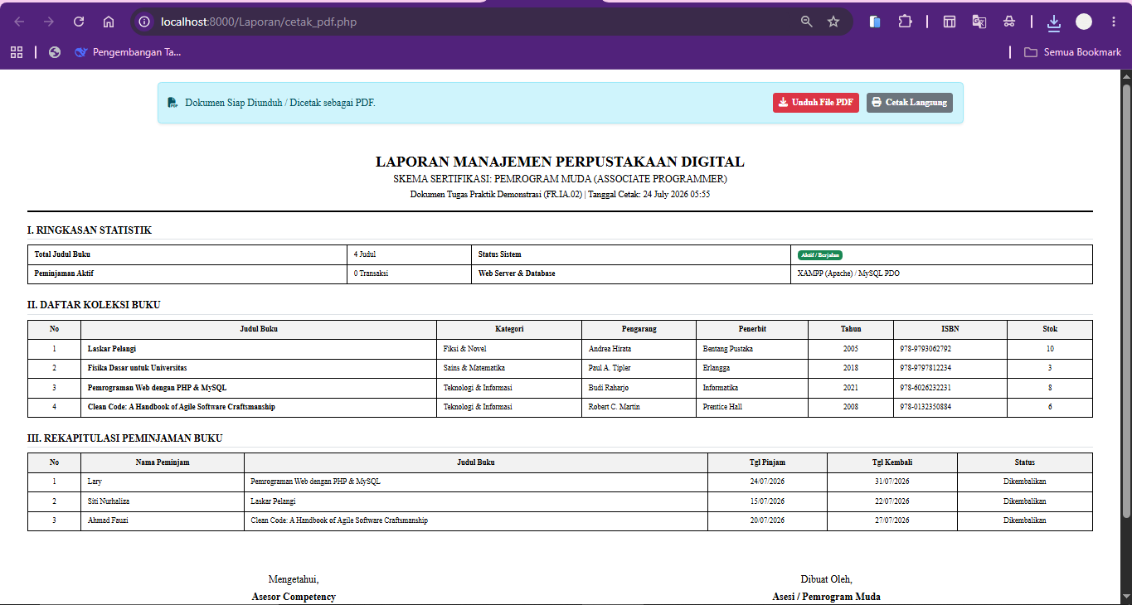

---------------------------------------------------------------------------------------------------------------------------D. HASIL PENGUJIANKODE & DEBUGGING (KELOMPOK PEKERJAAN 2)
---------------------------------------------------------------------------------------------------------------------------
no | Fitur / Unit | Pengujian Skenario | Hasil Diharapkan | Status
1 | Autentikasi | Login username & password valid | Berhasil masuk ke dashboard | PASS
2 | Autentikasi | Login password salah | Menampilkan pesan error validasi | PASS
3 | CRUD Data Buku | Tambah buku baru | Data tersimpan di DB & tabel | PASS
4 | CRUD Data Buku | Edit data buku & ubah stok | Data di DB ter-update akurat | PASS
5 | Filter & Search | Cari judul buku / filter kategori | Tabel menampilkan hasil filter | PASS
6 | Peminjaman Buku | Catat peminjaman baru | Stok buku berkurang 1 | PASS
7 | Pengembalian Buku | Klik tombol kembalikan buku | Status berubah & stok +1 | PASS
8 | Cetak Laporan PDF | Klik tombol Cetak Laporan PDF | File PDF ter-generate | PASS

---------------------------------------------------------------------------------------------------------------------------E. LAMPIRAN SOURCE CODE FILE UTAMA
---------------------------------------------------------------------------------------------------------------------------
1. File: classes/Database.php
--------------------------------------------------------------------------------
<?php
/**
* Class Database
* Memenuhi Unit Kompetensi: J.620100.018.02 (OOP) & J.620100.021.02 (Akses Basis Data)
*/
class Database {
private static $instance = null;
private $host = "localhost";
private $db_name = "db_perpustakaan";
private $username = "root";
private $password = "";
private $conn;

private function __construct() {
try {
// First connect without DB selected to ensure DB exists
$this->conn = new PDO(
"mysql:host=" . $this->host . ";charset=utf8mb4",
$this->username,
$this->password,
[
PDO::ATTR_ERRMODE => PDO::ERRMODE_EXCEPTION,
PDO::ATTR_DEFAULT_FETCH_MODE => PDO::FETCH_ASSOC
]
);

// Create DB if not exists and select it
$this->conn->exec("CREATE DATABASE IF NOT EXISTS `" . $this->db_name . "` DEFAULT CHARACTER SET utf8mb4 COLLATE utf8mb4_unicode_ci");
$this->conn->exec("USE `" . $this->db_name . "`");

// Auto-initialize tables & seeder if not present
$this->initTables();

} catch (PDOException $e) {
die("Koneksi Database Gagal: " . $e->getMessage());
}
}

private function initTables() {
try {
$check = $this->conn->query("SHOW TABLES LIKE 'users'");
if ($check && $check->rowCount() === 0) {
$schemaPath = __DIR__ . '/../database/schema.sql';
if (file_exists($schemaPath)) {
$sql = file_get_contents($schemaPath);
$this->conn->exec($sql);
} else {
$this->createTablesDirectly();
}
}
} catch (Exception $e) {
$this->createTablesDirectly();
}
}

private function createTablesDirectly() {
$queries = [
"CREATE TABLE IF NOT EXISTS `users` (
`id` INT AUTO_INCREMENT PRIMARY KEY,
`username` VARCHAR(50) NOT NULL UNIQUE,
`password` VARCHAR(255) NOT NULL,
`nama_lengkap` VARCHAR(100) NOT NULL,
`role` ENUM('admin', 'petugas') DEFAULT 'admin',
`created_at` TIMESTAMP DEFAULT CURRENT_TIMESTAMP
) ENGINE=InnoDB DEFAULT CHARSET=utf8mb4;",

"CREATE TABLE IF NOT EXISTS `kategori` (
`id` INT AUTO_INCREMENT PRIMARY KEY,
`nama_kategori` VARCHAR(100) NOT NULL,
`deskripsi` TEXT NULL,
`created_at` TIMESTAMP DEFAULT CURRENT_TIMESTAMP
) ENGINE=InnoDB DEFAULT CHARSET=utf8mb4;",

"CREATE TABLE IF NOT EXISTS `buku` (
`id` INT AUTO_INCREMENT PRIMARY KEY,
`id_kategori` INT NOT NULL,
`judul` VARCHAR(200) NOT NULL,
`pengarang` VARCHAR(150) NOT NULL,
`penerbit` VARCHAR(150) NOT NULL,
`tahun_terbit` INT(4) NOT NULL,
`isbn` VARCHAR(30) NULL,
`stok` INT DEFAULT 1,
`created_at` TIMESTAMP DEFAULT CURRENT_TIMESTAMP,
FOREIGN KEY (`id_kategori`) REFERENCES `kategori`(`id`) ON DELETE CASCADE ON UPDATE CASCADE
) ENGINE=InnoDB DEFAULT CHARSET=utf8mb4;",

"CREATE TABLE IF NOT EXISTS `peminjaman` (
`id` INT AUTO_INCREMENT PRIMARY KEY,
`id_buku` INT NOT NULL,
`nama_peminjam` VARCHAR(100) NOT NULL,
`tanggal_pinjam` DATE NOT NULL,
`tanggal_kembali` DATE NOT NULL,
`status` ENUM('dipinjam', 'dikembalikan') DEFAULT 'dipinjam',
`created_at` TIMESTAMP DEFAULT CURRENT_TIMESTAMP,
FOREIGN KEY (`id_buku`) REFERENCES `buku`(`id`) ON DELETE CASCADE ON UPDATE CASCADE
) ENGINE=InnoDB DEFAULT CHARSET=utf8mb4;",

"INSERT INTO `users` (`id`, `username`, `password`, `nama_lengkap`, `role`) VALUES
(1, 'admin', '$2y$10$4y9pB2z8n.VzN0M4A9aQde3.x4K0H6y9aW2l1Q3m5P4o5R6s7T8u9', 'Administrator Utama', 'admin')
ON DUPLICATE KEY UPDATE `username`=`username`;",

"INSERT INTO `kategori` (`id`, `nama_kategori`, `deskripsi`) VALUES
(1, 'Teknologi & Informasi', 'Buku-buku tentang komputer, jaringan, dan pemrograman'),
(2, 'Sains & Matematika', 'Buku ilmu pengetahuan alam dan matematika'),
(3, 'Fiksi & Novel', 'Koleksi cerita fiksi, novel, dan sastra'),
(4, 'Ekonomi & Bisnis', 'Buku pengelolaan finansial dan kewirausahaan')
ON DUPLICATE KEY UPDATE `nama_kategori`=`nama_kategori`;",

"INSERT INTO `buku` (`id`, `id_kategori`, `judul`, `pengarang`, `penerbit`, `tahun_terbit`, `isbn`, `stok`) VALUES
(1, 1, 'Clean Code: A Handbook of Agile Software Craftsmanship', 'Robert C. Martin', 'Prentice Hall', 2008, '978-0132350884', 5),
(2, 1, 'Pemrograman Web dengan PHP & MySQL', 'Budi Raharjo', 'Informatika', 2021, '978-6026232231', 8),
(3, 2, 'Fisika Dasar untuk Universitas', 'Paul A. Tipler', 'Erlangga', 2018, '978-9797812234', 3),
(4, 3, 'Laskar Pelangi', 'Andrea Hirata', 'Bentang Pustaka', 2005, '978-9793062792', 10)
ON DUPLICATE KEY UPDATE `judul`=`judul`;",

"INSERT INTO `peminjaman` (`id`, `id_buku`, `nama_peminjam`, `tanggal_pinjam`, `tanggal_kembali`, `status`) VALUES
(1, 1, 'Ahmad Fauzi', '2026-07-20', '2026-07-27', 'dipinjam'),
(2, 4, 'Siti Nurhaliza', '2026-07-15', '2026-07-22', 'dikembalikan')
ON DUPLICATE KEY UPDATE `nama_peminjam`=`nama_peminjam`;"
];

foreach ($queries as $q) {
try {
$this->conn->exec($q);
} catch (Exception $ex) {
// Continue if already exists
}
}
}

public static function getInstance() {
if (self::$instance === null) {
self::$instance = new Database();
}
return self::$instance;
}

public function getConnection() {
return $this->conn;
}
}

2. File: classes/Buku.php
--------------------------------------------------------------------------------
<?php
/**
* Class Buku
* Memenuhi Unit Kompetensi: J.620100.017.02 & J.620100.018.02 & J.620100.021.02
*/
require_once __DIR__ . '/Database.php';

class Buku {
private $db;
private $table = "buku";

public function __construct() {
$this->db = Database::getInstance()->getConnection();
}

public function getAll($search = '', $kategori_id = '') {
$query = "SELECT b.*, k.nama_kategori
FROM " . $this->table . " b
LEFT JOIN kategori k ON b.id_kategori = k.id
WHERE 1=1";

if (!empty($search)) {
$query .= " AND (b.judul LIKE :search OR b.pengarang LIKE :search OR b.isbn LIKE :search)";
}
if (!empty($kategori_id)) {
$query .= " AND b.id_kategori = :kategori_id";
}

$query .= " ORDER BY b.id DESC";

$stmt = $this->db->prepare($query);

if (!empty($search)) {
$search_param = "%" . $search . "%";
$stmt->bindParam(':search', $search_param);
}
if (!empty($kategori_id)) {
$stmt->bindParam(':kategori_id', $kategori_id);
}

$stmt->execute();
return $stmt->fetchAll();
}

public function getById($id) {
$query = "SELECT b.*, k.nama_kategori
FROM " . $this->table . " b
LEFT JOIN kategori k ON b.id_kategori = k.id
WHERE b.id = :id LIMIT 1";
$stmt = $this->db->prepare($query);
$stmt->bindParam(':id', $id);
$stmt->execute();
return $stmt->fetch();
}

public function create($data) {
$query = "INSERT INTO " . $this->table . " (id_kategori, judul, pengarang, penerbit, tahun_terbit, isbn, stok)
VALUES (:id_kategori, :judul, :pengarang, :penerbit, :tahun_terbit, :isbn, :stok)";
$stmt = $this->db->prepare($query);
$stmt->bindParam(':id_kategori', $data['id_kategori']);
$stmt->bindParam(':judul', $data['judul']);
$stmt->bindParam(':pengarang', $data['pengarang']);
$stmt->bindParam(':penerbit', $data['penerbit']);
$stmt->bindParam(':tahun_terbit', $data['tahun_terbit']);
$stmt->bindParam(':isbn', $data['isbn']);
$stmt->bindParam(':stok', $data['stok']);
return $stmt->execute();
}

public function update($id, $data) {
$query = "UPDATE " . $this->table . "
SET id_kategori = :id_kategori, judul = :judul, pengarang = :pengarang,
penerbit = :penerbit, tahun_terbit = :tahun_terbit, isbn = :isbn, stok = :stok
WHERE id = :id";
$stmt = $this->db->prepare($query);
$stmt->bindParam(':id', $id);
$stmt->bindParam(':id_kategori', $data['id_kategori']);
$stmt->bindParam(':judul', $data['judul']);
$stmt->bindParam(':pengarang', $data['pengarang']);
$stmt->bindParam(':penerbit', $data['penerbit']);
$stmt->bindParam(':tahun_terbit', $data['tahun_terbit']);
$stmt->bindParam(':isbn', $data['isbn']);
$stmt->bindParam(':stok', $data['stok']);
return $stmt->execute();
}

public function delete($id) {
$query = "DELETE FROM " . $this->table . " WHERE id = :id";
$stmt = $this->db->prepare($query);
$stmt->bindParam(':id', $id);
return $stmt->execute();
}

public function count() {
$query = "SELECT COUNT(*) as total FROM " . $this->table;
$stmt = $this->db->prepare($query);
$stmt->execute();
$row = $stmt->fetch();
return $row['total'];
}
}

======================================================================
LEMBAR PENGESAHAN HASIL DEMONSTRASI
======================================================================

Mengetahui, Dibuat Oleh,
Asesor Competency Asesi / Pemrogram Muda

( ________________________ ) ( ________________________ )
No. Reg: __________________ Tanggal: 24 / 07 / 2026

