**JUnit Guide** 陳振炎 2020.03.12

This document gives an example of using JUnit, a useful Java unit testing tool. A test code “TestAdd” is developed to test source code “add” method.

Double click on Eclipse icon. Click OK on workspace.

On upper left corner, click File, move to New, and select Others. Click Java Project. Click Next. For Project Name, type “p”. Then, click Finish.

Open Perspective? Click Yes.

Click “p” in project explorer on upper left corner. Click File, move to New, and select Class. For package, type “p1”. For Name, type “Main”. Then click Finish.

Copy the below to it:

class Main {

public static void main (String[] args) {

C o1 = new C();

o1.add(6);

}

}

Click “p” in project explorer on upper left corner. Click File, move to New, and select Class. For package, type “p1”. For Name, type “C”. Then click Finish.

Copy the below to it:

class C {

int a=3;

public C ( ) { }

public int add (int b) {

return (this.a + b);

}

}

We have now entered Java code. Next, let us enter JUnit unit test.

Click File, move to New, and select “JUnit test case”. For name, type “TestC”.

Then click Finish. Add JUnit to build path? Click OK.

Remember to choose New Junit 4 test. (The initial setting is New Junit Jupiter test; and it will be New Junit 5 test)

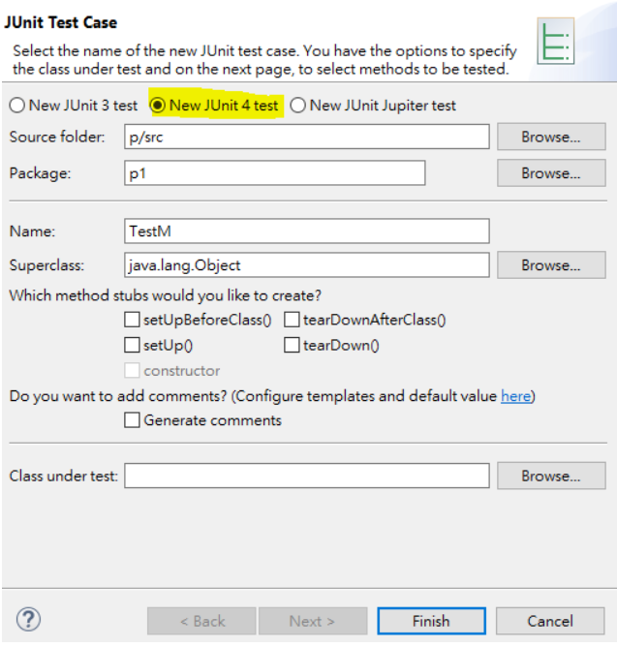

Copy the below to replace the old method:

@Test

public void testC1() {

*assertNotNull* (new C());

}

@Test

**public** **void** testC2() {

*assertEquals* (3, (**new C())**.a);

}

Click File, move to New, and select “JUnit test case”. For name, type “TestAdd”. Then click Finish. Copy the below to replace the old method:

@Test

**public** **void** testAdd1() {

*assertEquals (9,* (**new C())***.add(6) );*

}

@Test

**public** **void** testAdd2() {

*assertEquals (-2,* (**new C())***.add(-5) );*

}

@Test

**public** **void** testAdd3() {

*assertEquals (3,* (**new C())***.add(0) );*

}

Click Run on tool bar. Select Run. Save and Launch? OK.

You will see a green line on the left with “runs 3/3”

3 test cases of TestAdd passed! GOOOOD WORK!!!

Now, play with the exercises below to get familiar with JUnit.

**Exercise:**

In addition to the “add (int b)” method above, develop another method “times (int c)” that returns “a” times “c”. Also, in the “times ” method, the “add” method is called in a “for” loop.

Do the unit test named “TestTimes” after testing “TestAdd.”

Run “TestTimes” to get a green line.