110522130 資工碩一 李信鋌

110526005 資工碩一 林季陽

資料科學實務 – Lab Financial Distress Prediction

Null hypothesis (h0): Baseline model is the best.

Alternative hypothesis (h1): Proposed model is better than (wins) baseline model.

Our result after running code.

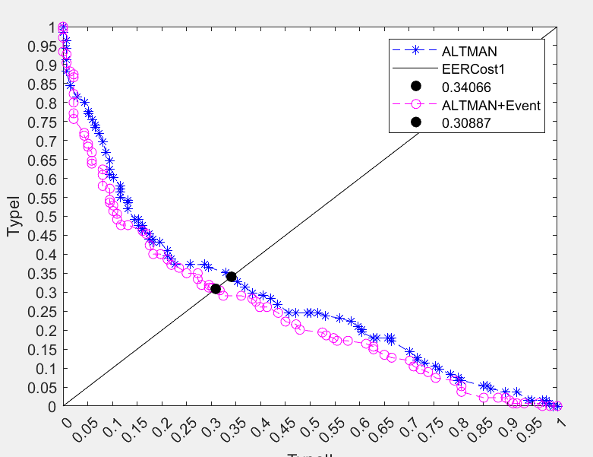

According to DET curve, it shows that the error curve of ALTMAN features (0.34066) is higher than the error curve of ALTMAN+Event features. (0.30887)

Therefore, proposed model is better than baseline model.

Before we are going to use Wilcoxon Test, we need to define the definition of p-value in different intervals.

If p-value < 0.01, there is **overwhelming evidence** to infer that the alternative hypothesis is true.

If 0.01 < p-value < 0.05, there is **strong evidence** to infer that the alternative hypothesis is true.

If 0.05 < p-value < 0.10, there is **weak evidence** to infer that the alternative hypothesis is true.

If 0.1 < p-value, there is **no evidence** to infer that the alternative hypothesis is true.

According to Wilcoxon test, the p-value of Proposed model in 10-fold training test are 1, 0.8867, 1, 1, 1, 1, 1, 1, 1, 1 (Fig 1)

Because none of the p-values of proposed model are between 0.01 to 0.05.

Therefore, we cannot infer that the alternative hypothesis (Proposed model is better than baseline model) is true.

Fig 1. P value figure (L: BASELINE, R: PROPOSED)

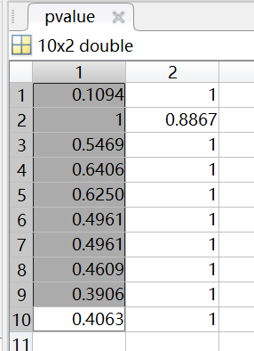

Fig 2. Type I Error Figure

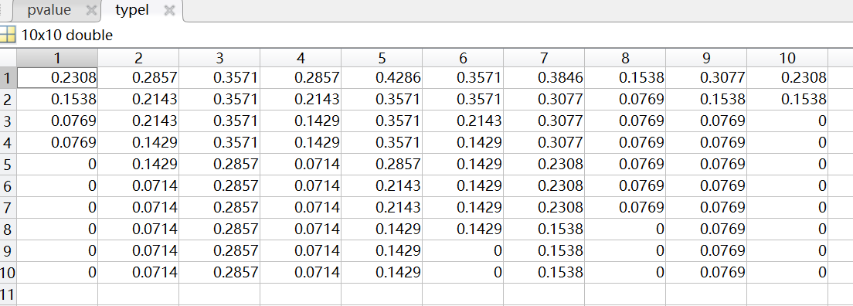

Fig 3. Type II Error Figure

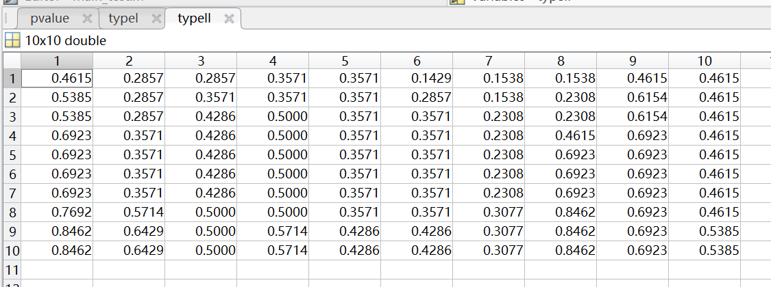

The detailed accuracy. (In confusion matrix line 1)

0.500000000000000 0.500000000000000 0.500000000000000 0.538461538461538 0.538461538461538 0.576923076923077 0.615384615384615 0.615384615384615 0.615384615384615 0.615384615384615 0.615384615384615 0.615384615384615 0.615384615384615 0.615384615384615 0.615384615384615 0.615384615384615 0.615384615384615 0.615384615384615 0.615384615384615 0.653846153846154 0.692307692307692 0.692307692307692 0.692307692307692 0.730769230769231 0.730769230769231 0.730769230769231 0.730769230769231 0.769230769230769 0.769230769230769 0.769230769230769 0.769230769230769 0.769230769230769 0.769230769230769 0.769230769230769 0.769230769230769 0.769230769230769 0.769230769230769 0.769230769230769 0.769230769230769 0.769230769230769 0.769230769230769 0.730769230769231 0.730769230769231 0.730769230769231 0.730769230769231 0.692307692307692 0.653846153846154 0.653846153846154 0.653846153846154 0.653846153846154 0.653846153846154 0.653846153846154 0.653846153846154 0.653846153846154 0.653846153846154 0.653846153846154 0.615384615384615 0.615384615384615 0.615384615384615 0.615384615384615 0.576923076923077 0.615384615384615 0.615384615384615 0.615384615384615 0.576923076923077 0.538461538461538 0.538461538461538 0.538461538461538 0.538461538461538 0.500000000000000 0.538461538461538 0.538461538461538 0.538461538461538 0.538461538461538 0.538461538461538 0.538461538461538 0.576923076923077 0.615384615384615 0.615384615384615 0.615384615384615 0.576923076923077 0.538461538461538 0.576923076923077 0.615384615384615 0.615384615384615 0.615384615384615 0.615384615384615 0.615384615384615 0.615384615384615 0.615384615384615 0.576923076923077 0.538461538461538 0.538461538461538 0.538461538461538 0.538461538461538 0.500000000000000 0.500000000000000 0.500000000000000 0.500000000000000 0.500000000000000