110522130 資工碩一 李信鋌

110526005 資工碩一 林季陽

資料科學實務 – Lab Activity HHT

Code that we have written are inside test.m file.

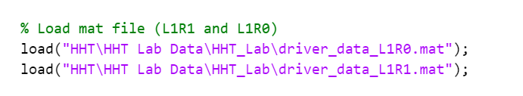

Load the mat file.

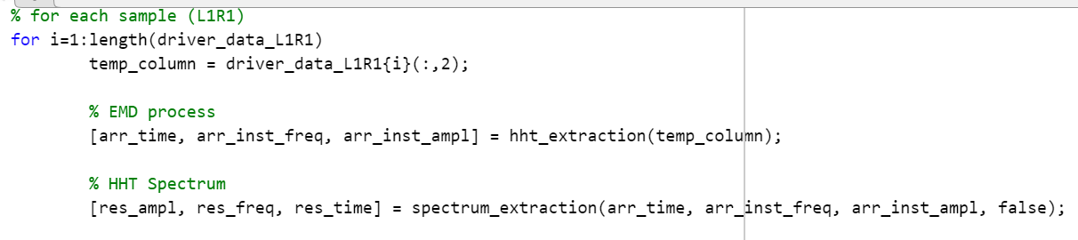

Implement EMD process and HHT Spectrum on L1R1 data.

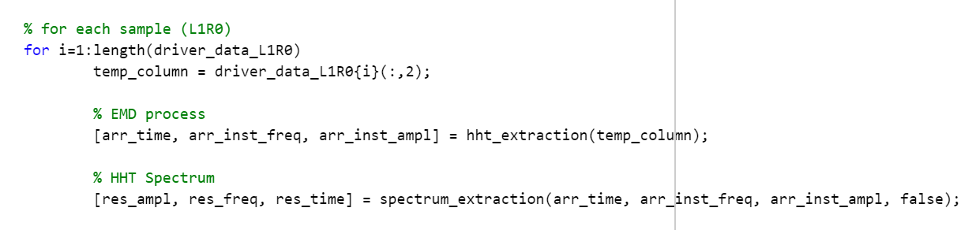

Same process as the above with L1R0 data.

Results of L1R0 (Table)

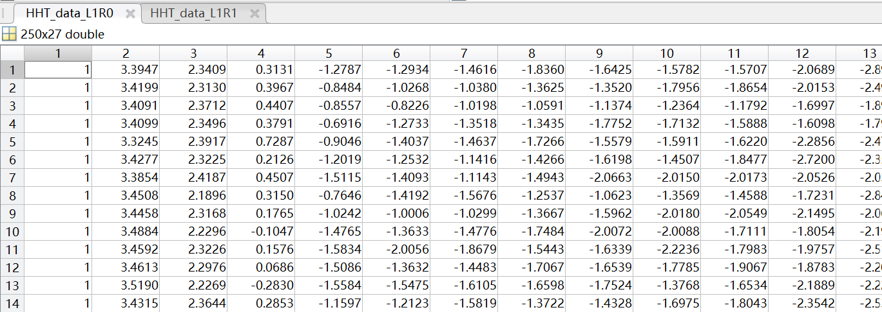

Results of L1R1 (Table)

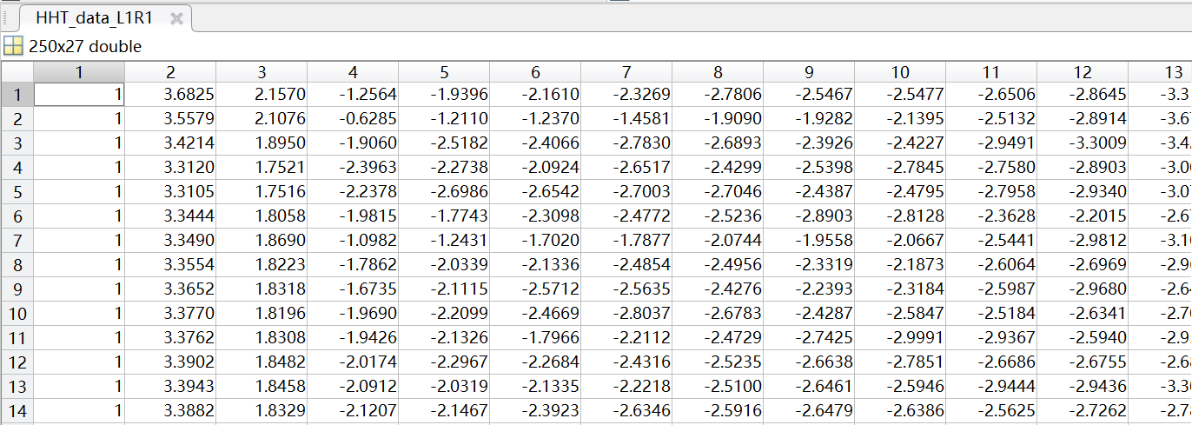

Results of L1R0 (Figure)

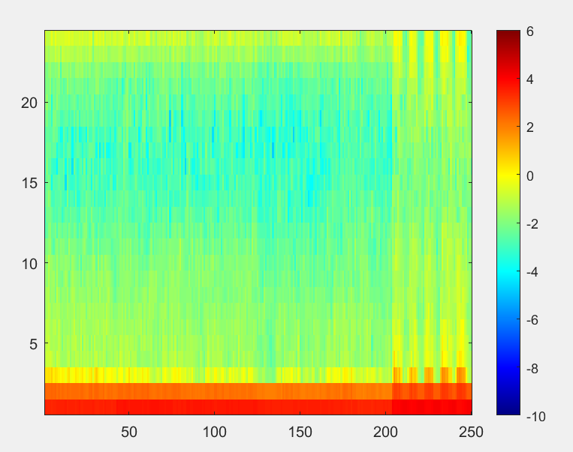

Results of L1R1 (Figure)

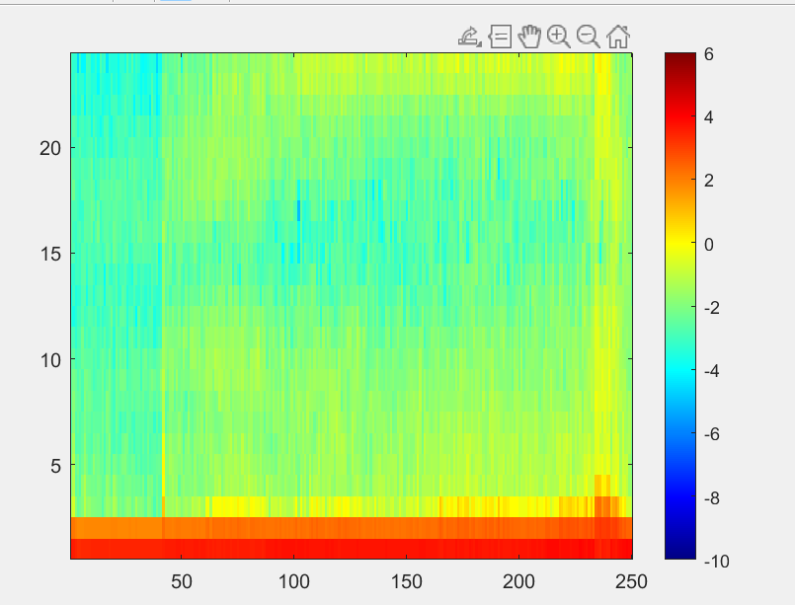

The left side between L1R0 figure and L1R1 figure are different

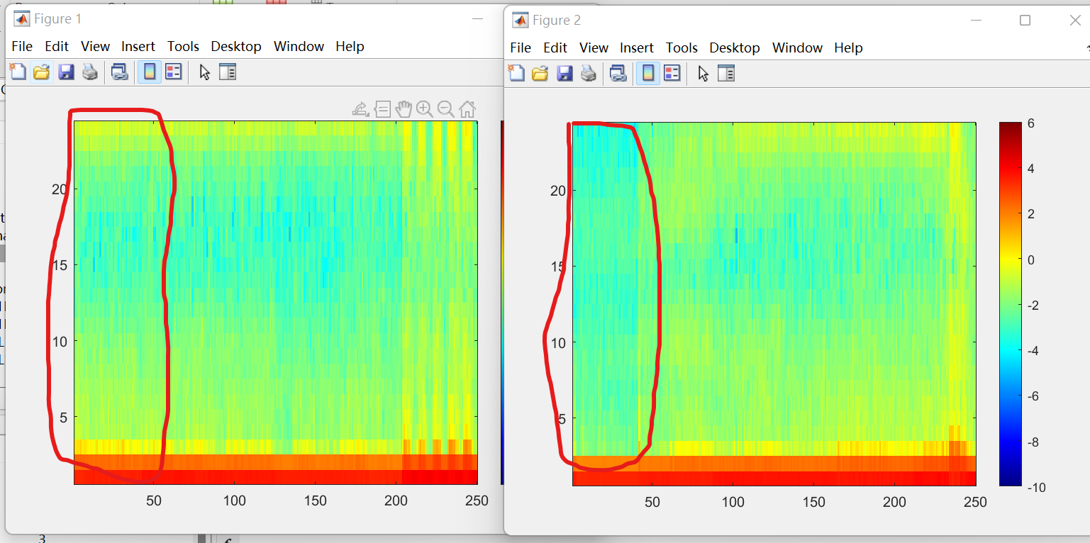

The right parts are also slightly different. It can really show that the driver is driving without right hand.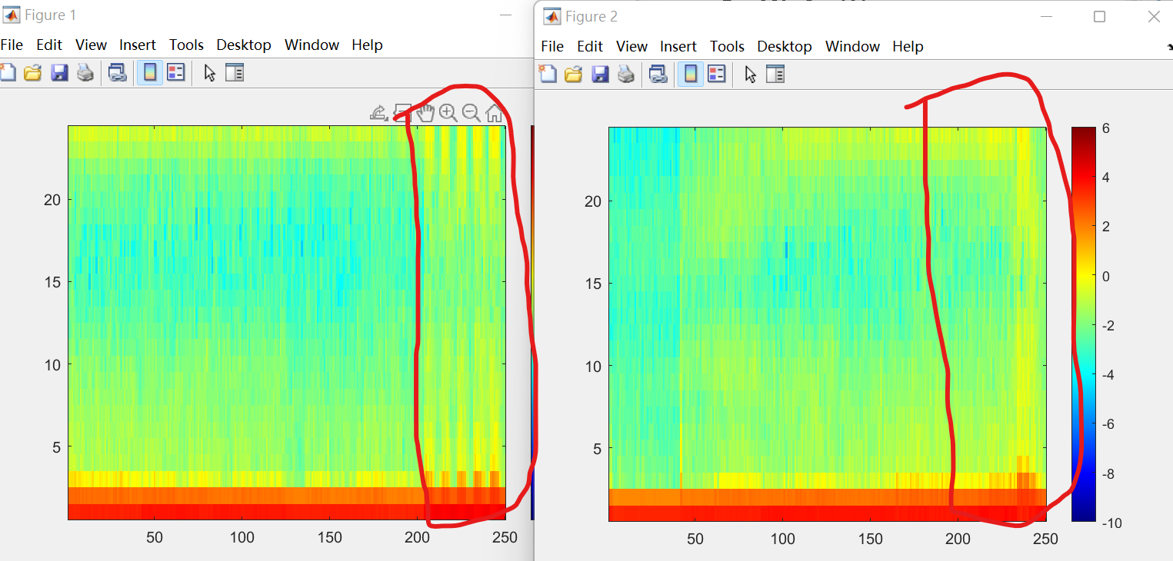

The advantage of using HHT:

1. Tell us which frequencies occur at which times.
2. This also show the time-varying nature of the data.