110522130 資工碩一 李信鋌

110526005 資工碩一 林季陽

資料科學實務 – Lab Activity -- Histogram

The code we have written for this assignment.

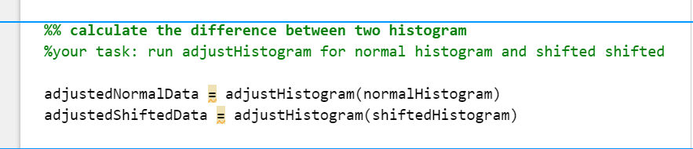

Results

1. Screenshot of original histogram (Normal and Shifted)

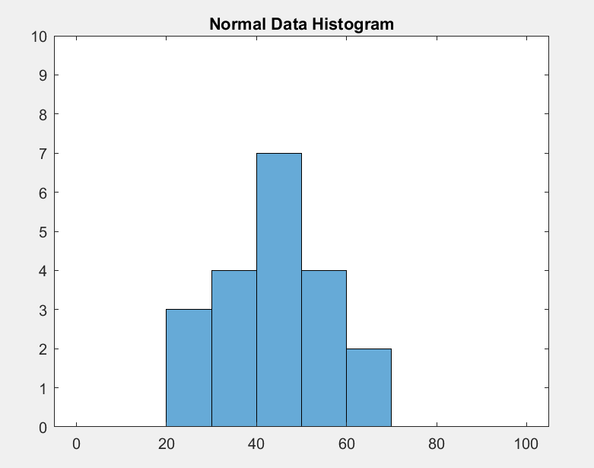 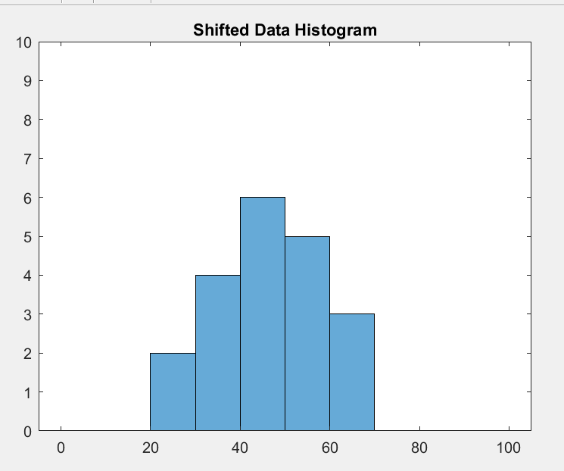

1. Screenshot of adjusted histogram (Normal and Shifted)

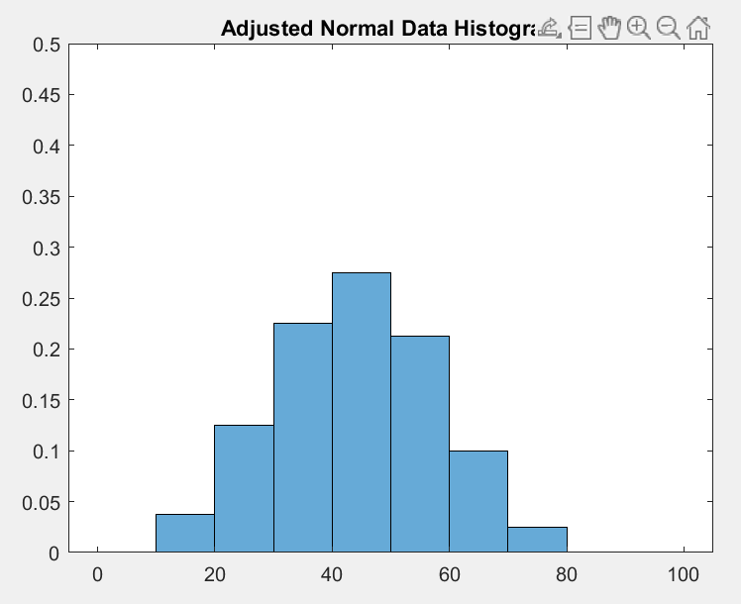 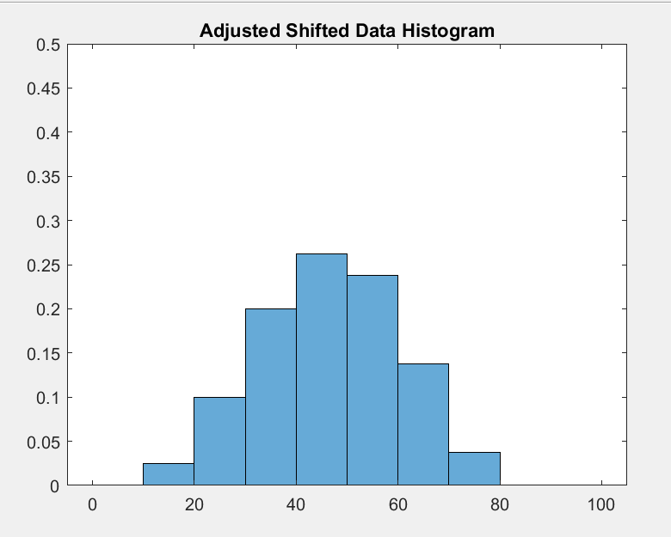

The histogram after adjustment seems to be more balanced before adjustment.

1. Distant Calculation

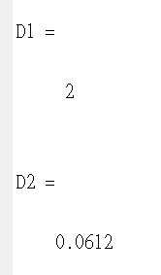

D1 is distance between two original histogram.

D2 is distance between two adjusted histogram.

The histogram adjustment method will minimize the distance between normal data and shifted data.

Before we implement histogram adjustment, the distance between normal data and shifted data is 2.

After we implement histogram adjustment, the distance between data and shifted data is 0.0612.

Because 0.0612 < 2, it shows that the histogram adjustment method will minimize the distance between normal data and shifted data.

It becomes more noise tolerant after adjustment because more distributions are shown in the chart.