110522130 資工碩一 李信鋌

110526005 資工碩一 林季陽

資料科學實務 – Lab Activity Wilcoxon Test

Load the file for Wilcoxon Test

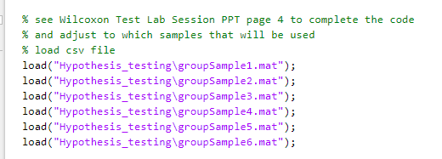

Follow TA’s code.

We specify a two-sided signed rank test with 5% significance level.

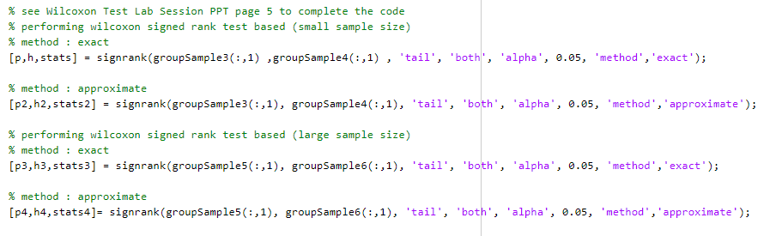

Results are as follows.

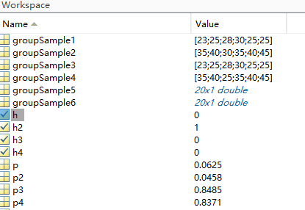

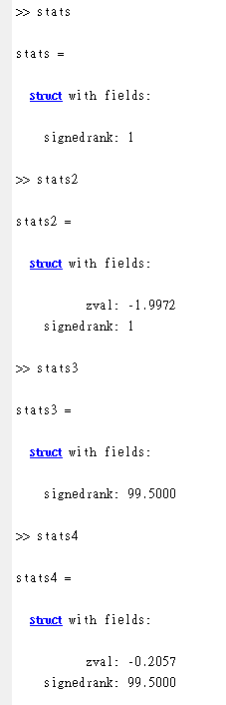

1. Compare the hypothesis result from exact and approximate method from small sample size

The p-value from exact method from small sample size: 0.0625

Because 0.05 < 0.0625(p-value) < 0.10, it indicates that there is weak evidence to infer that the alternative hypothesis is true.

The result of the hypothesis test from exact method from small sample size: 0

(This indicates a failure to reject the null hypothesis at 5% significance level)

The p-value from approximate method from small sample size: 0.0458

Because 0.01 < 0.0458(p-value) < 0.05, it indicates that there is strong evidence to infer that the alternative hypothesis is true.

The result of the hypothesis test from approximate method from small sample size: 1 (This indicates the rejection of the null hypothesis at 5% significance level)

There is different hypothesis result when we are using approximate and exact method in small datasets.

1. Compare the hypothesis result from exact and approximate method from large sample size

The p-value from exact method from large sample size: 0.8485

Because 0.1 < 0.8485(p-value) , it indicates that there is no evidence to infer that the alternative hypothesis is true.

The result of the hypothesis test from exact method from small sample size: 0

(This indicates a failure to reject the null hypothesis at 5% significance level)

The p-value from approximate method from large sample size: 0.8371

Because 0.1 < 0.8371(p-value) , it indicates that there is no evidence to infer that the alternative hypothesis is true.

The result of the hypothesis test from approximate method from small sample size: 0

(This indicates a failure to reject the null hypothesis at 5% significance level)

There is no different hypothesis result when we are using approximate and exact method in large datasets.