Orderflow Engine: Architecture of a Multi-Country Order Pricing and Confirmation Service
Jesús Ariel González Bonilla
2026-10-17
Question this document answers: which artifacts make up Orderflow Engine, and what does each one do and why?
Orderflow Engine — Tech Lead technical assessment

Abstract
Orderflow Engine prices and confirms the orders that shopkeepers place with beverage distributors on a multi-tenant, multi-country business-to-business marketplace. This report describes its architecture and inventories every artifact of the six repositories that deliver it: a Java 21 and Spring Boot 4.1.1 service, an Angular 22 web client, a Docker Compose infrastructure, a governed documentation set, a repository of generators and checks, and a folder reserved for a future mobile app. The service is a hexagonal modular monolith. Its pure pricing domain applies gifts, combos, marginal tier discounts and per-line taxes in a fixed, justified order, with BigDecimal money rounded only per line at a scale read from country data. Quotes are sealed and insert-only, and an order references its quote without storing any amount, so the confirmed total equals the quoted total by construction. Confirmation runs in one PostgreSQL 17 transaction that locks the idempotency key, the quote and the credit account in that order, and it answers 201 only after the commit. Push and ERP effects leave through a transactional outbox with a leased relay, and consumers deduplicate them by event id. The report also covers the data model, internationalization, delivery and the verified evidence: 333 unit and 308 integration tests, full line and branch coverage of the pricing domain, 185 of 185 mutations detected, 209 web specs and an end-to-end flow in Spanish and English. It closes with the risks, their mitigations and what was consciously left out.
Keywords: pricing engine, idempotency, transactional outbox, hexagonal architecture, exact money arithmetic, multi-tenancy, PostgreSQL, Spring Boot, Angular

Context and Quality Goals

The Assignment
The assignment, kept unchanged in orderflow-engine-docs/assignment/, describes a business-to-business marketplace where shopkeepers buy from beverage distributors. The platform runs in several countries (Colombia, Ecuador, Guatemala and Peru, among others) and for several commercial brands, on one multi-tenant platform. An order moves through catalog, cart, checkout (the quote), confirmation and history. Five commercial levers act on the price and may coexist in one order: a tier discount by SKU or family, a combo, a gift, a tax rate per SKU and a customer credit limit.
The take-home has three parts. A1 asks for the pricing engine: a breakdown per line and totals, a defined and justified lever order, and a credit check. A2 asks for an order confirmation in which a defect seen in three releases becomes impossible: an order number was returned to the shopkeeper, and the order was later missing from the history, sometimes never recorded. A3 asks for one architecture decision record of at most one page. The delivery is a Git repository with a single test command, a README that explains how to run the service, the lever order, the rounding policy and the consistency model, the ADR, and a readable commit history. An optional front, time-boxed to one hour, is one order-summary screen judged on three past defects: truncated text, controls hidden by the system bar or the keyboard, and grid images scaled inconsistently.

Quality Goals
The assignment names its non-functional requirements as the core of the exercise. The specification (orderflow-engine-docs/spec/SPEC.md §0) turns them into four guarantees, and the constitution (spec/constitution.md) adds fifteen principles, P-01 to P-15, each with the test or check that verifies it. Table 1 lists the quality goals, the mechanism that delivers each one and the evidence that proves it.
Table 1. Quality goals, mechanisms and evidence
Goal | Mechanism | Verified by
G-1: the quoted total is the confirmed total, even if prices or levers change in between | A sealed, insert-only quote. The order references it and stores no amount | QuoteConfirmRegressionIT (golden test 6)
G-2: no floating point for money; scale, rounding rule and rounding points are explicit | A Money value object over BigDecimal, scale and mode from country data, rounding per line | DomainPurityArchTest, MoneyTest, RoundingPolicyTest
G-3: a 201 means the order exists and can be read; retries never duplicate orders or consume credit twice | One ACID transaction for order, credit, idempotency key and outbox; the reply after the commit | ConfirmOrderCommitOrderingIT, OrderReadYourWritesIT, ConfirmOrderConcurrencyIT
G-4: push and ERP effects are never lost and never applied twice | Transactional outbox, leased relay with retries, deduplication by event_id | OutboxWriteIT, OutboxRelayIT
Multi-country: no currency, scale or rate in the code | Country, tenant, price and lever data in tables | GoldenPricingTest (multi-country case), the Liquibase seeds
Front: no truncated text, no hidden control, consistent images | One component owns each defect | order-summary.spec.ts, screen-rules.spec.ts

Scope Boundary
SPEC §1 fixes the boundary. In scope are the quote, order, history and product-list operations, the pricing engine with its credit check, the outbox relay and retention housekeeping, internationalization in Spanish (default) and English, the Angular client, and a local run with Docker. Out of scope, each with its reason, are authentication (tenant and customer come from headers), catalog and lever administration (stores, products and levers are seeded by Liquibase changesets), real push and ERP integrations (fakes sit behind ports), a server-side cart, payment capture, cancellation and credit release, quote revocation, deployment, cloud infrastructure and an OpenAPI file.
The front carries one recorded deviation. On 2026-10-15 the product owner extended the one-hour order-summary screen to the full flow: cart, quote, confirmation, order and My orders, with a store picker. The API deliverable neither depends on nor waits for it, and the measured time is recorded in three parts in the API README under "Not included": the assignment's screen took 68 minutes; its container, the full stack and the web step of the workspace test command took 55 minutes; and the extension took 3 hours 1 minute.

Sources and Conventions of This Report
Every statement about the system was verified by reading the repositories: source code, changelogs, Docker and Compose files, scripts, READMEs, the specification set and the handoff. Project artifacts are cited by workspace-relative path and by section or code (for example, SPEC §7.1, DEC-05 or AC-26), because they are the subject of the report rather than literature. External works are cited in the author-date style of the American Psychological Association (2020). Figures are the generated diagrams of orderflow-engine-docs/diagrams/, numbered by first appearance, so Figure 1 is 01-runtime-topology and Figure 9 is 09-outbox-lifecycle. The verified numbers come from the state table of orderflow-engine-docs/handoff/HANDOFF.md §3, the only place where the verified state lives.

System Overview

Runtime Topology
At run time the system has one deployable service, one database and one web client. As Figure 1 shows, the browser talks only to the web container, whose nginx serves the built Angular client and forwards /api/ to the service. The service holds the web adapter, the use cases, the pure pricing engine, the persistence adapter and the outbox relay. PostgreSQL is the single source of truth. Push and the ERP are reached only by the relay, after the order is committed (principles P-04 and P-05).
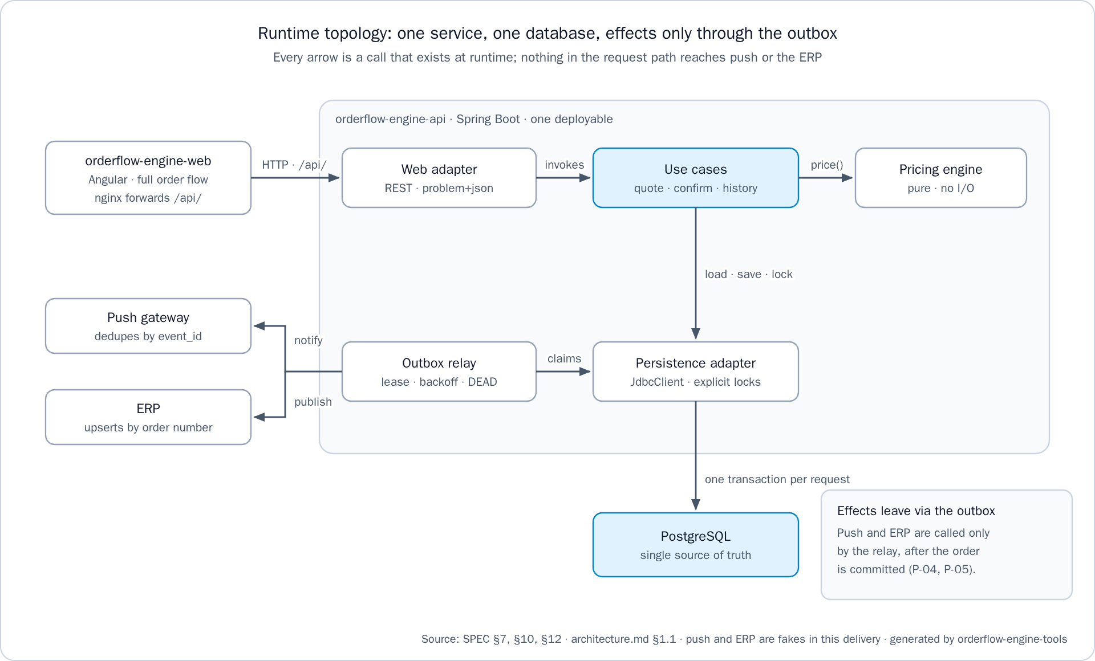
Figure 1. Runtime topology: one service, one database, effects only through the outbox
Table 2 lists the runtime elements of the full stack started by orderflow-engine-infra/compose.yaml.
Table 2. Runtime elements of the full stack
Element | Technology | Port | Responsibility
Web client | Angular 22.2.3, served by nginx-unprivileged 1.30.6 | 8081 on the host, 8080 inside the container | Serves the client and forwards /api/ to the service
Service | Java 21, Spring Boot 4.1.1 | 8080 | Prices carts, seals quotes, confirms orders, serves history and the product list, relays outbox events, runs housekeeping
Database | PostgreSQL 17 | Not published to the host | Catalog, levers, credit, quotes, orders, idempotency keys and outbox
Push and ERP gateways | Fake adapters inside the service | — | Receive the confirmed order, deduplicate by event_id, and can be told to fail

Workspace Repositories
The workspace is six sibling folders, each a GitHub repository, private during the work and public at delivery, with its own README in English and Spanish and an MIT license. As Figure 2 shows, the specification in orderflow-engine-docs governs all of them, orderflow-engine-tools generates the figures and deliverables kept in the documentation repository, and orderflow-engine-infra builds and tests the service and the web client. Decision DEC-15 chose separate repositories over a monorepo because the service, the screen, the infrastructure and the documentation are released, owned and evolved independently, while orderflow-engine-api still stands alone as the deliverable.
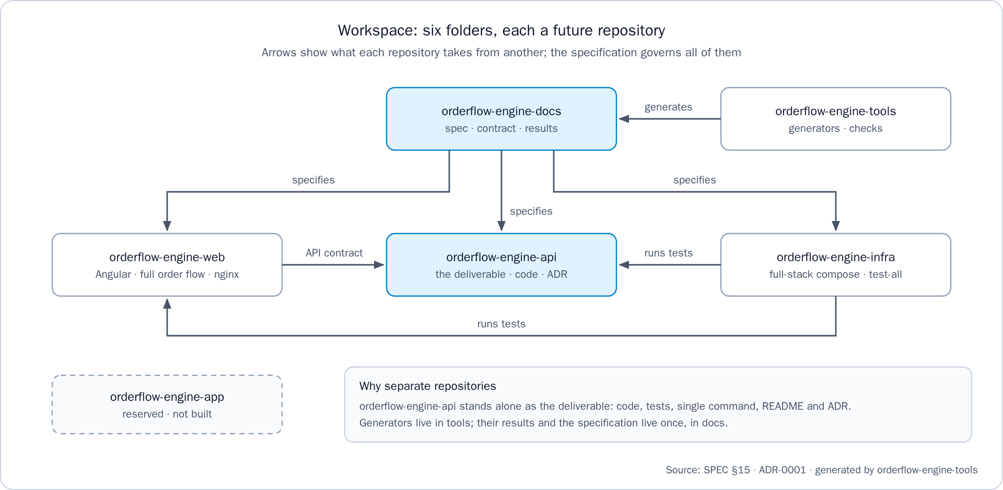
Figure 2. Workspace: six folders, each a future repository
Table 3 summarizes the role of each repository and its long-lived branches.
Table 3. Repositories of the workspace
Repository | Role | Long-lived branches
orderflow-engine-api | The deliverable: service, tests, single command, README and ADR | main, dev
orderflow-engine-web | The Angular client: the order summary and the flow around it | main, dev
orderflow-engine-infra | Full-stack Compose file, workspace test command, end-to-end suite | main, dev
orderflow-engine-docs | Specification, governance, handoff, figures, rendered deliverables | main only
orderflow-engine-tools | Generators and checks for documents and repositories | main, dev
orderflow-engine-app | Reserved for a future mobile app; nothing is built | main, dev

Artifact Inventory
This section inventories the artifacts of each repository. The tables name each artifact by its location and state what it contains and why it exists.

The Service Repository
orderflow-engine-api holds all the code and tests that the assignment evaluates. Its Java sources live under src/main/java/com/orderflow/engine, and Table 4 lists them with the build, resources, tests and container files.
Table 4. Artifacts of orderflow-engine-api
Location | Contents and purpose
pom.xml, mvnw, mvnw.cmd, .mvn/ | Maven Wrapper build on the Spring Boot 4.1.1 parent for Java 21. ./mvnw verify runs every test and the JaCoCo 0.8.15 coverage gate; the optional mutation profile runs PIT 1.30.1
pricing/domain | Money, CurrencyPolicy, Cart, CartLine, CartNormalizer, PricingSnapshot, PricingEngine, Breakdown, LineBreakdown, Totals, Discount, ComboAllocation, Gift
pricing/domain/lever | The lever steps and rules: GiftStep, GiftRule, GiftTaxPolicy, ComboStep, ComboRule, LargestRemainderAllocator, TierDiscountStep, TierRule
quoting | CreateQuoteUseCase, GetQuoteUseCase, ListProductsUseCase, the derived QuoteStatus, and the ports SnapshotProvider, QuoteRepository, CreditAdvisor, ProductCatalog
ordering | ConfirmOrderUseCase, GetOrderUseCase, ListOrdersUseCase, and the ports OrderRepository, CreditLedger, IdempotencyStore, OutboxWriter
outbox | OutboxRelay, BackoffPolicy, HousekeepingJob, and the ports PushNotificationPort, ErpPublisherPort, OutboxRepository, HousekeepingStore
adapters/in/web | QuoteController, OrderController, ProductController, request and response records, ProblemDetailsAdvice, ErrorCode, CorrelationIdFilter, LocaleConfig, RequestHash
adapters/out/persistence | JdbcClient repositories with explicit SQL and locks, LockWaits, MoneyColumns, UuidV7Generator
adapters/out/push, adapters/out/erp | FakePushGateway and FakeErpGateway, which deduplicate by event_id and can be told to fail
config | The composition root: QuotingConfig, OrderingConfig, OutboxConfig (relay and gauges), HousekeepingConfig, TimeConfig (the injected Clock) and typed properties
application.yml, .env.example | Defaults of every app.* key. The database connection comes only from environment variables, with no secret default
db/changelog | A master changelog that includes eight changelogs (33 changesets) in order: five create the schema, one seeds Colombia and Ecuador, one renames the seeds in Spanish, and one adds Guatemala and Peru
i18n | messages.properties (Spanish base), messages_es.properties and messages_en.properties
src/test | Unit, golden, contract, integration and architecture tests, and eleven golden fixture folders under golden/
Dockerfile, compose.yaml | A two-stage image (JDK 21 build with the wrapper, JRE 21 runtime as a non-root user, one layer per Spring Boot layer) and the service with its own PostgreSQL 17
README.md, README.es.md, docs/adr/ | How to run, lever order, rounding policy, consistency model, golden tests, ADR, not included, operations and repositories; ADR-0001 in English and Spanish

The Web Client Repository
orderflow-engine-web is a standalone Angular application (DEC-16) that consumes the API over relative /api/ paths. Table 5 lists its artifacts.
Table 5. Artifacts of orderflow-engine-web
Location | Contents and purpose
package.json, angular.json | Angular 22.2.3, ngx-translate 18.0.0, Vitest 5.0.5 with its Playwright browser provider, and Playwright 1.64.1. The unit-test builder runs the specs in headless Chromium
src/app/app.routes.ts | The four screens: /cart (also /), /quotes/:quoteId, /orders/:orderId and /orders. Any other path opens the cart
src/app/pages | The screens cart, order-summary, order and history
src/app/breakdown | Breakdown lines and totals, shared by the order summary and the order
src/app/ui | ui-text, ui-action-bar, ui-product-image, ui-problem-notice and ui-notice
src/app/shell | The header: navigation, the ES/EN switch and the store picker
src/app/core | API clients for quotes, orders and products, the header interceptor, the money pipe, the cart store, idempotency keys, store context, language, problem handling and browser storage
src/testing | Fixtures with very long names, the order-summary fixture with the shape of E-02, screen checks and a test harness
public/i18n | The es.json and en.json dictionaries
public/config/stores.json | The eight seeded stores of the store picker, two per tenant
public/products | One SVG image per seeded SKU and a placeholder
scripts/no-literal-text.mjs | Runs first in npm test and fails when a template holds literal text
nginx/default.conf.template | The nginx server: /api/ forwarded to API_UPSTREAM, every other path falls back to index.html
Dockerfile, compose.yaml, .env.example, proxy.conf.mjs | A three-stage image (specs on the Playwright image, build on Node 24.21.0, serve on nginx-unprivileged 1.30.6), the client alone against an API on the host, and the development-server proxy
README.md, README.es.md | Scope, how to run, prevention at component level and what each spec proves

The Infrastructure Repository
orderflow-engine-infra is the only repository that references its siblings, because it builds and runs them together. Table 6 lists its artifacts.
Table 6. Artifacts of orderflow-engine-infra
Location | Contents and purpose
compose.yaml | The full stack: db (postgres:17 with a health check and a named volume), api (built from ../orderflow-engine-api) and web (built from ../orderflow-engine-web, with API_UPSTREAM). Every service has restart: unless-stopped
.env.example | Every key with a comment and its default value: database, API port and locale, outbox, retention and web port
scripts/test-all.sh, scripts/test-all.ps1 | The workspace test command in five steps, for bash and PowerShell
scripts/e2e.sh, scripts/e2e.ps1 | The end-to-end step: version check, runner image, a stack on its own ports, the suite, and an unconditional teardown
e2e/ | The Playwright suite (tests/full-flow.spec.ts), its configuration, its runner Dockerfile on the Playwright 1.64.1 image, and check-playwright-version.mjs
README.md, README.es.md | Clone layout, how to run, the test command and the end-to-end flow

The Tools Repository
orderflow-engine-tools keeps generators and checks apart from the documents they produce (DEC-18). Table 7 lists them.
Table 7. Artifacts of orderflow-engine-tools
Location | Contents and purpose
docs-check/check-docs.mjs | The documentation gate: allowed locations, document map, language pairs with equal heading counts, links, front matter, required headings, ADR length, i18n key parity, progress chart, commit lines and deliverable sources
integrity/check-integrity.mjs | Ignore files, .gitattributes, .env.example where a repository runs with Docker, Docker files that stay inside their repository, and no secrets
progress/progress.mjs | The task progress chart, generated from the task table of the handoff
diagrams/generate_diagrams.py | The nine SVG figures, checked for overflowing text, overlapping labels, crossing edges and edges through boxes
render/render_document.py, render/build_deliverables.py | Markdown to Word with the print template (A4, Arial 12, black text, 2 cm margins), then PDF through LibreOffice, with the SHA-256 of each source in manifest.json
consistency/ | Cross-reference, stated-count, language-leak and English-Spanish parity checks
Dockerfile, requirements.txt | An image with Python 3.11, Node and the Python packages; the tools run from the mounted workspace

The Documentation Repository
orderflow-engine-docs owns the specification and every generated result. Its root holds only the READMEs and the license, and a document that is not in its document map does not exist (documentation rule DR-2). Table 8 lists its folders.
Table 8. Artifacts of orderflow-engine-docs
Location | Contents and purpose
assignment/ | The original assignment, never edited
spec/ | Constitution, SPEC, technical plan, TASKS, API contract, data model and architecture
governance/ | Golden rule, branches and environments, pull request rules, commit conventions, documentation rules, repository integrity, the check configuration docs-governance.json, and the ADR and document templates
handoff/ | HANDOFF.md, with the verified state, the commands to resume, open decisions and traps, and progress.svg
diagrams/ | The nine generated SVG figures
deliverables/ | ADR-0001 in Word and PDF, in English and Spanish, and manifest.json
delivery/ | The delivery documents in English and Spanish, this report among them, with the screenshots and the figure images
README.md, README.es.md | The folder glossary, the document map and the codes cited across documents

The Reserved App Repository
orderflow-engine-app holds only its READMEs and its license. It is reserved for a future mobile client, so a mobile app has a home without anything being built for it in this delivery.

Service Architecture

Hexagonal Structure
The service is a hexagonal modular monolith (DEC-03), in the sense of ports and adapters described by Cockburn (2005): the application core is surrounded by ports, and technology lives in adapters on either side. As Figure 3 shows, the driving side holds the REST controllers and the scheduled jobs, the core holds the use cases of quoting, ordering and outbox around the pure pricing.domain, and the driven side holds the JDBC adapter and the fake push and ERP gateways. Microservices were rejected because one transaction must span the order, the credit, the idempotency key and the outbox, and splitting them would buy a saga for no benefit.
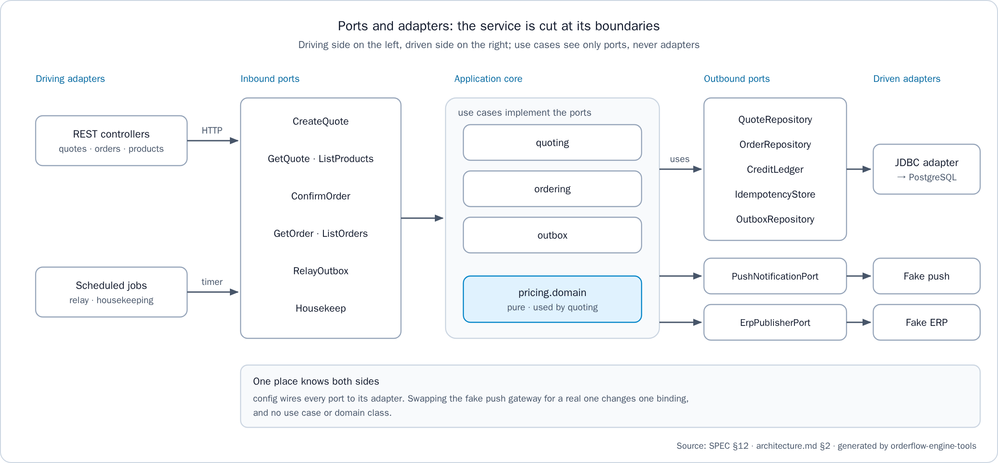
Figure 3. Ports and adapters: the service is cut at its boundaries
Table 9 lists the modules under the base package com.orderflow.engine and what each may depend on. The config package is the composition root: swapping the fake push gateway for a real one changes one binding and no use case or domain class.
Table 9. Modules of the service
Module | Kind | Depends on
pricing.domain | Domain, pure | The JDK only
quoting | Application | pricing.domain
ordering | Application | quoting ports, pricing.domain
outbox | Application | Its own ports
adapters.in.web | Driving adapter | Application ports
adapters.out.persistence | Driven adapter | Application ports
adapters.out.push, adapters.out.erp | Driven adapters | Outbox ports
config | Composition root | Every module
The domain follows the separation that Evans (2003) recommends between a domain model and the infrastructure around it: Money and CurrencyPolicy are immutable value objects, and the engine is a pure function price(cart, snapshot) that reads no clock, keeps no state and performs no input or output. Time is an injected Clock, which the tests fix, so the golden tests and quote expiry are deterministic.

The Dependency Rule and Its Enforcement
Source dependencies point inward. As Figure 4 shows, adapters depend on the application, the application depends on the domain, the domain imports only the JDK, and config is the only module that knows every layer. A dependency in the other direction fails the build, because ArchUnit rules (TNG Technology Consulting, n.d.) run with the other tests in ./mvnw verify.
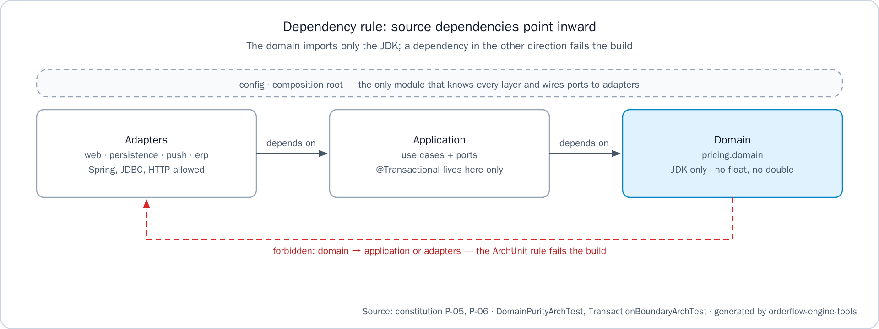
Figure 4. Dependency rule: source dependencies point inward
Table 10 lists the ten rules and the reason each one exists. The first four belong to DomainPurityArchTest and the other six to TransactionBoundaryArchTest.
Table 10. Architecture rules enforced by ArchUnit
Scope | Rule | Reason
Domain | The pricing domain depends only on the JDK and on itself | The engine is pure and deterministic (P-06)
Domain | The pricing domain uses no java.sql or javax.sql type | The domain never reaches the database
Domain | No field, parameter, return type, call or dependency of the domain uses float, double, Float or Double | Money is never binary floating point (AC-08)
Domain | The domain never uses java.util.Currency | Scale comes from country data; the JDK reports COP with scale 2
Transactions | @Transactional methods are declared only in application classes named *UseCase | A controller would answer before the commit, and an adapter would split one confirmation
Transactions | A class annotated as a whole with @Transactional is a use case | The transaction boundary is the use case
Transactions | A transactional method is called only from other classes | A call from its own class bypasses the proxy and runs with no transaction
Transactions | A class with a transactional method never depends on an HTTP client or on the push or ERP gateways | No remote call inside a database transaction (P-04, P-05)
Transactions | Application packages never depend on adapters or on config | Use cases see ports, never adapters
Transactions | ordering never uses PricingEngine or CartNormalizer, and never loads a pricing snapshot | The confirmation never prices again, so the confirmed total is the quoted total
The proxy rule exists because Spring applies @Transactional through a proxy, so a call from inside the same class silently runs without a transaction (Spring, n.d.). SPEC §7.6 lists that bypass as one plausible root cause of the reported defect.

API Surface and Error Model
The service exposes seven operations, specified as operation cards E-01 to E-07 in spec/api-contract.md. Every business operation needs the X-Tenant-Id and X-Customer-Id headers, Accept-Language is optional, and money is a JSON string at the currency's scale, never a JSON number. Table 11 lists the operations.
Table 11. Operations of the API
Id | Operation | Purpose | Success
E-01 | POST /api/v1/quotes | Prices the cart and seals the quote | 201 with Location
E-02 | GET /api/v1/quotes/{quoteId} | Reads the quote and its derived status | 200
E-03 | POST /api/v1/orders | Confirms a quote; requires Idempotency-Key | 201 with Location
E-04 | GET /api/v1/orders/{orderId} | Reads an order, rendered from its quote | 200
E-05 | GET /api/v1/orders?customerId= | The customer's orders, newest first, 20 per page by default and at most 100 | 200
E-06 | GET /actuator/health | Health, with no tenant headers | 200
E-07 | GET /api/v1/products | The tenant's products in SKU order, read-only, with no lever, customer or credit data | 200
Errors use the problem details format of RFC 9457 (Nottingham et al., 2023): application/problem+json with type, a localized title and detail, status, instance, a stable code and a correlationId that also appears in every log line of the request. Status codes keep their HTTP meaning (Fielding et al., 2022), as Table 12 shows. Only ProblemDetailsAdvice maps typed domain and application errors to statuses, and no body exposes a stack trace or SQL.
Table 12. Error statuses and codes
Status | Meaning | Codes
400 | Malformed request | VALIDATION_FAILED, INVALID_QUANTITY, CART_EMPTY, TENANT_NOT_FOUND, IDEMPOTENCY_KEY_MISSING, IDEMPOTENCY_KEY_INVALID
404 | Not found, or not visible to the caller | QUOTE_NOT_FOUND, ORDER_NOT_FOUND, CUSTOMER_NOT_FOUND
404, 405, 406, 415 | Route, method or media type rejected by the framework | REQUEST_NOT_SUPPORTED
409 | Conflict with the current state | QUOTE_EXPIRED, QUOTE_ALREADY_CONFIRMED, CREDIT_LIMIT_EXCEEDED, IDEMPOTENCY_KEY_IN_PROGRESS
422 | Valid request that breaks a business rule | UNKNOWN_SKU, CREDIT_NOT_ENABLED, IDEMPOTENCY_KEY_REUSED
500 | Unexpected, logged with the correlation id | INTERNAL_ERROR
A foreign quote, order or history answers 404, not 403, so the existence of another customer's resource is never revealed (behavior decision BD-01).

Pricing

Pricing Pipeline and Lever Order
The engine first normalizes the cart: duplicate SKUs are merged, lines are sorted by SKU code, and quantities must be whole numbers from 1 to 1,000,000 (rule BR-00), so the result never depends on the order the client sent. As Figure 5 shows, it then applies the levers in a fixed order, and only two steps round.
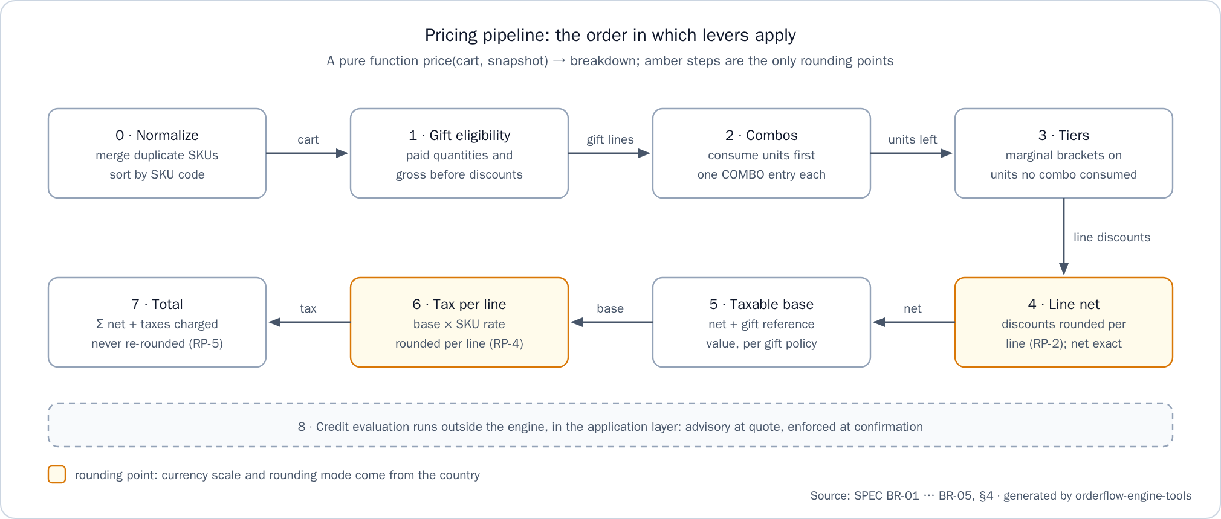
Figure 5. Pricing pipeline: the order in which levers apply
Table 13 gives the order and the reason for each position, as SPEC BR-01 and the API README state it.
Table 13. Lever order and its rationale
Step | Lever | Why this position
1 | Gift eligibility, on paid quantities or the gross subtotal before discounts | A gift is triggered by what is bought and never reduces what is paid for product
2 | Combos | A negotiated bundle price consumes its units first, so they never get a tier discount too
3 | Tier discounts, marginal brackets, on units no combo consumed | The generic volume incentive applies only to what the bundle did not price
4 | Line net = gross − discounts | Commercial discounts are settled before tax
5 | Taxable base: the net, plus the gift reference value where the country taxes gifts | The assignment requires tax on the base after commercial discounts
6 | Tax per line, at each SKU's rate | Rates are per SKU
7 | Total = Σ net + taxes | It needs every previous step
8 | Credit check, in the application layer | It needs the final total; advisory at quote, enforced at confirmation
Three readings complete the order. The assignment says tiers are "acumulativas por tramos" (cumulative by brackets); assumption A-01 reads this as marginal brackets, where each percentage applies only to the units inside its bracket, and the line discount is rounded once per line, never per bracket segment. A SKU rule takes precedence over a family rule for that SKU (A-02). A combo appears as exactly one COMBO:<id> discount entry, its products never show loose TIER discounts, and each participating line carries comboAllocations that only derive its taxable base (A-07); a combo that would not lower the price consumes nothing. A gift is a separate line with its quantity and its GIFT:<id> origin, priced at zero, and the country's gift tax policy decides whether its reference value is taxed.
Golden test 1 shows the marginal reading on the Colombian seed. Twenty-five colas at 2,500 give a gross of 62,500. The 10 units of the 10–19 bracket earn 5% (1,250) and the 6 units from 20 earn 10% (1,500), a discount of 2,750. The net 59,750 is the taxable base, the 19% tax of 11,352.50 rounds half up to 11,353, and the total is 71,103.

Money and Rounding
Money is never a binary floating-point number (P-01), following the long-standing advice to avoid float and double where exact answers are required (Bloch, 2018). Money is an immutable record that holds a BigDecimal (Oracle, n.d.) and a CurrencyPolicy. The policy carries the ISO currency code, the scale and the rounding mode, read from the currencies and countries tables and never from java.util.Currency, which reports COP with scale 2 (trap TR-01). An amount with more decimals than its scale is rejected, amounts are compared with compareTo, and the only rounding call is CurrencyPolicy.round. In the database, money is numeric(19,4) and rates are numeric(7,6); in the API, money is a string.
Rounding happens per line only. Table 14 lists the five rounding points of SPEC §4; only RP-2 and RP-4 round.
Table 14. Rounding points
Point | Where | Rule
RP-1 | Unit price × quantity | Exact, because prices are already at currency scale
RP-2 | Each discount component of a line (tier, combo allocation) | Rounded to currency scale; a combo is split by largest remainder so its parts add up exactly; a component that rounds to zero is not emitted
RP-3 | Net = gross − components | Exact
RP-4 | Tax per line | Rounded to currency scale
RP-5 | Order totals | Sums of rounded line values, never re-rounded
Per-line rounding was chosen because an electronic invoice carries tax per line, so the order always matches the invoice it produces. Rounding per tax-rate group was rejected because line values would disagree with the totals, and rounding only the total was rejected because it hides cent drift and cannot be audited line by line. Golden test 4 shows the effect: a combo discount of 3,600 is split into 2,647 and 953, the taxes are 1,397 at 19% and 132 at 5%, and the total is 11,529.

Quotes and Confirmation

Sealed Quotes: Quote Equals Confirmation
As Figure 6 shows, POST /api/v1/quotes normalizes the cart, loads a snapshot of prices, active levers, tax rates and country policy at time T through SnapshotProvider, runs the pure engine, adds the advisory credit result when the payment is CREDIT, and inserts the quote with its lines and discount components. Each line captures unit_price and tax_rate as they were at T and stores the rounded taxable_base and tax. These rows are insert-only: no UPDATE statement exists for quotes (data-model note DM-02).
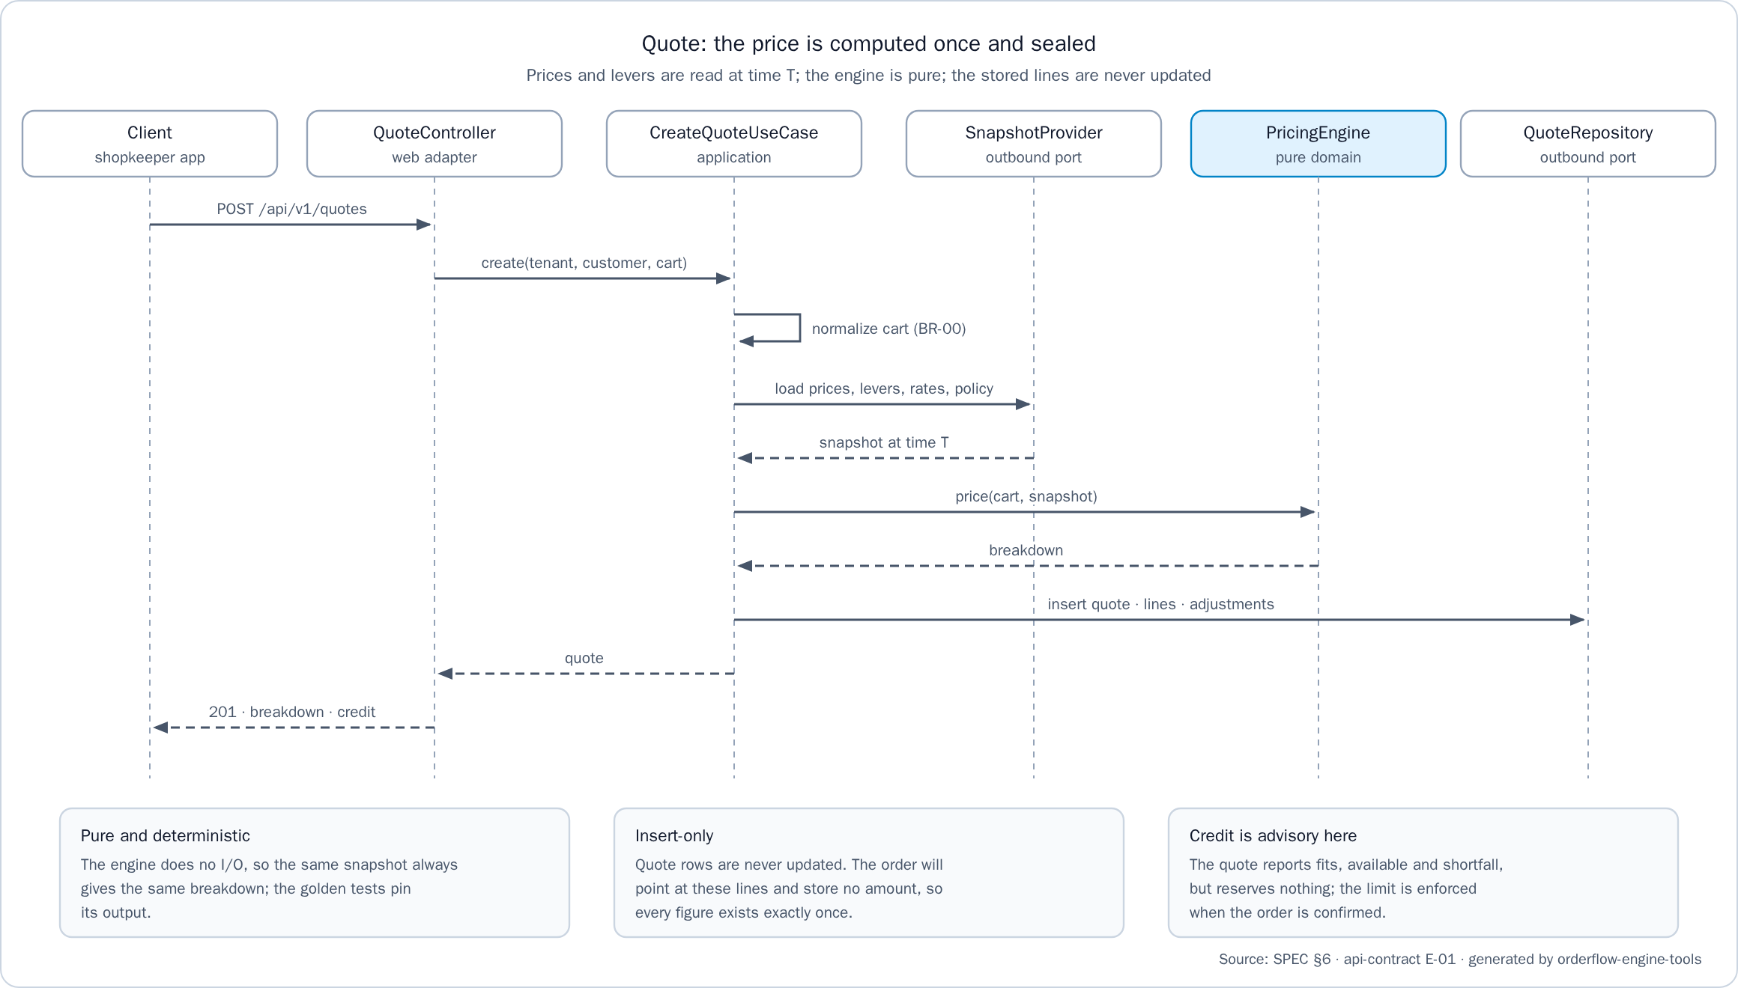
Figure 6. Quote: the price is computed once and sealed
The confirmation writes no amount. The order row holds its number and a reference to the quote, and its breakdown is rendered from the quote lines, so every figure exists exactly once and the confirmed total equals the quoted total by construction (P-02). The engine is never run again at confirmation, which an ArchUnit rule enforces; otherwise a deployment that changed the engine would alter every open quote. Golden test 6 proves the mechanism against PostgreSQL: between quote and confirmation a price changes and a lever is deactivated, the confirmed total still equals the quoted one, and a fresh quote differs, which shows the test can fail.
The quote state is derived, never stored, so a quote row is never updated:
OPEN ──confirm──▶ CONFIRMED (an order exists for the quote)
└ ──ttl──────▶ EXPIRED (now > expiresAt, and no order)
expiresAt is the creation time plus the country's quote time to live, 15 minutes in every seeded country. The trade-off is explicit: a price change applies only to new quotes, so a wrong price is honored for at most one time to live. This is the risk recorded in the ADR.

The Confirmation Transaction
ConfirmOrderUseCase runs SPEC §7.1 in one ACID transaction at READ COMMITTED with explicit row locks (PostgreSQL Global Development Group, n.d.). As Figure 7 shows, the 201 is serialized only after the commit returns, and nothing in the transaction calls a remote system. Explicit SQL through Spring's JdbcClient was chosen over JPA because JPA hides the locks and the flush order that these invariants depend on (DEC-05).
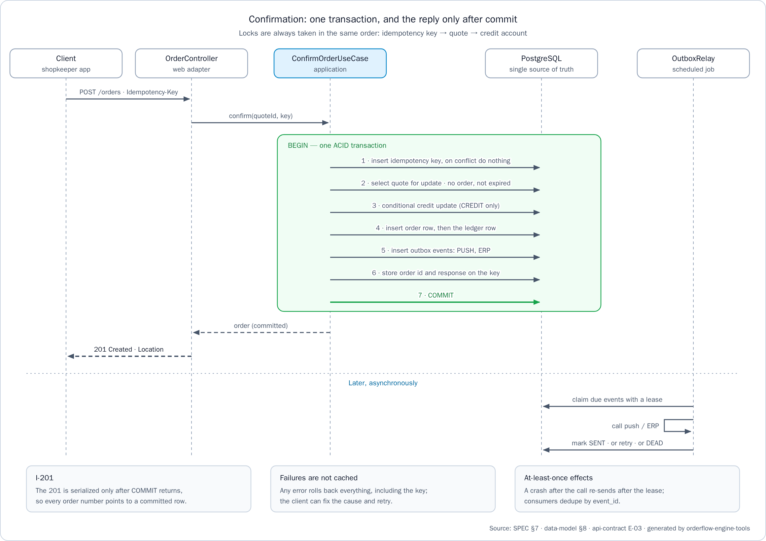
Figure 7. Confirmation: one transaction, and the reply only after commit
Table 15 lists the steps and the guarantee each one provides.
Table 15. Steps of the confirmation transaction
Step | Action | Guarantee
1 | Insert the idempotency key with ON CONFLICT DO NOTHING, then read it back | One owner per key; a concurrent duplicate waits on the uncommitted entry
2 | Lock the quote with SELECT … FOR UPDATE; check its owner, that it has no order and that it has not expired | One confirmation per quote
3 | When paying on credit, run the conditional credit update | Credit is never consumed over the limit
4 | Insert the order (number from the country sequence, confirmed_at), then the ledger row on credit | No order without its quote; orders.quote_id is unique
5 | Insert one outbox event per destination, PUSH and ERP | Effects are recorded atomically with the order
6 | Store the order id and the 201 body on the idempotency key | Replays return the same answer
7 | Commit, then send the 201 | The 201 invariant

Idempotency
The key is scoped to the tenant and the customer and must match ^[A-Za-z0-9_-]{8,64}$. The request is identified by request_hash, the SHA-256 of the method, the path, the customer and the canonical JSON body. Keeping the keys in the order transaction, not in a cache, makes them atomic with the order (DEC-08); idempotent retries of this kind are what make at-least-once requests safe (Kleppmann, 2017). Table 16 lists the outcomes.
Table 16. Retries and replays
Situation | Response
Same key, same request, already completed | The stored response, byte-identical, with Idempotent-Replayed: true
Same key, different request | 422 IDEMPOTENCY_KEY_REUSED
Same key while the first request is still running | Waits, then replays; 409 IDEMPOTENCY_KEY_IN_PROGRESS if the lock timeout passes first
Missing or malformed key | 400 IDEMPOTENCY_KEY_MISSING or IDEMPOTENCY_KEY_INVALID
A failed request (validation, expired quote, credit exceeded) | Not cached: the transaction rolls back and releases the key, so the client can fix the cause and retry
A new key on an already confirmed quote | 409 QUOTE_ALREADY_CONFIRMED, carrying the existing order number
Keys are kept for 24 hours. After that, a retry still receives QUOTE_ALREADY_CONFIRMED with the order number, because orders are never purged.

Locking Order and the Credit Ledger
Locks are always taken in the same order, idempotency key, then quote, then credit account, so concurrent confirmations cannot deadlock. Every lock wait is bounded by a transaction-local lock_timeout of two seconds (ConfirmOrderUseCase.LOCK_TIMEOUT), so a stuck request yields a 409 the client can retry instead of hanging.
Credit is consumed with one conditional statement: UPDATE credit_accounts SET consumed = consumed + :total … WHERE … AND consumed + :total <= credit_limit. If it updates no row, the answer is 409 CREDIT_LIMIT_EXCEEDED and the rollback leaves no order and no ledger row. Otherwise a credit_ledger row is appended right after the order row. A CHECK (consumed >= 0 AND consumed <= credit_limit) makes the limit hold even if application code were wrong, and consumed always equals the sum of the ledger, which CreditLimitIT asserts. At quote time the credit result (fits, available, shortfall) is advisory and reserves nothing (A-08).

The 201 Invariant
Invariant I-201 states that the 201 body is serialized only after the commit of the transaction that inserted the order row and drew its number, and that the order detail and the history read the same primary tables under READ COMMITTED. Therefore no order number is ever returned without a committed, readable row. SPEC §7.6 maps each plausible root cause of the reported defect to a design answer and a test, as Table 17 shows.
Table 17. How "confirmed but missing" is made impossible
Plausible root cause | Design answer | Verified by
Response sent before the commit | The reply is serialized after the commit | ConfirmOrderCommitOrderingIT
Transaction bypassed by a call from the same class | The transaction boundary is a separate use-case bean, enforced by ArchUnit | TransactionBoundaryArchTest, ConfirmOrderFailureInjectionIT
History read from a replica or from the ERP | History reads the primary tables in the request | OrderReadYourWritesIT
Order written in the background after replying | The order row is written in the request transaction; only the effects are deferred | ConfirmOrderFailureInjectionIT
Lost update or duplicate on a double tap | Unique idempotency key, unique quote_id, conditional credit update | ConfirmOrderConcurrencyIT

Data Model
The model is relational, in third normal form and without JSON columns, so every fact is a column that can be constrained and queried (DEC-19). Tenant-scoped tables use the composite key (tenant_id, id), and every foreign key between them includes tenant_id, so no row can reference another tenant's data and tables can later be partitioned by tenant without re-keying. Identifiers are UUIDv7 values generated by the application, so inserts stay local in the index. As Figure 8 shows, the 19 tables fall into four groups, and the order stores no breakdown amount.
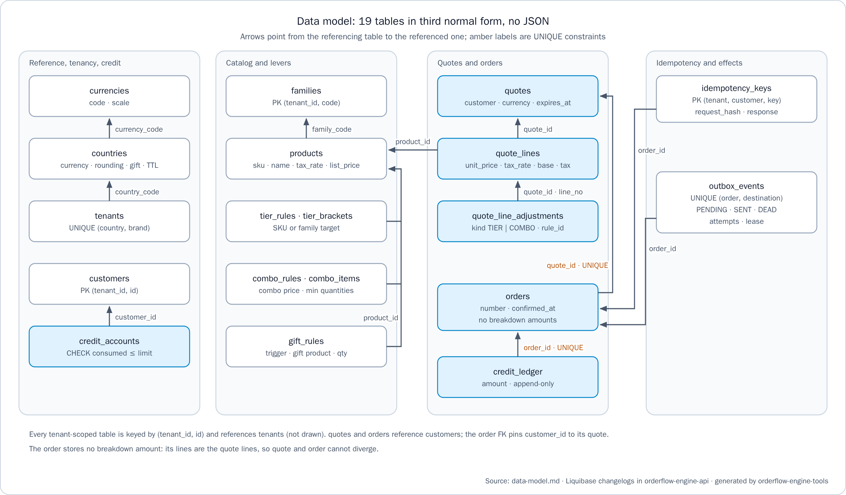
Figure 8. Data model: 19 tables in third normal form, no JSON
Table 18 lists the tables by group with the invariant each group holds.
Table 18. Main tables of the data model
Group | Tables | Invariant
Reference | currencies, countries, tenants | Scale belongs to the currency; rounding mode, gift tax policy and quote time to live belong to the country; a tenant is a unique (country, brand) pair
Catalog and levers | customers, families, products, tier_rules, tier_brackets, combo_rules, combo_items, gift_rules | Each product carries its tax rate and list price; one active tier rule per target; each gift rule has exactly one trigger
Credit | credit_accounts, credit_ledger | consumed never exceeds credit_limit; the ledger is append-only, one row per order, and consumed equals its sum
Quotes | quotes, quote_lines, quote_line_adjustments | Insert-only; lines capture unit_price and tax_rate and store the rounded taxable_base and tax; each adjustment is one rounded component, of kind TIER or COMBO
Orders | orders | No breakdown amount; one order per quote; a unique number per tenant; the customer is pinned to the quote by a composite foreign key
Idempotency and effects | idempotency_keys, outbox_events | One owner per key, with the raw SHA-256 hash and the stored response; one event per destination per order, in status PENDING, SENT or DEAD
The few columns that look derived are deliberate. Captured facts (unit_price, tax_rate, currency_code, expires_at) record what was in force at time T. Stored results (taxable_base, tax) record what the country policy and rounding produced, because recomputing them later is unsafe. consumed is a materialized sum guarded by its CHECK, and response_body exists because a replay must be byte-identical.
The schema is managed by Liquibase (Liquibase, n.d.). Changelogs live in db/changelog/YYYY/YYYY-MM-DD-NNN-verb-object.yaml, each changeset has a rollback that LiquibaseRollbackIT proves, and each file sets a logicalFilePath, so the files can move without being applied again. The changelogs live with the service, their only owner, and run when it starts (DEC-20).

Outbox Relay and Its Lifecycle
Every external effect goes through the outbox, written in the same transaction as the order (P-04). Publishing after the commit was rejected because a crash would lose the event, and a two-phase commit was rejected because push and the ERP cannot join it (DEC-09). This is the transactional outbox pattern (Richardson, n.d.).
As Figure 9 shows, an event is written as PENDING. Each poll of OutboxRelay claims up to 20 due events with FOR UPDATE SKIP LOCKED in a short transaction that commits at once, and sets a lease (locked_until), so several relay instances can run together. The relay then calls PushNotificationPort or ErpPublisherPort outside any transaction, passing the event_id as the downstream idempotency key. Success marks the event SENT. A retryable failure increases attempts and schedules next_attempt_at with exponential backoff and full jitter; after the last attempt, or at once on an error that retrying cannot fix, such as an ERP 4xx, the event becomes DEAD, an ERROR log line asks for an operator, and the outbox_dead gauge counts it. Only the lease holder marks the outcome.
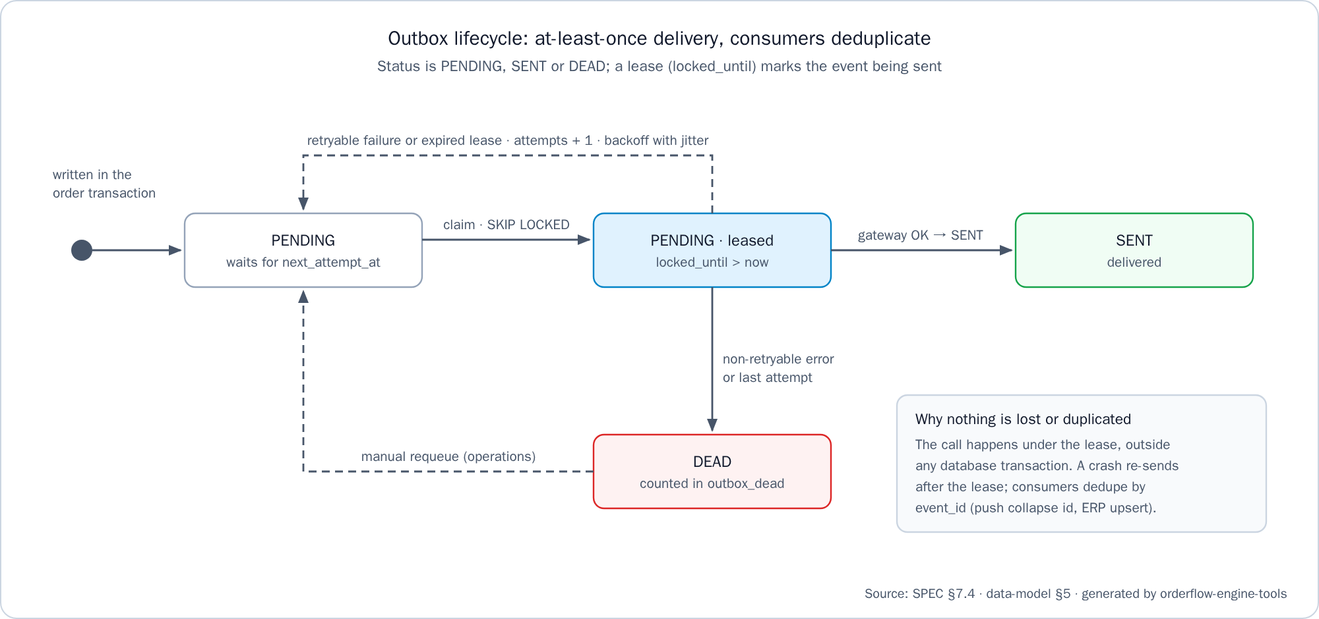
Figure 9. Outbox lifecycle: at-least-once delivery, consumers deduplicate
Delivery is at least once. If the process stops between send and mark, the lease expires and the event is sent again, and consumers deduplicate on event_id: push uses it as the collapse id and the ERP upserts by order number, so the effect happens once (Kleppmann, 2017). When an external system is down, the order stays confirmed, the effect waits in the outbox, the outbox_pending gauge shows the backlog, and delivery resumes when the system recovers. The API README documents the safe, repeatable statement that requeues a DEAD event after its cause is fixed.
A housekeeping job runs every hour for every tenant. It purges idempotency keys after 24 hours, unconfirmed quotes 7 days after they expire, and SENT events 7 days after they were written; orders, their quotes and DEAD events are never deleted. Table 19 lists the configuration keys and their defaults, which .env.example mirrors with one comment per key.
Table 19. Outbox, retention and locale configuration
Key | Default | Meaning
app.outbox.poll-interval | 1 s | Wait between two relay polls
app.outbox.lease | 30 s | How long a claimed event stays leased
app.outbox.max-attempts | 8 | Attempts before an event becomes DEAD
app.outbox.backoff.base, app.outbox.backoff.max | 2 s, 5 min | Bounds of the exponential backoff
app.idempotency.retention | 24 h | How long idempotency keys are kept
app.housekeeping.retention | 7 days | Retention of expired quotes and SENT events
app.i18n.default-locale | es | Language when Accept-Language is missing or unsupported

Multi-Tenancy and Multi-Country
A tenant is a (country, brand) pair. The X-Tenant-Id header resolves the tenant, the tenant resolves its country policy, and an unknown tenant answers 400 TENANT_NOT_FOUND. Prices, levers, tax rates, customers and credit accounts are tenant-scoped data, and no currency, scale, rate or rule is written in the logic (P-07). Table 20 lists the four seeded tenants, one per country the assignment names.
Table 20. Seeded tenants
Tenant | Country and money policy | Seeded taxes and levers | Stores in the web picker
co-alpha | Colombia, COP, scale 0, HALF_UP, gifts TAXED | 19% and 5%; a SKU tier rule, a combo and a repeatable gift | Tienda Norte, Tienda Sur
ec-alpha | Ecuador, USD, scale 2, HALF_UP, gifts EXEMPT | 15%; a family tier rule, a combo and a gift by gross subtotal | Tienda Quito, Tienda Guayaquil
gt-alpha | Guatemala, GTQ, scale 2, HALF_UP, gifts EXEMPT | 12%; a SKU tier rule and a repeatable gift | Tienda Ciudad de Guatemala, Tienda Quetzaltenango
pe-alpha | Peru, PEN, scale 2, HALF_UP, gifts TAXED | 18%; a combo and a gift by gross subtotal | Tienda Lima, Tienda Arequipa
Note: The seed data is demonstration data, chosen so that the tests cover both scales and both gift tax policies. It is not a statement of real tax law.
Each country has its own credit-enabled customer (credit limits of 500,000 COP, 1,500.00 USD, 5,000.00 GTQ and 2,000.00 PEN), and the quote time to live is 15 minutes everywhere. Order numbers come from one sequence per country, order_number_seq_co, _ec, _gt and _pe, formatted as CO-000042. Numbers are drawn inside the order transaction, so a rollback leaves a gap; gaps are acceptable and duplicates are not. Guatemala and Peru were added in task T-20 as data only, by the changelog 2026-10-16-002-seed-gt-and-pe.yaml with its two sequences, with no change to the engine or the API code, which is itself the proof that nothing is hard-coded. A new country therefore needs its rows and its sequence; catalog administration stays out of scope, so new stores, products and levers enter through Liquibase changesets.

Internationalization
End-user text never lives in code (P-09). Spanish is the default and English is complete, and adding a language means adding one file on each side. Table 21 summarizes the two mechanisms.
Table 21. Internationalization mechanisms
Side | Mechanism and files | Guard
API | Spring MessageSource in UTF-8, never the JVM locale: messages.properties (Spanish base), messages_es.properties, messages_en.properties | ErrorCatalogI18nTest fails when an error code lacks a message in any bundle
Web | ngx-translate with runtime JSON dictionaries: es.json and en.json in public/i18n | i18n-keys.spec.ts, no-literal-text.mjs, and the key-parity rule of check-docs
On the API side, the domain and application layers carry only error codes and arguments, and the web adapter resolves the localized title and detail from Accept-Language, falling back to es; logs stay in English. On the web side, the ES/EN switch or ?lang=en changes the language at run time, the choice is kept in browser storage, and every API call sends the active language in Accept-Language, so problem texts arrive in the language of the screen. Each dictionary names the locale that formats money, numbers and dates under app.formatLocale: es-419 for Spanish and en for English. Angular's built-in internationalization was rejected because it builds one bundle per locale and cannot switch at run time (DEC-11). Product and store names are tenant data in the tenant's language and are never translated by the client.

Web Client Architecture

Screens and Routes
The client is a thin layer over the contract, built with Angular standalone components (Google, n.d.). It never computes money, never stores an amount, and shows the API's figures and problem texts as they arrive. Table 22 lists its screens.
Table 22. Screens of the web client
Route | Screen | Calls
/cart, also / | Cart: product grid with image, name, SKU, list price before taxes, tax rate and quantity stepper; cash or credit | E-07, then E-01
/quotes/:quoteId | Order summary, the assignment's screen: status, expiry, the full breakdown and the advisory credit position | E-02 on every visit, then E-03
/orders/:orderId | Order: number, confirmation time, payment method and the same breakdown | E-04
/orders | My orders: number, date and total, newest first | E-05 on every visit
A store picker lists the eight seeded stores of public/config/stores.json and stands in for authentication (A-06). One HTTP interceptor sets X-Tenant-Id, X-Customer-Id and Accept-Language on every /api/ call, and screens never set headers. The cart lives only in the browser, one per store, and is emptied after a 201.

One Origin Through nginx
The client calls only relative /api/v1/… paths, and whoever serves it forwards /api/ to the API, so the browser never makes a cross-origin call and the API has no CORS configuration. The nginx image renders API_UPSTREAM into its configuration when the container starts, so one image runs against any API and a new address needs a restart, not a rebuild. proxy_pass carries no URI, so paths and headers such as Idempotency-Key, Location and Idempotent-Replayed pass unchanged (nginx, n.d.); any other path falls back to index.html, so a reload on a client route works; and /actuator is not forwarded. Table 23 lists the three ways the client is served: by nginx in the web container in the first two, and by the Angular development server in the third.
Table 23. Ways the client is served
Mode | Forwards `/api/` to | Set by
Full stack | api:8080, the API service on the Compose network | API_UPSTREAM in the infrastructure Compose file
Web client alone | host.docker.internal:8080, an API on the host | API_UPSTREAM in the web .env.example
Development server | localhost:8080 | proxy.conf.mjs

Component-Level Prevention
The assignment asks how the three past defects could be prevented at component level rather than per screen. Each defect has one component that owns it, and screens never print text, hold an action or draw a product image another way, so a new screen inherits the prevention. Table 24 lists the rules.
Table 24. Component-level prevention of the three defects
Defect | Component | Rule
Truncated text | ui-text | Always wraps, never uses ellipsis or a line clamp, grows vertically; an amount sits in a cell that never shrinks, so a long name wraps and the amount never splits
Controls hidden by the system bar or the keyboard | ui-action-bar | Sticky to the bottom, padded with the safe-area insets, lifted above the keyboard by following visualViewport; every control at least 44 × 44 px
Grid images scaled inconsistently | ui-product-image | One aspect ratio with object-fit: contain; a missing image falls back to a placeholder
The specs measure the real layout in headless Chromium at 768 × 1024 and 375 × 812, because a simulated DOM without a layout engine reports every width as zero (trap TR-11).

Money, Idempotency and Errors on the Client
Every amount on screen is a string from an API body, formatted as is by one money pipe with Intl.NumberFormat, so no amount becomes a binary float. Because COP and USD share the $ symbol, every screen with amounts names the ISO currency code. On the first tap of "Confirm order" the client creates one UUID Idempotency-Key per quote, keeps it in browser storage, disables the button while the request is in flight, and sends the same key on every retry, also after a reload; a replayed 201 shows "This order was already recorded". An open credit quote that does not fit disables confirmation and offers "Pay cash". Every problem shows the API's title and detail, its code and the first 8 characters of its correlationId, with exactly one way out; a request with no answer shows the client's own no-answer text instead. The server's guarantees never depend on the client; the client only avoids asking twice.

Infrastructure and Delivery

Containers and Compose
Each executable repository builds and runs with its own Docker files and its own .env.example, and a .env is never versioned. The service image builds with the wrapper on JDK 21 and runs on a JRE 21 as a non-root user. The web image has a test stage on the Playwright image, a build stage on Node and an unprivileged nginx stage. The infrastructure Compose file (Docker, n.d.) starts PostgreSQL first, the API once the database is healthy, and the web client after the API, because nginx resolves its upstream name when it starts (trap TR-12). Every service has restart: unless-stopped, so Docker restarts a service when it exits and the stack when the daemon starts, while a service stopped by hand stays stopped. The values of .env.example are also the Compose defaults, so the stack starts without a .env.

The Workspace Test Command
The assignment's single command is ./mvnw verify in orderflow-engine-api; it needs Docker running because Testcontainers starts a real PostgreSQL (Testcontainers, n.d.). The workspace adds one command that runs every check of every repository:
bash orderflow-engine-infra/scripts/test-all.sh
It runs, in order and stopping at the first failure: the API build and tests; docker build --target test . in orderflow-engine-web, so the host needs no Node for the specs; the end-to-end flow; check-docs; and check-integrity. The end-to-end step checks that the suite uses the Playwright version the web client pins, starts the full stack under its own Compose project on ports 18080 and 18081, runs the Playwright suite (Microsoft, n.d.) in a container on the stack's network, and always removes the stack with its volume, so every run starts from the seeds. The suite walks cart, quote, confirmation, order and My orders once in Spanish and once in English, and checks that the new order comes first in My orders and in the history read back from the API.

Branching Model, Phases and Commits
Code repositories keep main and dev; the documentation repository keeps only main, because it holds living documentation. Each task enters through one or more pull requests from a branch named <type>/T-NN-slug, squash-merged into dev (into main for the documentation) and then deleted. main of a code repository receives only dev, when the owner closes a phase, through a merge commit titled chore: close <phase> phase (T-NN). Every commit is one line of at most 60 characters in the Conventional Commits 1.0.0 format with its task tag (Conventional Commits, n.d.), for example feat(db): seed Guatemala and Peru tenants (T-20). The assignment does not ask for continuous integration, so verification runs locally and its output is pasted into each pull request. GitHub rejects rulesets on private repositories of a free plan, so the protection rules are followed by hand and the rulesets are applied when the repositories become public at delivery. Table 25 lists the four phases.
Table 25. Phases of the work
Phase | Tasks | Closed on | Pull requests
1. Preparation | T-00 | 2026-10-14 | 21 task and 5 phase-closing
2. Scaffold | T-01 | 2026-10-15 | 9 task and 2 phase-closing
3. Core | T-02 … T-16, T-18 | 2026-10-15 | 20 task and 3 phase-closing
4. Web | T-17, T-19, T-20 | 2026-10-17 | 18 task (plus the handoff record, docs #18, pending) and 4 phase-closing

Quality Strategy and Evidence

Test Layers
Every task follows the same cycle: write the failing test and see it fail for the expected reason, implement the minimum to make it pass, then break the guard once to prove the test bites, and restore it (P-08). Table 26 lists the test layers of SPEC §11.
Table 26. Test layers
Layer | Scope | Tooling
Unit | Money, normalization, each lever, the pipeline | JUnit 5, AssertJ
Golden | Full breakdowns for fixed inputs, with a fixed clock and fixed ids | JSON fixtures: request.json, snapshot.json, expected.json
Integration | Persistence, transactions, concurrency, outbox | Testcontainers PostgreSQL 17, Spring Boot test
Contract | HTTP status, problem shape, localized text | MockMvc
Architecture | Pure domain, no floating point, transaction boundary | ArchUnit
Coverage and mutation | Line and branch coverage of pricing; detection of injected faults in pricing.domain | JaCoCo (EclEmma, n.d.); PIT (Coles, n.d.)
Web | The three component rules on every screen, client idempotency, credit shortfall, problem actions, history freshness, money formatting, dictionary keys | Angular unit-test builder with Vitest in headless Chromium (Vitest, n.d.)
End to end | The whole flow in the browser against the real stack, in Spanish and English | Playwright, in test-all
Testcontainers was chosen over an in-memory database because a different locking model and SQL dialect would prove nothing about the confirmation invariants (DEC-12). Coverage alone says nothing about assertion quality, which is why mutation testing complements it (DEC-14).

Golden Tests
Every golden test is tagged @Tag("golden"), asserts exact amounts and checks the identities that hold for any breakdown, such as total = Σ net + taxes. Cases 1 to 5 are fixture folders under src/test/resources/golden/ (gt01-two-tier-brackets, gt02-combo-no-loose-discount, gt03-gift, gt04-combo-with-taxes and gt05-credit-exceeded), and case 6 runs against PostgreSQL with the seeded data. Table 27 maps the six cases the assignment requires to their tests.
Table 27. The six golden tests of the assignment
Case | Test | Key assertion
1. Discount in two brackets | GoldenPricingTest | A 2,750 discount and a 71,103 total
2. Combo without loose discounts | GoldenPricingTest | One COMBO entry and no TIER entry for consumed units
3. Gift with its quantity | GoldenPricingTest | A gift line with its quantity and GIFT origin
4. Combo with taxes | GoldenPricingTest | Tax on the allocated bases, included in the 11,529 total
5. Credit order over the limit | GoldenQuoteTest, CreditLimitIT | fits=false with available and shortfall; confirming answers 409 with no order and no ledger row
6. Quote and confirm match | QuoteConfirmRegressionIT | Confirmed total equals quoted total after a price and a lever change; a fresh quote differs
Further cases share the harness: both gift tax policies, rounding at .5, Colombia against Ecuador, and both countries without levers. QuoteLeversIT replays the tier, combo and gift cases through POST /api/v1/quotes against the seeded data, so the levers are proven end to end, not only in the engine.

Verified Evidence
Table 28 quotes the verified state of HANDOFF.md §3 with the command that produced each value.
Table 28. Verified evidence
Item | Value | Verified by
API tests | 333 unit and 308 integration tests green (Testcontainers PostgreSQL 17), the six golden tests among them | test-all on fresh clones, 2026-10-17
Coverage | 100% of lines and branches in pricing.domain (220 lines, 58 branches) and pricing.domain.lever (221 lines, 85 branches), gate ≥ 90%; 99.2% of lines and 98.0% of branches in the whole service | The JaCoCo report jacoco.xml
Mutation score | 185 of 185 mutations detected (100%), threshold 80% | ./mvnw -Pmutation verify
Web tests | The literal-text check passes on 14 templates, then 209 specs in 15 files pass in headless Chromium | The test stage of the web Dockerfile, with its cache disabled
End to end | Cart, quote, confirm, order and My orders pass in Spanish and in English (2 of 2) | The end-to-end step of test-all
Workspace | test-all: OK (API verify, web tests, end-to-end, documentation check, integrity check) | test-all.sh on fresh clones from GitHub, 2026-10-17
Phases | Preparation (T-00), scaffold (T-01), core (T-02 … T-16, T-18) and web (T-17, T-19, T-20), all closed on main | gh pr list --state merged on each repository
Note: Under heavy parallel load Testcontainers can time out while PostgreSQL starts, and the failure shows as ContainerLaunchException, never as an assertion (trap TR-14). A rerun on a quieter host is the first step before reading it as a defect.

Decisions

ADR-0001
The assignment asks for one decision record of at most one page, so the delivery has exactly one, in the lightweight format popularized by Nygard (2011) with the header table of MADR 4.0.0: orderflow-engine-api/docs/adr/0001-order-pricing-and-confirmation.md and its Spanish pair, accepted on 2026-10-15, with high confidence and medium confidence on gift tax. check-docs limits each language file to 500 words, and the rendered Word and PDF versions fit one A4 page. The record states five decisions:
- A sealed, insert-only quote that the order references with no amounts, instead of copying the breakdown or recomputing it on confirm, because copies diverge and prices change.
- BigDecimal rounded per line with totals never re-rounded, and combos before tiers, instead of integer minor units, a rounded total or tiers first, which are awkward with tax rates, mismatch the invoice or discount twice.
- One PostgreSQL ACID transaction with locks key, quote, credit, and the 201 after the commit, instead of an in-memory store, an asynchronous write or saga, or keys in a cache.
- A transactional outbox with lease and backoff, deduplicated by event_id, instead of publishing after the commit or a two-phase commit.
- A hexagonal monolith with explicit SQL and separate repositories, instead of microservices, JPA or a monorepo.
Its code review checklist asks a reviewer to look for: no float or double, money compared with compareTo, no UPDATE on quotes; @Transactional only on use cases, with no self-invocation and no remote calls; locks in the order key, quote, credit, the 201 after the commit and no cached failure; a relay that sends outside any transaction, where only the lease holder marks the outcome; and every lever with a golden test seen failing, with user text only in i18n.

Technical Decisions of the Plan
The technical plan (spec/plan.md §1) records every technical decision with its rejected alternatives. Table 29 summarizes them.
Table 29. Technical decisions and the alternatives rejected
Code | Decision | Main alternative rejected, and why
DEC-01 | Java 21 with Spring Boot, servlet stack | WebFlux: reactive drivers complicate the single blocking transaction, with no throughput need (Spring, n.d.)
DEC-02 | Maven Wrapper | Gradle: no advantage for one module; the wrapper needs no local install
DEC-03 | Hexagonal modular monolith with a pure pricing domain | Microservices: one transaction must span order, credit, key and outbox
DEC-04 | PostgreSQL with Liquibase changelogs and rollbacks | In-memory store: cannot prove atomicity or row locks
DEC-05 | JdbcClient with explicit SQL | JPA: hides locks and flush order
DEC-06 | BigDecimal with per-country scale, rounded per line | Integer minor units: awkward with tax rates
DEC-07 | Insert-only quote; the order stores no amount | Copying the breakdown, recomputing at confirm, or locking prices
DEC-08 | Idempotency keys in the order transaction | A cache: not atomic with the order
DEC-09 | Transactional outbox with a leased polling relay | Publishing after commit, two-phase commit, change data capture
DEC-10 | RFC 9457 problem details with a stable code | A custom error envelope that reinvents a standard
DEC-11 | MessageSource and ngx-translate runtime JSON | Angular built-in i18n: one build per locale
DEC-12 | Testcontainers PostgreSQL | An in-memory database with other locking and dialect
DEC-13 | Golden tests as JSON fixtures | Inline assertions: hard to review, easy to drift
DEC-14 | JUnit 5, JaCoCo, PIT and ArchUnit | Coverage alone; a quality server the evaluator cannot run
DEC-15 | Sibling repositories with a documentation repository | A monorepo that ties independent components together
DEC-16 | Angular standalone components | Flutter: not installed in the build environment
DEC-18 | Documentation governance by check-docs in a tools repository | Manual review only: unchecked rules decay
DEC-19 | Third normal form, no JSON, tenant-scoped composite keys, UUIDv7 | JSON documents for quotes; global surrogate keys only
DEC-20 | Changelogs in the service, applied at start-up | A migration job: a second credential and another quote lock. A schema repository: a clone of the service would have no schema

The Specification Deviation
The only recorded deviation is the front's scope, extended by the product owner from one order-summary screen to the full flow. SPEC §1 contains it: the front started after the core phase, adds no business rule, never computes money, adds one read-only operation (E-07) that ships and would be cut with the cart, and records its measured time. SPEC §14.3 lists every item beyond the assignment with what it buys, tagged as quality, stability or scalability: for example cart normalization, stable error codes, the architecture rules, the coverage gate, mutation testing, retention housekeeping, the outbox gauges, tenant-leading keys, the documentation and integrity checks, the Docker files per repository, client-side idempotency and the read-only catalog operation.

What Was Consciously Not Implemented
The ADR and the API README list what was left out on purpose. Table 30 summarizes it.
Table 30. Items not implemented, on purpose
Item | Why
Authentication | Out of scope; tenant and customer come from headers, and a gateway would inject them
Payment capture, cancellation, credit release | Not required
Server-side cart | Not required; the cart travels in the quote request
Quote revocation | Not required; it is the next step of the ADR's risk mitigation
Catalog and lever administration | Not required; migrations seed the data, and E-07 only reads
Tax categories and price history | Not required; each SKU carries its rate, and each quote line keeps the price and rate it was quoted with
Real push and ERP clients | Fakes behind ports prove the delivery guarantees
OpenAPI file, deployment, CORS | Not required; the contract is spec/api-contract.md, and one origin removes CORS
SonarQube, CI pipeline, mutation testing in CI | Each needs only CI configuration later; the JaCoCo report and the commands already exist
Migration job, least-privilege roles, schema repository | Liquibase runs at start-up with the owner's credential; the plan describes how each would be adopted
The adoption paths of spec/plan.md §3 give, for each of these later steps, today's state, how it would be adopted, the project changes it needs and its trigger.

Risks and Mitigations
The ADR records the main risk of the design: a sealed quote honors a wrong price until it expires. The mitigation is a 15-minute time to live per country, then a revocation operation (OPEN to REVOKED, answered with 409), to be revisited if an incident affects more than 100 quotes or the time to live exceeds one hour. Table 31 lists the risk register of spec/plan.md §4.
Table 31. Risk register
Code | Risk | Mitigation
RISK-01 | Contention on a customer's credit row under bursts of confirmations | One short transaction, a lock_timeout and an explicit 409; measured in ConfirmOrderConcurrencyIT
RISK-02 | The outbox grows while the ERP is down for a long time | Backoff, DEAD after the last attempt, the outbox_pending gauge and the requeue procedure
RISK-03 | A wrong price honored for the quote time to live | Accepted as the ADR risk, bounded by a 15-minute time to live, with revocation as the next step
RISK-04 | An engine change silently alters the prices of new quotes | The golden tests fail the build
RISK-05 | A downstream consumer does not deduplicate by event_id | The event_id contract, the push collapse id and the ERP upsert by order number
RISK-06 | Sibling repositories drift once split | The contract lives only in the documentation repository, and check-docs verifies links
RISK-07 | The five-day window | A day plan and a cut line after T-16, with cuts recorded under "Not included"
The consistency model states what is sacrificed. Order, credit, idempotency key and outbox are strongly consistent in one database, which sacrifices availability while the database is down and serializes the confirmations of one customer on its credit row. Push and the ERP are eventually consistent, with at-least-once delivery deduplicated by consumers, and lag behind the confirmation by the poll interval plus any retries.

Conclusion
Orderflow Engine meets the core of the assignment through structure rather than discipline alone. The quoted total equals the confirmed total because the order has no amounts of its own. Money is exact because a floating-point type in the domain fails the build, and rounding happens only at two named points per line. A 201 means a committed, readable order because the reply is serialized after the commit of one transaction that holds the key, the credit, the order and its outbox events, with locks in a fixed order. External effects are neither lost nor duplicated because they leave through a leased outbox and carry an id that consumers deduplicate on. Country behavior is data, as the data-only addition of Guatemala and Peru demonstrates, and the web client prevents the three reported interface defects in components rather than screens. The design is verified by golden, integration, architecture, mutation, component and end-to-end tests whose results are recorded with the commands that produced them, and its main remaining risk, a wrong price honored for one quote lifetime, is bounded and has a defined next step.

References
American Psychological Association. (2020). Publication manual of the American Psychological Association (7th ed.). https://doi.org/10.1037/0000165-000
Bloch, J. (2018). Effective Java (3rd ed.). Addison-Wesley.
Cockburn, A. (2005). Hexagonal architecture. https://alistair.cockburn.us/hexagonal-architecture/
Coles, H. (n.d.). PIT mutation testing. https://pitest.org/
Conventional Commits. (n.d.). Conventional Commits 1.0.0. https://www.conventionalcommits.org/en/v1.0.0/
Docker. (n.d.). Docker Compose. https://docs.docker.com/compose/
EclEmma. (n.d.). JaCoCo Java code coverage library. https://www.eclemma.org/jacoco/
Evans, E. (2003). Domain-driven design: Tackling complexity in the heart of software. Addison-Wesley.
Fielding, R. T., Nottingham, M., & Reschke, J. (Eds.). (2022). HTTP semantics (RFC 9110). Internet Engineering Task Force. https://doi.org/10.17487/RFC9110
Google. (n.d.). Angular. https://angular.dev/
Kleppmann, M. (2017). Designing data-intensive applications: The big ideas behind reliable, scalable, and maintainable systems. O'Reilly Media.
Liquibase. (n.d.). Liquibase documentation. https://docs.liquibase.com/
Microsoft. (n.d.). Playwright. https://playwright.dev/
nginx. (n.d.). Module ngx_http_proxy_module. https://nginx.org/en/docs/http/ngx_http_proxy_module.html
Nottingham, M., Wilde, E., & Dalal, S. (2023). Problem details for HTTP APIs (RFC 9457). Internet Engineering Task Force. https://doi.org/10.17487/RFC9457
Nygard, M. (2011, November 15). Documenting architecture decisions. Cognitect. https://cognitect.com/blog/2011/11/15/documenting-architecture-decisions
Oracle. (n.d.). BigDecimal (Java SE 21 & JDK 21). https://docs.oracle.com/en/java/javase/21/docs/api/java.base/java/math/BigDecimal.html
PostgreSQL Global Development Group. (n.d.). PostgreSQL 17 documentation. https://www.postgresql.org/docs/17/
Richardson, C. (n.d.). Pattern: Transactional outbox. Microservices.io. https://microservices.io/patterns/data/transactional-outbox.html
Spring. (n.d.). Spring Framework reference documentation. https://docs.spring.io/spring-framework/reference/
Testcontainers. (n.d.). Testcontainers for Java. https://java.testcontainers.org/
TNG Technology Consulting. (n.d.). ArchUnit user guide. https://www.archunit.org/userguide/html/000_Index.html
Vitest. (n.d.). Vitest. https://vitest.dev/

