**Microcontroller based capacity counter for Malls using infrared sensors**

A Thesis Presented to the Faculty of Electronics Engineering

College of Engineering Architecture and Technology

De La Salle University- Dasmarinas

Dasmarinas, City

In Partial Fulfillment of the Requirements for the Degree of

Bachelor of Science in Electronics Engineering

Edrian B. Abadiano

Rienger Roi N. Basuil

Darren Andrew L. Carcellar

April 2021

**CHAPTER 1**

**INTRODUCTION**

* 1. **Background of the study**

COVID-19 is spread by people who have been in close touch for a long time. When an infected person coughs, sneezes, or talks, droplets from their mouth or nose fly into the air and settle in the mouths or nostrils of those who are nearby. In addition, the droplets can be inhaled into the lungs. It is vital to stay at least 6 feet away since people can spread the illness before they realize they are sick. It is possible that a person could contract COVID-19 by touching a virus-infected surface or object and then touching their mouth, nose, or eyes. Outside the home, social separation reduces the chances of coming into contact with contaminated surfaces and infected persons.

We all know that the mall will be one of the busiest places. Because it is home to a diverse range of independent retail stores, service stations, entertainment venues, and other businesses. Because of the numerous amenities that malls may provide, many people use them on a regular basis. Answering the question of how we can execute the control of restricting the number of people entering the mall is a major challenge, especially during this pandemic. In most successful countries, the scale of coordination and data management required for the implementation of these policies has relied on the use of digital technology and its integration into policy and health care. The major contribution of this work is the development of a capacity counter system and to demonstrate the initial proof of concept to counter the social distancing issue in areas with a high density of people.

**Statement of the problem**

Malls specifically in the Philippines are not implementing strict measures when it comes to limiting the number of people inside the establishments. Probably due to the fact that doing it manually may appear to be impossible when it comes to large scale. While some tiny stalls within the mall implements it, it is done in a very manual manner, which consumes unnecessary time, energy and is prone to human error. And another challenge is that the way businesses implement safety guidelines varies from different retailers. It is a struggle to recommend a one for all system that fits to all retailers. As a result, the researchers propose the use of technology to automate the system to answer these problems.

**1.2 Objectives of the study**

**1.2.1 General Objective**

To create a simulated automated counter system using infrared sensors to limit the number of people inside the mall to ensure physical distancing.

**1.2.2 Specific Objectives**

1. To program a counter system that will be triggered by the use of infrared sensor.
2. To create a display that indicates whether a person can enter or whether the capacity is filled.
3. To create an alarm system if a person enters while the capacity is full.

**1.3 Significance of the study**

Business Establishments. This research aims to show an effective and efficient implementation of the given regulation in terms of limiting the number of individuals within an area with the use of technology

Future Researchers.This research seeks to inspire innovative ways to use technology to implement strong guidelines when it comes to ways of ensuring physical distancing.

**1.4 Scope and Delimitation**

The scope of the study will only be limited to a simulated system employing the Arduino and the respective sensors needed to perform the task. Since it will be simulated using packet tracer the motion sensor will represent the IR sensor since both works for the same function. The system will only be accepting of 1 entrance point for a given establishment. And all the exit points and entrance point will not be bidirectional.

**1.5 Conceptual Framework**

Figure 1.1

Figure 1.1 show the proposed framework in designing, and achieving the objecties of this study.

**1.6 Definition of terms**

**infrared sensor** - is an electronic device, that emits in order to sense some aspects of the surroundings.

**microcontroller** - is an integrated circuit (IC) device used for controlling other portions of an electronic system, usually via a microprocessor unit (MPU), memory, and some peripherals.

**program** - a series of coded software instructions to control the operation of a computer or other machine.

**bidirectional** – functioning in two directions.

**CHAPTER 2**

**REVIEW OF RELATED LITERATURE AND STUDIES**

**2.1 Related Literature**

**2.1.1 Foreign Literature**

**2.1.1.1 What Safe Shopping Looks Like During the Pandemic**

To limit the spread of Covid-19, the U.S. Centers for Disease Control and Prevention recommends that individuals practice [social distancing](https://www.cdc.gov/coronavirus/2019-ncov/prevent-getting-sick/social-distancing.html). When local conditions allow for retail establishments to start, they must adhere to a range of state-specific regulations. North Carolina, for example, has explicit limits on the number of customers allowed per square foot, but Oregon recommends that the number of consumers in the business be kept to a minimum of six feet apart. How retailers implement these guidelines also varies among types of retailers and even within store categories. Grocery stores, for example, have adopted a wide [variety of specific methods](https://www.grocerydive.com/news/tracking-grocers-response-to-the-coronavirus/574321/) to ensure that customers remain apart.

These variations are due to differences in the prevalence of the virus, diversity in local attitudes toward social distancing, and political forces. Because of differences in store architecture, customer flow, and consumers' desire to follow social-distancing counsel, it's also challenging to design and implement recommendations that apply to all sorts of retailers.

Given this uncertainty as well as the challenges of finding a “one-size-fits-all” set of guidelines, it also discuss how these values affect shops' bottom lines as they try to stay afloat while keeping their consumers and employees safe. All experts agree that to lower the risk of virus transmission, retailers must lower the density of people within the store. The easiest way to do that is to [limit](https://www.dailyherald.com/business/20200401/costco-home-depot-limit-shoppers-in-stores) the number of customers in the store at any one time.

# 2.1.1.2 Strong Social Distancing Measures in The United States Reduced the COVID-19 Growth Rate

# State and local governments imposed social distancing measures in March and April 2020 to contain the spread of the novel coronavirus disease (COVID-19). These measures included bans on large social gatherings; school closures; closures of entertainment venues, gyms, bars, and restaurant dining areas; and shelter-in-place orders.

# Adoption of government-imposed social distancing measures reduced the daily growth rate of confirmed COVID-19 cases by 5.4 percentage points after one to five days, 6.8 percentage points after six to ten days, 8.2 percentage points after eleven to fifteen days, and 9.1 percentage points after sixteen to twenty days. Holding the amount of voluntary social distancing constant, these results imply that there would have been ten times greater spread of COVID-19 by April 27 without shelter-in-place orders and more than thirty-five times greater spread without any of the measures. This article illustrates the potential danger of exponential spread in the absence of interventions, providing information relevant to strategies for restarting economic activity.

# 2.1.1.3 Big Benefits of Applying Automation to Healthcare

# According to a recent research by Health Leaders, three out of four hospital and health system CEOs cite overall cost reduction and efficiency as one of their top two financial goals. Automation of manual operations can be a significant aspect of a performance improvement plan in the healthcare business, which is constantly trying to reduce costs and waste while increasing efficiency and throughput.

Automation is defined as the use of control systems and information technologies to reduce the need for human work in the production of goods and services.One of the first kinds of automation was the assembly line, which was introduced by Ford Motor Company in 1913. Ford was able to reduce the time it takes to construct a car from 12 hours to 1.5 hours because to this breakthrough.To summarize, even if you recruit the best people to work for you, you must recognize that human error will occur. However, just because people make mistakes all the time does not mean you cannot try to prevent as many of them as possible.Using automation, can take steps to reduce human error and ensure a more accurate information, as well as smoothly completed tasks and processes.

**2.1.1.4 Human Reliability Analysis**

Human error can affect asset performance during many assets life cycles, such as design, transportation, commissioning, and operation, and must be avoided. Unfortunately, because to the assumption that no human error exists, human error is not considered during RAM analysis in many projects. Therefore, it is good practice to identify human error in different asset life cycle phases, which will affect asset performance during the operational phase.

In the case of a new asset concept, new equipment, or new technology, it is necessary to consider the impact of human error on asset performance by conducting a human reliability analysis and inputting such data into the RAM analysis to determine the quantitative effect on production efficiency and operational availability, as well as to propose mitigation measures to avoid it.

**2.1.2 Local Literature**

**2.1.2.1 DTI, DOH Remind Public on Malling Guidelines; Mall Operators Share Safety Initiatives**

With the easing of quarantine restrictions in different parts of the country and reports of shoppers flocking to malls the previous week, the Department of Health and the Department of Trade and Industry strongly reminded the public and mall operators in the country to strictly implement the official guidelines on mall operations.

According to DTI Undersecretary Ruth B. Castelo, said measures include strict monitoring of foot traffic and enforcing of physical distancing inside mall premises. Malls are also advised to limit the number of people inside the malls or shopping centers or even in individual stores by reducing the number of available customer seats in shops, reducing open entrances, creation of one-way flows inside premises, and limiting elevator access to senior citizens, persons with disabilities, and pregnant women only who are only allowed one companion each.

# 2.1.2.2 Philippines Urges Coronavirus Vigilance as Shoppers Ignore Safety Protocols

It was reported last year that the Philippine government called for vigilance against the coronavirus, a day after hordes of people trooped to shopping malls and ignored safety protocols, as authorities began loosening a two-month lockdown. Given advise for the public not to be complacent and to follow health protocols set by authorities after receiving reports of people who trooped to the malls with complete disregard of social/physical distancing measures. The government warned malls would be closed again if they do not strictly implement physical distancing and crowd control measures.

**2.2 Related Studies**

**2.2.1 Foreign Studies**

**2.2.1.1 Social distancing enhanced automated optimal design of physical spaces in the wake of the COVID-19 pandemic**

Manually upgraded ad-hoc solutions have assisted physical space designers and decision makers cope with the dynamic nature of space planning as the COVID-19 epidemic progresses. Because of the unpredictable nature of the pandemic, normal operating procedures fluctuate, and physical interaction guidelines must be re-evaluated on a regular basis. As a result, a technology solution to solve the current difficulty of reconfiguring common physical settings with specified physical separation measures is urgently required.

# 2.2.1.2 Accurate and precise distance estimation for noisy IR sensor readings contaminated by outliers

# Infrared sensors are widely used to estimate distance due to their practicality and cost-effectiveness. The distance is calculated by measuring the amplitude of IR light reflection from a target object. The non-linearity of reflected IR light, on the other hand, makes distance measurement problematic. In addition, IR sensors have a poor level of precision and accuracy. Some studies looked at distance estimation using infrared sensors in a shallow way. However, further research is needed on this topic since competitive market conditions force companies to manufacture high-quality gadgets at low costs. As a result, this research offered a method for enhancing the accuracy and precision of a low-cost, but noisy IR sensor's distance estimation.

**2.2.2 Local Studies**

**2.2.2.1 Automated Social Distancing Gate with Non-Contact Body Temperature Monitoring using Arduino Uno**

This paper proposes an automatic social distancing gate and body temperature detection sensor that uses infrared, ultrasonic, and infrared thermometer sensors to maximize efficiency and minimize cost. To monitor and maintain the social separation of persons entering the gate, ultrasonic and infrared sensors are combined with a speaker. At the end of the entry, an automatic non-contact body temperature sensor is installed to verify people's temperatures before they enter the area. When the observed body temperature rises over average, a buzzer sounds to alert gate employees to take quick action. The sensors, speaker, and buzzer are all controlled by an Arduino Uno.

**2.3 Previous Related Research**

**2.3.1** **Attendance system using infrared sensors**

The goal of this research is to create and test a system for student counters in the classroom. This Attendance System uses an IR sensor to detect the object and is based on the Arduino Uno R3 microcontroller. This technology is expected to make teaching staff's jobs easier by allowing them to undertake attendance tasks in the classroom without cutting into teaching and learning time.

**2.4 Synthesis**

One of the possible solutions to maintain social distancing is to keep a count of the number of people entering a heavily crowded premises and to maintain low occupancy within it. How individual stalls inside the mall implement these guidelines also varies among types of retailers and even within store categories. The challenge is to design and implement recommendations that apply to all sorts of retailers. And since physical interaction guidelines must strictly be imposed. Inexpensive technology solution to solve the current difficulty of reconfiguring physical settings with specified physical separation measures is urgently required. Which will be answered mainly by the employment of an infrared sensor suitable for this application.

**CHAPTER 3**

**METHODOLOGY**

**3.1 Introduction**

In this chapter outline the research methods that will follow in the study that is stated. Information about the procedures for creating a microcontroller-based capacity counter system will be presented. This chapter includes methodological framework, data gathering, flowcharts, components, and research methods. This study aims to discuss the process the researchers used to identify the gathered data and the study outline to present how the stated problem will be complied by the researchers.

**3.2 Methodological Framework**

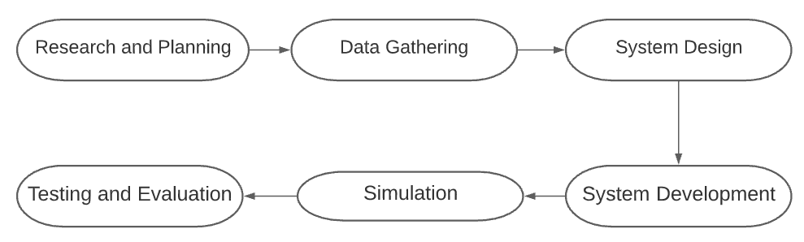

Figure 3.2 Methodological Framework

The Methodological framework presents the process that the researchers will follow to achieve this research. First, the researchers plan to study on the capacity counter by utilizing a microcontroller that will serve as main component of this study. Second, data will be gathered from varied sources from the internet and other available sources from public libraries etc. This will be the guide for the researchers to follow the steps to completion of this study. After the planning out the steps of creating the said system, the researchers will proceed to design the system, software components will be identified to proceed to developing the system. Thus, the simulation of the system will be done by following the specific objectives based on Chapter 1. Hence, evaluation of the system to check errors and for further improvement to reach the standard of the objectives.

**3.3 Data Gathering**

The researchers will test functionality of the system and will quantify the overall test of the counter display of the system. A table form is used to present the gathered data.

Table 1. Person entering.   
In this test the full capacity will be set equal to (10).

|  |  |  |  |  |
| --- | --- | --- | --- | --- |
| No. of Trials | Capacity | Sensor detection (No. of people) | Counter | Display |
| 1 | 0 | 1 |  |  |
| 2 | 0 | 2 |  |  |
| 3 | 0 | 3 |  |  |
| 4 | 0 | 4 |  |  |
| 5 | 0 | 5 |  |  |
| 6 | 0 | 6 |  |  |
| 7 | 0 | 7 |  |  |
| 8 | 0 | 8 |  |  |
| 9 | 0 | 9 |  |  |
| 10 | 0 | 10 |  |  |

The limit of the capacity will be set to 10 but the starting capacity will be set to zero (0). The sensor detection read with ten (10) trials. This data gathering will check if the display outputs the correct command once it starts to count from zero (0) until the capacity is full.

Table 2. Person leaving.

|  |  |  |  |  |
| --- | --- | --- | --- | --- |
| No. of Trials | Capacity | Sensor detection (No. of people) | Counter | Display |
| 1 | 10 | 0 |  |  |
| 2 | 10 | 1 |  |  |
| 3 | 10 | 2 |  |  |
| 4 | 10 | 3 |  |  |
| 5 | 10 | 4 |  |  |
| 6 | 10 | 5 |  |  |
| 7 | 10 | 6 |  |  |
| 8 | 10 | 7 |  |  |
| 9 | 10 | 8 |  |  |
| 10 | 10 | 9 |  |  |

Initially the display outputs to full capacity since it will be set to its limited volume. Starting capacity will be set to full then subtract from every sensor detection.

Table 3. Tests the functionality of the alarm system.

|  |  |  |  |  |
| --- | --- | --- | --- | --- |
| No. of Trials | Capacity | Sensor detection (No. of people) | Counter | Alarm |
| 1 | n | n +1 |  |  |
| 2 | n | n +1 |  |  |
| 3 | n | n +1 |  |  |
| 4 | n | n +1 |  |  |
| 5 | n | n +1 |  |  |
| 6 | n | n +1 |  |  |
| 7 | n | n +1 |  |  |
| 8 | n | n +1 |  |  |
| 9 | n | n +1 |  |  |
| 10 | n | n +1 |  |  |

**3.4 Research Method**

The researchers will derive data from different literatures, studies, and other existing data points to support this study. The data will be subjected to a series of tests and analyses that will determine how it relates to the subject at hand. The aim of these tests is to look for links between performance and other factors. Thus, quantitating the best factor for study.

**3.5 System Design**

**Sample Layout Implementation**

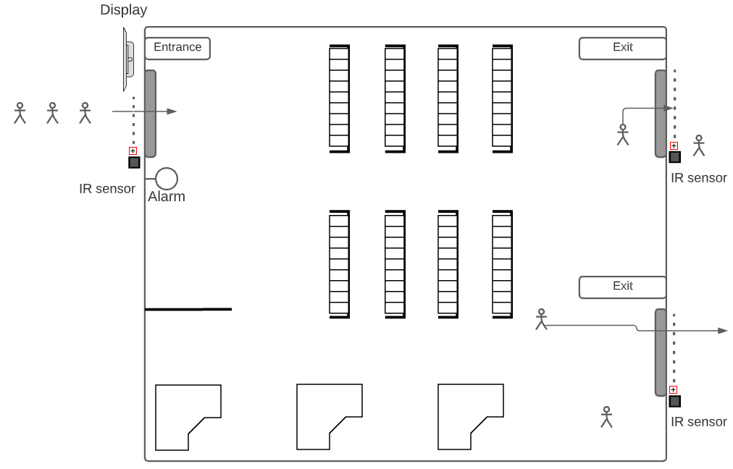

Figure 3.5.1 : Sample Vicinity Layout

Figure 3.5.1 depicts the sample layout of the vicinity, whereas the area has a single entrance point where a certain number of people can enter the area, with the given capacity, it will allow for the person to enter as long as the capacity is not yet filled. So, for every person entering the counter, it will add-up to the counter system. And the area has two (2) exit points where for every person exiting it will be subtracted from the counter.

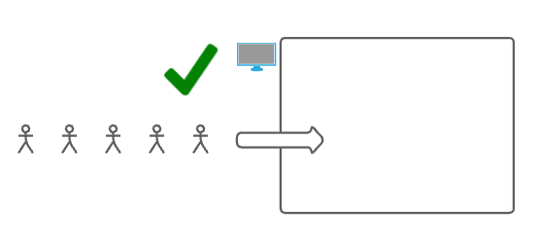

Figure 3.5.2 : Vicinity capacity zero (0)

Suppose that the initial capacity is zero (0). The LCD will display a message for the person to enter, up until the capacity is not yet on its limit.

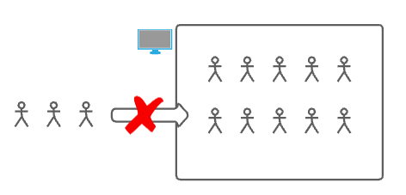

Figure 3.5.3 : Vicinity capacity full

When that the capacity limit is set to ten (10). Once the sensor detected ten (10) entries, it will display a message that the capacity is filled so the person must wait until another person exits the establishment.

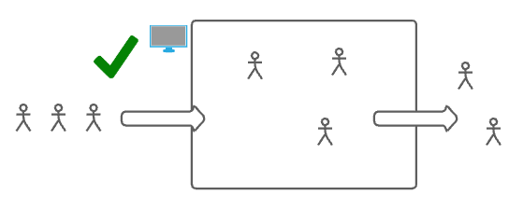

Figure 3.5.4 : Capacity changes

If the capacity has reached its limit and a person exits the premises. The number of people who exit will be subtracted from the present count. So, the people who are waiting in line can enter which will be notified again by the display.

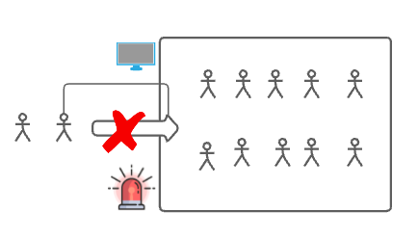

Figure 3.5.5 : Alarm Triggered

Now when that the capacity is filled, and a person unlawfully tries to enter. The alarm system will then be triggered.

**3.6 Flowchart**

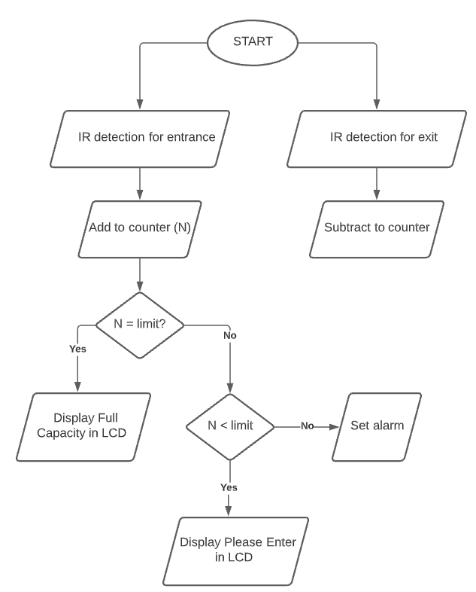

Figure 3.6 : The System Flowchart

**3.7 Components**

**3.7.1** **Infrared sensor**

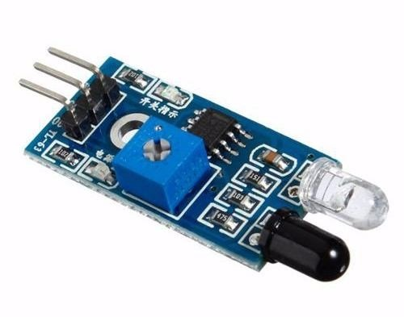

Figure 3.7.1 : Infrared sensor

An infrared sensor is an electronic device, that emits to sense some aspects of the surroundings. An IR sensor can measure the heat of an object as well as detects the motion. These types of sensors measure only infrared radiation, rather than emitting it that is called a passive IR sensor.

**3.7.2** **Microcontroller**

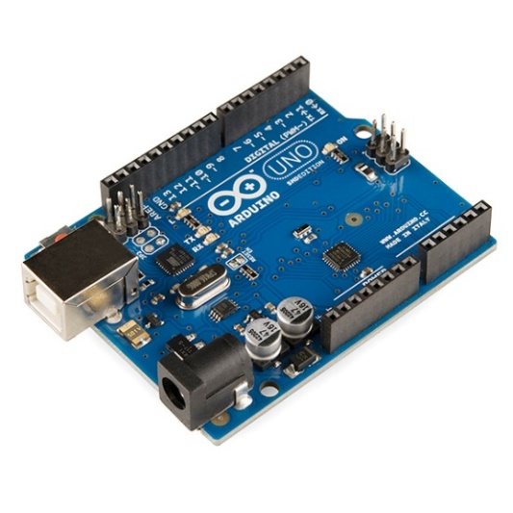

Figure 3.7.2 : Microcontroller

This device will be used for controlling other portions of an electronic system, usually via a microprocessor unit (MPU), memory, and some peripherals.

**3.7.3 LED**

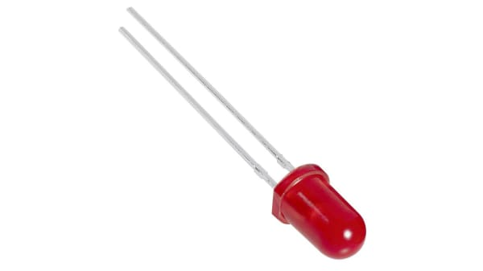

Figure 3.7.3 : LED

A light-emitting diode (LED) is a semiconductor light source that emits light when current flows through it. This will be used as an indication for the alarm.

**3.7.4** **LCD Display**

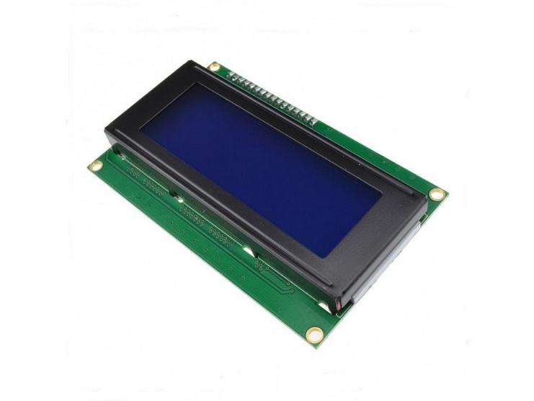

Figure 3.7.4 : LCD Display

Used to display when the capacity is full or not. Serves as a notice to when a person will be allowed to enter or not.

**3.7.5 Buzzer**

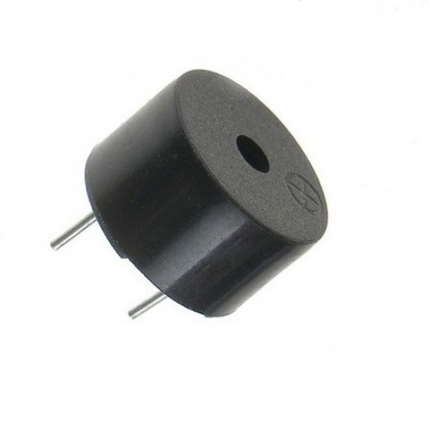

Figure 3.7.5 : Buzzer

Used to alarm sound when the capacity of the vicinity is full.

**3.7.6** **Arduino IDE**



Figure 3.7.6 : Arduino IDE

The Arduino IDE is an open source platform used to program microcontrollers. This is the main software will be used in this study to dictate the sequence of codes to the microcontroller and codes for reading, counting the data entered the sensors.

**3.7.7** **Cisco Packet Tracer**



Figure 3.7.7 : Cisco Packet Tracer

Packet Tracer is a cross-platform visual simulation tool designed by Cisco Systems, this will serve as a simulating platform to depict the functionality of the system.

**3.8 Procedures**

1. The researchers will first gather related literature regarding the topic.
2. The researcher will identify the best practices to achieve the desired outcome of the system.
3. The researchers will then proceed to program the infrared into the microcontroller.
4. Begin to code a counter system for the object being detected by the sensor so that the program will know when to display the desired output.
5. The researchers will then proceed to gather data to test its functionality and accuracy as stated in this literature.
6. With the gathered data, the researchers will form their conclusion and recommendation.

**Bibliography**

1. Shumsky, R., & Debo, L. (2020). What Safe Shopping Looks Like During the Pandemic. From <https://hbr.org/2020/07/what-safe-shopping-looks-like-during-the-pandemic>
2. Courtemanche, C., Garuccio, J., Le, A., Pinkston, J., & Yelowitz, A. (2020). Strong Social Distancing Measures in the United States Reduced the COVID-19 Growth Rate. From <https://www.healthaffairs.org/doi/full/10.1377/hlthaff.2020.00608>
3. Ugail, H., Aggarwal, R., Iglesias, A., Howard, N., Campuzano, A., Suárez, P., Maqsood, M., Aadil, F., Mehmood, I., Gleghorn, S., Taif, K., Kadry, S., & Muhammad, K. (2020). Social distancing enhanced automated optimal design of physical spaces in the wake of the COVID-19 pandemic. From <https://doi.org/10.1016/j.scs.2021.102791>.
4. Özcan, M., Aliew, F., & Görgün, H. (2019). Accurate and precise distance estimation for noisy IR sensor readings contaminated by outliers. From <https://www.sciencedirect.com/science/article/pii/S0263224120301706>
5. Alvarez, G., Garcia, M., & Alvarez, D. (2020). Automated Social Distancing Gate with Non-Contact Body Temperature Monitoring using Arduino Uno. From <https://www.irjet.net/archives/V7/i7/IRJET-V7I7758.pdf>
6. Khairudin, M. (2020). Attendance System Using Infrared Sensors. From <https://iopscience.iop.org/article/10.1088/1742-6596/1456/1/012012/pdf>
7. DTI, DOH Remin Public on Malling Guidelines, May 2020, <https://doh.gov.ph/press-release/DTI-DOH-remind-public-on-malling-guidelines-mall-operators-share-safety-initiatives>
8. Dias, J. (2014). Benefits of Applying Automation to Healthcare. From <https://hitconsultant.net/2014/07/21/6-big-benefits-of-applying-automation-to-healthcare/#.YLWNLqgzbx4>
9. Calixto, E. (2016). Human Reliability Analysis (2nd ed). From <https://www.sciencedirect.com/science/article/pii/B9780128054277000051>
10. dela Cruz, E. & Matarise, E. (2020, May 17). Philippines urges coronavirus vigilance as shoppers ignore safety protocols. Reuters. From <https://www.reuters.com/article/us-health-coronavirus-philippines-idUSKBN22T0E3>