**History**

Rice farming is the act of cultivating rice species, Oryza sativa and Oryza glaberrima varieties, commonly for consumption and derivation of starch-based products like flour and rice wine. It is one of the earliest forms of agriculture directed on shifting from nomadic ways to settlements. With the earliest appearance of estimated 10,000 years ago, the species Oryza rufipogon was one of the first species to be cultivated by the early civilizations which over the years paved the way for the domestication of the species to the more common O. sativa (Kovach, Sweeney, & McCouch). Geographical production distribution is mostly based on the two mentioned varieties. The O. sativa varieties, or the Asian rice strains, have the greater proportion of cultivation occurrences with them being cultivated around the world. On the other hand, the O. glaberrima varieties, the African rice strains, are cultivated in West Africa on a small scale production (Abdulrahman Mahmoud Dogara; Aisha Ishaq Jumare).

**Cultivation Methods**

Current methods of rice cultivation include the flooding of paddy fields. Unlike other types of cultivated plants, rice is semi-aquatic in nature. It can survive prolonged periods of submergence and oxygen limiting. Behavioral analysis indicates that the rice plant mitigates the deprivation effects by elongation of the stem or by metabolic adaptations (Das & Uchimiya). The irrigation requirements of rice production has a different model when compared with other types of cultivated plants. Other form of rice cultivation is the process of rearing aquatic animals along with the rice plants. The rice-fish cultivation system is a type of a semi-intensive aquaculture technique where common hardy fishes like Cyprinus carpio (common carp) or Oreochromis niloticus (Nile Tilapia) are reared within paddies of rice. The reared fishes establish mutualism by providing nutrients to the plants through excreted waste and eating the pests that are local to the area. The other side of mutual relationship is that the rice plants act as biological filtration to the water thus making it suitable for the fishes to thrive (Lu & Li).

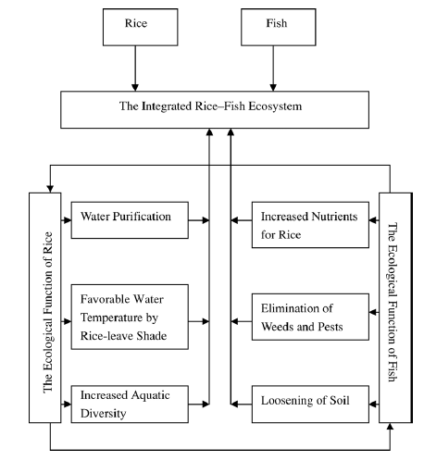

(Lu & Li)

**Economy**

Rice is one of the most cultivated source of carbohydrate and calorie requirements. In 2014, the global production of rice reached 490 million metric ton with 402 million of it being used as food and the remaining as feed and other purposes (FAO). In the Philippines, it is estimated that the national production reached 7.6 million metric ton in first half of 2015 with the 23.59% of the total production coming from the Central Luzon region. The average yield for the same region was 5.64 metric tons per hectare. It is also forecasted that there will be a total of 12.27% increase in national production in the first half of 2017. (Authority, Philippine Statistics). Rice farming is a big contributor to the development and progress of the Philippine economy.

**Philippine Grains Standardization Program**

The rice market in the Philippines is one of its biggest. The reason for this is that Filipinos are one of the nationalities with rice as its staple food. Though rice is relatively bland in taste, its consumers could differentiate quality among varieties of rice. Quality can be assessed through physical, chemical, and market preferences. The chemical methods of assessing the quality of rice employ the analysis of the percentage composition and moisture content. Though this method is highly selective and accurate, its cost is not feasible for frequent evaluation. Sensory evaluation through tasting is highly subjective to the tester’s ability to differentiate and ‘tasting’ skills. The physical method of evaluation the quality of rice is deemed to balance the trade-off between economic feasibility and precision.

The Philippine Grains Standardization Program of 2002 is a government program spearheaded by the National Food Authority to integrate recommended industrial and commercial assessment that will provide inclusive growth, uniformity, compliance, and food quality and safety standards for the labelling and quality assessment of corn and rice grains produced in the Philippines. The National Grains Standard provides the standard specifications on the quality assessment, labelling, and recommended packaging for corn and rice products. The significance of providing quality assessment specifications is mainly to classify rice products so that the appropriate prices are set fairly and justifiably based on the superiority of the products. The NGS provides grading criteria to classify the rice product into Premium or any from Grade 1 to Grade 5. The specifications for milled rice grading are provided in table … .

|  |  |  |  |  |  |  |
| --- | --- | --- | --- | --- | --- | --- |
| **PARAMETER** | **GRADE** | | | | | |
| **PREMIUM** | **GRADE 1** | **GRADE 2** | **GRADE 3** | **GRADE 4** | **GRADE 5** |
| Grain Size | Very Long, Long, Medium, Short | | | | | |
| Degree of Milling | Over milled, Well milled | Well milled | Regular milled | | | |
| **GRADE FACTORS**  **(% by weight)** | **GRADE** | | | | | |
| **PREMIUM** | **GRADE 1** | **GRADE 2** | **GRADE 3** | **GRADE 4** | **GRADE 5** |
| Brokens, max. (total including brewers) | 5.00 | 10.00 | 15.00 | 25.00 | 35.00 | 45.00 |
| Brewers, max. | 0.10 | 0.20 | 0.40 | 0.60 | 1.00 | 2.00 |
| **Defectives:** |  |  |  |  |  |  |
| Damaged kernel, max. | 0.50 | 0.70 | 1.00 | 1.50 | 2.00 | 3.00 |
| Discolored kernel, max. | 0.50 | 0.70 | 1.00 | 3.00 | 5.00 | 8.00 |
| Chalky kernel, max. | 4.00 | 5.00 | 7.00 | 7.00 | 10.00 | 15.00 |
| Immature kernel, max. | 0.20 | 0.30 | 0.50 | 2.00 | 2.00 | 2.00 |
| Contrasting type, max. | 3.00 | 5.00 | 10.00 | - | - | - |
| Red kernel, max. | 1.00 | 2.00 | 4.00 | 5.00 | 5.00 | 7.00 |
| Foreign matters, max. | 0.025 | 0.10 | 0.15 | 0.17 | 0.20 | 0.25 |
| Paddy, max. (no. per 1000 grams) | 10.00 | 15.09 | 20.00 | 25.00 | 25.00 | 25.00 |
| Moisture content | 14.00 | | | | | |
| Milling degree | OMR, WMR | WMR | RMR, WMR(Super),  UMR(Ordinary) | | | |

(Picture Here)

(Define the table here)