**Chapter 2**

**REVIEW OF RELATED LITERATURE**

**History of Rice Farming**

Rice farming is the act of cultivating rice species, Oryza sativa and Oryza glaberrima varieties, commonly for consumption and derivation of starch-based products like flour and rice wine. It is one of the earliest forms of agriculture directed on shifting from nomadic ways to settlements. With the earliest appearance of estimated 10,000 years ago, the species Oryza rufipogon was one of the first species to be cultivated by the early civilizations which over the years paved the way for the domestication of the species to the more common O. sativa (Kovach, Sweeney, & McCouch). Geographical production distribution is mostly based on the two mentioned varieties. The O. sativa varieties, or the Asian rice strains, have the greater proportion of cultivation occurrences with them being cultivated around the world. On the other hand, the O. glaberrima varieties, the African rice strains, are cultivated in West Africa on a small scale production (Abdulrahman Mahmoud Dogara; Aisha Ishaq Jumare).

**Cultivation Methods**

Current methods of rice cultivation include the flooding of paddy fields. Unlike other types of cultivated plants, rice is semi-aquatic in nature. It can survive prolonged periods of submergence and oxygen limiting. Behavioral analysis indicates that the rice plant mitigates the deprivation effects by elongation of the stem or by metabolic adaptations (Das & Uchimiya). The irrigation requirements of rice production has a different model when compared with other types of cultivated plants. Other form of rice cultivation is the process of rearing aquatic animals along with the rice plants. The rice-fish cultivation system is a type of a semi-intensive aquaculture technique where common hardy fishes like Cyprinus carpio (common carp) or Oreochromis niloticus (Nile Tilapia) are reared within paddies of rice. The reared fishes establish mutualism by providing nutrients to the plants through excreted waste and eating the pests that are local to the area. The other side of mutual relationship is that the rice plants act as biological filtration to the water thus making it suitable for the fishes to thrive (Lu & Li).

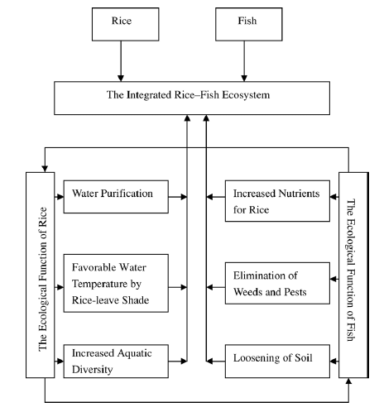

Figure. Rice-fish cultivation system diagram (Lu & Li)

**Economy**

Rice is one of the most cultivated source of carbohydrate and calorie requirements. In 2014, the global production of rice reached 490 million metric ton with 402 million of it being used as food and the remaining as feed and other purposes (FAO). In the Philippines, it is estimated that the national production reached 7.6 million metric ton in first half of 2015 with the 23.59% of the total production coming from the Central Luzon region. The average yield for the same region was 5.64 metric tons per hectare. It is also forecasted that there will be a total of 12.27% increase in national production in the first half of 2017. (Authority, Philippine Statistics). Rice farming is a big contributor to the development and progress of the Philippine economy.

**Philippine Grains Standardization Program**

The rice market in the Philippines is one of its biggest. The reason for this is that Filipinos are one of the nationalities with rice as its staple food. Though rice is relatively bland in taste, its consumers could differentiate quality among varieties of rice. Quality can be assessed through physical, chemical, and market preferences. The chemical methods of assessing the quality of rice employ the analysis of the percentage composition and moisture content. Though this method is highly selective and accurate, its cost is not feasible for frequent evaluation. Sensory evaluation through tasting is highly subjective to the tester’s ability to differentiate and ‘tasting’ skills. The physical method of evaluation the quality of rice is deemed to balance the trade-off between economic feasibility and precision.

The Philippine Grains Standardization Program of 2002 is a government program spearheaded by the National Food Authority to integrate recommended industrial and commercial assessment that will provide inclusive growth, uniformity, compliance, and food quality and safety standards for the labelling and quality assessment of corn and rice grains produced in the Philippines. The National Grains Standard provides the standard specifications on the quality assessment, labelling, and recommended packaging for corn and rice products. The significance of providing quality assessment specifications is mainly to classify rice products so that the appropriate prices are set fairly and justifiably based on the superiority of the products. The NGS provides grading criteria to classify the rice product into Premium or any from Grade 1 to Grade 5. The specifications for milled rice grading are provided in Table.

Table. The National Grains Standard

|  |  |  |  |  |  |  |
| --- | --- | --- | --- | --- | --- | --- |
| **PARAMETER** | **GRADE** | | | | | |
| **PREMIUM** | **GRADE 1** | **GRADE 2** | **GRADE 3** | **GRADE 4** | **GRADE 5** |
| Grain Size | Very Long, Long, Medium, Short | | | | | |
| Degree of Milling | Over milled, Well milled | Well milled | Regular milled | | | |
| **GRADE FACTORS**  **(% by weight)** | **GRADE** | | | | | |
| **PREMIUM** | **GRADE 1** | **GRADE 2** | **GRADE 3** | **GRADE 4** | **GRADE 5** |
| Brokens, max. (total including brewers) | 5.00 | 10.00 | 15.00 | 25.00 | 35.00 | 45.00 |
| Brewers, max. | 0.10 | 0.20 | 0.40 | 0.60 | 1.00 | 2.00 |
| **Defectives:** | | | | | | |
| Damaged kernel, max. | 0.50 | 0.70 | 1.00 | 1.50 | 2.00 | 3.00 |
| Discolored kernel, max. | 0.50 | 0.70 | 1.00 | 3.00 | 5.00 | 8.00 |
| Chalky kernel, max. | 4.00 | 5.00 | 7.00 | 7.00 | 10.00 | 15.00 |
| Immature kernel, max. | 0.20 | 0.30 | 0.50 | 2.00 | 2.00 | 2.00 |
| Contrasting type, max. | 3.00 | 5.00 | 10.00 | - | - | - |
| Red kernel, max. | 1.00 | 2.00 | 4.00 | 5.00 | 5.00 | 7.00 |
| Foreign matters, max. | 0.025 | 0.10 | 0.15 | 0.17 | 0.20 | 0.25 |
| Paddy, max. (no. per 1000 grams) | 10.00 | 15.09 | 20.00 | 25.00 | 25.00 | 25.00 |
| Moisture content | 14.00 | | | | | |
| Milling degree | OMR, WMR | WMR | RMR, WMR(Super),  UMR(Ordinary) | | | |

**Definitions and classification of parameters and factors**

The National Grains Standard defined the factors and parameters of the specifications. The following definitions are directly referenced from the NGS.

*Grain Size*

The grain size of a particular sample is the average of the individual sizes of the grain’s measured major axis length. With the specification of the National Grains Standards, only the major axis length of the grain is measured with disregard to the minor axis length. The size classifications are defined in Table.

Table. The National Grain Standards Grain Size Classification

|  |  |
| --- | --- |
| **Grain Size** | **Description** |
| Very Long | Rice with 80% or more of whole milled rice kernels having a length of 7.5mm and above. |
| Long | Rice with 80% or more of whole milled rice kernels having a length of 6.4 to 7.4mm. |
| Medium | Rice with 80% or more of while milled rice kernels having a length of 5.5 to 6.3mm. |
| Short | Rice with 80% or more of the whole milled rice having a length of less than 5.5mm. |

*Degree of Milling*

The rice seed is coated with plant material called bran. The degree of milling is defined as the extent of how much bran layers and germ have been removed in the milled rice. The classifications of the degree of milling are defined in Table.

Table. The National Grains Standard Degree of Milling Classification

|  |  |
| --- | --- |
| **Degree of Milling** | **Description** |
| Regular milled | Rice kernel from which the hull, the germ, the outer bran layers and the greater part of the inner bran layers have been removed but parts of the lengthwise streaks of the bran layers shall be within the range of 20-40% of the kernels. |
| Well milled | Rice kernels from which the hull, the germ, the outer bran layers and the greater part of the inner bran layers have been removed, but parts of the lengthwise streaks of the layers shall be less than 20% of the kernels. |
| Over milled | Rice kernel from which the hull, the germ and the bran layers have been completely removed. |

*Broken Kernels*

The broken kernels are described as the pieces of kernels smaller than 75% of the average length of the unbroken kernel.

*Brewers*

The brewers are grain samples that can pass through sieves having round perforations of 1.4 mm in diameter.

*Damaged Kernels*

The damaged kernels are those that are sprouted or distinctly damaged by insects, water, fungi, and/or any other means.

*Discolored Kernel*

The discolored kernels are kernels that have changed their original color as a result of heating and other means. They are also known as ‘yellow kernels’ or ‘fermented kernels’.

*Chalky Kernel*

The chalky kernels are those, whole or broken, one-half or more of which is white like the color of white chalk and is brittle upon removal of the hull for palay.

*Immature Kernel*

The immature kernels are those, whole or broken, which are light green and chalky with soft texture.

*Contrasting Type*

Palay/rice kernels of different varieties other than the variety designated, wherein the size, shape, and color differ distinctly from the characteristics of kernels of the variety designated.

*Red Kernel*

The red kernels are those that have red bran covering, wholly or partly.

*Foreign Matter*

Organic and inorganic components other than whole or broken rice kernels (e.g. foreign seeds, husks, bran, sand, dust, and other crop seeds).

*Paddy*

Paddy is the cut part of the rice plant other than the seeds.

*Moisture Content*

The moisture content is the water content of palay, milled rice and corn, expressed in percent (%) as received.

**Morphological Indicators**

The NGS is based on the physical characteristics and morphology average quantification of the rice grains. The characteristic set of each sample could indicate and be classified into grades.

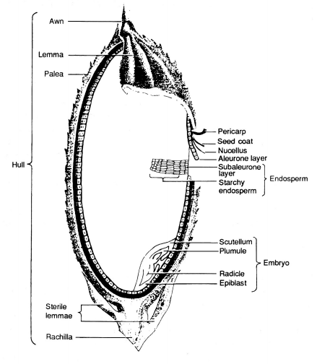

Figure. Longitudinal section of a rice grain

The rice grain is the seed of a rice plant that is sexually mature. The color of a rice grain begins from being light green to progressively yellow to golden. This change in morphology could indicate the ripeness of the grain for harvest. Milled rice is rice grain where its bran is removed to an extent. The NGS defined the extent classification of milling. In Figure, the hull is the outer layer of the grain which defines the color of the grain. As the hull is removed, the bran will be left behind. The bran is a layer in the grain structure which lines the starchy endosperm of the grain.

**Grain size**

The white part of a hulled rice grain is the starchy endosperm cells. These cells are composed of starch structures that provide sustenance for the embryo of the rice grain. The grain size is determined by the major axis length of the endosperm. Although the NGS does not provide the length to width ratio specification, it classifies rice grain size based on the major axis length. This means that the width or length of the minor axis could be disregarded for classification parameter. The grain size is significant to assess the volumetric property of the rice product.

**Degree of milling**

Milling is the process of removing the husk, bran, and the embryo of the rice grain. The main purpose of milling to a degree is to manage the starch to protein content of the resulting grain. As mentioned, the starch resides in the endosperm. However, proteins and lipids are found in the bran which is removed in the milling process. High degree of milling means the starch to protein content ratio is higher.

# Physicochemical and nutritional properties of pigmented rice subjected to different degrees of milling

**Brokens**

**Brewers**

**Damaged kernel**

**Discolored kernel**

**Chalky kernel**

**Immature kernel**

**Red kernel**