**Chapter 1**

**INTRODUCTION**

Rice is the staple food of the Philippines. It is a major agricultural commodity that is mass produced in the country. In the first half of 2015, around 7.6 million metric tons of rice is produced by the Philippines (Philippine Statistics Authority). The Philippine Grain Standardization Program is a government program spearheaded by the National Food Authority to provide commercial assessment standards for the determination of the grade and quality of milled rice products. The implementation of the program started on September 21, 2002. From its establishment, the National Grains Standard has been formed. The National Grains Standards defined the characteristics classification of the rice grain samples. Factors for determining grade include dimensional length, degree of milling, percentage by weight of broken kernels, brewers, red kernels, immature kernels, chalky kernels, damaged kernels, yellow kernels, age-related changes, and other characteristics. The grades are based on the percentage by weight of the classified grains to the overall weight of the product. The Grade 5 is the lowest and the Premium grade is the highest grade a milled rice product can be classified to. Moreover, the implementation of these standards in the market is expected to boost the quality of the rice products in the Philippines. The NGS not only defined provisions about grading, but several packaging regulations, labelling, and quality testing procedures are also outlined. The program institutionalizes the standards to promote inclusive growth and better-quality products. Using the standards retailers, farmers, and distributors can grade their products accordingly. However, the process of grading is still manual and is highly subjective. Assessment experts rely on their own perceptual inference and the manual measurement using precision tools only. The differences in the assessment could render the standards pointless.

Existing studies are aimed to develop simple, affordable, and accessible grading methodologies. Image processing techniques are the most common methods used to classify and grade rice grains based from different standards all over the world. Thresholding techniques were used to distinguish the chalky region of a grain and ultimately quantify its region percentage (Chandra, Barman, & Ghosh). The amount of the chalky region signifies the breaking capacity of the grain and this degrades the quality of the product. A lot of studies correlate the degree of milling of the rice products to its quality. A study made in 2001 monitors the degree of milling of rice grain samples using the whiteness of the rice grains (Yadav & Jindal). An image of the rice grain samples is obtained using CCD Camera mounted to a platform equipped with image enhancing components. The image is analyzed by a computer running an analysis software. Several studies even use machine learning algorithms to determine the grade of the milled rice. The machine learning program learned how to distinguish between grades when fed with the training data obtained from manual methods (Neelamegam. P, S, & Valantina.S.).

Even though there are a lot of studies directed towards fast and affordable rice grading, the standards from where they were based are diverse and local. They also tend to determine the grade of the rice products based on few factors. Moreover, there are currently no studies in the Philippines which are based on the National Grain Standards. This lack of study exposes the vulnerability of the current assessment methods of rice grain products in the Philippines. The grading procedure remains manual, highly subjective, and rely heavily to the expertise of the assessors. This has the potential to create sampling variations which may affect the general Philippine rice market.

The purposes of this study are to lessen the subjectivity of rice grading assessments based on the National Grain Standards by utilizing the consistency and precision of computer-aided assessments and to speed up the grading time. Using image processing methodologies, the study aims to develop a milled rice grading system that is portable and accessible to people and organizations who are working directly on rice like millers, distributors, and farmers. To meet these purposes, the following objectives are to be completed: (1) gather reference values for the evaluation of qualitative grading factors based on the definition of NGS and the assessment of rice-grading assessors; (2) develop an image acquisition and grade reporting platform that is portable and accessible to people who work in rice-related bodies; and (3) develop and implement an image processing application that will work with the portable platform to grade rice samples based on the NGS provisions and reference values.

The grade of a milled rice product affects its price. Therefore, it is essential to find a less subjective and more precise method of grading milled rice products. Fortunately, the NGS provided the data to accurately grade a product. A device that will produce precise and accurate grading based on the NGS can improve the profit of a rice business. Moreover, a device that is accessible and portable can reach even the remotest parts of the Philippines. This effectively extends the reach of the Philippine Standardization Program. In general, the potential impact of this study is related to increasing the productivity of the business by decreasing grading time, providing a fair and accurate grading method, and increasing the accessibility of the method to bigger demographics.

The study is limited to the definitions of the National Grain Standards and the reference values from rice-grading assessors. Moreover, the factors that will be considered by the portable grading system are: dimensional length, degree of milling, percentage by weight of broken kernels, brewers, red kernels, immature kernels, chalky kernels, damaged kernels, and yellow kernels. The percentages by weight of foreign materials and paddy are not considered in the study due to the fact that these measurements are often small compared to the overall weight of the product being sampled and their presence does not conclude the characteristics of the rice grains. In addition, the degree of contrast in the rice variety as a grading factor is not included in the study. The moisture content is also excluded since this measurement is dependent on the age of the unhusked rice gain (palay) and the study is limited to milled rice. The study aims to develop a portable device that grade a rice sample based from an acquired image of non-overlapping rice grains in the sample. For portability, the device will be a standalone system powered by a battery. An image acquisition platform with constant lighting setup will be developed to reduce the perception variation of the images. The device is expected to display the grade of the rice sample along with the measured values of the following factors: rice gain count, dimensional length, degree of milling, percentage by weight of broken kernels, brewers, red kernels, immature kernels, chalky kernels, damaged kernels, and yellow kernels. Furthermore, the open-source Raspberry Pi will be used as the main computer of the device and the Open Source Computer Vision Library (OpenCV) with the Python interface for the image processing application.

**Chapter 2**

**REVIEW OF RELATED LITERATURE**

**History of Rice Farming**

Rice farming is the act of cultivating rice species, Oryza sativa and Oryza glaberrima varieties, commonly for consumption and derivation of starch-based products like flour and rice wine. It is one of the earliest forms of agriculture directed on shifting from nomadic ways to settlements. With the earliest appearance of estimated 10,000 years ago, the species Oryza rufipogon was one of the first species to be cultivated by the early civilizations which over the years paved the way for the domestication of the species to the more common O. sativa (Kovach, et al., 2007). Geographical production distribution is mostly based on the two mentioned varieties. The O. sativa varieties, or the Asian rice strains, have the greater proportion of cultivation occurrences with them being cultivated around the world. On the other hand, the O. glaberrima varieties, the African rice strains, are cultivated in West Africa on a small scale production (Dogara, et al., 2014).

**Economy**

Rice is one of the most cultivated source of carbohydrate and calorie requirements. In 2014, the global production of rice reached 490 million metric ton with 402 million of it being used as food and the remaining as feed and other purposes (FAO, 2014). In the Philippines, it is estimated that the national production reached 7.6 million metric ton in first half of 2015 with the 23.59% of the total production coming from the Central Luzon region. The average yield for the same region was 5.64 metric tons per hectare. It is also forecasted that there will be a total of 12.27% increase in national production in the first half of 2017. (Philippine Statistics Authority, 2016). Rice farming is a big contributor to the development and progress of the Philippine economy.

**Philippine Grains Standardization Program**

The rice market in the Philippines is one of its biggest. The reason for this is that Filipinos are one of the nationalities with rice as its staple food. Though rice is relatively bland in taste, its consumers could differentiate quality among varieties of rice. Quality can be assessed through physical, chemical, and market preferences. The chemical methods of assessing the quality of rice employ the analysis of the percentage composition and moisture content. Though this method is highly selective and accurate, its cost is not feasible for frequent evaluation. Sensory evaluation through tasting is highly subjective to the tester’s ability to differentiate and ‘tasting’ skills. The physical method of evaluation the quality of rice is deemed to balance the trade-off between economic feasibility and precision.

The Philippine Grains Standardization Program of 2002 is a government program spearheaded by the National Food Authority to integrate recommended industrial and commercial assessment that will provide inclusive growth, uniformity, compliance, and food quality and safety standards for the labelling and quality assessment of corn and rice grains produced in the Philippines. The National Grains Standard provides the standard specifications on the quality assessment, labelling, and recommended packaging for corn and rice products. The significance of providing quality assessment specifications is mainly to classify rice products so that the appropriate prices are set fairly and justifiably based on the superiority of the products. The NGS provides grading criteria to classify the rice product into Premium or any from Grade 1 to Grade 5. The specifications for milled rice grading are provided in Table 2.1.

**Table 2.1** The National Grains Standard

|  |  |  |  |  |  |  |
| --- | --- | --- | --- | --- | --- | --- |
| **PARAMETER** | **GRADE** | | | | | |
| **PREMIUM** | **GRADE 1** | **GRADE 2** | **GRADE 3** | **GRADE 4** | **GRADE 5** |
| Grain Size | Very Long, Long, Medium, Short | | | | | |
| Degree of Milling | Over milled, Well milled | Well milled | Regular milled | | | |
| **GRADE FACTORS**  **(% by weight)** | **GRADE** | | | | | |
| **PREMIUM** | **GRADE 1** | **GRADE 2** | **GRADE 3** | **GRADE 4** | **GRADE 5** |
| Brokens, max. (total including brewers) | 5.00 | 10.00 | 15.00 | 25.00 | 35.00 | 45.00 |
| Brewers, max. | 0.10 | 0.20 | 0.40 | 0.60 | 1.00 | 2.00 |
| **Defectives:** | | | | | | |
| Damaged kernel, max. | 0.50 | 0.70 | 1.00 | 1.50 | 2.00 | 3.00 |
| Discolored kernel, max. | 0.50 | 0.70 | 1.00 | 3.00 | 5.00 | 8.00 |
| Chalky kernel, max. | 4.00 | 5.00 | 7.00 | 7.00 | 10.00 | 15.00 |
| Immature kernel, max. | 0.20 | 0.30 | 0.50 | 2.00 | 2.00 | 2.00 |
| Contrasting type, max. | 3.00 | 5.00 | 10.00 | - | - | - |
| Red kernel, max. | 1.00 | 2.00 | 4.00 | 5.00 | 5.00 | 7.00 |
| Foreign matters, max. | 0.025 | 0.10 | 0.15 | 0.17 | 0.20 | 0.25 |
| Paddy, max. (no. per 1000 grams) | 10.00 | 15.09 | 20.00 | 25.00 | 25.00 | 25.00 |
| Moisture content | 14.00 | | | | | |
| Milling degree | OMR, WMR | WMR | RMR, WMR(Super),  UMR(Ordinary) | | | |

**Definitions and classification of parameters and factors**

The National Grains Standard defined the factors and parameters of the specifications. The following definitions are directly referenced from the NGS.

*Grain Size*

The grain size of a particular sample is the average of the individual sizes of the grain’s measured major axis length. With the specification of the National Grains Standards, only the major axis length of the grain is measured with disregard to the minor axis length. The size classifications are defined in Table 2.2.

**Table 2.2** The National Grain Standards Grain Size Classification

|  |  |
| --- | --- |
| **Grain Size** | **Description** |
| Very Long | Rice with 80% or more of whole milled rice kernels having a length of 7.5mm and above. |
| Long | Rice with 80% or more of whole milled rice kernels having a length of 6.4 to 7.4mm. |
| Medium | Rice with 80% or more of while milled rice kernels having a length of 5.5 to 6.3mm. |
| Short | Rice with 80% or more of the whole milled rice having a length of less than 5.5mm. |

*Degree of Milling*

The rice seed is coated with plant material called bran. The degree of milling is defined as the extent of how much bran layers and germ have been removed in the milled rice. The classifications of the degree of milling are defined in Table 2.3.

**Table 2.3** The National Grains Standard Degree of Milling Classification

|  |  |
| --- | --- |
| **Degree of Milling** | **Description** |
| Regular milled | Rice kernel from which the hull, the germ, the outer bran layers and the greater part of the inner bran layers have been removed but parts of the lengthwise streaks of the bran layers shall be within the range of 20-40% of the kernels. |
| Well milled | Rice kernels from which the hull, the germ, the outer bran layers and the greater part of the inner bran layers have been removed, but parts of the lengthwise streaks of the layers shall be less than 20% of the kernels. |
| Over milled | Rice kernel from which the hull, the germ and the bran layers have been completely removed. |

*Broken Kernels*

The broken kernels are described as the pieces of kernels smaller than 75% of the average length of the unbroken kernel.

*Brewers*

The brewers are grain samples that can pass through sieves having round perforations of 1.4 mm in diameter.

*Damaged Kernels*

The damaged kernels are those that are sprouted or distinctly damaged by insects, water, fungi, and/or any other means.

*Discolored Kernel*

The discolored kernels are kernels that have changed their original color as a result of heating and other means. They are also known as ‘yellow kernels’ or ‘fermented kernels’.

*Chalky Kernel*

The chalky kernels are those, whole or broken, one-half or more of which is white like the color of white chalk and is brittle upon removal of the hull for palay.

*Immature Kernel*

The immature kernels are those, whole or broken, which are light green and chalky with soft texture.

*Contrasting Type*

Palay/rice kernels of different varieties other than the variety designated, wherein the size, shape, and color differ distinctly from the characteristics of kernels of the variety designated.

*Red Kernel*

The red kernels are those that have red bran covering, wholly or partly.

*Foreign Matter*

Organic and inorganic components other than whole or broken rice kernels (e.g. foreign seeds, husks, bran, sand, dust, and other crop seeds).

*Paddy*

Paddy is the cut part of the rice plant other than the seeds.

*Moisture Content*

The moisture content is the water content of palay, milled rice and corn, expressed in percent (%) as received.

**Morphological Indicators**

The NGS is based on the physical characteristics and morphology average quantification of the rice grains. The characteristic set of each sample could indicate and be classified into grades.

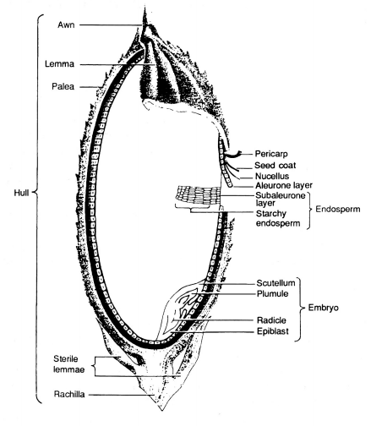

**Figure 2.1** Longitudinal section of a rice grain (FAO, 2014)

The rice grain is the seed of a rice plant that is sexually mature. The color of a rice grain begins from being light green to progressively yellow to golden. This change in morphology could indicate the ripeness of the grain for harvest. Milled rice is rice grain where its bran is removed to an extent. The NGS defined the extent classification of milling. In Figure 2.1, the hull is the outer layer of the grain which defines the color of the grain. As the hull is removed, the bran will be left behind. The bran is a layer in the grain structure which lines the starchy endosperm of the grain.

**Grain size, broken and brewer grains**

The white part of a hulled rice grain is the starchy endosperm cells. These cells are composed of starch structures that provide sustenance for the embryo of the rice grain. The grain size is determined by the major axis length of the endosperm. Although the NGS does not provide the length to width ratio specification, it classifies rice grain size based on the major axis length. This means that the width or length of the minor axis could be disregarded for classification parameter. The grain size is significant to assess the volumetric property of the rice product.

Broken rice grains degrade the quality of the overall product. The breaking of the rice grains is caused by milling procedures or the general property and chemical quality of the rice grains. Broke rice grains are originally whole rice grains but have lengths that are less than 75% of the average length. Market preference indicates that the lesser the amount of broken grains per whole grains means the quality of the grain products is higher (Dalen, 2004). Brewers are similar to the broken grains. However, brewers are rounded. The brewer grains also decrease the perceived quality of the product. The major axis length of the rice grain is used to indicate if the sample grain is a broken, brewer, or a regular desired rice grain.

Image processing dimensional measurements are often used in the grading. In a study made in 2004, the dimensional length and width of the rice grains are used to determine if it is broken (Dalen, 2004). Broken kernels have length less than 75% of the average length. The author used image processing tools to segment, binarize, and measure the dimensions.

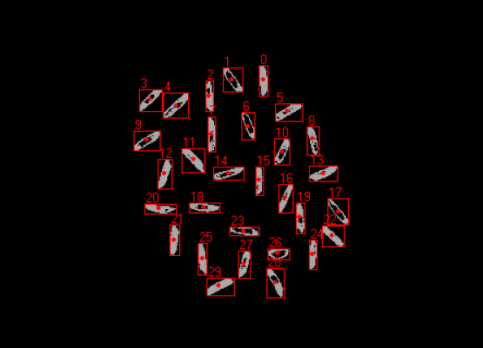

**Figure 2.2** Individual connected component analysis of grain threshold image with count labels (Bambole, et al., 2015)

The classification of grain size depends on the average length of the sample. The individual size must be compared to the mean length to provide a statistically significant classification of the rice. Using connected-component algorithm, threshold rice grains can be analyzed individually by labelling them. In this way, the total count of the rice grain sample can also be obtained (Bambole, et al., 2015).

**Degree of milling**

Milling is the process of removing the husk, bran, and the embryo of the rice grain. The main purpose of milling to a degree is to manage the starch to protein content of the resulting grain. As mentioned, the starch resides in the endosperm. However, proteins and lipids are found in the bran which is removed in the milling process. High degree of milling means the starch to protein content ratio is higher (Paiva, et al., 2014).

A study indicated that the degree of milling and the whiteness of the rice grains are related with each other (Yadav, et al., 2001). In this study, using image processing techniques, the head rice yield and the degree of milling are estimated. The head rice yield is the ratio of the weight of the milled rice grains to the total amount of unhusked rice grains. This ratio aims to provide a general quantification of the extent of the removal of the husks and other internal coverings. The whiteness of the rice is said to be proportional to the lipid concentration in the rice grain. High lipid concentration means the rice grain is whiter. As the degree of milling increases, the amount of whiteness in the grain intensifies. The whiteness is defined by the overall white level of the sample and not by region only. Therefore, a gray level distribution mean was used to indicate the overall whiteness. Increasing degree of milling corresponds to increase in mean gray level.

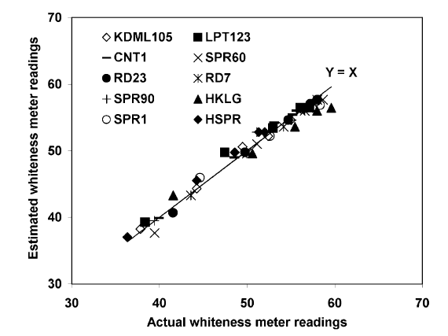

**Figure 2.3** Comparison between whiteness estimation using mean gray levels and the actual whiteness (Yadav, et al., 2001)

In another study, the surface lipid concentration on the grain was used to estimate the degree of milling and found that higher degree of milling results in lower surface lipid concentrations (Liu, et al., 1998). A vision system is used to acquire images of the both sides of the rice grain. Applying thresholding, a threshold value of 10 is used to create a binary image. The total area of the grain is obtained based on the pixel binary values. The same method was used to get the total area of the surface lipid. A threshold value of 10<T<255 was used to normalize the pixels within the range. The total area of the surface lipid is obtained based on the pixel binary values. The T value is adjusted based on the amount of feature extraction for the surface lipid concentration. The surface lipid area percentage is the ratio between the total area surface lipid and the total area of the grain.

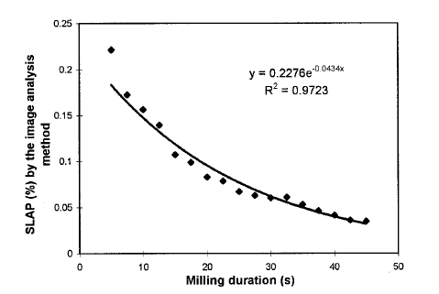

**Figure 2.4** The relationship between the surface lipid area percentage versus the milling duration with T = 130 (Liu, et al., 1998)

By measuring the relative whiteness of the rice grain and the region percentage of the color imperfections caused by varying surface lipid, the degree of milling can be estimated.

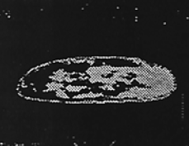

**Figure 2.5** Detecting bran and other internal coverings using thresholding (Liu, et al., 1998)

Furthermore, low to medium degree of milling retains some bran coverings on the rice grain. Through image processing, the bran coverings’ area can be compared to the whole grain area. Comparing the ratio of bran to whole area to some calibration values, the degree of milling can be estimated. Ultimately, this is similar to the method mentioned previously by measuring the amounts of imperfection on the surface of the grain.

**Damaged kernel**

External factors like the temperature, humidity, presence of pests, fungi, and rots causes the damage in the kernels of the rice. In excess humidity, unhusked rice grains could begin to sprout. This is visible even when the rice grains are milled. Also, fungal contamination like molds contribute to the decreasing quality of the rice grains. Damaged kernels can be distinguished by the visible and unnatural looking spots in the rice grain or the presence of sprout like structures.

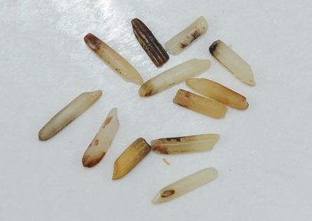

**Figure 2.6** Collection of damaged kernels (Buhler, 2017)

Damaged kernels show unnatural discolorations. In a study made for classifying defects in rice grains, gray scale images were analyzed for features of discoloration (Chandra, et al., 2014). Using statistical parameters, the texture properties of the rice grain were analyzed. The gray level co-occurrence was analyzed to provide an insight to the texture of the rice grains. The damage ratio is described as the ratio of damage texture to the healthy texture. As with the detection of milling degree, the surface imperfections can be used to estimate the damage in the kernels by getting the ratio of the classified damaged region and the total area of the region.

**Discolored kernel**

Discolored kernels are those that have gone through the process of ‘fermentation’. Rice products that have undergone this process indicates that the products are stored for a long time. Unnecessary high storage temperature also causes discolored kernels. Fermentation in the rice can be indicated by the collective yellowness of the grains.

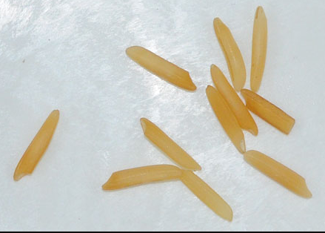

**Figure 2.7** Yellow discolored Basmati rice grain (Buhler, 2017)

By estimating the mean yellow of the rice grains and then compared to calibrated values, the degree of fermentation can be obtained. Also, the yellowness tends to form a gradient on the rice grain meaning there is a low tendency for a region to be sharply yellow compared to the other regions. The yellowness tends to diffuse from the starting point of the fermentation.

**Chalky kernel**

Rice grains with colors that can be compared to the color of a white chalk tends to break easily (Bambole, et al., 2015). Chalky grains, when stored or milled, turns into broken grains and powdery substrates. The degree of whiteness on a region compared to the overall whiteness of the sample is used to indicate the chalkiness of the rice grain.

The degree of chalkiness could be processed as the measured opaqueness of the rice grains by passing light through them. However, more recent methodologies use thresholding algorithms that compare the degree of whiteness of the rice grains with the threshold value and then computing the summed ratio of the degree of whiteness (Bambole, et al., 2015). Based from the study, the chalkiness of the sample is obtained by the ratio of the number of the grains classified as chalky and the total number of the sample grains. To determine if a grain is chalky or not, a threshold was applied to the binarized image. Chalky regions are represented by black pixels. The ratio between the chalky region to the whole region represents the chalkiness of the grain. If the chalkiness is over 20%, then the grain is considered chalky.

Using thresholding, the colors can be differentiated and reduced to standard preset values. This makes the color distribution easier to analyze. The chalkiness of the rice can be measured by the ratio of the chalky white regions to the overall area of the region (Chandra, et al., 2014).

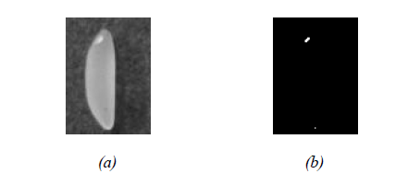

**Figure 2.8** (a) original image to apply threshold, (b) resulting threshold binary image to extract chalky regions (Chandra, et al., 2014)

In another study, a support vector machine coupled image processing method was developed to identify the chalky regions and the dimensional features of the grain. The application of linear classifiers proved to be successful with a maximum success rate of 98.5% classification. By segmenting the chalky threshold regions, the area of those regions was quantified and compared to the overall grain area region. This method is similar to the previously mentioned classification techniques (Sun, et al., 2014)

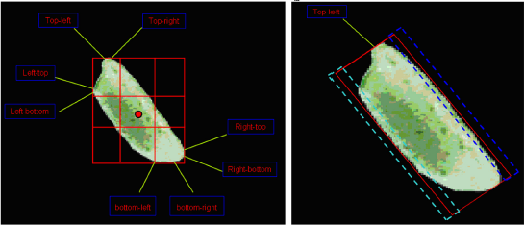

**Figure 2.9** Segmented chalky regions through thresholding (Sun, et al.,2014)

**Immature kernel**

Immature kernels are those that are harvested before the desired maturation of the seeds. Immature kernels exhibit their young age through the color of the endosperm. As mentioned, the desired maturity of the grains is indicated by the yellow to golden color of the husk. Immature kernels have greenish endosperms. The degree of green in the endosperm indicates the immaturity of the rice kernel.

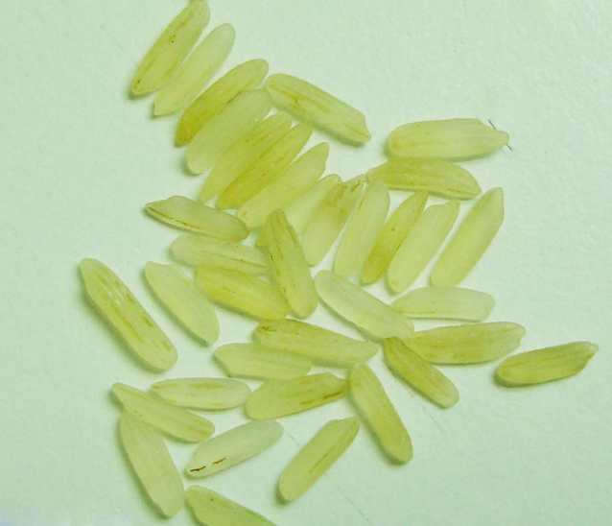

**Figure 2.10** Immature rice grains (Riceland, 2016)

Similar to fermented kernels, the diffusion of the color is gradient. In this case, the green color tends to diffuse from tips radiating towards the center of the grain. No visibly sharp regions are present.

**Red kernel**

Red kernel properties are almost similar to the degree of milling. The bran is the covering of the endosperm. Red kernels still have this covering depending on the milling. Well-milled rice grains are supposed to contain less red kernels. However, for regular milled rice grains, the red kernels are relatively abundant. In essence, red kernels could determine the degree of milling of the rice grains.

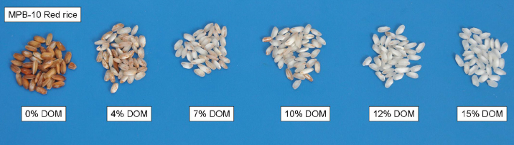

**Figure 2.11** Degree of milling comparison (Paiva, et al., 2014)