Portable Milled Rice Grain Feature Extraction Platform Using Computer Vision
First Author#, Second Author*, Third Author#
#First-Third Department, First-Third University
Address
¹first.author@first-third.edu
³third.author@first-third.edu
*Second Company
Address Including Country Name
²second.author@second.com

Abstract— This document gives formatting instructions for authors preparing papers for publication in the Proceedings of an IEEE conference. The authors must follow the instructions given in the document for the papers to be published. You can use this document as both an instruction set and as a template into which you can type your own text.

Index Terms— Include at least 5 keywords or phrases
- Introduction
Rice is the staple food of the Philippines. It is a major agricultural commodity that is mass produced in the country and in other developing countries (Juliano, 2016). The price of a milled rice product depends on its perceived quality. Thus, the stakeholders often employ different quality assessments which are quantifiable yet prone to bias and variations. The traditional method of milled rice grading in the Philippines is often done by some accredited personnel from the National Food Authority or other government bodies responsible for the certification of trade. The dimension, shape, and the color of the milled rice sample are the main factors considered when grading (insert NGS here). The grading process relies on the classification of the milled rice grains into different types (e.g. red, green, or yellow kernel) and are measured by percentage by weight. A visual analysis for this grading methodology creates a vulnerability on the process as it will be opened to variations and differences of perception. Furthermore, the method could be considered as an approximation thus introducing a certain rate of information loss about the sample.

To help reduce the information loss of grading a milled rice grain sample, the study is structured to provide a methodology by designing a computer vision and image acquisition platform capable of extracting grain images and perform feature extractions that are useful for classifiers and image analyses. Furthermore, the study aims to: (1) design a standalone image acquisition platform with constant light settings, (2) assemble a computing module using the Raspberry Pi module for image analysis and feature extraction, (3) extract individual images of rice grains into a collection, and (4) apply a set of image analyses and histogram of gradient and color histogram features extraction.
- Methodology
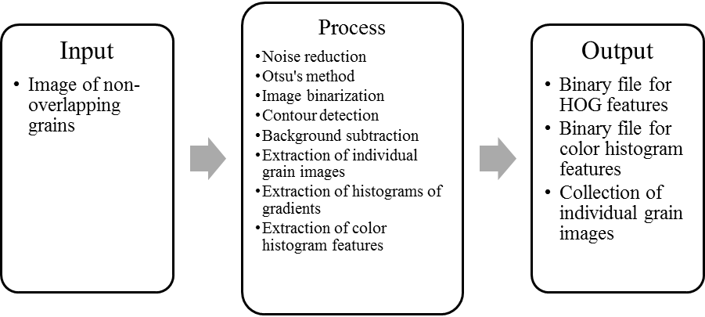
Fig. 1 The conceptual framework for the portable milled rice grain feature extraction platform

The information loss in the process of quantifying properties (e.g. shape, color) of the milled rice grain samples can promote variations in the assessment of the grade. The study proposes a methodology for extracting two sets of features: (1) histogram of gradients and (2) color histogram features. These two sets of features can be applied to different classifiers and analysis algorithms (e.g. SVMs, linear classifiers)

The conceptual framework for the study is illustrated by Fig. 1. The system has different parts: the computing module, and the image acquisition platform as shown in Fig. The image acquisition platform is designed to minimize the light setting variation of each extraction session. This is achieved by using artificial lighting using low cost white LEDs. The computing module is composed of the Raspberry Pi minicomputer fitted with a compatible digital camera capable of capturing medium resolution images of milled rice grain samples. The device captures a single image of the sample with grains that are not overlapping. The device itself must also be calibrated to produce a medium resolution image of the sample. It is significant to perform this before any image analysis so that a better success rate of background subtraction can be achieved.

The pre-processing method block is composed of the image segmentation and connected-component labelling. Before the image is binarized using the thresholding method based on the Otsu’s threshold value, it will undergo median blurring as a form of noise reduction. Contours are needed to extract and detect individual grains. The contour detection process uses the border following method source. For individual images, the HOG and its color histogram features are extracted. The collection of HOG and color histogram features will be saved into different CSV files along with the collection of the extracted individual grain images.
- System Flowchart

- Image Pre-processing and Grain Detection

- Histogram of Gradients

- Color Histogram Features

- Results and Discussion
All paragraphs must be indented. All paragraphs must be justified, i.e. both left-justified and right-justified.
- Text Font of Entire Document
The entire document should be in Times New Roman or Times font. Type 3 fonts must not be used. Other font types may be used if needed for special purposes.
Recommended font sizes are shown in Table 1.
- Title and Author Details
Title must be in 24 pt Regular font. Author name must be in 11 pt Regular font. Author affiliation must be in 10 pt Italic. Email address must be in 9 pt Courier Regular font.

TABLE I
Font Sizes for Papers
Font Size | Appearance (in Time New Roman or Times)
Font Size | Regular | Bold | Italic
8 | table caption (in Small Caps),  figure caption,  reference item |  | reference item (partial)
9 | author email address (in Courier),  cell in a table | abstract body | abstract heading (also in Bold)
10 | level-1 heading (in Small Caps),  paragraph |  | level-2 heading,  level-3 heading,  author affiliation
11 | author name
24 | title

All title and author details must be in single-column format and must be centered.
Every word in a title must be capitalized except for short minor words such as “a”, “an”, “and”, “as”, “at”, “by”, “for”, “from”, “if”, “in”, “into”, “on”, “or”, “of”, “the”, “to”, “with”.
Author details must not show any professional title (e.g. Managing Director), any academic title (e.g. Dr.) or any membership of any professional organization (e.g. Senior Member IEEE).
To avoid confusion, the family name must be written as the last part of each author name (e.g. John A.K. Smith).
Each affiliation must include, at the very least, the name of the company and the name of the country where the author is based (e.g. Causal Productions Pty Ltd, Australia).
Email address is compulsory for the corresponding author.
- Section Headings
No more than 3 levels of headings should be used. All headings must be in 10pt font. Every word in a heading must be capitalized except for short minor words as listed in Section III-B.
- Level-1 Heading: A level-1 heading must be in Small Caps, centered and numbered using uppercase Roman numerals. For example, see heading “III. Page Style” of this document. The two level-1 headings which must not be numbered are “Acknowledgment” and “References”.
- Level-2 Heading: A level-2 heading must be in Italic, left-justified and numbered using an uppercase alphabetic letter followed by a period. For example, see heading “C. Section Headings” above.
- Level-3 Heading: A level-3 heading must be indented, in Italic and numbered with an Arabic numeral followed by a right parenthesis. The level-3 heading must end with a colon. The body of the level-3 section immediately follows the level-3 heading in the same paragraph. For example, this paragraph begins with a level-3 heading.
- Figures and Tables
Figures and tables must be centered in the column. Large figures and tables may span across both columns. Any table or figure that takes up more than 1 column width must be positioned either at the top or at the bottom of the page.
Graphics may be full color. All colors will be retained on the CDROM. Graphics must not use stipple fill patterns because they may not be reproduced properly. Please use only SOLID FILL colors which contrast well both on screen and on a black-and-white hardcopy, as shown in Fig. 1.

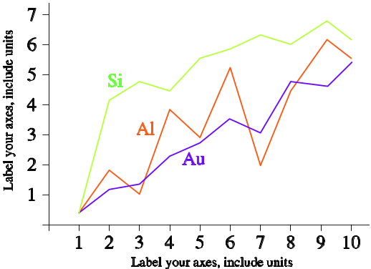
Fig. 2 A sample line graph using colors which contrast well both on screen and on a black-and-white hardcopy

Fig. 2 shows an example of a low-resolution image which would not be acceptable, whereas Fig. 3 shows an example of an image with adequate resolution. Check that the resolution is adequate to reveal the important detail in the figure.
Please check all figures in your paper both on screen and on a black-and-white hardcopy. When you check your paper on a black-and-white hardcopy, please ensure that:
- the colors used in each figure contrast well,
- the image used in each figure is clear,
- all text labels in each figure are legible.
- Figure Captions
Figures must be numbered using Arabic numerals. Figure captions must be in 8 pt Regular font. Captions of a single line (e.g. Fig. 2) must be centered whereas multi-line captions must be justified (e.g. Fig. 1). Captions with figure numbers must be placed after their associated figures, as shown in Fig. 1.

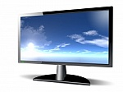
Fig. 3 Example of an unacceptable low-resolution image

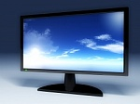
Fig. 4 Example of an image with acceptable resolution

- Table Captions
Tables must be numbered using uppercase Roman numerals. Table captions must be centred and in 8 pt Regular font with Small Caps. Every word in a table caption must be capitalized except for short minor words as listed in Section III-B. Captions with table numbers must be placed before their associated tables, as shown in Table 1.
- Page Numbers, Headers and Footers
Page numbers, headers and footers must not be used.
- Links and Bookmarks
All hypertext links and section bookmarks will be removed from papers during the processing of papers for publication. If you need to refer to an Internet email address or URL in your paper, you must type out the address or URL fully in Regular font.
- References
The heading of the References section must not be numbered. All reference items must be in 8 pt font. Please use Regular and Italic styles to distinguish different fields as shown in the References section. Number the reference items consecutively in square brackets (e.g. [1]).
When referring to a reference item, please simply use the reference number, as in [2]. Do not use “Ref. [3]” or “Reference [3]” except at the beginning of a sentence, e.g. “Reference [3] shows …”. Multiple references are each numbered with separate brackets (e.g. [2], [3], [4]–[6]).
Examples of reference items of different categories shown in the References section include:
- example of a book in [1]
- example of a book in a series in [2]
- example of a journal article in [3]
- example of a conference paper in [4]
- example of a patent in [5]
- example of a website in [6]
- example of a web page in [7]
- example of a databook as a manual in [8]
- example of a datasheet in [9]
- example of a master’s thesis in [10]
- example of a technical report in [11]
- example of a standard in [12]
- Conclusions
The version of this template is V2. Most of the formatting instructions in this document have been compiled by Causal Productions from the IEEE LaTeX style files. Causal Productions offers both A4 templates and US Letter templates for LaTeX and Microsoft Word. The LaTeX templates depend on the official IEEEtran.cls and IEEEtran.bst files, whereas the Microsoft Word templates are self-contained. Causal Productions has used its best efforts to ensure that the templates have the same appearance.
Acknowledgment
The heading of the Acknowledgment section and the References section must not be numbered.
Causal Productions wishes to acknowledge Michael Shell and other contributors for developing and maintaining the IEEE LaTeX style files which have been used in the preparation of this template. To see the list of contributors, please refer to the top of file IEEETran.cls in the IEEE LaTeX distribution.
References
- S. M. Metev and V. P. Veiko, Laser Assisted Microtechnology, 2nd ed., R. M. Osgood, Jr., Ed. Berlin, Germany: Springer-Verlag, 1998.
- J. Breckling, Ed., The Analysis of Directional Time Series: Applications to Wind Speed and Direction, ser. Lecture Notes in Statistics. Berlin, Germany: Springer, 1989, vol. 61.
- S. Zhang, C. Zhu, J. K. O. Sin, and P. K. T. Mok, “A novel ultrathin elevated channel low-temperature poly-Si TFT,” IEEE Electron Device Lett., vol. 20, pp. 569–571, Nov. 1999.
- M. Wegmuller, J. P. von der Weid, P. Oberson, and N. Gisin, “High resolution fiber distributed measurements with coherent OFDR,” in Proc. ECOC’00, 2000, paper 11.3.4, p. 109.
- R. E. Sorace, V. S. Reinhardt, and S. A. Vaughn, “High-speed digital-to-RF converter,” U.S. Patent 5 668 842, Sept. 16, 1997.
- (2002) The IEEE website. [Online]. Available: http://www.ieee.org/
- M. Shell. (2002) IEEEtran homepage on CTAN. [Online]. Available: http://www.ctan.org/tex-archive/macros/latex/contrib/supported/IEEEtran/
- FLEXChip Signal Processor (MC68175/D), Motorola, 1996.
- “PDCA12-70 data sheet,” Opto Speed SA, Mezzovico, Switzerland.
- A. Karnik, “Performance of TCP congestion control with rate feedback: TCP/ABR and rate adaptive TCP/IP,” M. Eng. thesis, Indian Institute of Science, Bangalore, India, Jan. 1999.
- J. Padhye, V. Firoiu, and D. Towsley, “A stochastic model of TCP Reno congestion avoidance and control,” Univ. of Massachusetts, Amherst, MA, CMPSCI Tech. Rep. 99-02, 1999.
- Wireless LAN Medium Access Control (MAC) and Physical Layer (PHY) Specification, IEEE Std. 802.11, 1997.

